Conversion of Verilog
wbdeppsimple.v
With MyHDLto
toplevel.v
05/06/16

The file “my_wbdepp.py” is a Python program that can provide both Verilog or VHDL files. The file “my_wbdepp.y” is found a Appendix A. To create “toplevel.v”. The command to create the “toplevel.v” “python my_wbdepp.py –convert”. The file “toplevel.v” is at Appendix B. toplevel.v In addition MyHDL can simulate the Verilog. The command “python my_wbdepp –trace” to generate a VCD “tb.vcd” which can be viewed with “gtkwave tb.vcd”.

In this simultion the signal “i_rpi2B” is not connected to “i_depp” is being set to 0x00 at each of time steps. After setting the “i_depp” to 0x00 the signal “i_write_n” is set lo and then hi. The signal “x_write_n” is delayed by one clock. The signal “r_write_n is delay by 2 clocks.

The signal “i_astb_n” is set lo and then hi. The signal “x_astb_n” is delayed by one clock. The signal “r_astb_n is delay by 2 clocks.

It appears that the code setting the “o_wait” is working currently. The signal goes lo following the signal “i_astb_n” going lo and the hi. This is in line 179 assign o_wait = w_wait; which is dependent on line 183 assign w_wait = (!(x_dstb_n && x_astb_n && r_dstb_n && r_astb_n && l_dstb_n && l_astb_n));

It also appears that the delayed signals are working correctly.

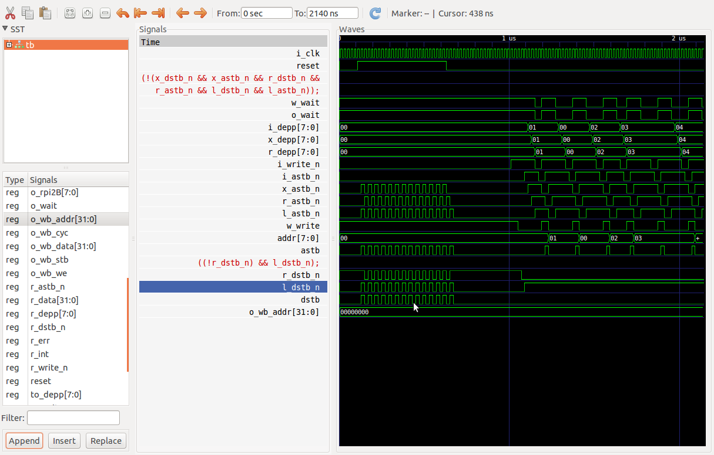
Appendix A. my_wbdepp.py
Appendix B wbdeppsimple.v
Appendix C. toplevel.v

