Correcting many errors in wavesim_53.py, add_mul_sim_53.py.
The original values for k1 &k2. It appears that k1 = 0.4 & k2 = 0.15 yield the best results see pg 3.

# Scale coeff:
k1 = 0.81289306611596146 # 1/1.230174104914
k2 = 0.61508705245700002 # 1.230174104914/2
Testing
k1 = .5
k2 = .25
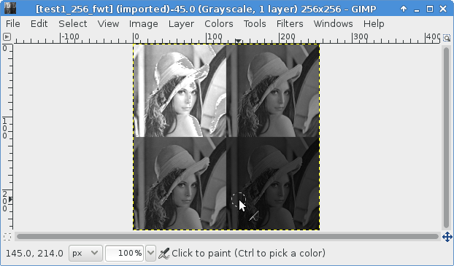
Testing
k1 = 0.6
k2 = 0.3

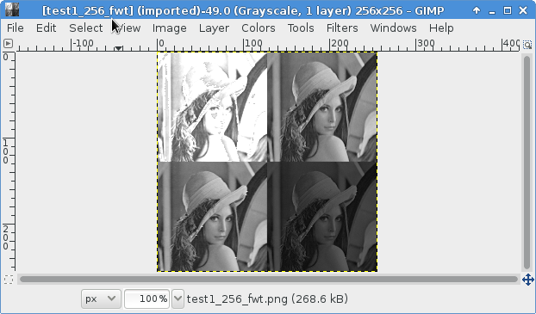
Testing
k1 = 0.4
k2 = 0.25
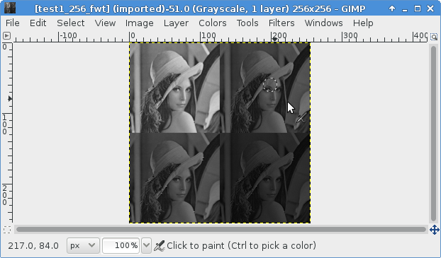
Testing
k1 = 0.4
k2 = 0.2

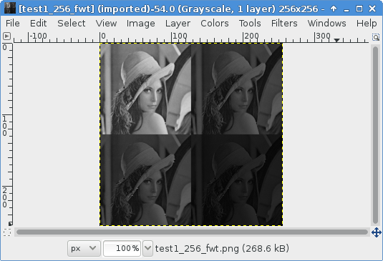
Testing
k1 = 0.4
k2 = 0.15
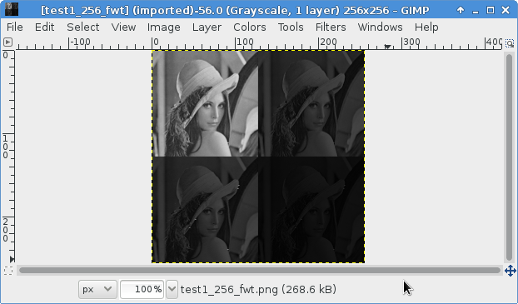
Simulation of add_shift_ram
python ex_add_sh.py

100 110 5

0x64 0x6e 0x5

202 182 -10

0xca 0xb6 -0xa

111110110 0x1f6

- 000001010

200 174 -13

0xc8 0xae -0xd

111110011 0x1f3

- 000001101

204 194 -5

0xcc 0xc2 -0x5

111111011 0x1fb

- 000000101

106 126 10

0x6a 0x7e 0xa

136 106 -15

0x88 0x6a -0xf

111110001 0x1f1

- 000001111

0x64 0x60 0x31

