After the file lena256.hex is created with the Steps to create the *.hex file below and the file t_wave_53.py is restored.

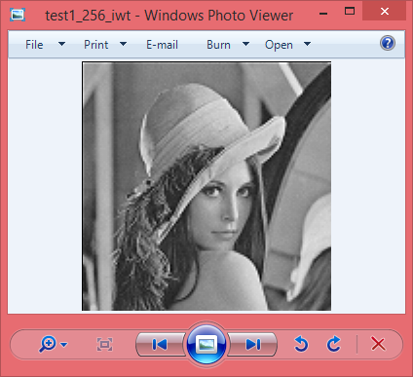

The following lines read a png image
im = dwt.Image.open("../lena_256.png")
pix = im.load()
m = list(im.getdata())
#print m.__sizeof__()
m = [m[i:i+im.size[0]] for i in range(0, len(m), im.size[0])]

The the m list is written with the data from lena256.hex with the method convert_intelhex_to_list():
The forward & inverse dwt is executed and the files test1_256_fwt.png & test1_256_iwt.png are written.
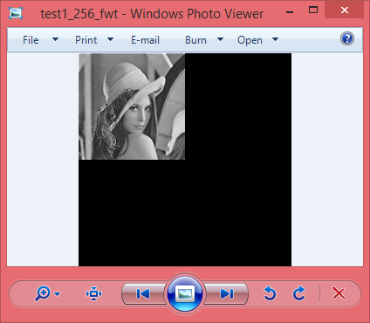

Steps to create the *.hex file

In the file jpeg-2000-test-\ipython_fixbv\t_wave_53.py
commenting out the lines
convert_intelhex_to_list() This line reads the hex file and replaces the values that were read with the
lines
im = dwt.Image.open("../lena_256.png")
pix = im.load()
m = list(im.getdata())
m = dwt.fwt97_2d(m, 1) This line computes a 1 level of fwd dwt on a 2d image.
dwt.seq_to_img(m, pix) This line converts the 2d image to a seq

python t_wave_53.py will read the image and generate the file tmp_level.bin
With the bin2hex convert the file to intelHex file
python ..\..\..\..\..\..\Python27\Scripts\bin2hex.py tmp_level.bin lena256.hex

cd "c:\Program Files (x86)\XSTOOLs"
xsload.exe -usb 0 -f hex -ram "c:\Users\vidal\My Documents\GitHub\jpeg-2000-test\ipython_fixbv\lena256.hex"
pause
lena256.hex
:020000040000FA 0 65535 2**16-1
:020000040001F9 65536 131071

ttt.hex
:020000040001F9 0 65535 2**16-1
:020000040002F8
:020000040003F7

rd_img_2.bat
m:
dir ttt.hex
del ttt.hex
"c:\Program Files (x86)\XSTOOLs\xsload.exe" -usb 0 -f hex -u 0x0000 0x3FFFF -ram ttt.hex
dir ttt.hex
copy ttt.hex "c:\Users\vidal\Documents\GitHub\jpeg-2000-test\ipython_fixbv"

pause

