Java jj2000

On laptop rsync -avl --delete ws009:~/fedora20_ws009/jj2000 .

“cd /run/media/vidal/ef8bceae-4730-4810-b594-ce6aafd13919/vidal/fedora20_ws009/netbeans/netbeans-6.8/bin”
“./netbeans &”
Using sources “/home/vidal/fedora20_ws009/jj2000”.
-debug on -verbose -Ffilters w5x3 -Qtype reversible -i /run/media/vidal/ef8bceae-4730-4810-b594-ce6aafd13919/vidal/fedora20_ws009/jpeg-2000-test/lena_256.pgm -rate 0.25 -o /run/media/vidal/ef8bceae-4730-4810-b594-ce6aafd13919/vidal/fedora20_ws009/jpeg-2000-test/lena_256.pgx

-rw-r--r-- 1 vidal users 65590 Jun 11 20:05 lena_256.pgm
-rw-r--r-- 1 vidal users 1977 Jul 21 15:12 lena_256.pgx

-debug on -verbose -Ffilters w5x3 -Qtype reversible -i /run/media/vidal/ef8bceae-4730-4810-b594-ce6aafd13919/vidal/fedora20_ws009/jpeg-2000-test/lena_256.pgm -rate 0.5 -o /run/media/vidal/ef8bceae-4730-4810-b594-ce6aafd13919/vidal/fedora20_ws009/jpeg-2000-test/lena_256.pgx

-rw-r--r-- 1 vidal users 65590 Jun 11 20:05 lena_256.pgm
-rw-r--r-- 1 vidal users 4067 Jul 21 15:15 lena_256.pgx

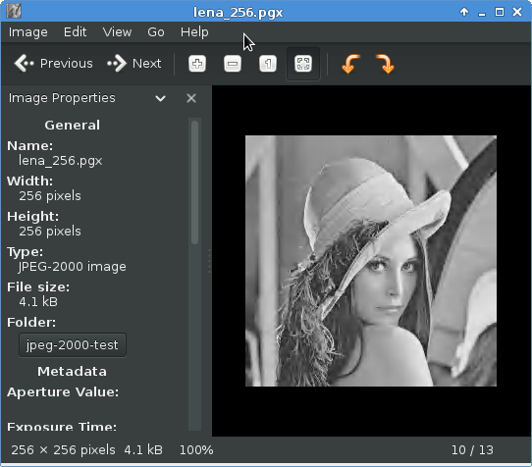
EncoderSpecs
AnWTFilterSpec
AnWTFilterIntLift5x3
public
void analyze_lpf(int inSig[], int inOff, int inLen, int inStep,
int lowSig[], int lowOff, int lowStep,
int highSig[], int highOff, int highStep) {
int i;
int iStep = 2 * inStep; //Subsampling in inSig
int ik; //Indexing inSig
int lk; //Indexing lowSig
int hk; //Indexing highSig

/* Generate high frequency subband */

//Initialize counters
ik = inOff + inStep;
hk = highOff;

//Apply first lifting step to each "inner" sample.
for(i = 1; i < inLen-1; i += 2) {
highSig[hk] = inSig[ik] -
((inSig[ik-inStep] + inSig[ik+inStep])>>1);

ik += iStep;
hk += highStep;
}

//Handle head boundary effect if input signal has even length.
if( inLen % 2 == 0 ) {
highSig[hk] = inSig[ik] - ((2*inSig[ik-inStep])>>1);
}

/* Generate low frequency subband */

//Initialize counters
ik = inOff;
lk = lowOff;
hk = highOff;

if(inLen>1) {
lowSig[lk] = inSig[ik] + ((highSig[hk] + 1)>>1);
}
else {
lowSig[lk] = inSig[ik];
}

ik += iStep;
lk += lowStep;
hk += highStep;

//Apply lifting step to each "inner" sample.
for(i = 2; i < inLen-1; i += 2) {
lowSig[lk] = inSig[ik] +
((highSig[hk-highStep] + highSig[hk] + 2)>> 2);

ik += iStep;
lk += lowStep;
hk += highStep;
}

//Handle head boundary effect if input signal has odd length.
if(inLen % 2 == 1) {
if(inLen>2) {
lowSig[lk] = inSig[ik] + ((2*highSig[hk-highStep]+2)>>2);
}
}
}

