******************** Draft ********************

Ultibo provides bare metal programming for the Rpi-Zero, RP2B, and RPi3B
Compiling Ultibo Edition for Raspberry Pi (Rpi)
01/08/17
Based on infromation found at https://ultibo.org/wiki/Building_for_Raspbian

The scripts and config files are found at https://github.com/develone/jpeg-2000-test/tree/master/bare-metal/build_ultibo_RPi

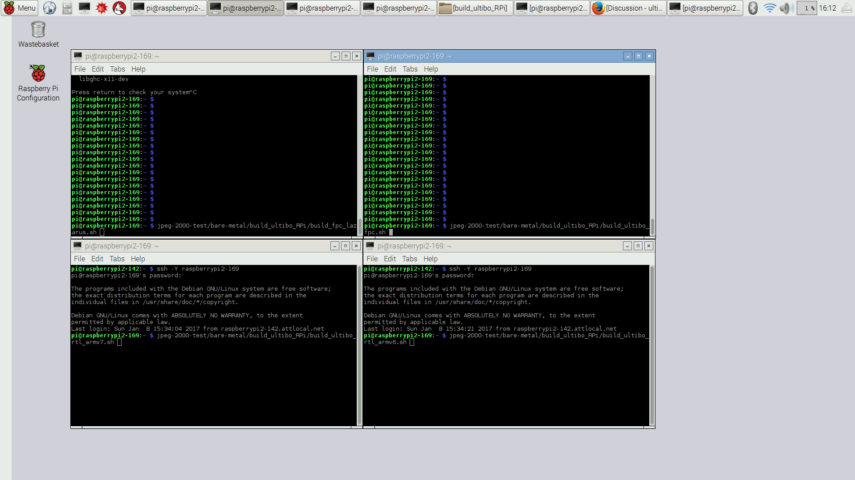
B

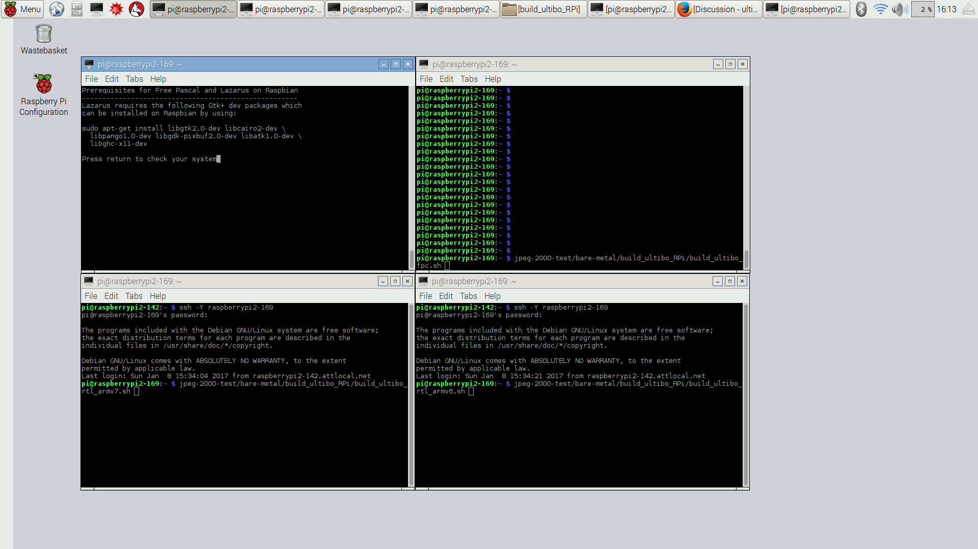
C

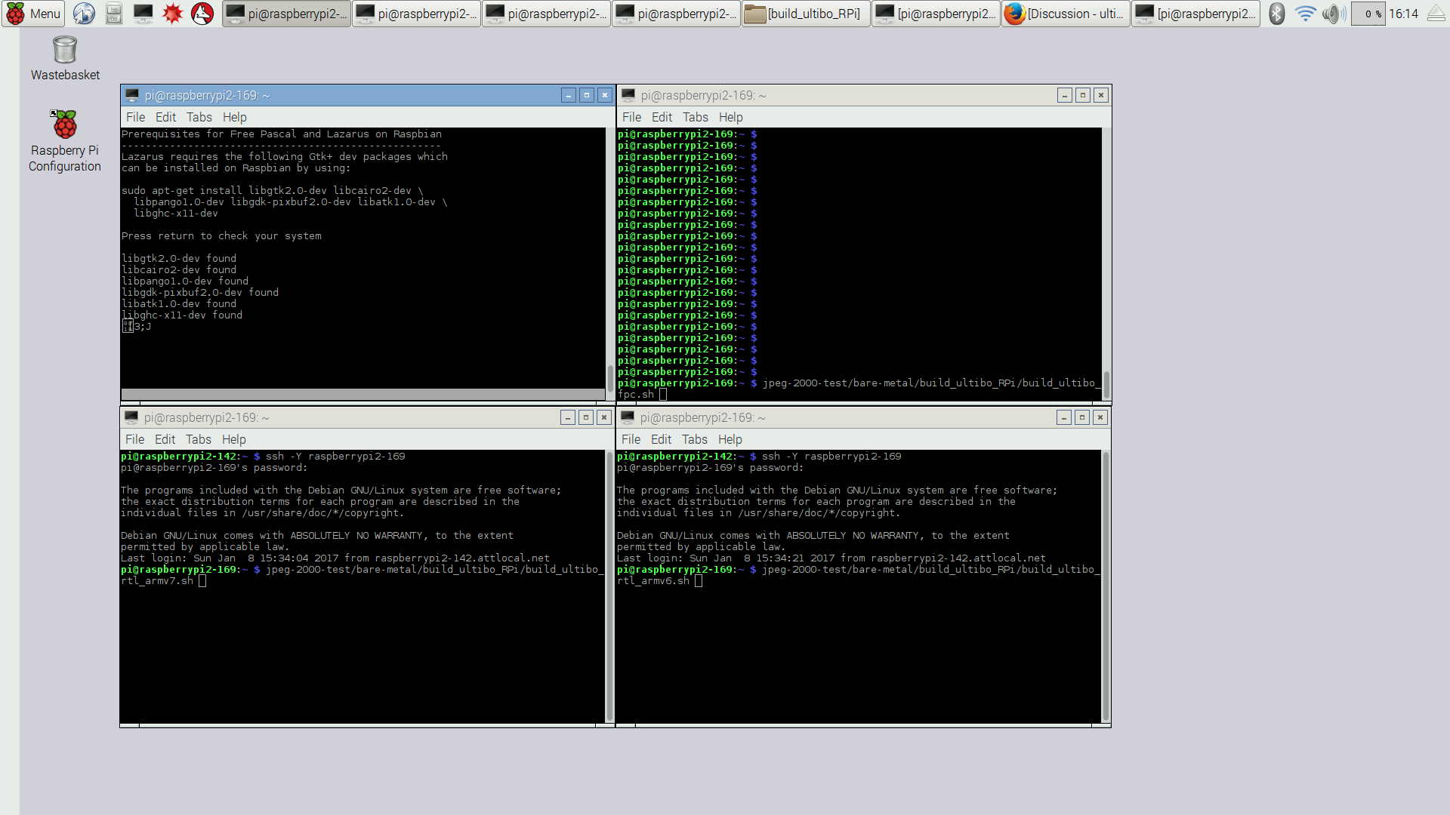
D

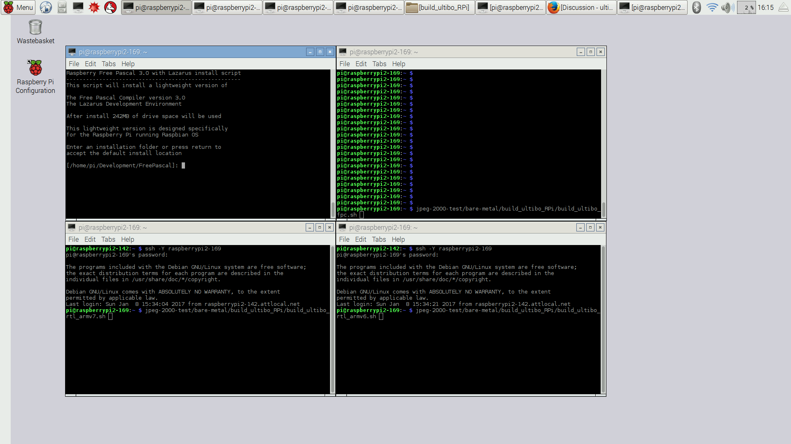
E

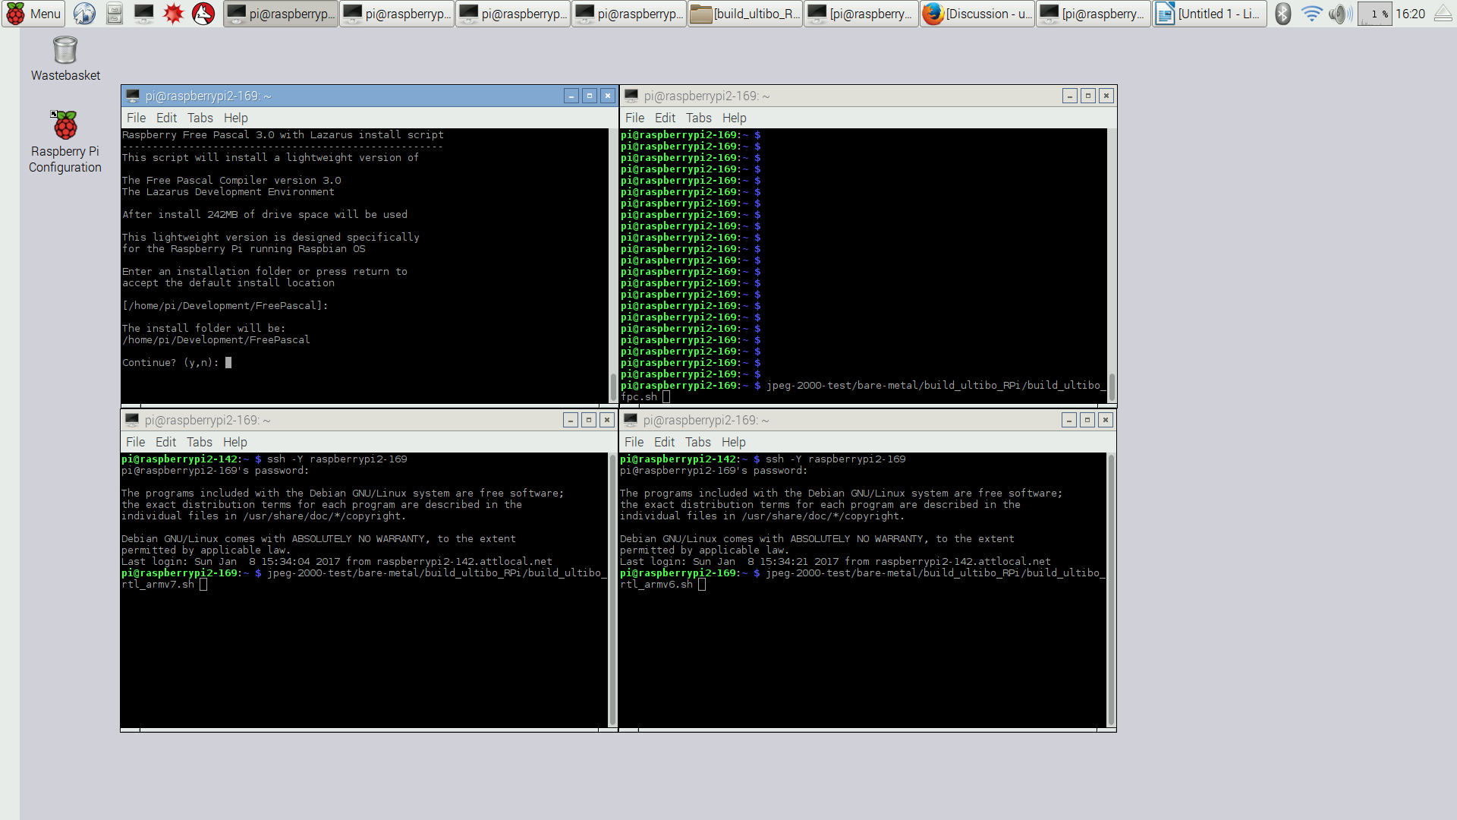
F

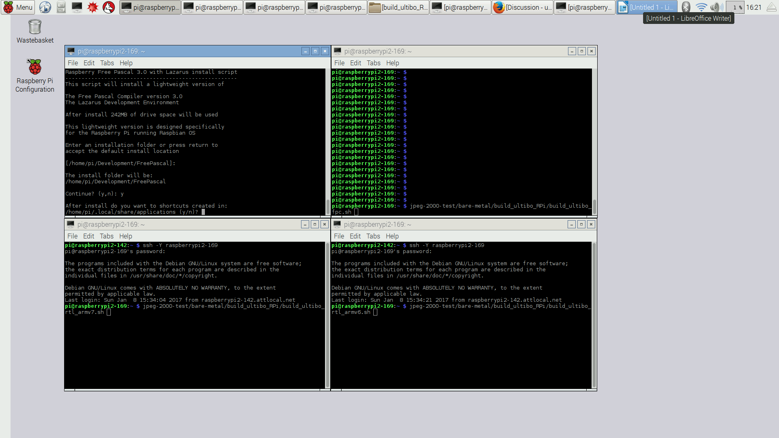
G

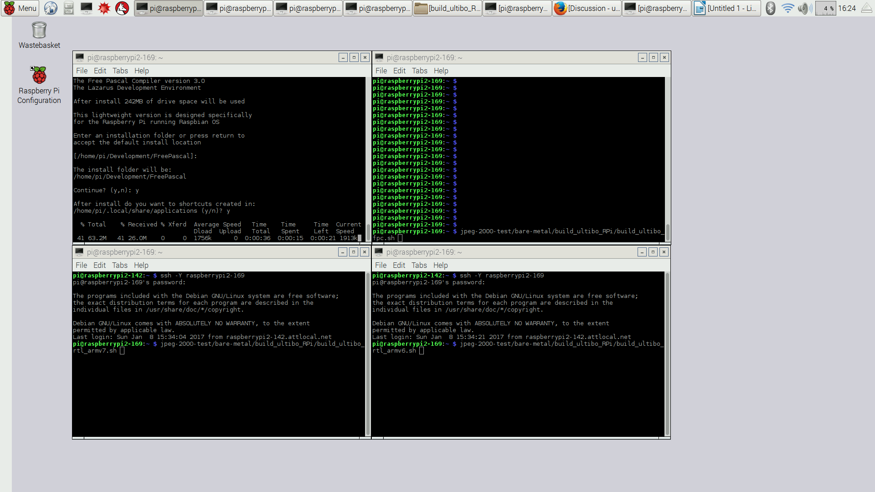
H

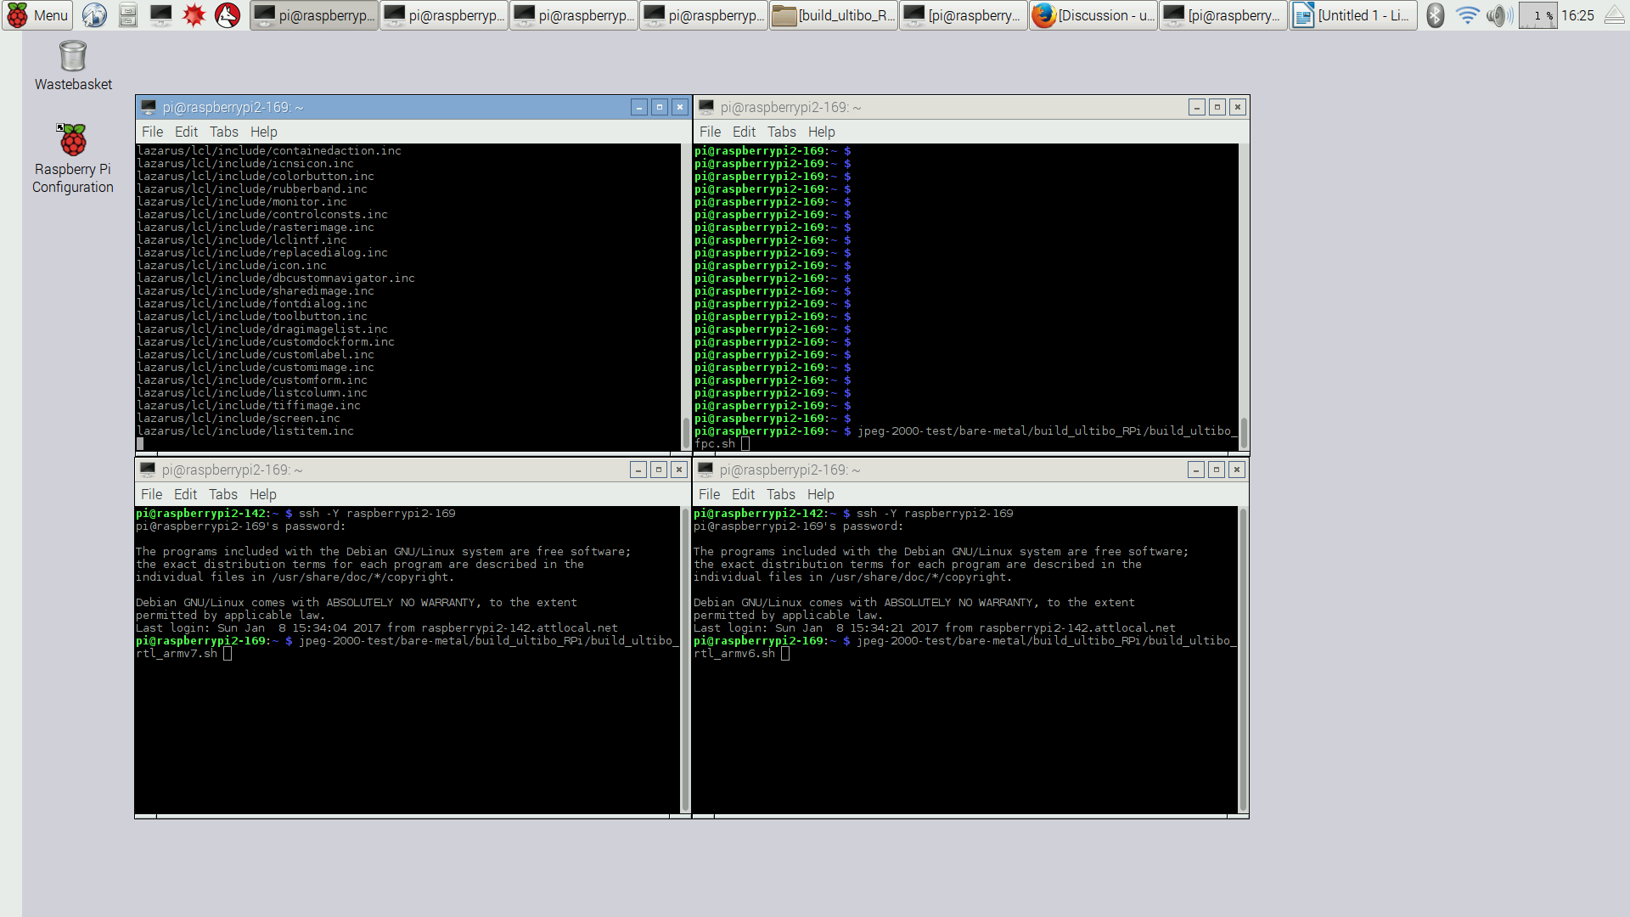
I

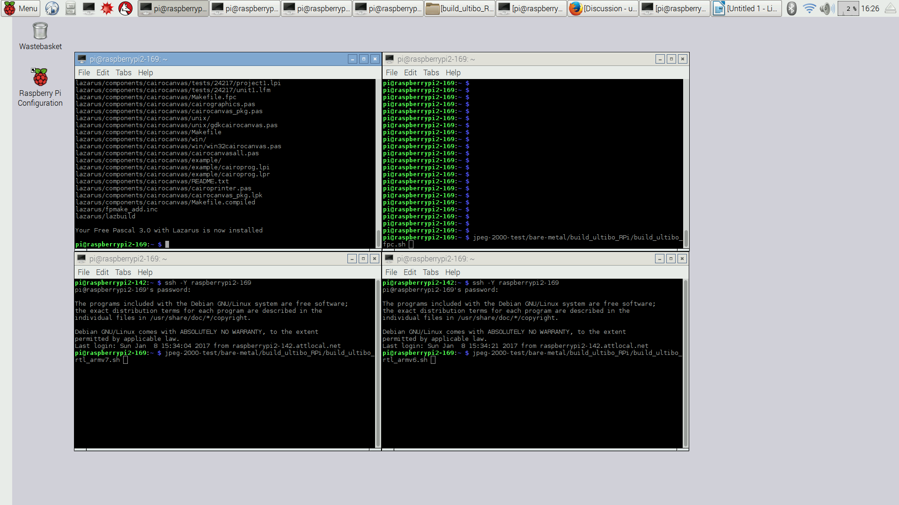
When the first shell, in the upper left hand corner, returns to the prompt the sources of fpc 3.0 and Lazarus have been downloaded an compiled. The 3.0 version of fpc will be used to compile the Ultibo Edition which be 3.1.1. This version is located at Development/FreePascal/
fpc freepascal.desktop lazarus lazarus.desktop.

pi@raspberrypi2-142:~/Development/FreePascal/lazarus $ ./startlazarus

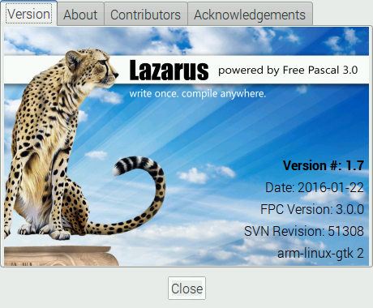

This is Lazarus with the first example opened.

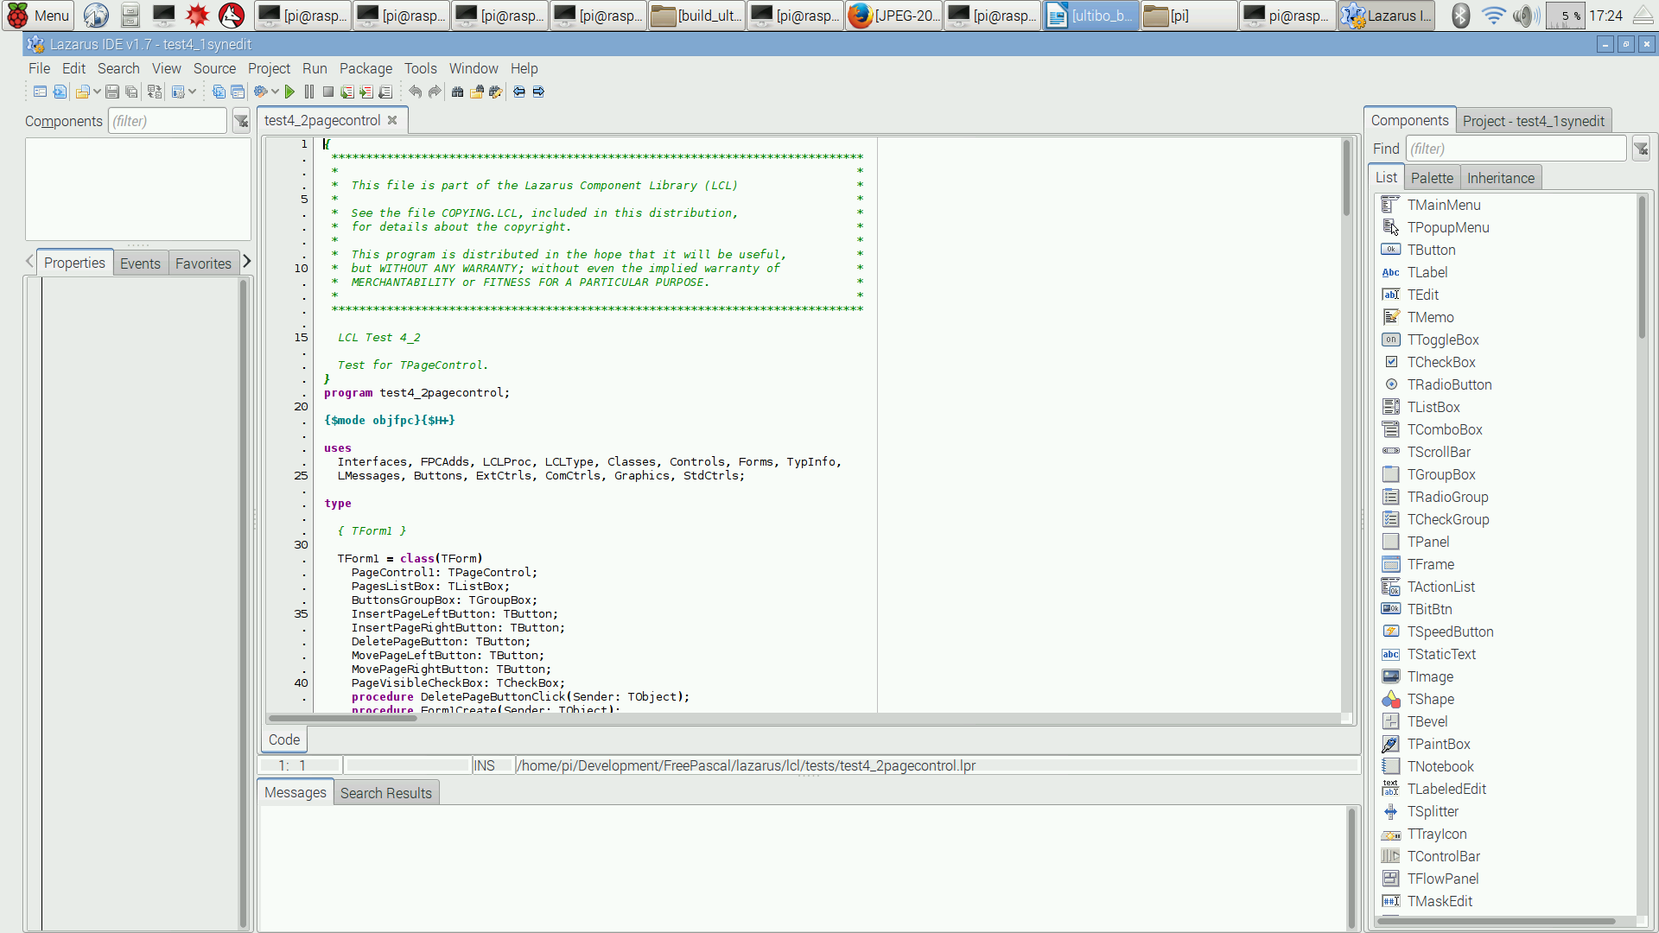

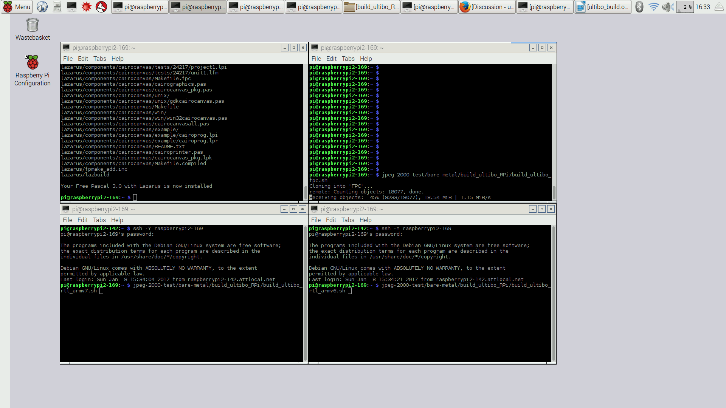
K

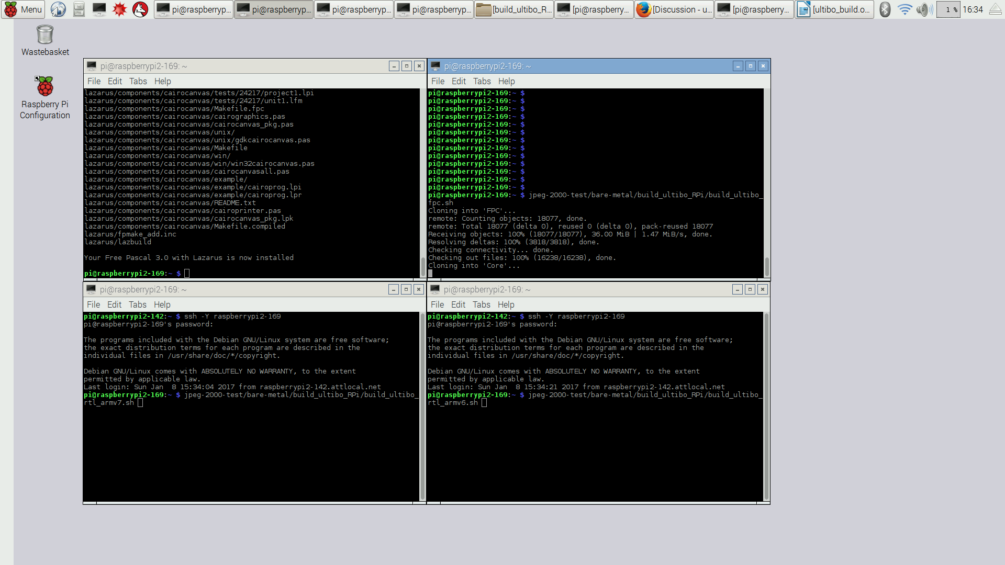
L

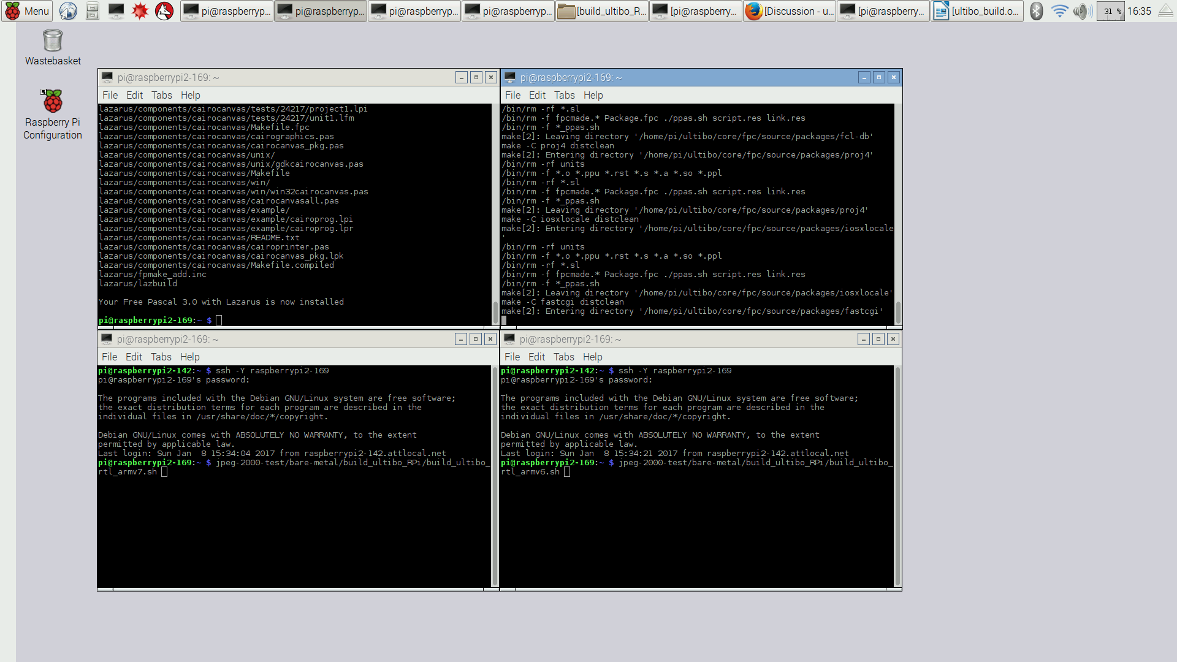
M
In the upper right hand window many applications are being compiled for fpc 3.1.1.

ls lib/fpc/3.1.1/units/arm-linux/
a52 fcl-registry hermes ncurses rtl-extra
aspell fcl-res httpd22 newt rtl-objpas
bfd fcl-sdo httpd24 numlib rtl-unicode
bzip2 fcl-sound ibase odbc sdl
cairo fcl-stl iconvenc oggvorbis sqlite
cdrom fcl-web imagemagick openal svgalib
chm fcl-xml imlib opengl symbolic
dblib fftw jni opengles syslog
dbus fpgtk ldap openssl tcl
dts fpindexer libcurl oracle unzip
fastcgi fpmkunit libenet pasjpeg users
fcl-async fppkg libgd paszlib utils-lexyacc
fcl-base fv libmicrohttpd pcap utmp
fcl-db gdbint libpng postgres uuid
fcl-extra gdbm libsee proj4 x11
fcl-fpcunit ggi libtar ptc xforms
fcl-image gmp libvlc pthreads zlib
fcl-js gnome1 libxml2 pxlib zorba
fcl-json googleapi lua regexpr
fcl-net gtk1 mad rsvg
fcl-passrc gtk2 modplug rtl
fcl-process hash mysql rtl-console

Ultibo for the ARMv7 is compiled in the lower left hand window. ARMv7 is the processor for the RPi2B & RPi3B.

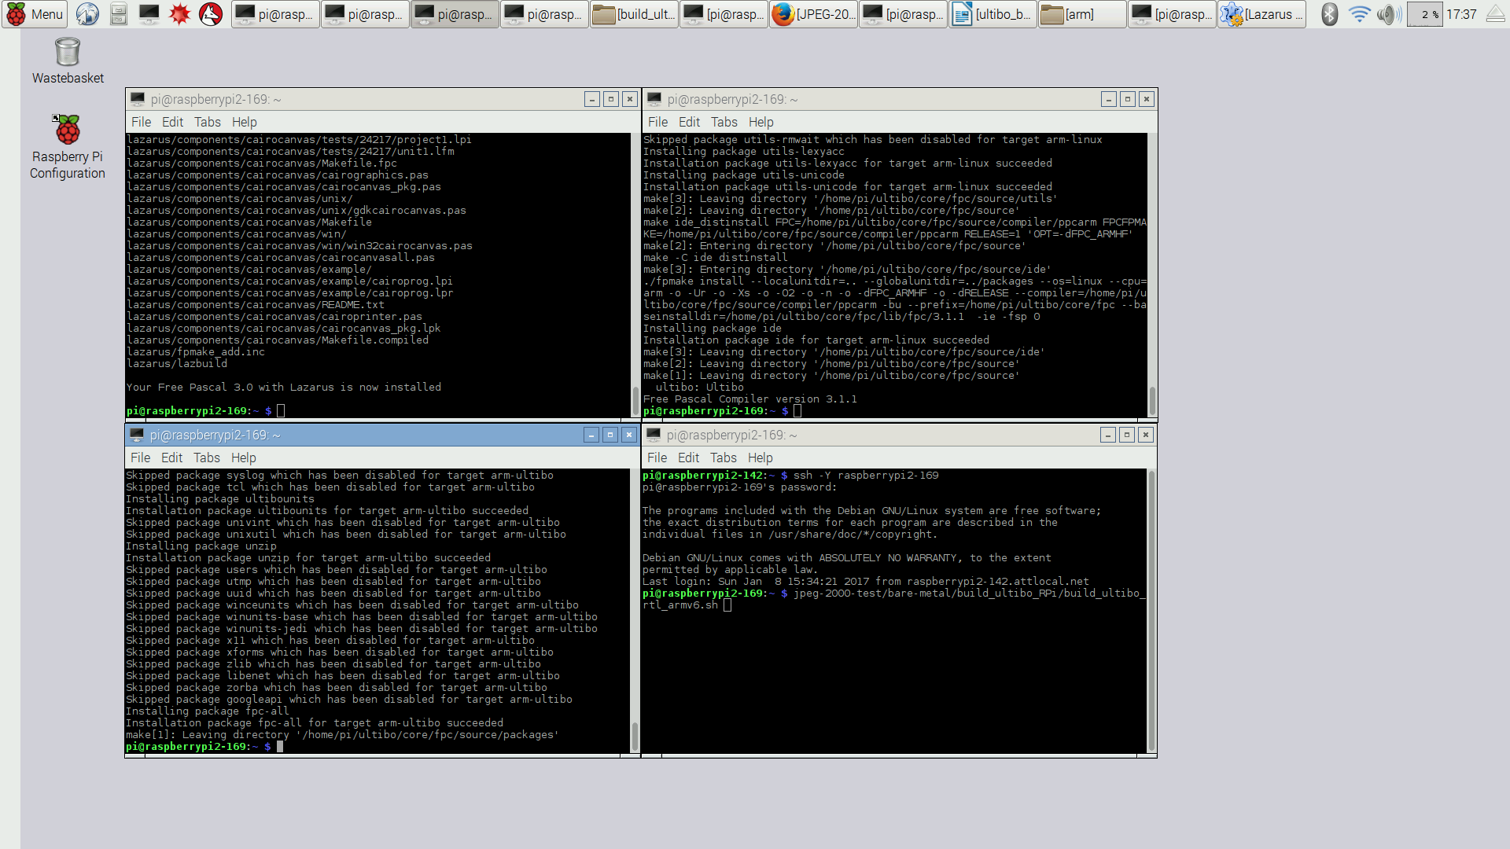

Ultibo for the ARMv6 is compiled in the lower right hand window. ARMv6 is the processor of the RPiA/B/A+/B+ and Zero use the ARMv6.

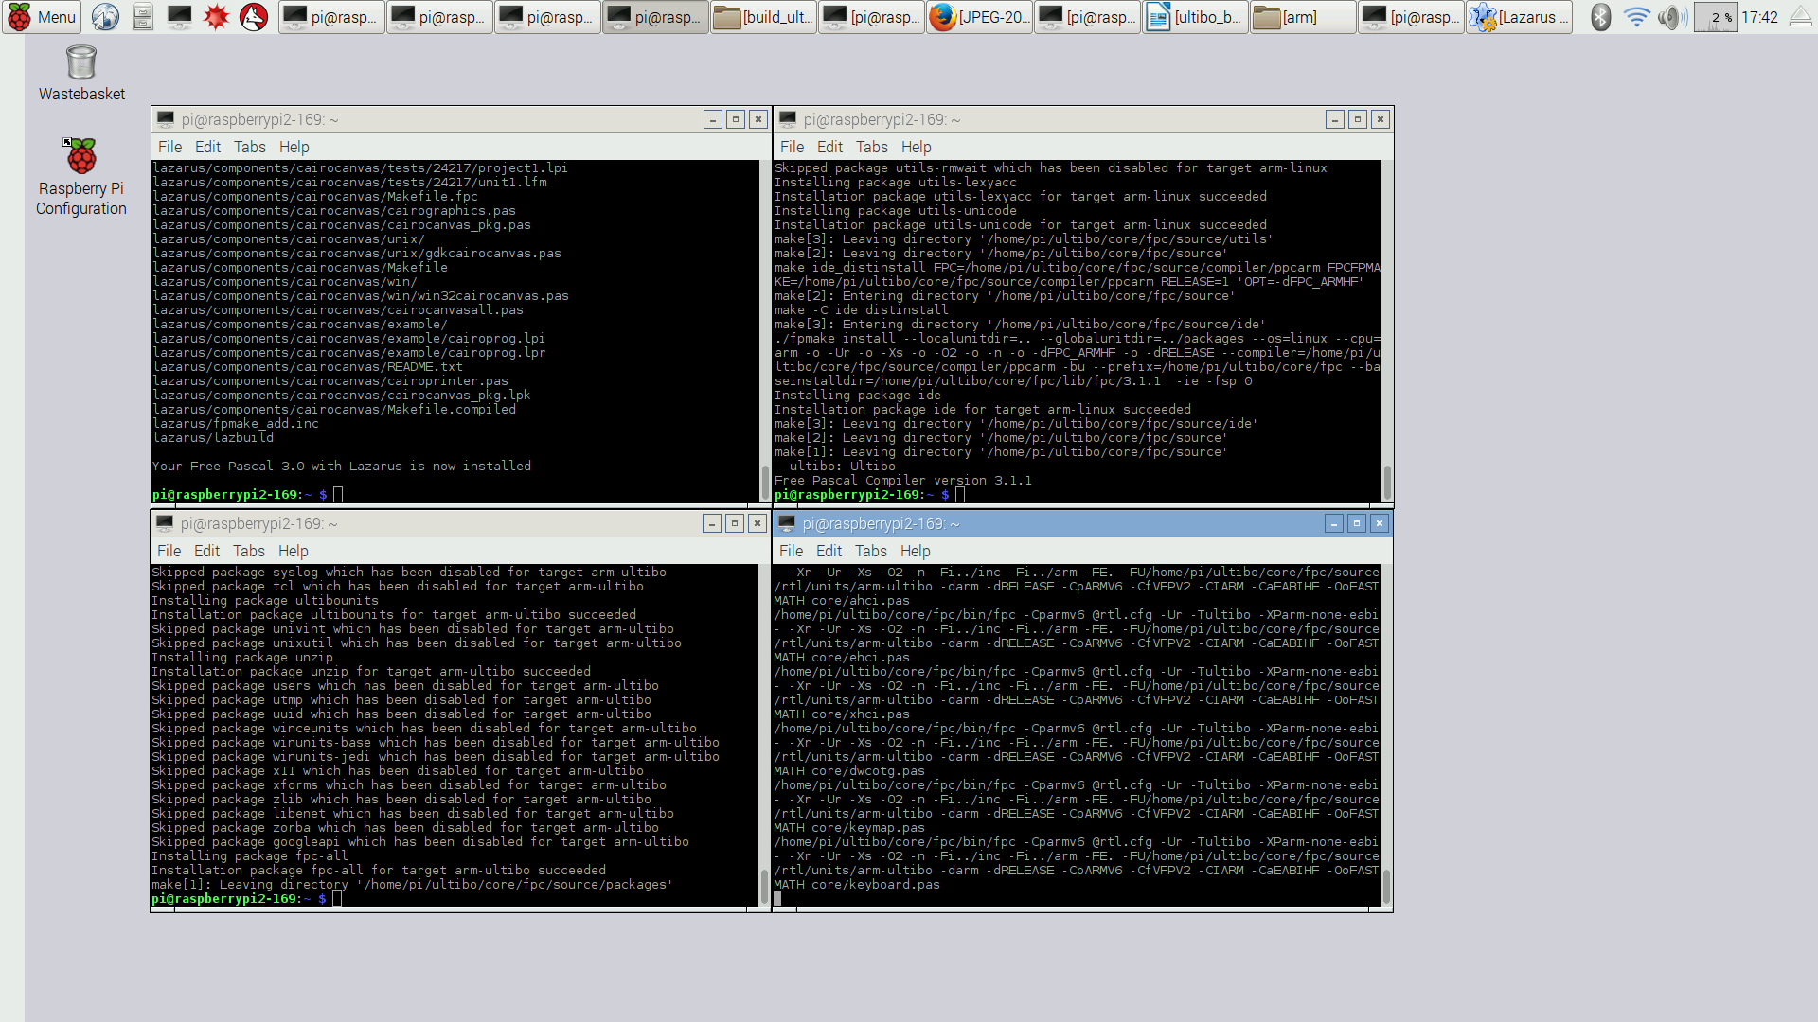
ARM6v

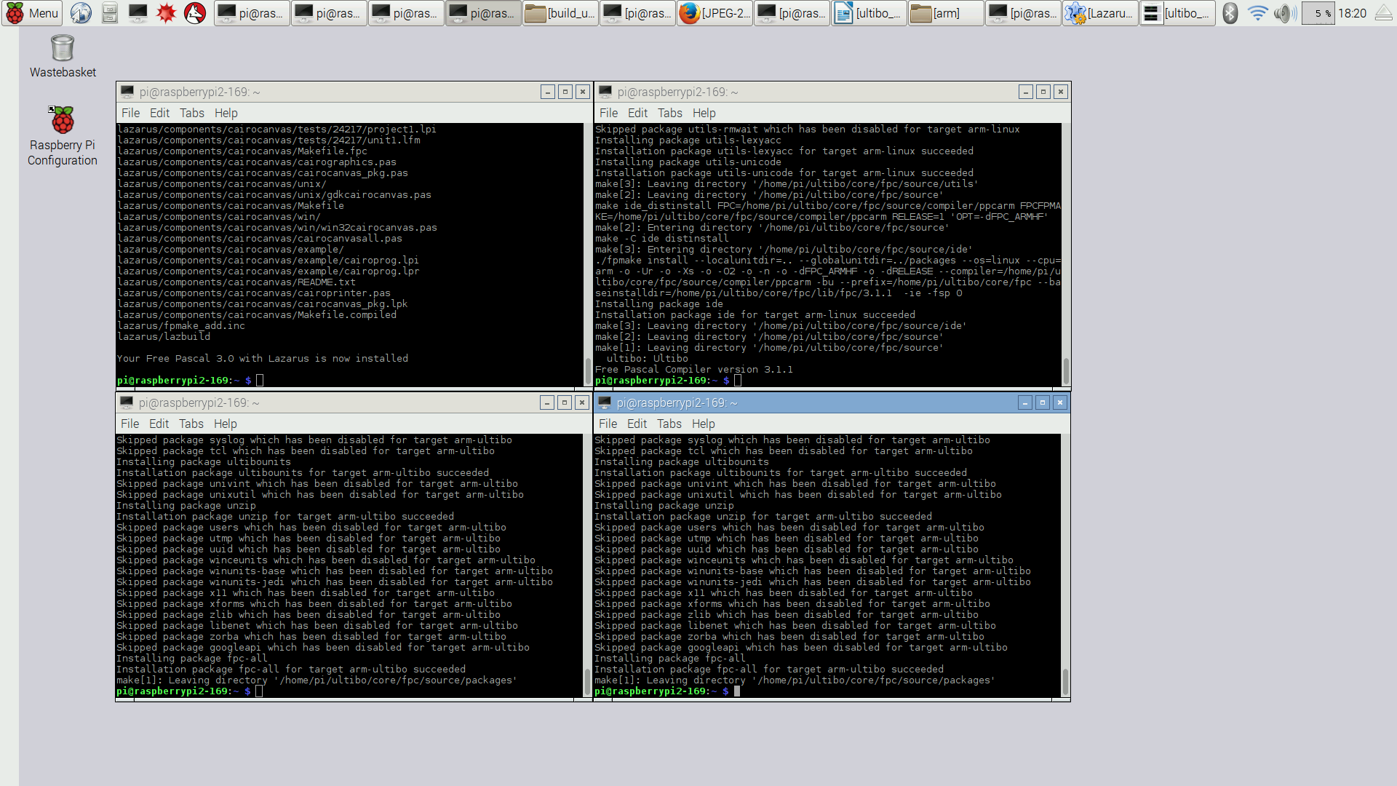

Now the configurations files need to added to the /home/pi/ultibo/fpc/bin/ foldered.

pi@raspberrypi2-169:~ $ cp jpeg-2000-test/bare-metal/build_ultibo_RPi/rpi*.cfg ultibo/core/fpc/bin

mkdir test_ultibo

cd test_ultibo

git clone https://github.com/ultibohub/Demo.git

cd Demo

export PATH=/home/pi/ultibo/core/fpc/bin:$PATH

fpc -B -Tultibo -Parm -CpARMV6 -WpRPIB @/home/pi/ultibo/core/fpc/bin/rpi.cfg -O2 UltiboDemoRPi.lpr
Free Pascal Compiler version 3.1.1 [2017/01/08] for arm
Copyright (c) 1993-2015 by Florian Klaempfl and others
Target OS: Ultibo
Compiling UltiboDemoRPi.lpr
Compiling DemoMain.pas
Assembling demomain
Assembling ultibodemorpi
Linking UltiboDemoRPi
1765 lines compiled, 4.0 sec, 2598596 bytes code, 81824 bytes data

fpc -B -Tultibo -Parm -CpARMV7A -WpRPI2B @/home/pi/ultibo/core/fpc/bin/rpi2.cfg -O2 UltiboDemoRPi2.lpr
Free Pascal Compiler version 3.1.1 [2017/01/08] for arm
Copyright (c) 1993-2015 by Florian Klaempfl and others
Target OS: Ultibo
Compiling UltiboDemoRPi2.lpr
Compiling DemoMain.pas
Assembling demomain
Assembling ultibodemorpi2
Linking UltiboDemoRPi2
1765 lines compiled, 4.8 sec, 2612452 bytes code, 84472 bytes data

fpc -B -Tultibo -Parm -CpARMV7A -WpRPI3B @/home/pi/ultibo/core/fpc/bin/rpi3.cfg -O2 UltiboDemoRPi3.lpr
Free Pascal Compiler version 3.1.1 [2017/01/08] for arm
Copyright (c) 1993-2015 by Florian Klaempfl and others
Target OS: Ultibo
Compiling UltiboDemoRPi3.lpr
Compiling DemoMain.pas
Assembling demomain
Assembling ultibodemorpi3
Linking UltiboDemoRPi3
1766 lines compiled, 4.9 sec, 2609932 bytes code, 84440 bytes data

