Building Ultido for RPi and Linux
12/28/16
Built fpc & lazarus per notes in https://github.com/develone/jpeg-2000-test/blob/master/bare-metal/linux-raspberrypi/notes_install_fpc.txt

The verison installed on the RPi using apt-get of Free Pascal Compiler version 2.6.4.
The verison installed on the RPi using apt-get of Lazarus is 1.6.

The version needed by Ultibo of Free Pascal Compiler is version 3.1.1
The version needed by Ultibo of Lazarus is 1.7

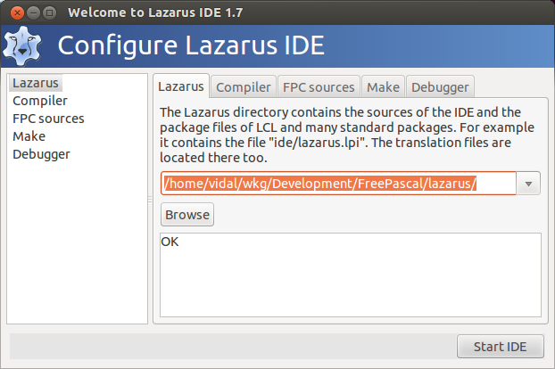
Compiler

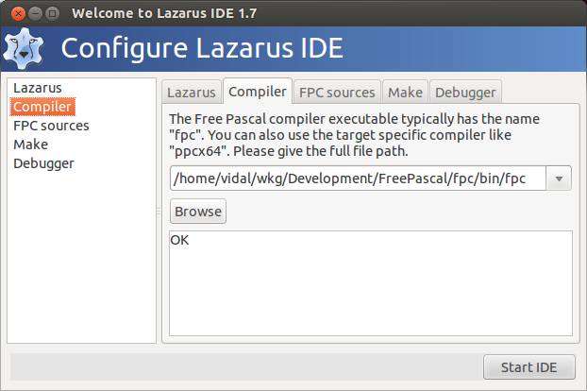
FPC sources

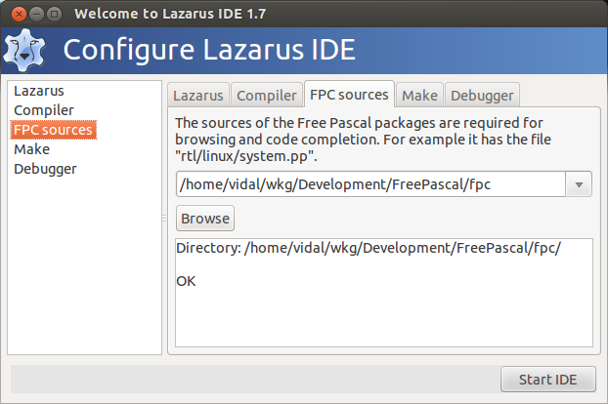
Make

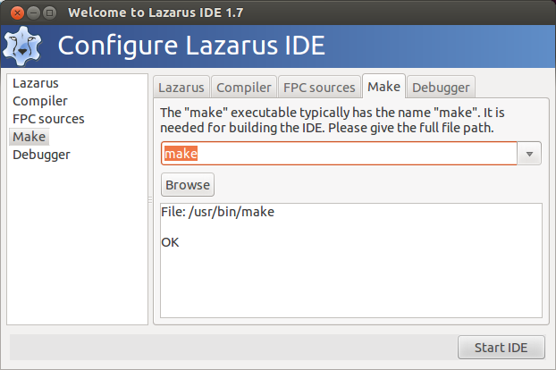

Debugger

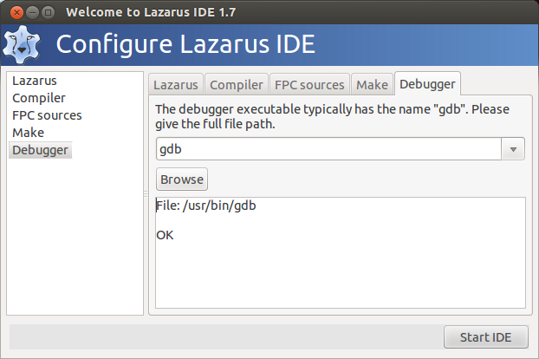
Depress Start IDE

