The latest version of jpeg.c
commit 39e1e2781dd811f1fe1f2d85bf28f2f31da2199c
Author: develone <develone@sbcglobal.net>
Date: Mon Apr 25 10:26:18 2016 -0600

during clean up interleave,num_passes and index no longer needed.

vidal@ws009:~/wkg/jpeg-2000-test/zipcpu$ gccjpeg.c -o jpeg



This is 1 pass no de-interleave
vidal@ws009:~/wkg/jpeg-2000-test/zipcpu$ ./jpeg img_to_fpga.bin pass.bin 1 0
vidal@ws009:~/wkg/jpeg-2000-test/zipcpu$ python rd_pass.py

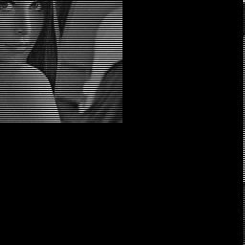

vidal@ws009:~/wkg/jpeg-2000-test/zipcpu$ ./jpeg img_to_fpga.bin pass.bin 1 1
vidal@ws009:~/wkg/jpeg-2000-test/zipcpu$ python rd_pass.py

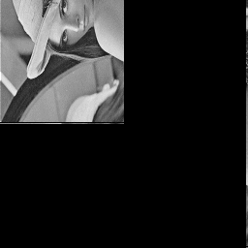

vidal@ws009:~/wkg/jpeg-2000-test/zipcpu$ ./jpeg img_to_fpga.bin pass.bin 2 0
vidal@ws009:~/wkg/jpeg-2000-test/zipcpu$ python rd_pass.py

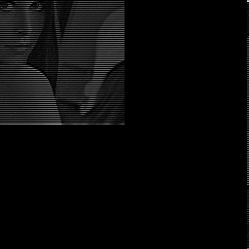

This is 2 passes and de-interleave and lower to upper using 1D arrays.

