Testing 16 parallel instances of multi_jpeg
This could be expanded to
32 instances, 64 instances or 128

New questions:
The advantages of an FPGA is the capability of doing things in parallel compared to sequential processing.
The disadvantages of multiple instances is the increased number of signals.
With MyHDL signals are either unsigned or std_logic_vector. What is the preferred?
sign_in_x is made up [0xxx flgs right_s(9bits) sam_s(9bits) left_s(9bits)] (31bits)
where 0xxx flgs
| | |____ even_odd_s = sig_in_x(27)
| |______fwd_inv_s = sig_in_x(28)
|_______updated_s = sig_in_x(29)
Testing indicates that if the res_s is of 11 bits the (left_s, sam_s, and right_s) can only be 9 bits.
res_s 11 bits signed needs to go sam_s 9 bits unsigned

For a 256 X 256 image 130048 operations are required of 1 of the 4 equations below.
if updated_s:
noupdate_s.next = 0
if even_odd_s:
if fwd_inv_s:
res_s.next = sam_s - ((left_s >> 1) + (right_s >> 1))
else:
res_s.next = sam_s + ((left_s >> 1) + (right_s >> 1))
else:
if fwd_inv_s:
res_s.next = sam_s + (((left_s) + (right_s) + 2)>>2)
else:
res_s.next = sam_s - (((left_s) + (right_s) + 2)>>2)
else:
noupdate_s.next = 1
return jpeg

This is what makes up the lifting scheme of forward or inverse DWT.
I generated data which is now in the file "sam_data.py" to test the 16 instances of jpeg_process. The sam_data.py was generated with the program t_wave_53.py which calls waveletsim_53.py. The file waveletsim_53a.py is used in place of waveletsim_53.py to generate the data sam_data.py. One level of forward DWT and the inverse DWT.

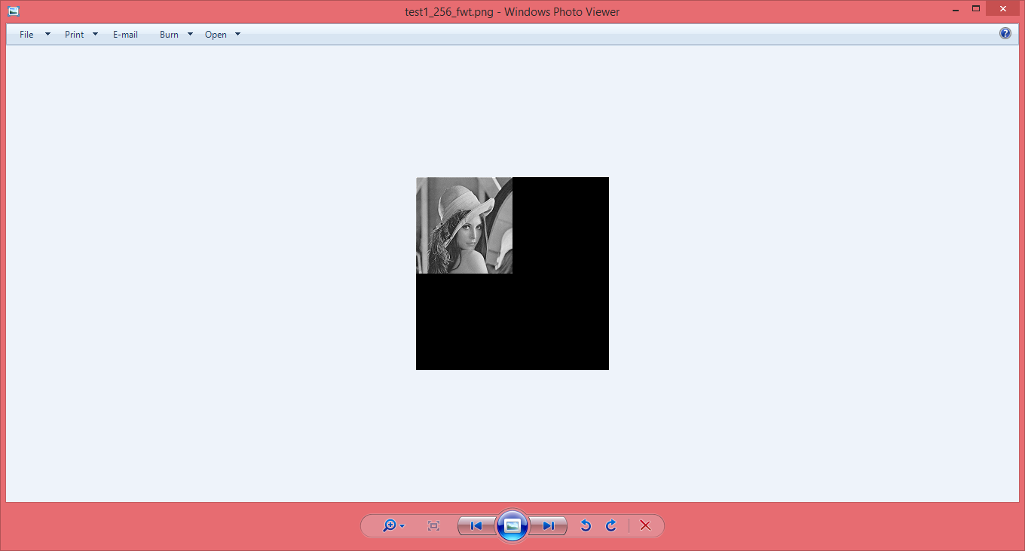
Inverse DWT
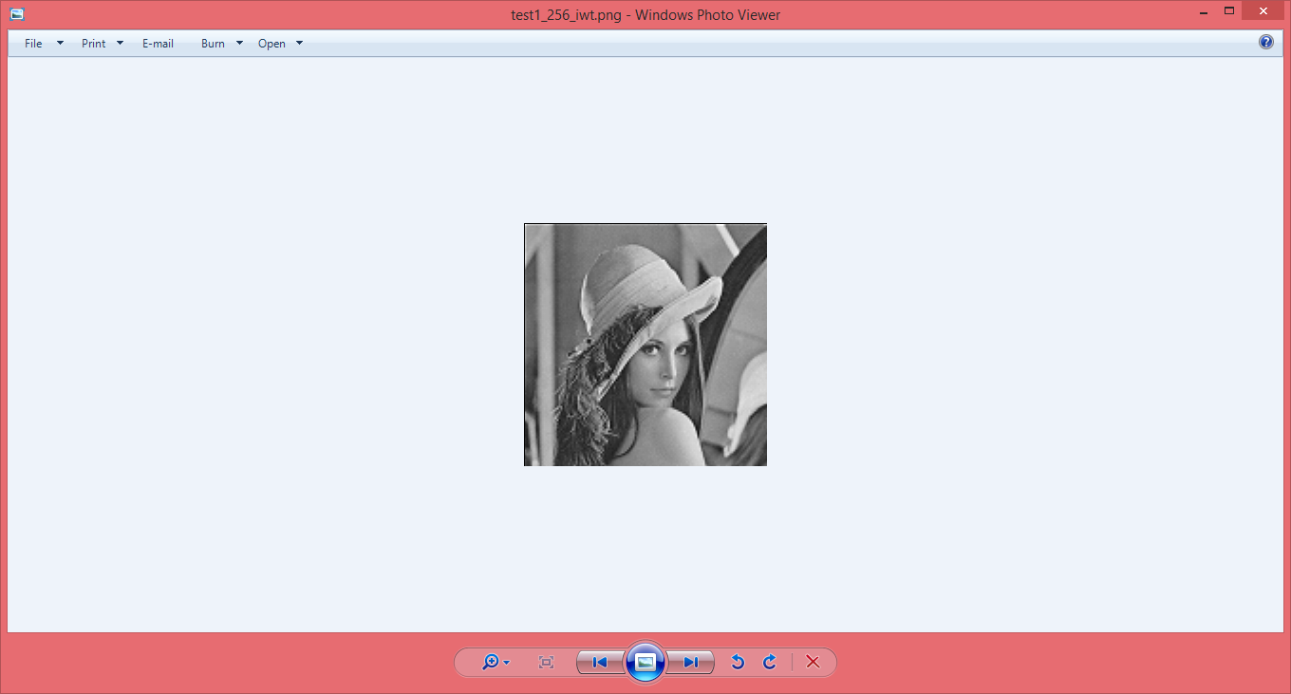
sig0_in_x ... sig7_in_x a 31 bits consisting of flgs left_s sam_s and right_s. With the 3 bits you can determine if forward or inverse DWT and if the input values are even or odd and when the data has been updated_s.
jpeg 0 to 7
even samples
u0 0 1 2 3 4 5 6 7 8 9
10 11 12 13 14 15

samples (1 2 3), (3 4 5), (5 6 7), (7 8 9) (9 10 11), (11 12 13), (13 14 15), (15 16 17) (17 18 19), (19 20 21), (21 22 23), (23 24 25) (25 26 27), (27 28 29), (29 30 31), (31 32 33)

odd samples
u0 0 1 2 3 4 5 6 7 8 9
10 11 12 13 14 15
samples (0 1 2 ), (2 3 4), (4 5 6 ), (6 7 8 ) (8 9 10), (10 11 12), (12 13 14), (14 15 16) (16 17 18), (18 19 20), (20 21 22), (22 23 24)(24 25 26), (26 27 28), (28 29 30), (30 31 32)
Below is a simulation of 16 instances of jpeg_process

