**************Draft************
Installing Wine on Ubuntu 16.04 sim2
Examples of Lazarus running QEMU
09/08/17
**************Draft************

On newly built Ubuntu 16.04.

sudo apt-get update
sudo apt-get install wine
sudo apt-get install binutils-arm-none-eabi
sudo apt-get install gcc-arm-none-eabi
sudo apt-get install openssh-server
sudo apt-get install git
git clone https://github.com/develone/Core.git
git clone https://github.com/develone/Examples.git
sudo apt-get install tree diffuse

The following command installs Lazarus & Free Pascal Compiler FPC for Ultibo.

“vidal@sim2:~$ wine Ultibo-Core-1.3.077-Cucumber.exe”

The following commands starts Lazarus.

“cd /home/vidal/.wine/drive_c/Ultibo/Core”
“wine startlazarus.exe”

Note:
Updating the RTL
vidal@sim2:~/.wine/drive_c/Ultibo/Core/fpc/3.1.1/source/rtl$ rsync -avl /home/vidal/Core/source/rtl/ultibo .
Needed to create a file in ~/.wine/drive_c/Ultibo/Core/tools/BuildRTL.ini
with the contents below.
[BuildRTL]
PathPrefix=%PATH%;
This fixed the problem of not rebuilding the RTL using Lazarus.
from the Tools/Build Ultibo RTL

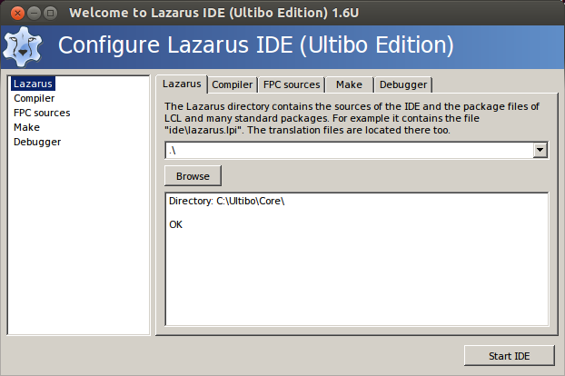
Compiler

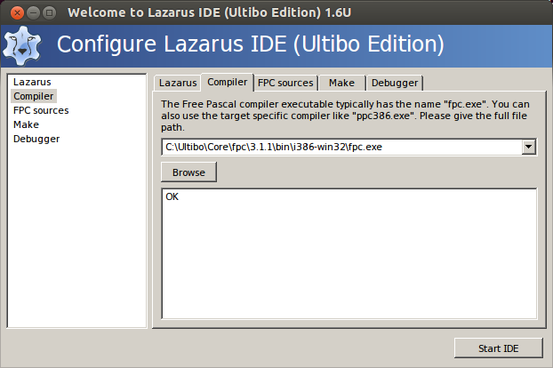
FPC Sources

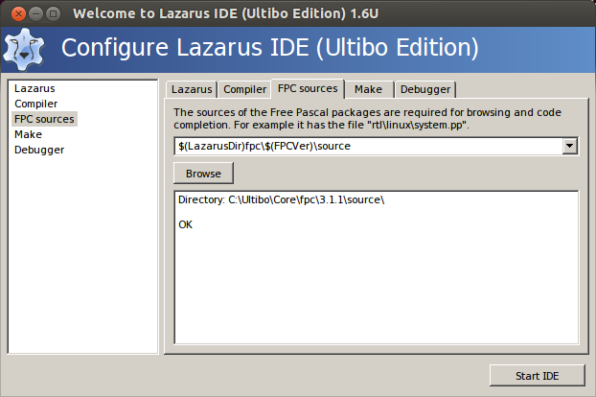
Make

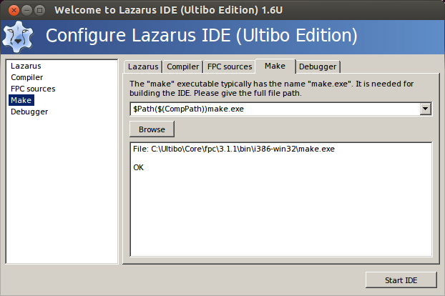

Debugger

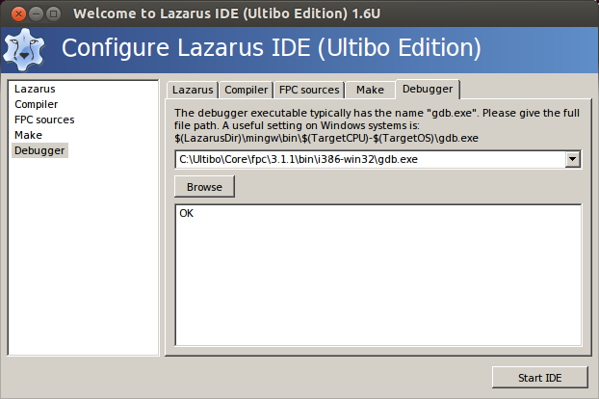

commit 63af0987b6ca8e075627d84a52332ad043b9d4c8
Author: Ultibo <admin@ultibo.org>
Date: Wed Dec 28 16:18:08 2016 +1100

Update gitignore to allow __buildrtl.bat
vidal@ws009:~/wkg/Core/source/rtl$ cp -R ultibo/ ~/.wine/drive_c/Ultibo/Core/fpc/3.1.1/source/rtl/

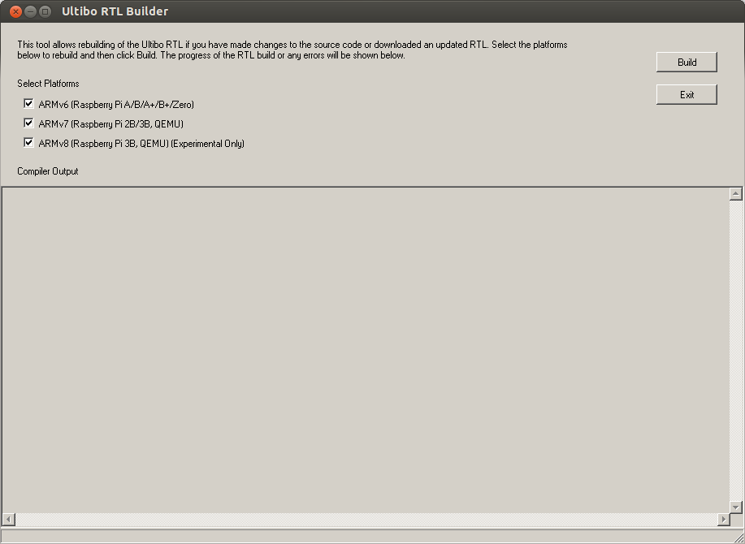
Need to compile the file test.c to test.o with the command “arm-none-eabi-gcc -O2 -mabi=aapcs -marm -march=armv7-a -mfpu=vfpv3-d16 -mfloat-abi=hard -c test.c”

Need to create the file libtest.a from the file test.o with the command “arm-none-eabi-ar rcs libtest.a test.o”

Created a project LibCTest from the file LibCTestRPI2.lpr

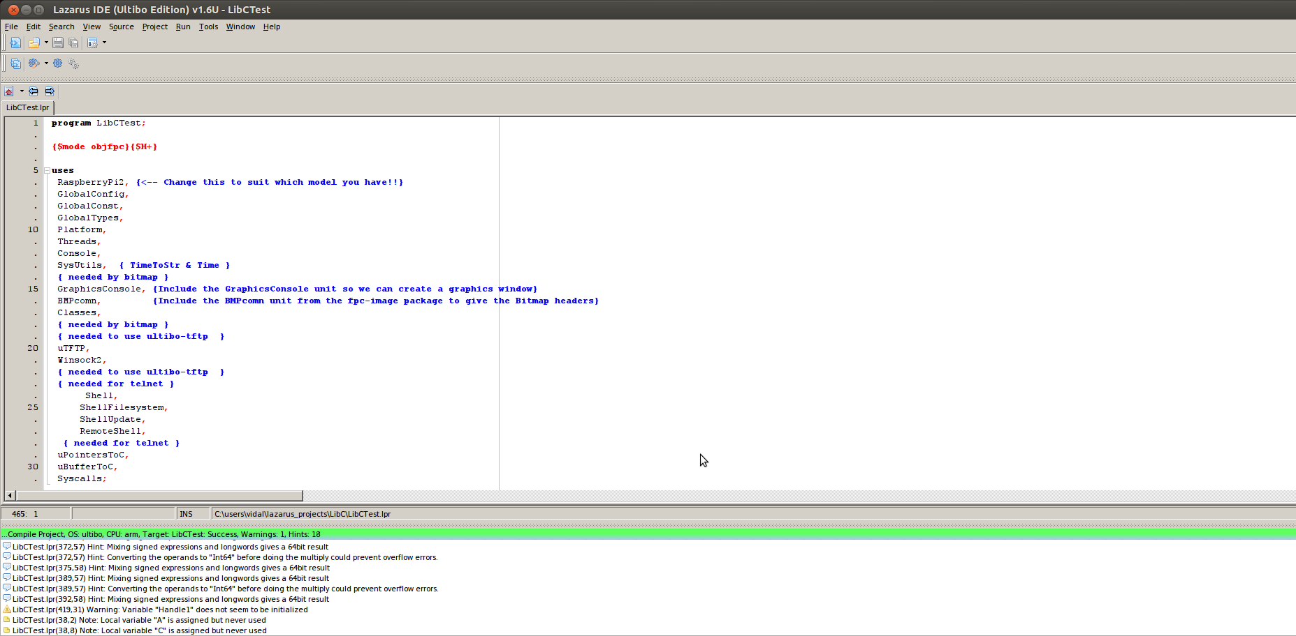
Created a project LibCTest from the file LibCTestRPI2.lpr

Transfer kernel7.img to target RPi3.

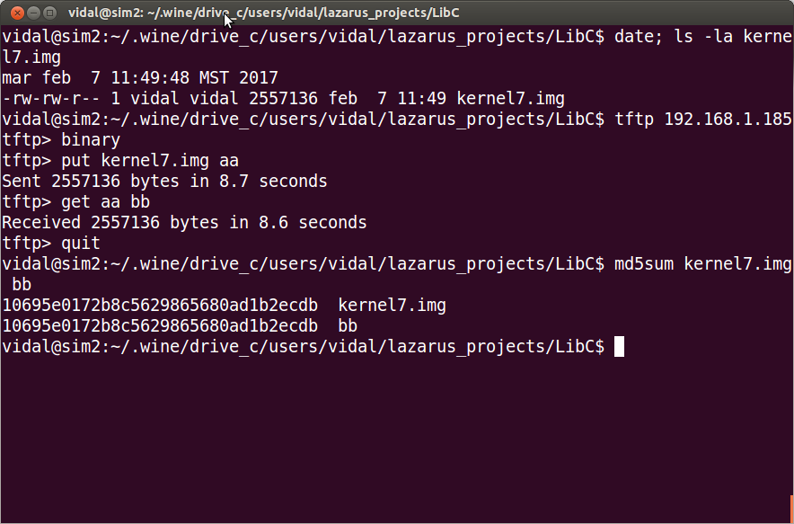
Once the kernel7.img has been transferred as aa.
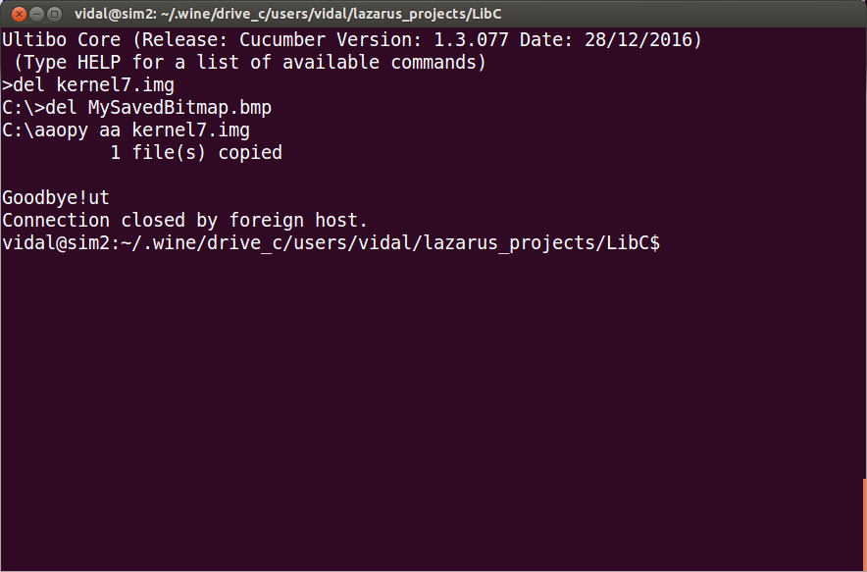

QEMU is part of Ultibo.

Using Example 03-ScreenOutput
https://github.com/develone/Examples.git
cp -R ~/wkg/Examples/03-ScreenOutput/QEMU/ ~/.wine/drive_c/users/vidal/lazarus_projects/

QEMU screen 1

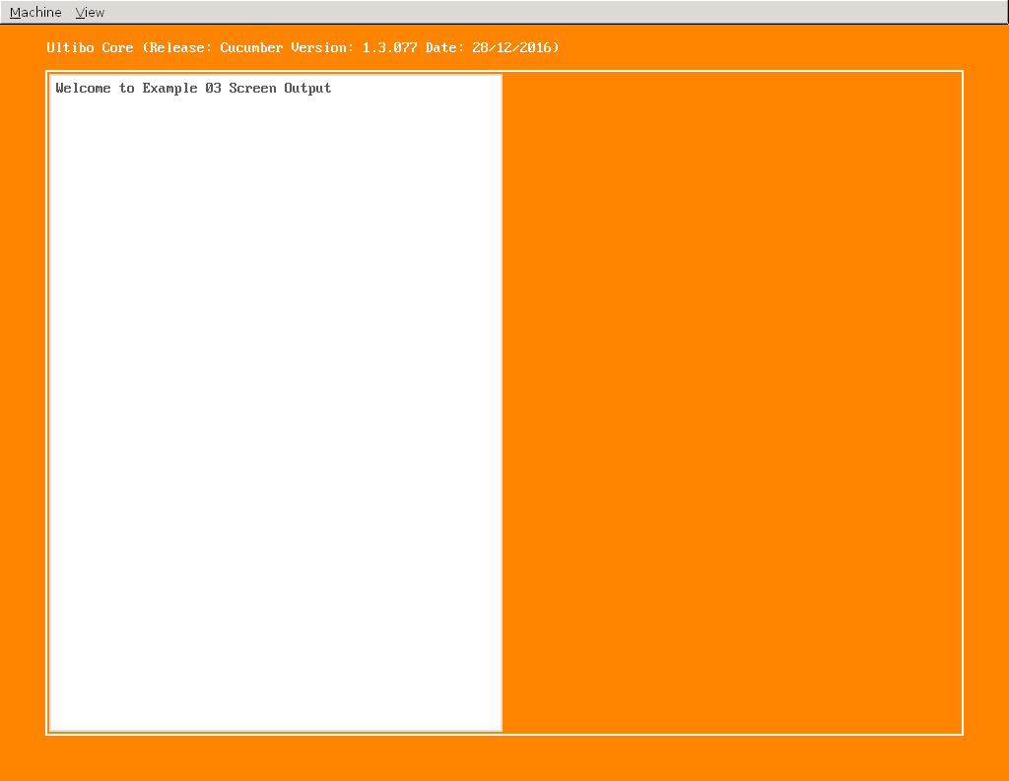

QEMU screen 2

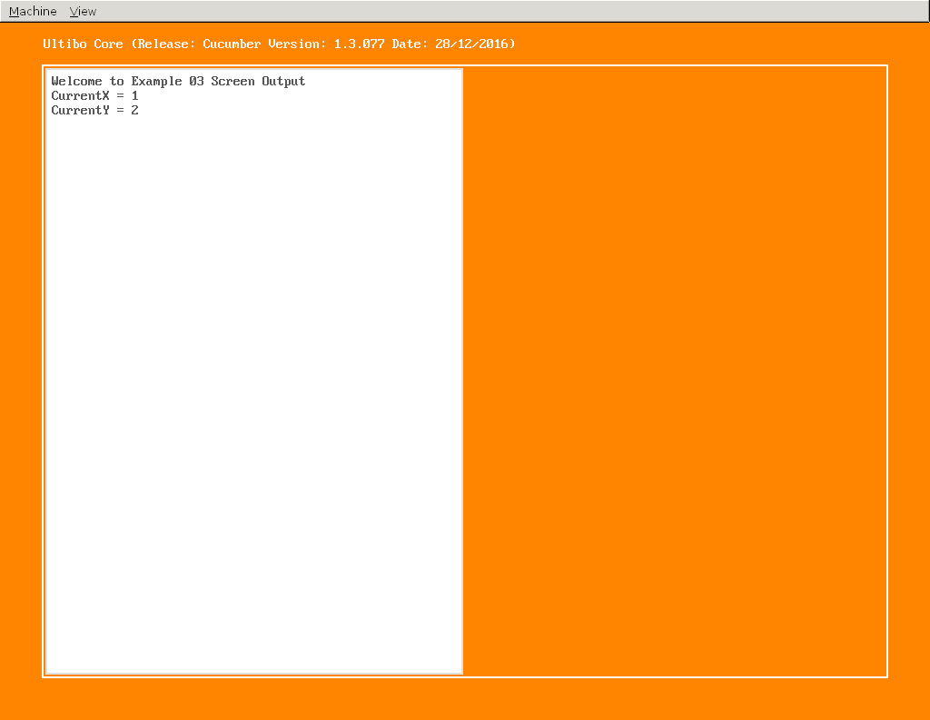

QEMU screen 3

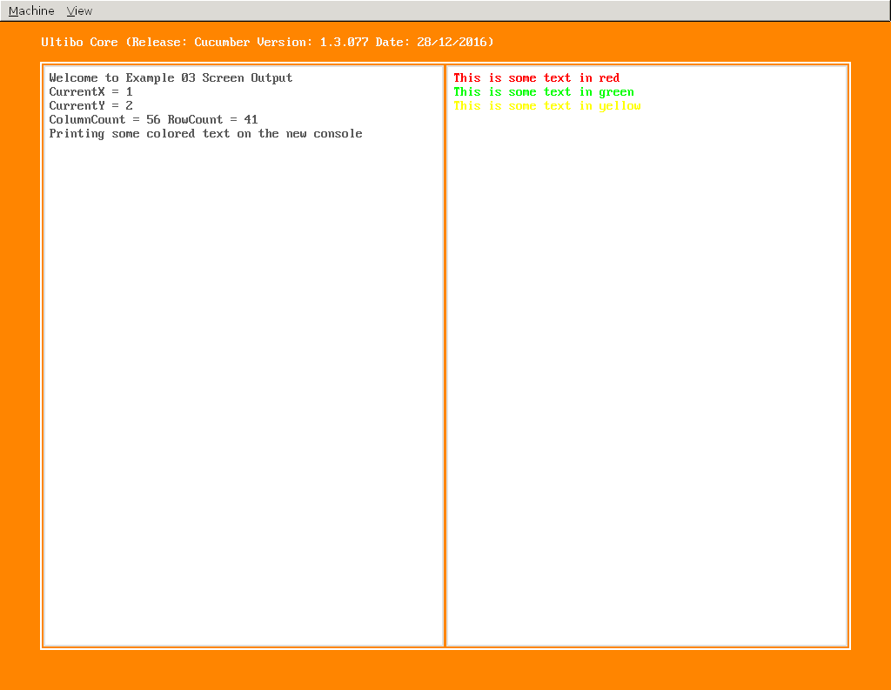

QEMU screen 4

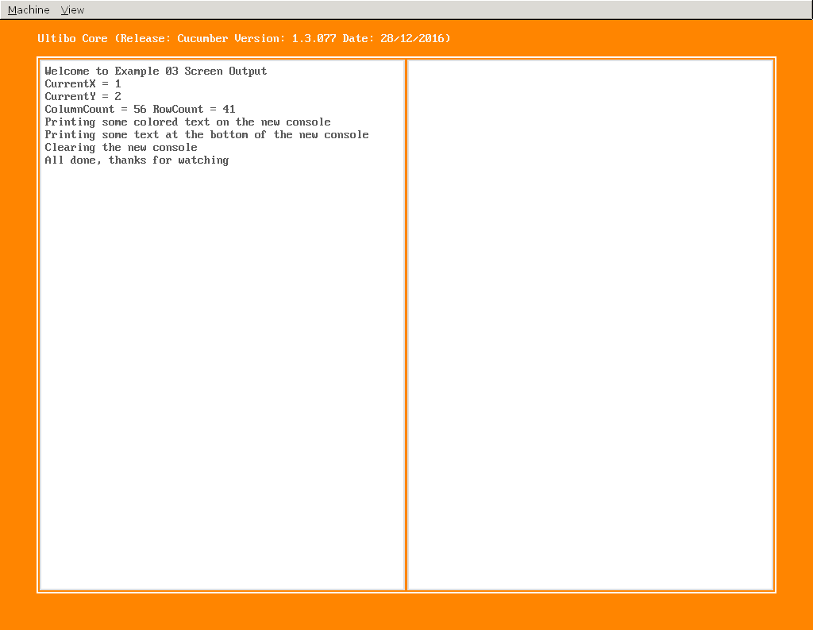
Using C in Ultibo using QEMU
Create a file compile_qemu.sh

#!/bin/bash
arm-none-eabi-gcc -O2 -mabi=aapcs -marm -march=armv6 -mfpu=vfp -mfloat-abi=hard -c test.c
arm-none-eabi-ar rcs libtest.a test.o

Create test.c

/*
* test.c
*
* A simple C library to include in your Ultibo project
*
*/

#include <stdio.h>

void test ()
{

printf ("Hello Ultibo from C!!\n");

}

Create a file LibC_QEMU.lpr

program LibCTest;

{$mode objfpc}{$H+}

uses
QEMUVersatilePB,
GlobalConfig,
GlobalConst,
GlobalTypes,
Platform,
Threads,
Console,
Syscalls;

{$linklib test}

procedure test; cdecl; external 'libtest' name 'test';

var
Handle:THandle;

begin
Handle:=ConsoleWindowCreate(ConsoleDeviceGetDefault,CONSOLE_POSITION_FULL,True);

test;

ThreadHalt(0);
end.

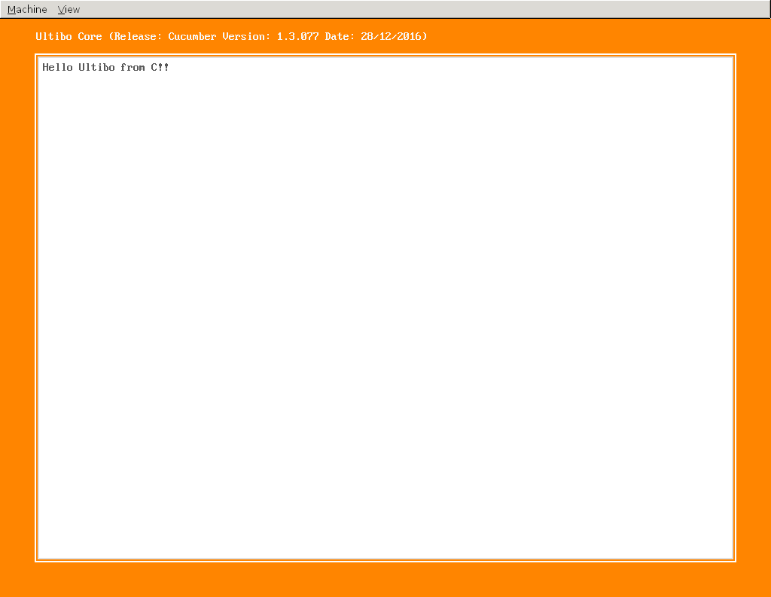

**********DRAFT**********
Compile DWT_LIFT_RPi2.lpr
using Lazarus
04/06/17
**********DRAFT**********

vidal@sim2:~/.wine/drive_c/users/vidal/lazarus_projects/openjp$ pwd
/home/vidal/.wine/drive_c/users/vidal/lazarus_projects/openjp

vidal@sim2:~/.wine/drive_c/users/vidal/lazarus_projects/openjp$ cp -R ~/wkg/jpeg-2000-test/bare-metal/openjp/ .

When using on Larzarus on x86_64 under wine.

Note: If you can not create the libopenjp2.a
Needed to modified "compile.sh" such not to remove the libopenjp2.a
and not call the fpc compiler when using Lazarus.

vidal@sim2:~/.wine/drive_c/users/vidal/lazarus_projects/openjp$ diff compile.sh ~/wkg/jpeg-2000-test/bare-metal/openjp/compile.sh
7c7
< #rm -f libopenjp2.a
---
> rm -f libopenjp2.a
9c9
< #cp ~/t_ultibo/src/lib/openjp2/libopenjp2.a .
---
> cp ~/t_ultibo/src/lib/openjp2/libopenjp2.a .
23c23
< #fpc -vi -B -Tultibo -Parm -CpARMV7A -WpRPI2B @/home/pi/ultibo/core/fpc/bin/rpi2.cfg -O4 DWT_LIFT_RPi2.lpr
---
> fpc -vi -B -Tultibo -Parm -CpARMV7A -WpRPI2B @/home/pi/ultibo/core/fpc/bin/rpi2.cfg -O4 DWT_LIFT_RPi2.lpr

From the Run menu select Compile.

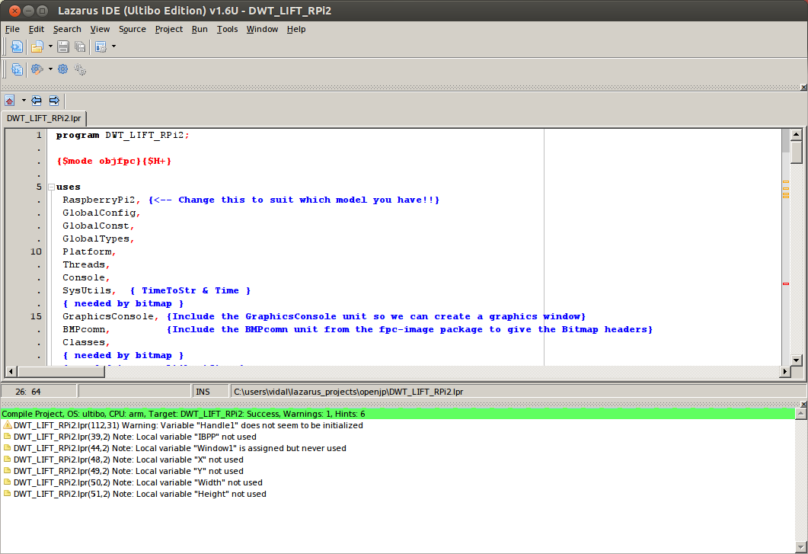
Following the cleanup of unused items.
This version continues to have issues with images of 2048 x 2048.

