DRAFT
FPGA simulation of xulalx25soc built
for xulA2-LX9 Ubuntu 12.04 & RPi
07/29/16

The original xulalx25soc supported the XulA2-LX25. Now the project supports both the XulA2-LX9 & XulA2-LX25. In addition the binutils-2.25 & gcc-5.3.0 for the zipcpu are provided.

Note: To build for xulA2-LX9 modify the files xulalx25soc/trunk/rtl/busmaster.v, xulalx25soc/trunk/rtl/cpu/cpudefs.v and xulalx25soc/trunk/bench/cpp/busmaster_tb.cpp by commenting out the first line of each file `define XULA25.

Note: The program busmaster_tb allows the user to test the ASM & C code without the FPGA hardware.
Now with the “ -p” option the programs wbregs, ziprun, zipdbg, and zipstate connect to port 7239 instead of running in the FPGA.
Once that busmaster_tb is running.
Since this build was done on 07/27/16.
The following command displays the date.

pi@raspberrypi2-146:~/jpeg-2000-test/zipcpu/uart_test_code $ wbregs -p version
00000101 ( VERSION) : [...$] 20160724
FPGA was interrupted

The following command displays
pi@raspberrypi2-146:~/jpeg-2000-test/zipcpu/uart_test_code $ zipstate -p
0x0000100f: STALL SW-HALT

The followubg command displays the debugger
pi@raspberrypi2-146:~/jpeg-2000-test/zipcpu/uart_test_code $ zipdbg -p
The debugger commands are q, s, and g
Peripherals CPU State: 0x00001613 Halted
>PIC > 0x00002706< WDT : 0x00000000 WBUS: 0x00003ffc PIC2: 0x00000000
TMRA: 0xcb8000a0 TMRB: 0x00002926 TMRC: 0x7ffce3ba JIF : 0x00000000
MTSK: 0x00000000 MOST: 0x00000000 MPST: 0x00000000 MICT: 0x00000000

Supervisor Registers
sR0 : 0x00002706 sR1 : 0x00000000 sR2 : 0x00003ffc sR3 : 0x00000000
sR4 : 0xcb8000a0 sR5 : 0x00002926 sR6 : 0x7ffce3ba sR7 : 0x00000000
sR8 : 0x00000000 sR9 : 0x00000000 sR10: 0x00000000 sR11: 0x00000000
sR12: 0x00000000 sSP : 0x00003eec sCC :HLT sPC : 0x00002707
User Registers
uR0 : 0x00002026 uR1 : 0x00000000 uR2 : 0x34800020 uR3 : 0xff000000
uR4 : 0xcb800020 uR5 : 0x00000000 uR6 : 0xcb80002f uR7 : 0x0000000f
uR8 : 0x00000001 uR9 : 0x00000000 uR10: 0x00000000 uR11: 0x000021e2
uR12: 0x000021e2 uSP : 0x00003ffc uCC : Z uPC : 0x000021f6

0x0000270a 0x68800113 ADD $275,SP >00003eec 0x00002026
0x00002709 0x34874112 LOD $274(SP),R6 00003eed 0x00000000
0x00002708 0x2c874111 LOD $273(SP),R5 00003eee 0x00000000
>0x00002707 0x04874110 LOD $272(SP),R0 00003eef 0x00000000
0x00002706 0x70c00010 HALT 00003ef0 0x00000000 .

The current projects xulalx25soc & zipcpu are managed in subversion at opencores.org.

Current ver of xulalx25soc is 116
vidal@vidal-MX6438:~/wkg/xulalx25soc/trunk$ svn info
Path: .
URL: http://opencores.org/ocsvn/xulalx25soc/xulalx25soc/trunk
Repository Root: http://opencores.org/ocsvn/xulalx25soc
Repository UUID: 6dd62048-26e6-457e-a111-74efc207c9ac
Revision: 116
Node Kind: directory
Schedule: normal
Last Changed Author: dgisselq
Last Changed Rev: 116
Last Changed Date: 2016-07-25 05:35:59 -0600 (Mon, 25 Jul 2016)

Current ver of zipcpu is 168
vidal@vidal-MX6438:~/wkg/zipcpu/trunk$ svn info
Path: .
URL: http://opencores.org/ocsvn/zipcpu/zipcpu/trunk
Repository Root: http://opencores.org/ocsvn/zipcpu
Repository UUID: 753a1494-afa9-4eb1-9a3f-b6aaa4ffd0d3
Revision: 168
Node Kind: directory
Schedule: normal
Last Changed Author: dgisselq
Last Changed Rev: 168
Last Changed Date: 2016-07-16 14:26:36 -0600 (Sat, 16 Jul 2016)

On the Ubuntu system since bison is not the most current version
These files were required.
zasm.tab.c zasm.tab.h and the file is created zasm.lex.cpp

On Ubuntu 12.04 the cputest passes all tests.

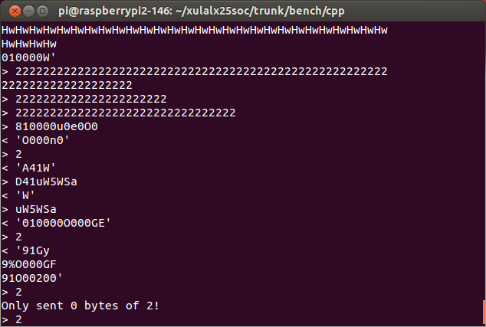

telnet localhost 7240 Following the loading of cputest in memory. In the window where you ran “ziprun -p cputest” will display

Clearing the cache
The CPU should be fully loaded, you may now start
it. To start the CPU, type wbregs cpu 0
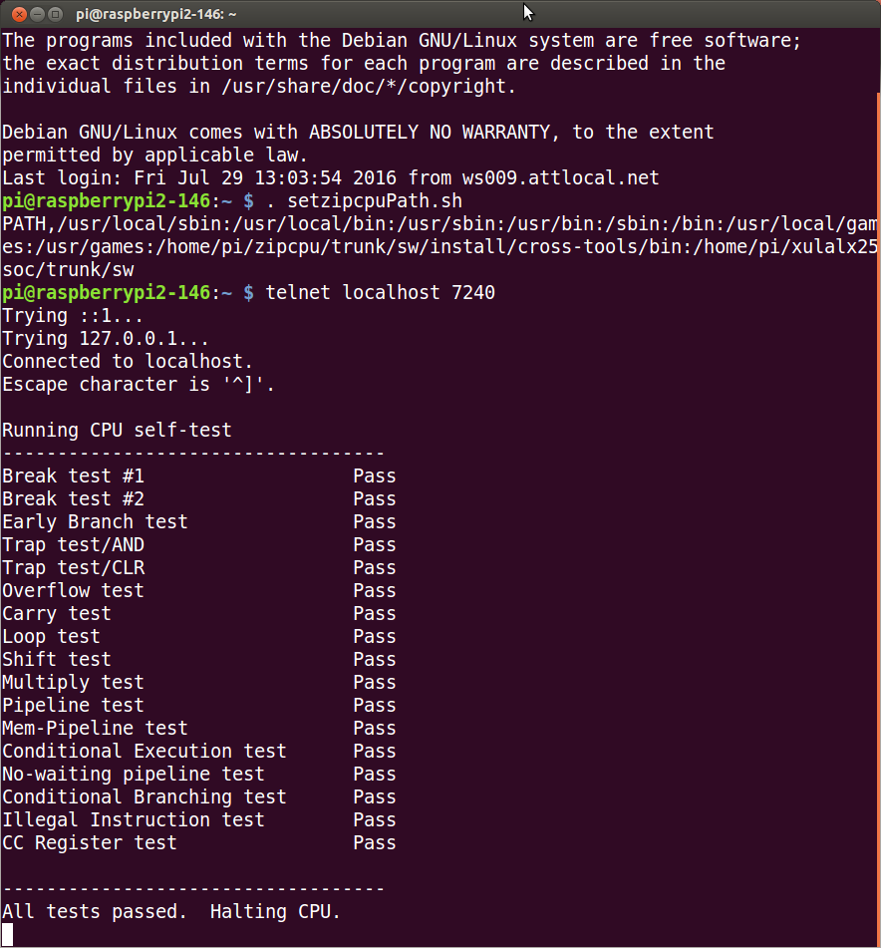

A program to test the compiler and the zipcpu is found in zipcpu/trunk/bench/asm/cputest.c

vidal@ws009:~/wkg/jpeg-2000-test/zipcpu/uart_test_code$ zip-gcc -O3 -Wall -Wextra -nostdlib -fno-builtin -T xula.ld -Wl,-Map,cputest.map cputest.c -o cputest

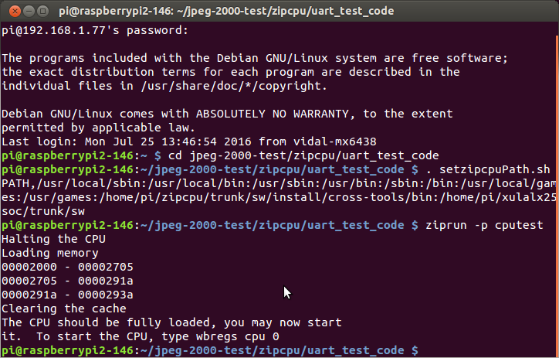
wbregs -p cpu 15
