Comparing 1 level of forward DWT using 9/7. The k1 and k2 scaling values were modified to yield new image to compare with the left image. Based on the results below k1 = .29 and k2 = 0.13 provide the best visual results. The first values tested k1 = .25 and k2 = 0.15 show less darkness behind the hat.
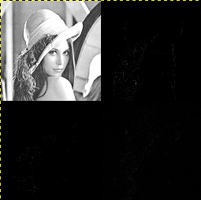
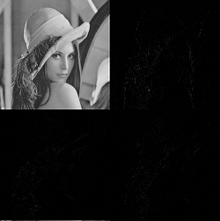

k1 = .25
k2 = 0.15
python cmp_png_fwd.py

mse = 0.000747680664062

max = 151.0

[vidal@ws009 ipython_fixbv]$ python cmp_png_fwd.py

0 0

0 103

0 104

mse = 0.000747680664062

max = 151.0

k1 = .29
k2 = 0.13
python cmp_png_fwd.py

0 0

mse = 0.0009765625

max = 145.0

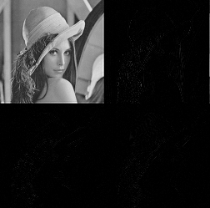

k1 = .23
k2 = 0.15 no visual difference
cmp_png_fwd.py

0 0

0 102

0 103

0 104

mse = 0.000747680664062

max = 162.0

k1 = .27
k2 = 0.15 no visual difference
python cmp_png_fwd.py

0 0

mse = 0.000747680664062

max = 147.0

k1 = .29
k2 = 0.15 no visual difference
python cmp_png_fwd.py

0 0

mse = 0.000747680664062

max = 145.0

