*****************Draft*****************
Testing kissfft using kissfft-example
08/27/20
*****************Draft*****************

forked the kissfft-example

git clone https://github.com/heavyii/kissfft-example.git

git clone https://github.com/develone/kissfft-example.git

cd kissfft-example/

make
kiss_fftr.c: In function ‘kiss_fftr_alloc’:
kiss_fftr.c:53:18: warning: cast increases required alignment of target type [-Wcast-align]
st->tmpbuf = (kiss_fft_cpx *) (((char *) st->substate) + subsize);

cp ../kissfft/kiss_fft.c .

cp ../kissfft/*.h .

cp ../kissfft/*.hh .

make

sudo pip install matplotlib

sudo apt-get install python-gi-cairo

./real-fft dump-raw-3.txt test-output.txt

image1
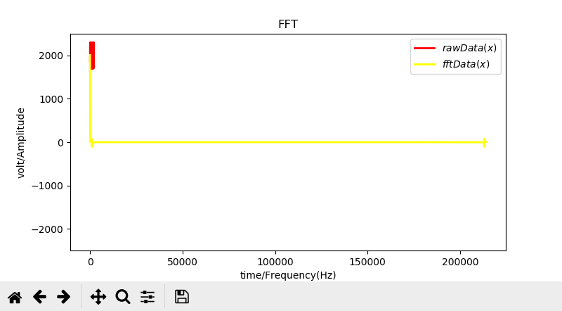
image2
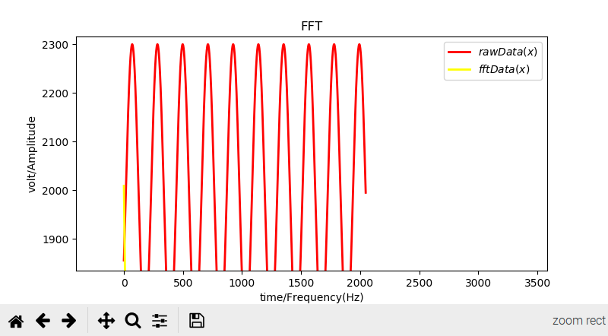
image3
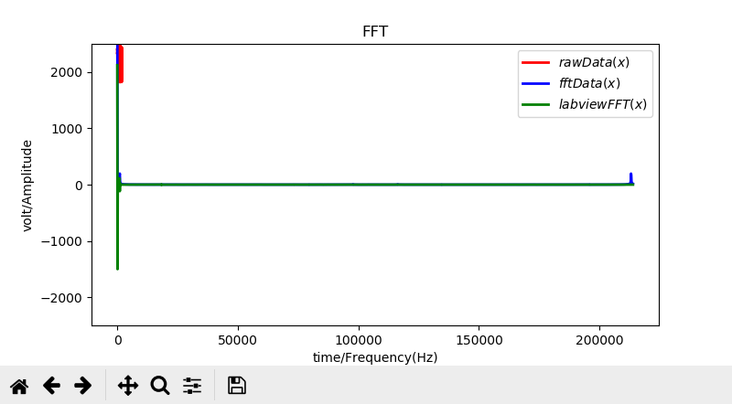
image4
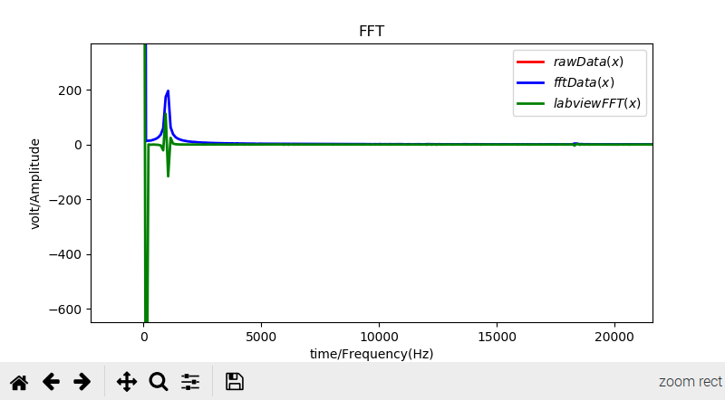
image5
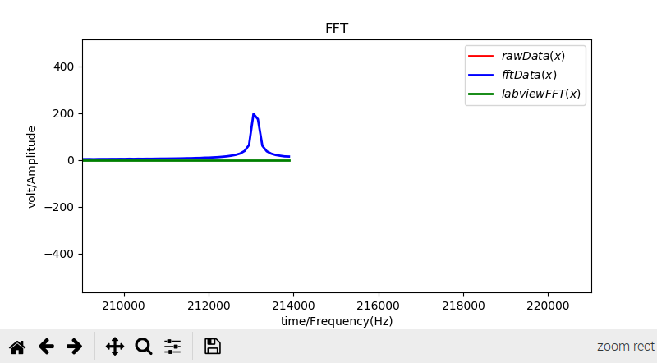
image6

