****************Draft****************
FFT Octave
08/25/20
****************Draft****************

Starting with an example in Matlab at “https://www.mathworks.com/help/matlab/ref/fft.html”

The signal below is combination of 3 frequencies. The 3 frequencies are
50, 120, and 200 Hz.

Figure 1
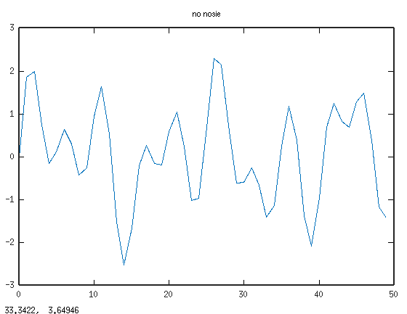

Taking the FFT demonstrates what frequencies make up the signal above.

Figure 2
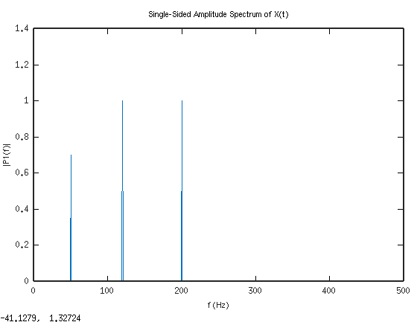
The signal below is combination of 3 frequencies witgh random noise. The 3 frequencies are
50, 120, and 200 Hz.

Figure 3
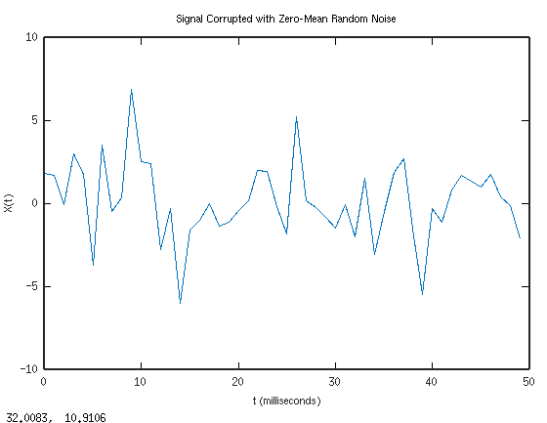

Taking the FFT demonstrates what frequencies make up the signal above.

Figure 4
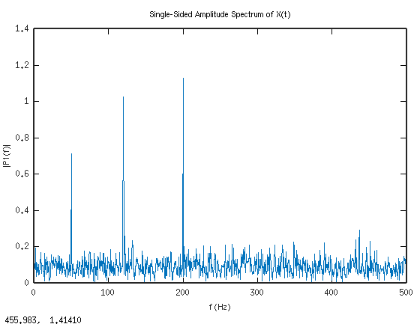

Octave code that produce the plots above.

clear
close all

Fs = 1000; % Sampling frequency
T = 1/Fs; % Sampling period
L = 1500; % Length of signal
t = (0:L-1)*T; % Time vectorc

%S = 0.7*sin(2*pi*50*t) + sin(2*pi*120*t);
S = 0.7*sin(2*pi*50*t) + sin(2*pi*120*t) + sin(2*pi*200*t);

X = S + 2*randn(size(t));

figure

plot(1000*t(1:50),X(1:50))
title('Signal Corrupted with Zero-Mean Random Noise')
xlabel('t (milliseconds)')
ylabel('X(t)')

Y = fft(X);

P2 = abs(Y/L);
P1 = P2(1:L/2+1);
P1(2:end-1) = 2*P1(2:end-1);

figure
f = Fs*(0:(L/2))/L;
plot(f,P1)
title('Single-Sided Amplitude Spectrum of X(t)')
xlabel('f (Hz)')
ylabel('|P1(f)|')

