Debugging Abort Issue
10/15/18
The simulation pc-main_tb Aborts when 9th
short SDRAMSIM::operator()(int clk, int cke, int cs_n, int ras_n, int cas_n, int we_n,
int bs, unsigned addr, int driv, short data, short dqm)

parameter is sets to m_core→i_ram_data.
In the xulalx25soc the 9th parameter is set m_core→o_ram_drive_data.
The following is in toplevel of xulalx25soc design.
assign io_ram_data = (ram_drive_data) ? ram_data : 16'bzzzz_zzzz_zzzz_zzzz;
reg [15:0] r_ram_data_ext_clk;
// always @(posedge intermediate_clk_n)
always @(posedge clk_s)
r_ram_data_ext_clk <= io_ram_data;
always @(posedge clk_s)
r_ram_data <= r_ram_data_ext_clk;

When setting the 9th parameter to 21930 0x55aa the simulation does not Abort.
Setting the 9th parameter to o_ram_drive_data the simulation does not compile.
Adding io_ram_data to
@MAIN.PORTLIST
i_wb_cyc, i_wb_stb, i_wb_we, i_wb_addr, i_wb_data, i_wb_sel,
o_wb_ack, o_wb_stall, o_wb_data,
o_ram_cs_n, o_ram_cke, o_ram_ras_n, o_ram_cas_n, o_ram_we_n,
o_ram_bs, o_ram_addr,
o_ram_dmod, i_ram_data, o_ram_data, o_ram_dqm,
o_debug, io_ram_data
and adding @MAIN.IODECL=
inout wire [15:0] io_ram_data;
Now the simulation compiles.

@SIM.TICK=
#ifdef @$(ACCESS)
m_core->i_ram_data = (*m_@$(MEM.NAME))(1,m_core->o_ram_cke,
m_core->o_ram_cs_n,m_core->o_ram_ras_n,m_core->o_ram_cas_n,
m_core->o_ram_we_n,m_core->o_ram_bs,m_core->o_ram_addr,
//m_core->o_ram_drive_data,m_core->o_ram_data,m_core->o_ram_dqm);
//21930,m_core->o_ram_data,m_core->o_ram_dqm);
m_core->io_ram_data,m_core->o_ram_data,m_core->o_ram_dqm);
#endif // @$(ACCESS)
./pc-wbregs 0x1000004 0x55aa
01000004 ( )-> 000055aa

./pc-main_tb
Listening on port 8363
Listening on port 8364
Successful settup! SDRAM switching to operational
Accepted CMD connection
POLL = 1
RCVD: 14 bytes
< A1000005W55aa
R/W Op
SDRAM[00000002] <= 0000
pc-main_tb: sdramsim.cpp:187: short int SDRAMSIM::operator()(int, int, int, int, int, int, int, unsigned int, int, short int, short int): Assertion `driv' failed.
Aborted (core dumped)

From toplevel.v xulalx25soc
assign io_ram_data = (ram_drive_data) ? ram_data : 16'bzzzz_zzzz_zzzz_zzzz;
reg [15:0] r_ram_data_ext_clk;
// always @(posedge intermediate_clk_n)
always @(posedge clk_s)
r_ram_data_ext_clk <= io_ram_data;
always @(posedge clk_s)
r_ram_data <= r_ram_data_ext_clk;

m_core->i_ram_data = m_sdram(1,
m_core->o_ram_cke, m_core->o_ram_cs_n,
m_core->o_ram_ras_n, m_core->o_ram_cas_n,
m_core->o_ram_we_n, m_core->o_ram_bs,
m_core->o_ram_addr, m_core->o_ram_drive_data,
m_core->o_ram_data, m_core->o_ram_dqm);
0x55AA 21930

@SIM.TICK=
#ifdef @$(ACCESS)

m_core->i_ram_data = (*m_@$(MEM.NAME))(1,m_core->o_ram_cke,
m_core->o_ram_cs_n,m_core->o_ram_ras_n,m_core->o_ram_cas_n,
m_core->o_ram_we_n,m_core->o_ram_bs,m_core->o_ram_addr,
21930,m_core->o_ram_data,m_core->o_ram_dqm);
//m_core->i_ram_data,m_core->o_ram_data,m_core->o_ram_dqm);
#endif // @$(ACCESS)

pi@mypi3-1:~/testbuilds/catzip_simulation/catzip/sw/host $ ./ttt.sh
01000004 ( )-> 55aaaa55
01000004 ( ) : [....] 00000000
010ffff8 ( )-> 55aaaa55
010ffff8 ( ) : [....] 00000000
01800004 ( )-> 55aaaa55
01800004 ( ) : [....] 00000000
018ffff8 ( )-> 55aaaa55
018ffff8 ( ) : [....] 00000000
01c00004 ( )-> 55aaaa55
01c00004 ( ) : [....] 00000000
01cffff8 ( )-> 55aaaa55
01cffff8 ( ) : [....] 00000000
01f00004 ( )-> 55aaaa55
01f00004 ( ) : [....] 00000000
01fffff8 ( )-> 55aaaa55
01fffff8 ( ) : [....] 00000000

pi@mypi3-1:~/testbuilds/catzip_simulation/catzip/sim/verilated $ ./arm-main_tb -d
Listening on port 8363
Listening on port 8364
Opening Bus-master with
Debug Access port = 8363
Serial Console = 8364
VCD File = trace.vcd
Successful settup! SDRAM switching to operational
Accepted CMD connection
POLL = 1
RCVD: 18 bytes
< A1000005W55aaaa55
R/W Op
SDRAM[00000002] <= 55aa
SDRAM[00000003] <= aa55
> A01000005
> K00000000
POLL = 1
RCVD: 0 bytes
< [CLOSED]
Accepted CMD connection
POLL = 1
RCVD: 10 bytes
< A1000005R
R/W Op
SDRAM.Q[ 6] 55aa <= SDRAM[00000002]
SDRAM.Q[ 7] aa55 <= SDRAM[00000003]
> A01000005R00000000
POLL = 1
RCVD: 0 bytes
< [CLOSED]
Accepted CMD connection
POLL = 1
RCVD: 18 bytes
< A10ffff9W55aaaa55
R/W Op
SDRAM[0007fffc] <= 55aa
SDRAM[0007fffd] <= aa55
> A010ffff9
> K00000000
POLL = 1
RCVD: 0 bytes
< [CLOSED]
Accepted CMD connection
POLL = 1
RCVD: 10 bytes
< A10ffff9R
R/W Op
SDRAM.Q[14] 55aa <= SDRAM[0007fffc]
SDRAM.Q[15] aa55 <= SDRAM[0007fffd]
> A010ffff9R00000000
POLL = 1
RCVD: 0 bytes
< [CLOSED]
Accepted CMD connection
POLL = 1
RCVD: 18 bytes
< A1800005W55aaaa55
R/W Op
SDRAM[00400002] <= 55aa
SDRAM[00400003] <= aa55
> A01800005
> K00000000
POLL = 1
RCVD: 0 bytes
< [CLOSED]
Accepted CMD connection
POLL = 1
RCVD: 10 bytes
< A1800005R
R/W Op
SDRAM.Q[ 6] 55aa <= SDRAM[00400002]
SDRAM.Q[ 7] aa55 <= SDRAM[00400003]
> A01800005R00000000
POLL = 1
RCVD: 0 bytes
< [CLOSED]
Accepted CMD connection
POLL = 1
RCVD: 18 bytes
< A18ffff9W55aaaa55
R/W Op
SDRAM[0047fffc] <= 55aa
SDRAM[0047fffd] <= aa55
> A018ffff9
> K00000000
POLL = 1
RCVD: 0 bytes
< [CLOSED]
Accepted CMD connection
POLL = 1
RCVD: 10 bytes
< A18ffff9R
R/W Op
SDRAM.Q[ 6] 55aa <= SDRAM[0047fffc]
SDRAM.Q[ 7] aa55 <= SDRAM[0047fffd]
> A018ffff9R00000000
POLL = 1
RCVD: 0 bytes
< [CLOSED]
Accepted CMD connection
POLL = 1
RCVD: 18 bytes
< A1c00005W55aaaa55
R/W Op
SDRAM[00600002] <= 55aa
SDRAM[00600003] <= aa55
> A01c00005
> K00000000
POLL = 1
RCVD: 0 bytes
< [CLOSED]
Accepted CMD connection
POLL = 1
RCVD: 10 bytes
< A1c00005R
R/W Op
SDRAM.Q[ 6] 55aa <= SDRAM[00600002]
SDRAM.Q[ 7] aa55 <= SDRAM[00600003]
> A01c00005R00000000
POLL = 1
RCVD: 0 bytes
< [CLOSED]
Accepted CMD connection
POLL = 1
RCVD: 18 bytes
< A1cffff9W55aaaa55
R/W Op
SDRAM[0067fffc] <= 55aa
SDRAM[0067fffd] <= aa55
> A01cffff9
> K00000000
POLL = 1
RCVD: 0 bytes
< [CLOSED]
Accepted CMD connection
POLL = 1
RCVD: 10 bytes
< A1cffff9R
R/W Op
SDRAM.Q[ 6] 55aa <= SDRAM[0067fffc]
SDRAM.Q[ 7] aa55 <= SDRAM[0067fffd]
> A01cffff9R00000000
POLL = 1
RCVD: 0 bytes
< [CLOSED]
Accepted CMD connection
POLL = 1
RCVD: 18 bytes
< A1f00005W55aaaa55
R/W Op
SDRAM[00780002] <= 55aa
SDRAM[00780003] <= aa55
> A01f00005
> K00000000
POLL = 1
RCVD: 0 bytes
< [CLOSED]
Accepted CMD connection
POLL = 1
RCVD: 10 bytes
< A1f00005R
R/W Op
SDRAM.Q[14] 55aa <= SDRAM[00780002]
SDRAM.Q[15] aa55 <= SDRAM[00780003]
> A01f00005R00000000
POLL = 1
RCVD: 0 bytes
< [CLOSED]
Accepted CMD connection
POLL = 1
RCVD: 18 bytes
< A1fffff9W55aaaa55
R/W Op
SDRAM[007ffffc] <= 55aa
SDRAM[007ffffd] <= aa55
> A01fffff9
> K00000000
POLL = 1
RCVD: 0 bytes
< [CLOSED]
Accepted CMD connection
POLL = 1
RCVD: 10 bytes
< A1fffff9R
R/W Op
SDRAM.Q[14] 55aa <= SDRAM[007ffffc]
SDRAM.Q[15] aa55 <= SDRAM[007ffffd]
> A01fffff9R00000000
POLL = 1
RCVD: 0 bytes
< [CLOSED]
^C
The image below is the 2 writes & 2 reads to each of the 4 banks

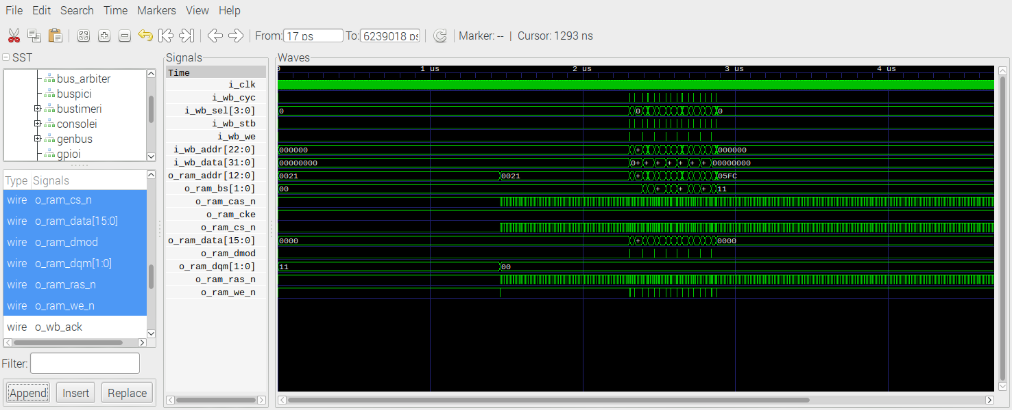
The image below is writing to 0x1000004 0x55aaaa55 The write to 2nd address of 1st bank
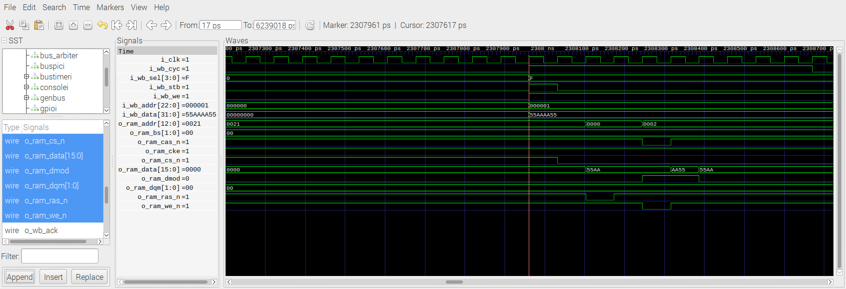
The image below is reading to 0x1000004 The read to 2nd address of 1st bank
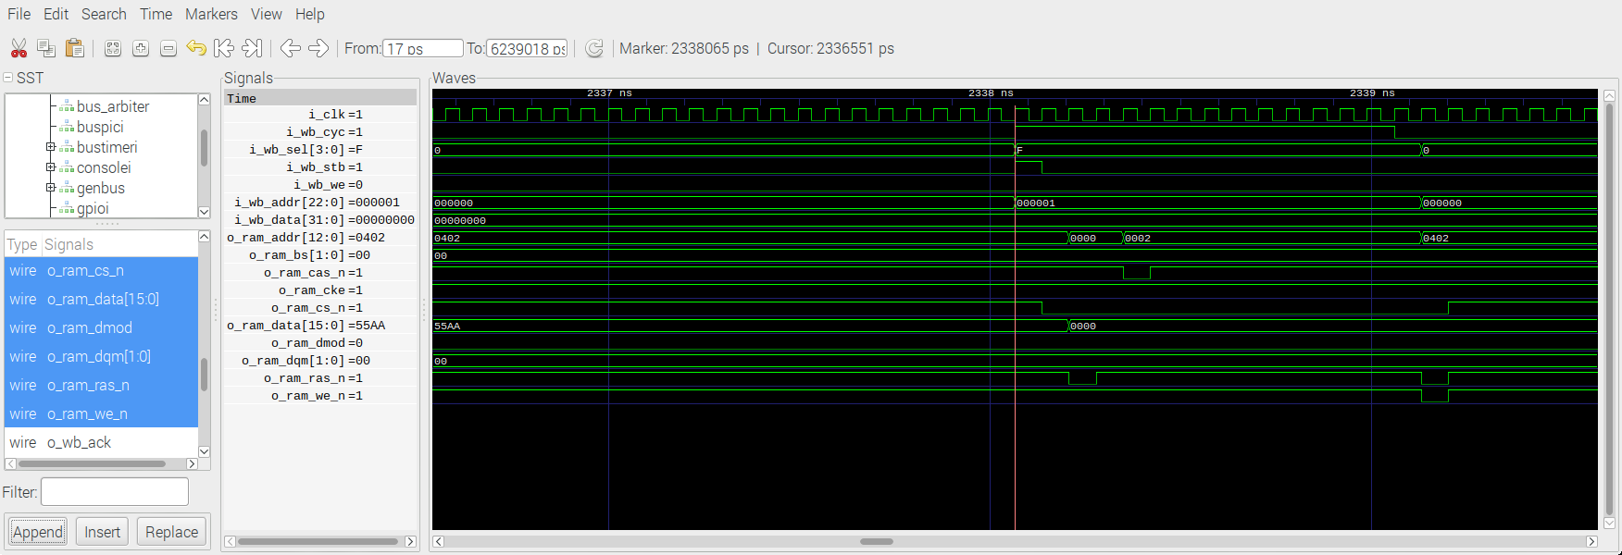
The image below is writing to 0x010ffff8 0x55aaaa55 The write to next to last address of 1st bank
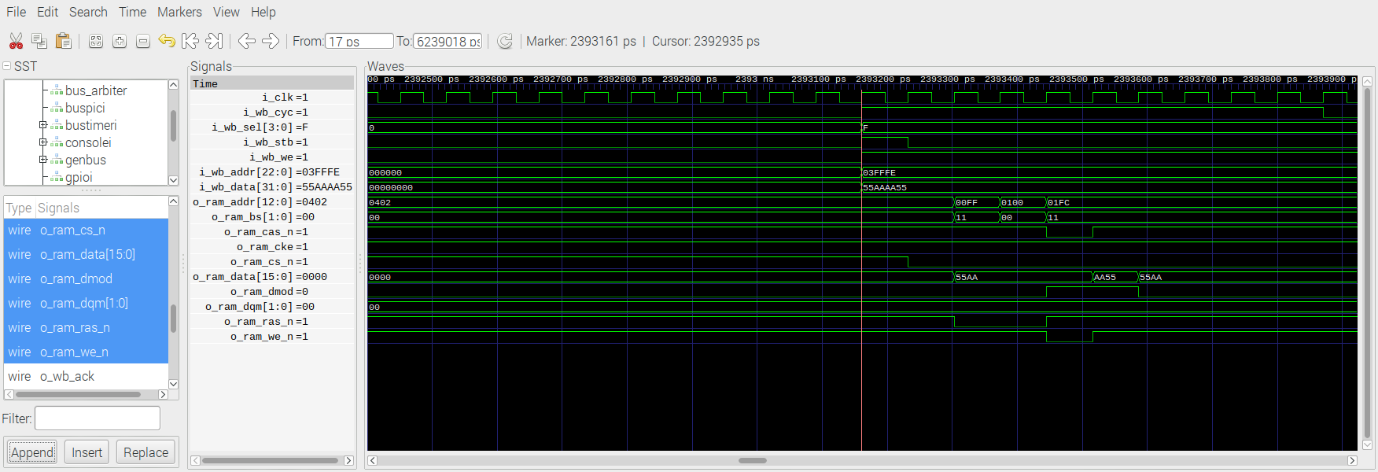
The image below is writing to 0x01800004 0x55aaaa55 The write to 2nd address of 2nd bank
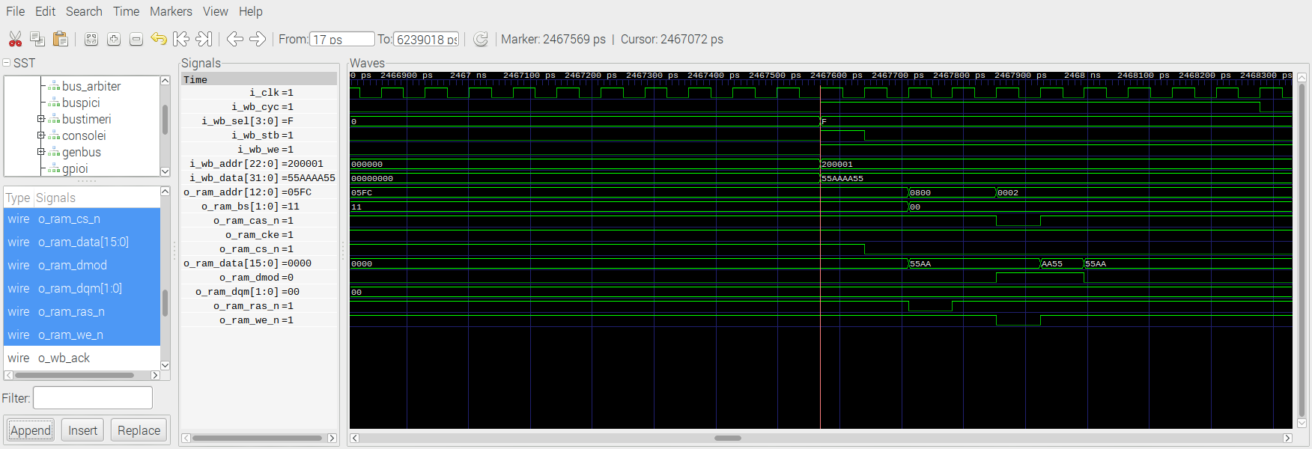
The image below is writing to 0x018ffff8 0x55aaaa55 The write to next to last address of 2nd bank
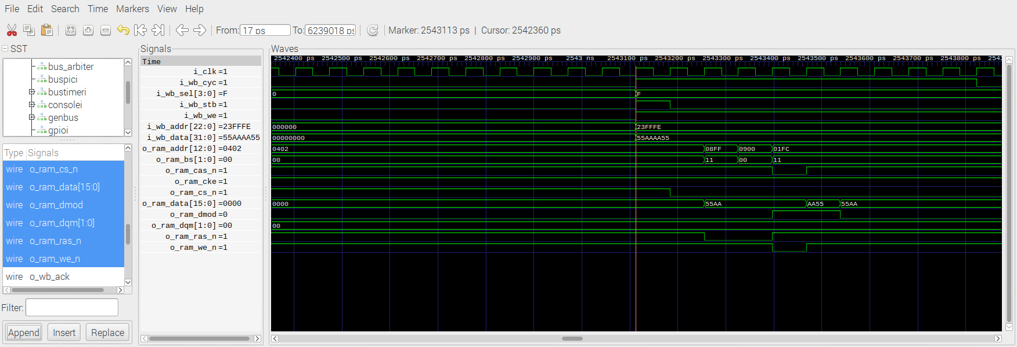
The image below is writing to 0x01c00004 0x55aaaa55 The write to 2nd address of 3rd bank

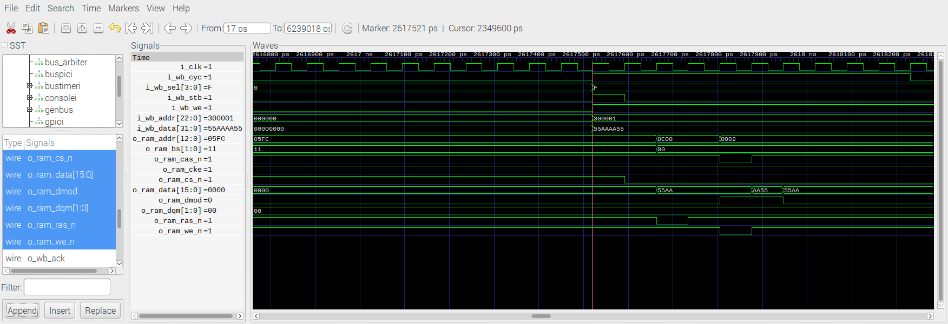
The image below is writing to 0x01cffff8 0x55aaaa55 The write to next to last address of 3rd bank
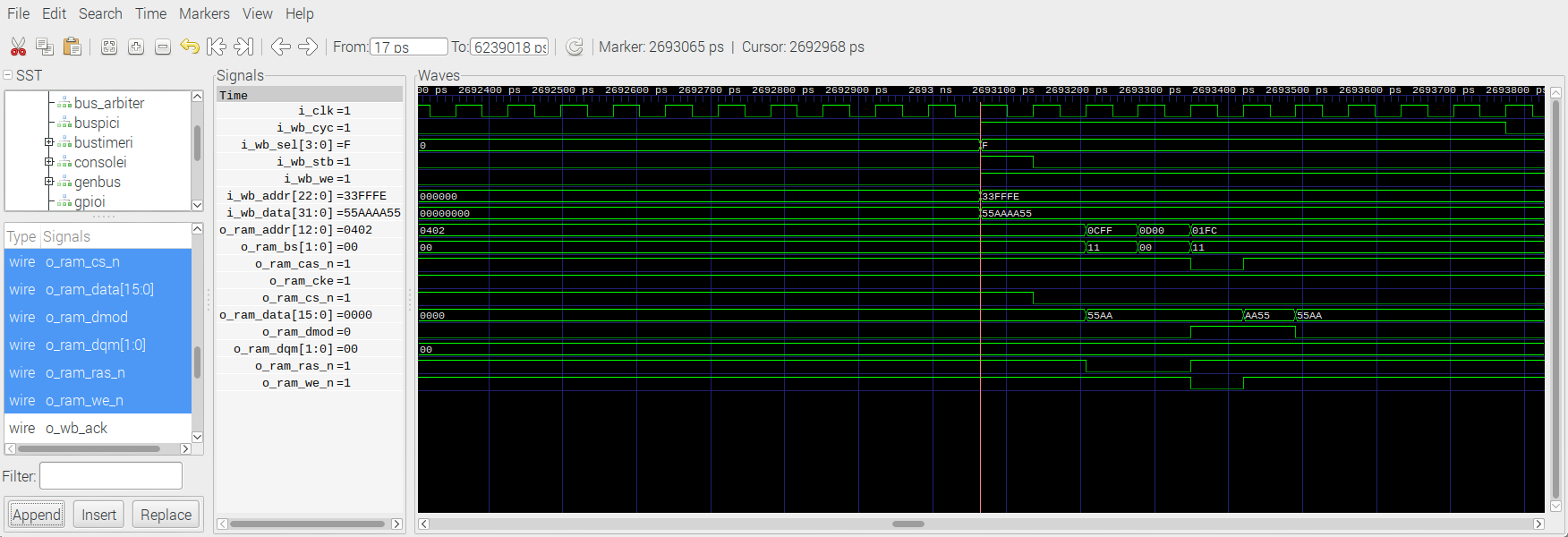
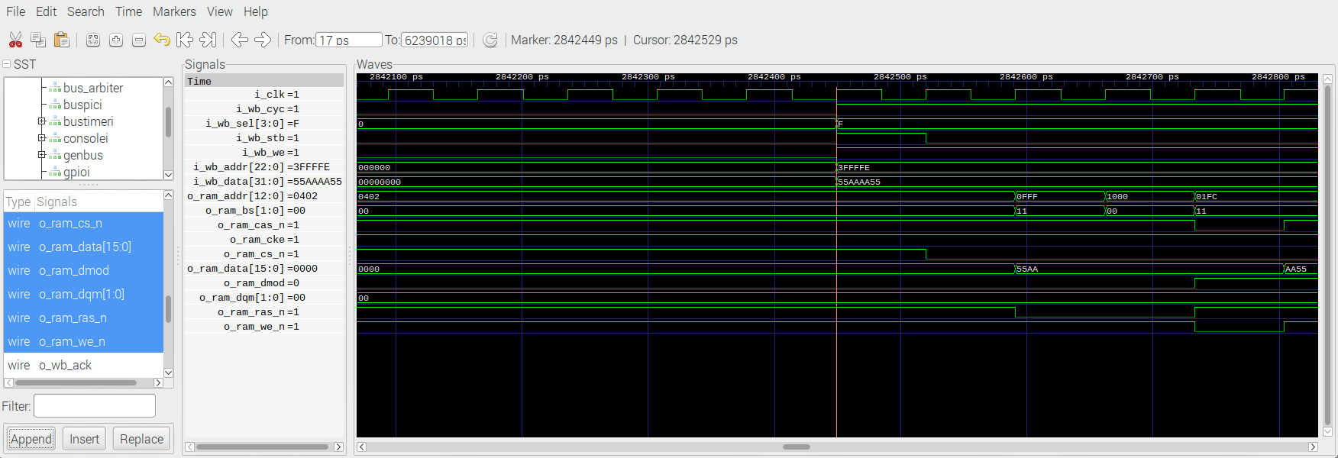
The image below is writing to 0x01f00004 0x55aaaa55 The write to 2nd address of 4th bank
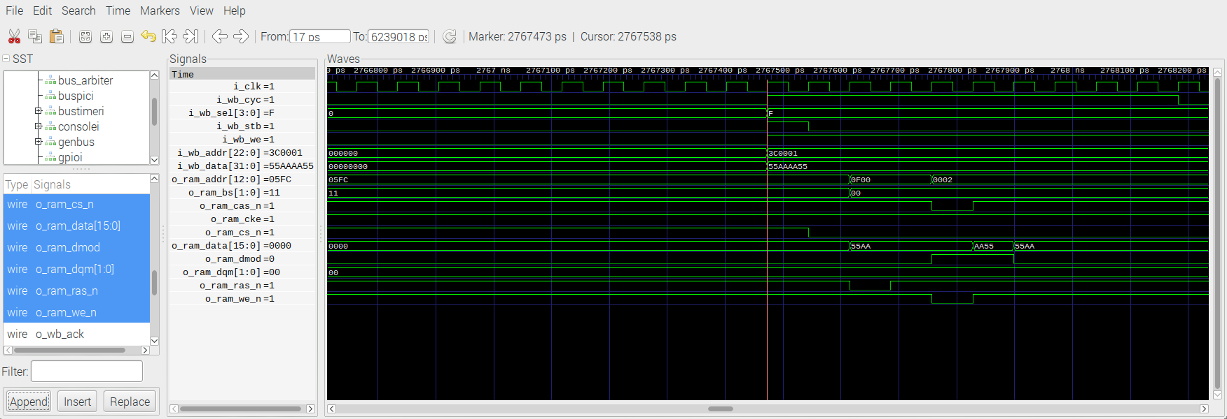
The image below is writing to 0x01fffff8 0x55aaaa55 The write to next to last address of 4th bank
The image below is reading to 0x01fffff8 The read to next to last address of 4th bank
