******************Draft******************
Initial Testing Wavedrom
11/13/18
******************Draft******************

Updated https://github.com/develone/wavedrom.git
git clone https://github.com/develone/wavedrom.git
git remote add upstream https://github.com/wavedrom/wavedrom.git
git fetch upstream
git merge upstream/master
git push origin master

commit a867a8dfe60b4c9127bc8aa86ed673961f86e5fc
Author: Aliaksei Chapyzhenka <alex.drom@gmail.com>
Date: Thu Nov 8 11:34:27 2018 -0800

1.8.0
file:///home/pi/testbuilds/wavedrom/doc/LogiDrom.html

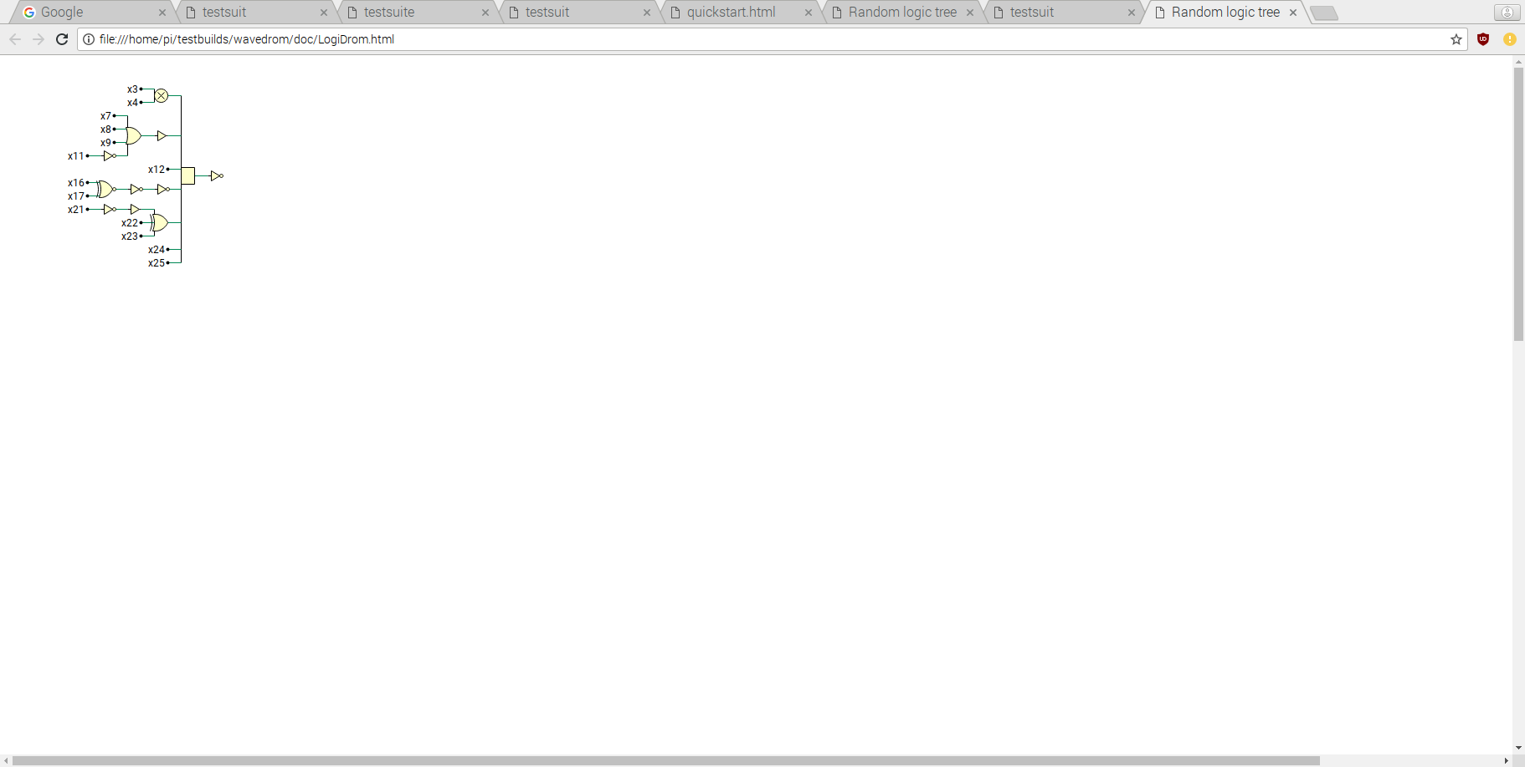
file:///home/pi/testbuilds/wavedrom/test/test.html

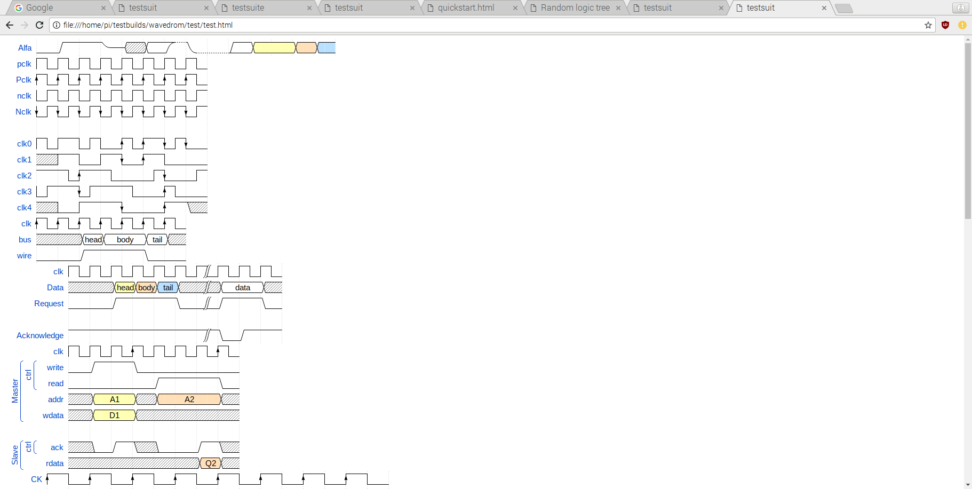

file:///home/pi/testbuilds/wavedrom/test/test-reg.html

