******************Draft******************
08/02/18
******************Draft******************

# Learning Hardware Description Language HDL
# For several years I have tried to learn Hardware Description Language HDL.
# The two major versions of HDL are Verilog and VHDL. At this point I am focusing on Verilog
# Goals
- FSM Finite State Machine
- UART Universal Asynchronous Receiver-Transmitter
- SDRAM
- ram & rom
- fifo
- SPI
- Parallel data transfer
- led digit display
- oled displays
- dsp
- SOC
- Simulation test bench
# Requirements
* GIT
* FPGA Field Programmable Gate Array Boards
- Zedboard Xilinx Zynq 7000
- XulA2-LX9 Xilinx Spartan 6 LX9
- Arty Xilinx Artix-7 35T
- Catboard Lattice ice40 HX8K
* Programming Languages
- C
- Python
- Perl
- Verilog

* Developement Hardware
- Xilinx Ubuntu high development system
- ISE
- Vivado
- RPi3B+
- Software versions as 07/29/18
- MyHDL a311468f
- yosys e060375f
- icestorm f0299751
- arachne-pnr 5d830dd9
- icozip 9dcbacfe
- autofpga c0df9413
- zipcpu ab82a886
- verllator f0ed4346

.
# There are many tools that are required to write and simulate HDL.
* MyHDL Jan Decaluwe
- Takes Python and creates Verilog or VHDL
- MyHDL provides simulation & co-simulation with Icarus Verilog
* Simulators
- Icarus Verilog Stephen Williams
- Privides co-simulation with MyHDL
- iverilog creates a module from verilog files
- vvp
* Verilator Wilson Snyder
- Converts Verilog to C
- C simulation
* GTKWAVE Displays Value Change Dump VCD files generated with simulation
* Yosys Open Synthesis Suite Clifford Wolf
- yosys
- icestorm
- arachne-pnr

Key item of this build is the echo.py instaniates the uart_rx uart_tz and forceHi.
uart_rx_0 = uart_rx(i_Clk,i_uart_rx,w_RX_DV,w_RX_Byte,state_rx,CLKS_PER_BIT=868)
uart_tx_0 = uart_tx(i_Clk,w_RX_DV,w_RX_Byte,w_TX_Active,w_TX_Serial,o_TX_Done,state_tx,CLKS_PER_BIT=868)
forceHi_0 = forceHi(w_TX_Serial,w_TX_Active,o_uart_tx)
This creates echo.v currently over 200 lines of verilog that can be synthized, placed & route, and a bin file created.

In this build the key items were wires & regs.
assign o_uart_tx = w_TX_Active ? w_TX_Serial : 1'b1;

A always_comb was used. This was a key in getting the echo working in hardware.

always @(w_TX_Serial, w_TX_Active) begin: ECHO_FORCEHI0_0_COMB
if (w_TX_Active) begin
o_uart_tx = w_TX_Serial;
end
else begin
o_uart_tx = 1'b1;
end
And the st
ates of FSM

It appears that several signals need to initialized for the echo to work.
This will be the next step to add a reset to both the uart_rx & uart_tx.

python echo.py

diffuse echo.v echo.v.wkg This step should be removed when the reset is add

diff echo.v echo.v.wkg
3c3
< // Date: Thu Aug 2 20:29:37 2018
---
> // Date: Thu Aug 2 16:19:36 2018
22c22
< reg [2:0] state_rx;
---
> reg [2:0] state_rx=0;
26,28c26,28
< reg [2:0] state_tx;
< reg [11:0] uart_tx0_0_r_Clock_Count;
< reg [2:0] uart_tx0_0_r_Bit_Index;
---
> reg [2:0] state_tx=0;
> reg [11:0] uart_tx0_0_r_Clock_Count=0;
> reg [2:0] uart_tx0_0_r_Bit_Index=0;
33,35c33,35
< reg [11:0] uart_rx0_0_r_Clock_Count;
< reg [2:0] uart_rx0_0_r_Bit_Index;
< reg [7:0] uart_rx0_0_r_RX_Byte;
---
> reg [11:0] uart_rx0_0_r_Clock_Count=0;
> reg [2:0] uart_rx0_0_r_Bit_Index=0;
> reg [7:0] uart_rx0_0_r_RX_Byte=0;

make echo

sudo config_cat echo.bin

=== echo ===
Number of wires: 136
Number of wire bits: 265
Number of public wires: 17
Number of public wire bits: 68
Number of memories: 0
Number of memory bits: 0
Number of processes: 0
Number of cells: 243
SB_CARRY 44
SB_DFF 10
SB_DFFE 49
SB_DFFSR 6
SB_LUT4 134

iverilog -o echo tb_dut_echo.v uart_rx.v uart_tx.v forceHi.v
vvp echo
gtkwave dump.vcd

python trace_tx.py
gtkware testbench.vcd

python trace_rx.py
gtkware testbench.vcd

UART Universal Asynchronous Receiver-Transmitter
FSM Finite State Machine
Simulators

MyHDL Trace
“python trace_tx.py”
“gtkwave testbench.vcd”
The image below is the uart_tx simulation sending “helloworld”
A FSM is 'TX_IDLE', 'TX_START_BIT', 'TX_DATA_BITS', 'TX_STOP_BIT', 'TX_CLEANUP'
used in the design of the “uart_tx”.
A FSM is 'RX_IDLE', 'RX_START_BIT', 'RX_DATA_BITS','RX_STOP_BIT','RX_CLEANUP'
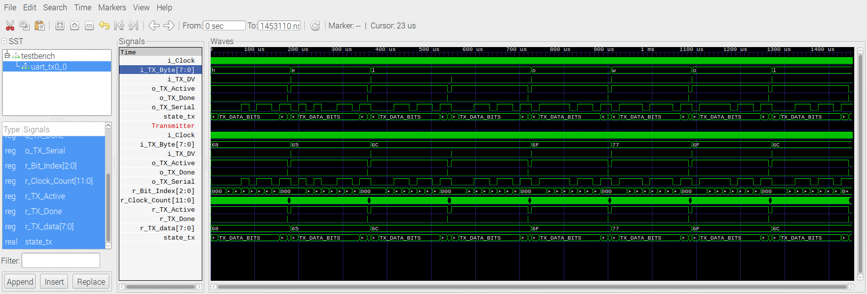
This is the echo of character with a Iverilog Simulation.
“python uart_rx.py” creates the Verilog uart_rx.v.
“python uart_tx.py” creates the Verilog uart_tx.v.
“iverilog -o echo tb_dut_echo.v uart_rx.v uart_tx.v”
Creates the module “echo”
“vvp echo” executes the simulation creating “dump.vcd”
“gtkwave dump.vcd” is the command to view the VCD file.

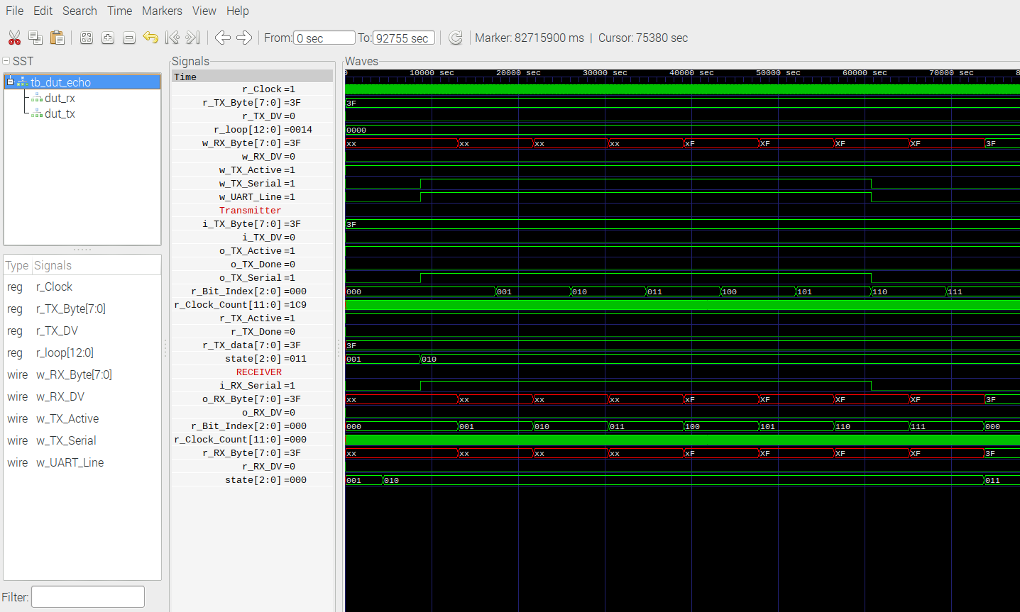
START_BIT At 100 MHz 868 is the number of counts for 115200 Baud.
Note The uart_rx transistions from state 1 to state 2 earlier than the uart_tx.

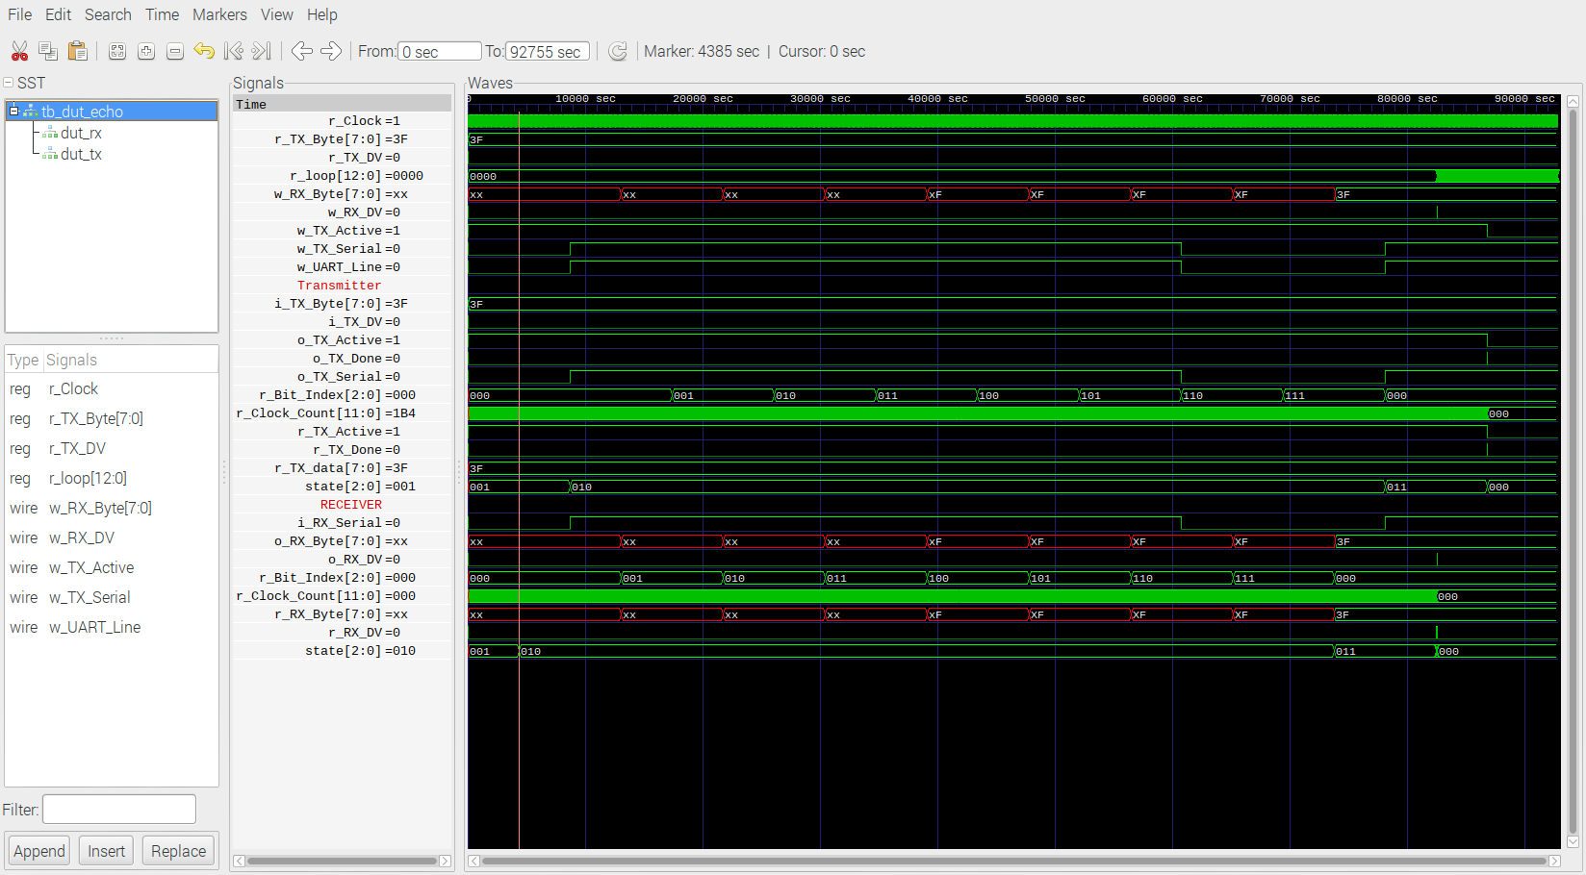
Stop_BIT
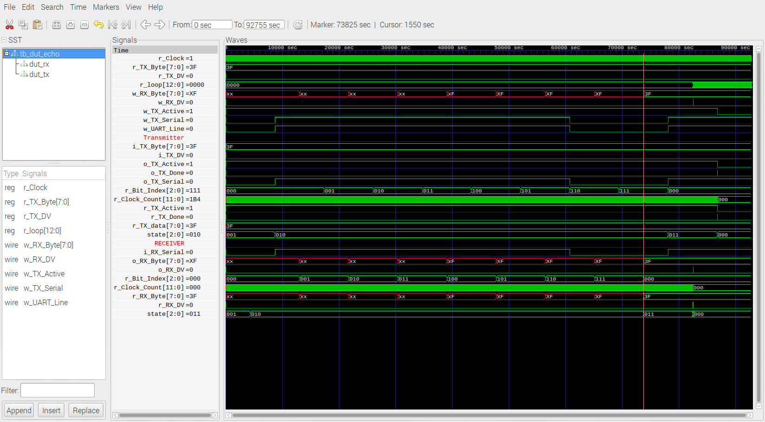
Data
