********Draft********
12/21/18
********Draft********

The FPGA is used to create hardware logic using Hardware Definition Language Verilog or VHDL. The images below were found at the following site http://www.ee.surrey.ac.uk/Projects/CAL/digital-logic/gatesfunc/#andgate.

The basic gates are AND, OR, NOT, NAND, NOR, EXOR, and EXNOR. These gates can be use to create FLIP FLOPS, and COUNTERS when connected to together. As example the two NOR gates can create a SET RESET FLIP FLOP https://www.elprocus.com/digital-electronics-flip-flop-circuit-types-and-applications/

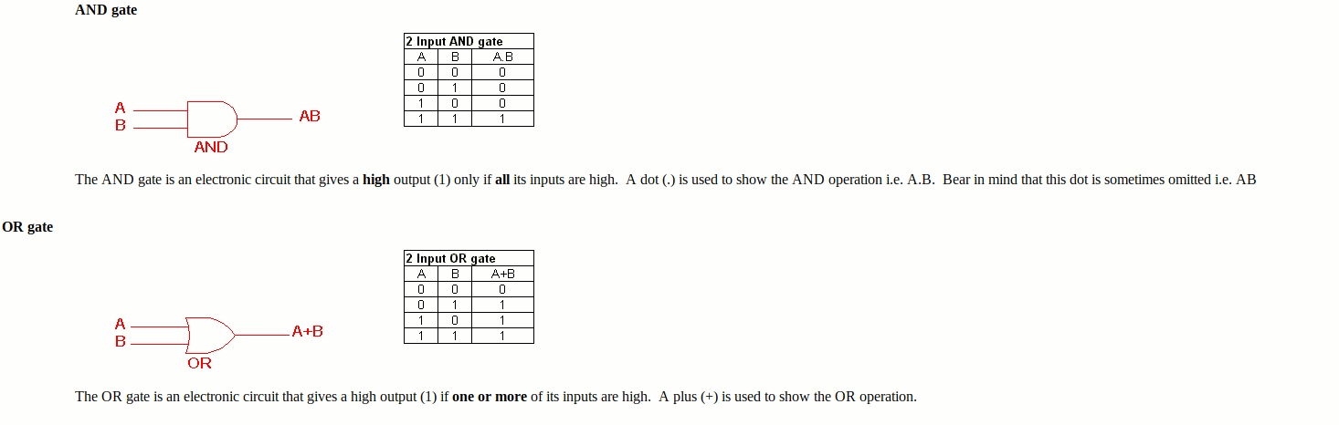
NOT, NAND, NOR
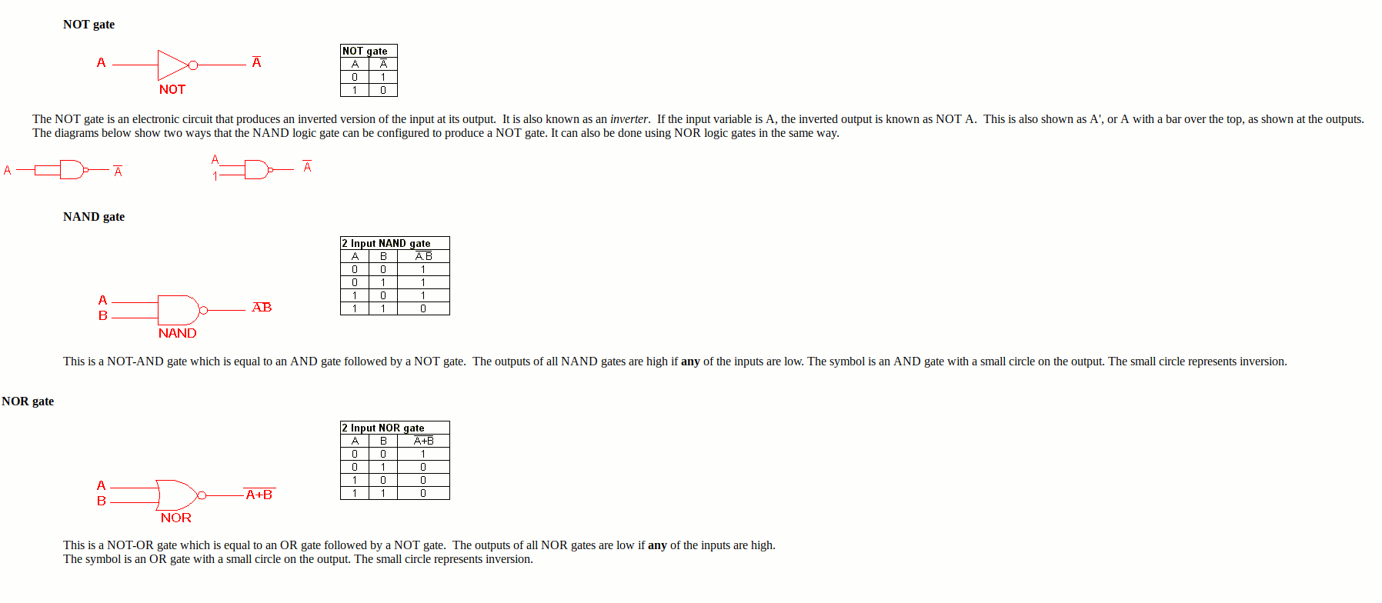
EXOR, EXNOR
