**************DRAFT**************
SDRAM
10/02/18
**************DRAFT**************

Trying to add sdram support to the catzip. Steps
The command “python main_sdramdev.py”
creates sdramdev.v & Sdcntl.v Verilog files and the testbench main_sdramdev_tb.vcd.
Steps to obtain the Values Change Dump VCD. This creates the files sdramdev.v & Sdcntl.v
Modified the /testbuilds/catzip_simulated/catzip/sim/verilated/Makefile
to add the sdramsim.cpp to /testbuilds/catzip_simulated/catzip/sim/verilated/arm-main_tb.
The disassemble is found at
Appendix D: Disassemble of testbuilds/catzip_simulation/catzip/sim/verilated/arm-main_tb where the SDRAMSIM

Note: Only one sdramdev_inst.convert(name = 'sdramdev') or SdCntl_inst.convert(name = 'Sdcntl')
can be uncommeted at the same time
not both or the following error will occur
Signal has multiple drivers: host_intf_rst_i

In the directory /home/pi/testbuilds/learning_hdl/MyHDL/sdram
“rm -f *.vcd”
“python main_sdramdev.py”
“gtkwave main_sdramdev_tb.vcd”
Create sdramdev.txt this is currently a draft version for use with /home/pi/testbuilds/catzip_simulated/catzip/auto-data for the catzip.
/home/pi/testbuilds/catzip_simulated/catzip/auto-data for the catzip.
/home/pi/testbuilds/catzip_simulated/catzip/make autodata
Copying auto-data/toplevel.v to rtl/catzip/toplevel.v
Copying auto-data/main.v to rtl/catzip/main.v
Copying auto-data/regdefs.h to sw/host/regdefs.h
Copying auto-data/regdefs.cpp to sw/host/regdefs.cpp
Copying auto-data/board.h to sw/board/board.h
Copying auto-data/board.ld to sw/board/board.ld
Copying auto-data/rtl.make.inc to rtl/catzip/auto.mk
Copying auto-data/main_tb.cpp to sim/verilated/main_tb.cpp
Copying auto-data/testb.h to sim/verilated/testb.h
Steps to obtain the Values Change Dump VCD. This creates the file sdramdev.v.

Add the sdramsim.cpp & sdramsim.h to /testbuilds/catzip_simulated/catzip/sim/verilated.

Steps used to get a working catzip
“cd catzip”
“. ./myenv.sh”
“make datestamp”
“make autodata”
“cd rtl/catzip”
“make” This command creates catzip.bin that can downloaded to FPGA. The Yosys Tools
were used.
“cd ../../sim/verilated”
“make” This command creates arm-main_tb used to simulate the HX8K FPGA
“cd ../../sw/host” This creates
”make” This command creates arm-netpport & arm-wbregs

The script restores “config_catzip_simulation.sh” located in the learning_hdl/MyHDL/sdram folder.
Starts with a working catzip
1st shell
. /home/pi/testbuilds/catzip_simulation/catzip/myenv.sh
/home/pi/testbuilds/catzip_simulation/catzip/
make autodata
2nd shell
. /home/pi/testbuilds/catzip_simulation/catzip/myenv.sh
/home/pi/testbuilds/catzip_simulation/catzip/rtl/catzip
make clean
make cpudefs.h
make design.h
make verilated
make bin
/home/pi/testbuilds/catzip_simulation/catzip/sim/verilated/
make clean
make
3rd shell
. /home/pi/testbuilds/catzip_simulation/catzip/myenv.sh
cd testbuilds/catzip_simulation/catzip/sim/verilated/
make clean
make
./arm-main_tb
The script used to execute the arm-wbregs command is found at Appendix A: Script that executes the arm-wbregs commands sim_hw_test.sh
The output of the arm-main_tb is found at Appendix B: CATZIP testing the verilator simulation.
Listening on port 8363
Listening on port 8364
> T
In 4th shell
. /home/pi/testbuilds/catzip_simulation/catzip/myenv.sh
cd testbuilds/catzip_simulation/catzip/sw/host/
./sim_hw_test.sh
The output of the sim_hw_test.sh is found at Appendix C: CATZIP testing the verilator simulation running wbregs command from the script
sim_hw_test.sh .
cp testbuilds/learning_hdl/MyHDL/sdram/ topsdcntl.v & SdramCntl.v ~/testbuilds/catzip_simulation/catzip/rtl/catzip/
cp ~/testbuilds/learning_hdl/MyHDL/sdram/sdramdev.txt ~/testbuilds/catzip_simulation/catzip/auto-data/
cp ~/testbuilds/learning_hdl/MyHDL/sdram/Makefile_autodata ~/testbuilds/catzip_simulation/catzip/auto-data/Makefile
Note This provides a verilator sim of both sram & blkram
. ~/testbuilds/catzip_simulation/catzip/myenv.sh
cd ~/testbuilds/catzip_simulation/catzip/autodata

Create sdcntl.txt
Modified Makefile in ~/testbuilds/catzip_simulation/catzip/autodata → Makefile_autodata

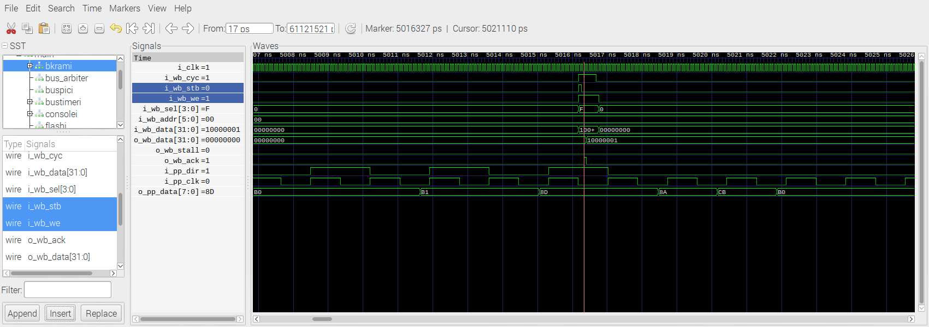
The Catboard has HX8K FPGA with a SDRAM that provides 0x000000 to 0xFFFFFF 16 bit locations.
The SDCONTROLLER takes care of refreshing the SDRAM and interface between the FPGA and the SDRAM. The data 0x05DC 1500 is being wrote to address 0x000BB8 3000, the data 0xFFFF 65535 is being wrote to address 0xFFFFFF 16777215. Then the data is read from
address 0x000BB8 3000.

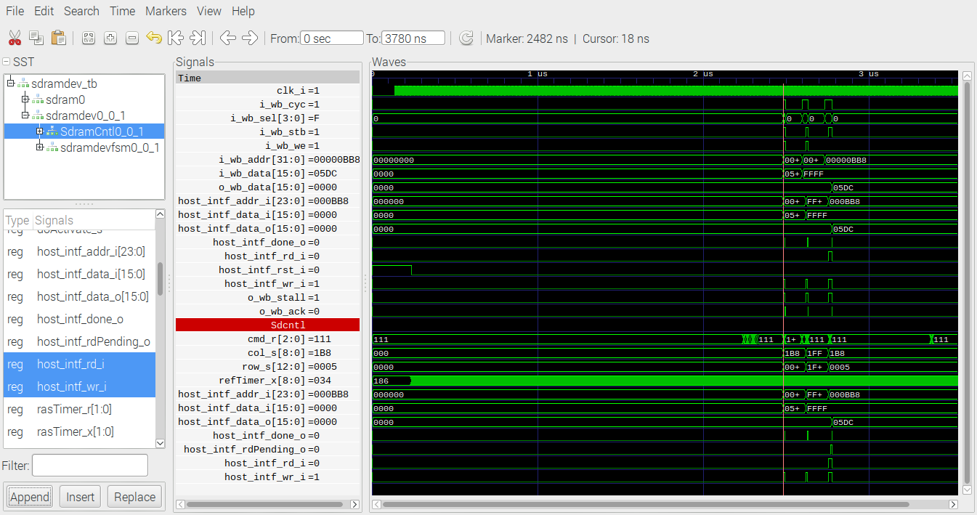

This test writes two SDRAM address and reads the value wrote to first location.
The data 0x05DC 1500 is being wrote to address 0x00000BB8 3000, 0xFFFF 65535 is being wrote to address 0x00FFFFFF 16777215. This is followed by reading the value at
address 0x00000BB8 3000 which was 0x05DC 1500.

BANK 0 STATE : [CHANGE] Uninitialized -> Initialized @ 2138
BANK 1 STATE : [CHANGE] Uninitialized -> Initialized @ 2138
BANK 2 STATE : [CHANGE] Uninitialized -> Initialized @ 2138
BANK 3 STATE : [CHANGE] Uninitialized -> Initialized @ 2138
--------------------------
Mode | CAS | Burst
--------|-------|---------
Burst | 3 | 1
--------------------------
SDRAM : Bank 0 has active row 0005
BANK 0 STATE : WRITING @ 2514
DATA : [WRITE] Addr: 440 Data: 1500
The data 0x05DC 1500 is being wrote to address 0x000BB8 3000 Row 0005 col Addr: 440 0x1B8 is where the 1500 0x05DC is written.

SDRAM : Bank 3 has active row 1fff
BANK 3 STATE : WRITING @ 2652
DATA : [WRITE] Addr: 511 Data: 65535
BANK 3 STATE : WRITING TO 01ff:511

The data 0xFFFF 65535 is being wrote to address 0xFFFFFF 16777215 (this is the last location in the sdram) Row 1FFF col Addr: 511 0x1FF is where the 65535 0xFFFF is written.

SDRAM : Bank 0 has active row 0005
BANK 0 STATE : READING @ 2790
SDRAM : [READ] Commnad registered
BANK 0 STATE : READING FROM 01b8:440
STATE : [READ] Data Ready @ 2794 value : 1500

BANK 0 STATE : WRITING TO 01b8:440
4400440: 1500
SDRAM : Bank 3 has active row 1fff
BANK 3 STATE : WRITING @ 2652
DATA : [WRITE] Addr: 511 Data: 65535
BANK 3 STATE : WRITING TO 01ff:511
4400440: 1500
5110511: 65535
SDRAM : Bank 0 has active row 0005
BANK 0 STATE : READING @ 2790
SDRAM : [READ] Commnad registered
BANK 0 STATE : READING FROM 01b8:440
STATE : [READ] Data Ready @ 2794 value : 1500

In the image below the data 0x05DC 1500 is being wrote to address 0x00000BB8 3000, 0xFFFF 65535 is being wrote to address 0x00FFFFFF 16777215. This is followed by reading the value at
address 0x00000BB8 3000 which was 0x05DC 1500.
BANK 3 STATE : WRITING @ 2652

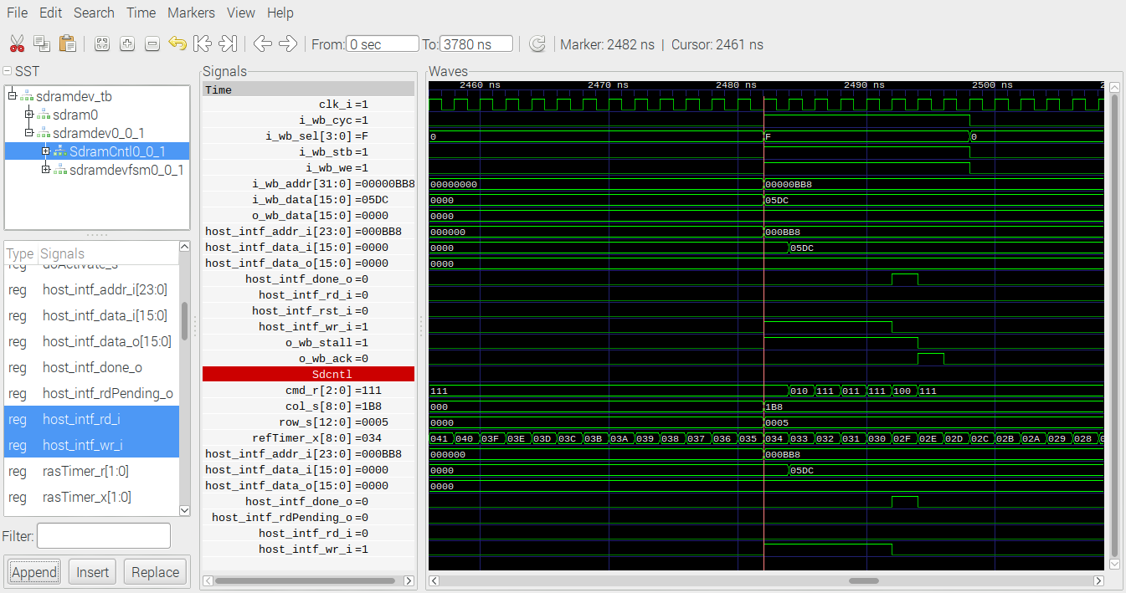

DATA : [WRITE] Addr: 511 Data: 65535
BANK 3 STATE : WRITING TO 01ff:511

SDRAM : Bank 0 has active row 0005
BANK 0 STATE : WRITING @ 2514
DATA : [WRITE] Addr: 440 Data: 1500
BANK 0 STATE : WRITING TO 01b8:440
In the image below the data 0x05DC 1500 is being wrote to address 0x000BB8 3000

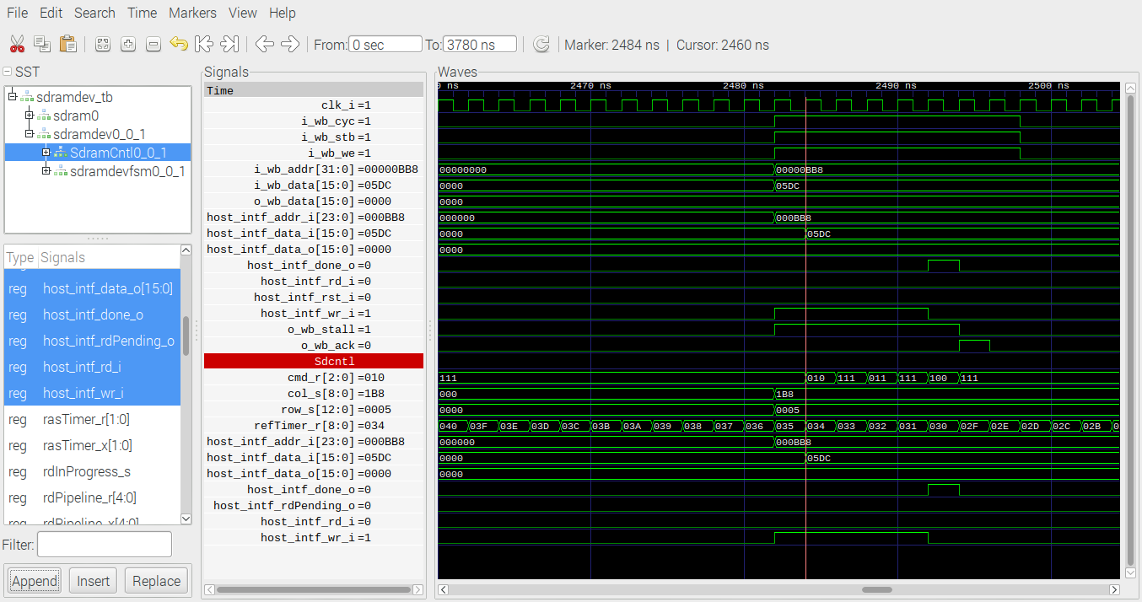

SDRAM : Bank 3 has active row 1fff
BANK 3 STATE : WRITING @ 2652
DATA : [WRITE] Addr: 511 Data: 65535
BANK 3 STATE : WRITING TO 01ff:511
In the image below the data 0xFFFF 65535 is being wrote to address 0xFFFFFF 16777215.

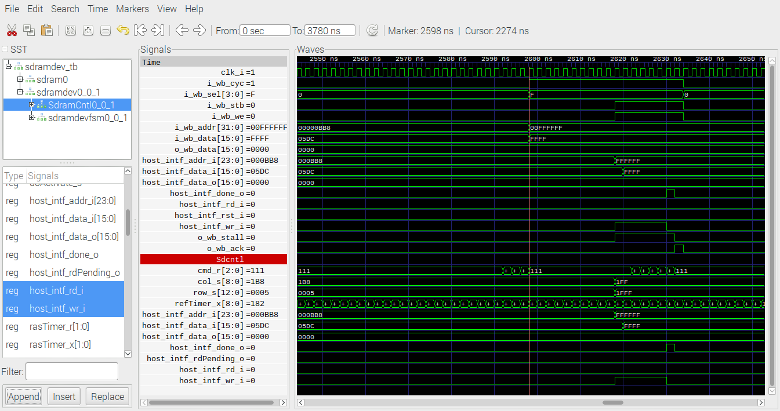

BANK 0 STATE : READING @ 2790
SDRAM : [READ] Commnad registered
BANK 0 STATE : READING FROM 01b8:440
STATE : [READ] Data Ready @ 2794 value : 1500
In the image below reading the value at address 0x00000BB8 3000 which was 0x05DC 1500.

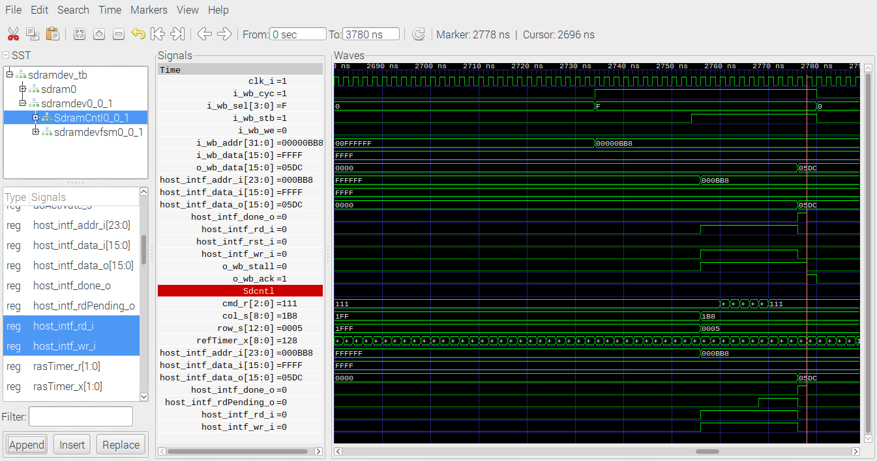

The memory_test takes approximately 3.5 sec or 175e6 clocks to complete at 50MHz. The memory_test writes to 16777215 locations and reads the data written.

Catboard running top.bin after the program has been load starting to write to memory during the memory_test

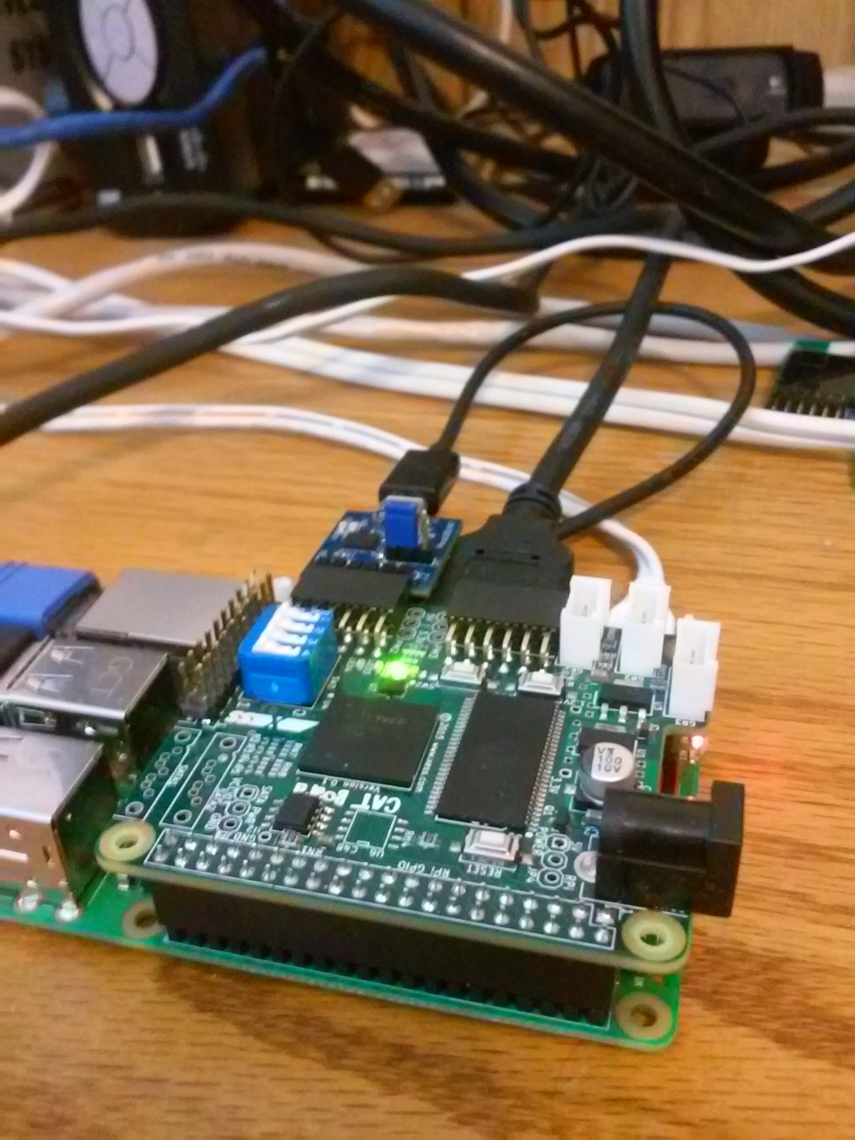

Catboard running top.bin after the program has been load starting to read from memory during the memory_test

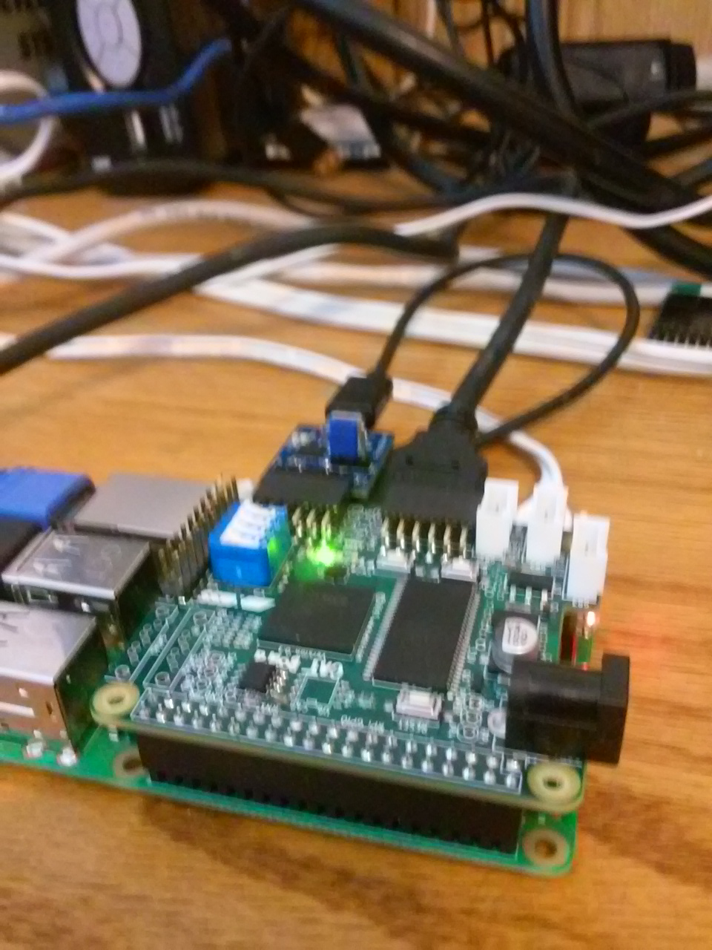

Catboard running top.bin after the program has been load and the end memory memory_test. Note all 4 leds are on.

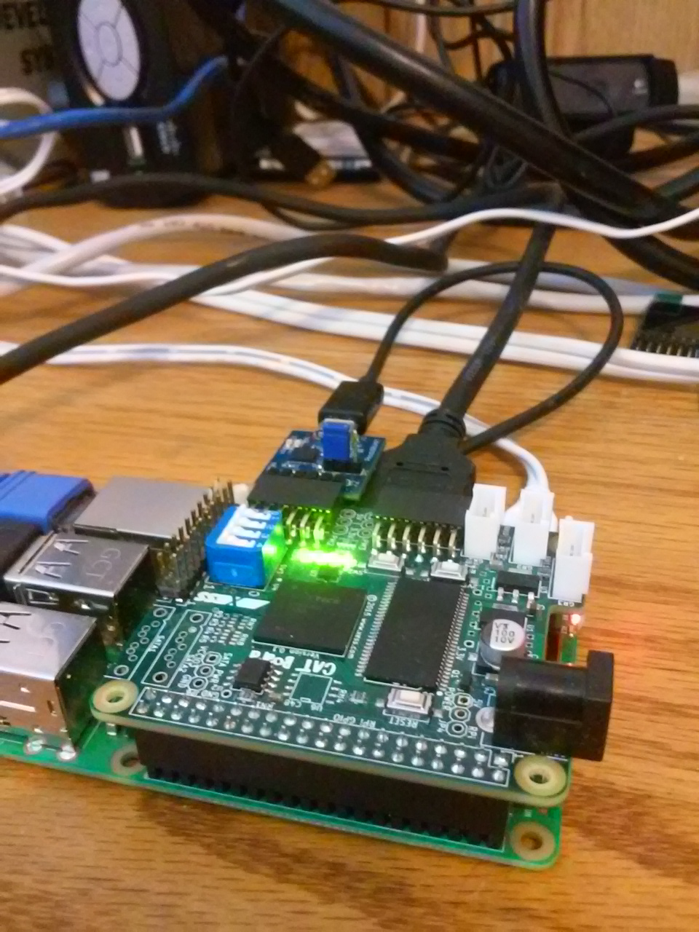

Now the sdram_test is memdev
module top (
clk100MHz,
sdram_clk,
sdram_return_clk,
led_status,
pb,
memdev0_SdramCntl0_sd_intf_cke,
memdev0_SdramCntl0_sd_intf_we,
memdev0_SdramCntl0_sd_intf_addr,
memdev0_SdramCntl0_sd_intf_dqml,
memdev0_SdramCntl0_sd_intf_cas,
memdev0_SdramCntl0_sd_intf_dqmh,
memdev0_SdramCntl0_sd_intf_ras,
memdev0_SdramCntl0_sd_intf_bs,
memdev0_SdramCntl0_sd_intf_cs,
memdev0_SdramCntl0_sd_intf_dq
);
=== top ===

Number of wires: 441
Number of wire bits: 968
Number of public wires: 84
Number of public wire bits: 537
Number of memories: 0
Number of memory bits: 0
Number of processes: 0
Number of cells: 719
$_TBUF_ 16
SB_CARRY 68
SB_DFF 4
SB_DFFE 4
SB_DFFER 98
SB_DFFES 1
SB_DFFESR 45
SB_DFFESS 4
SB_DFFR 52
SB_DFFS 8
SB_DFFSR 3
SB_DFFSS 4
SB_LUT4 412

Host interface signals
wire [23:0] memdev0_SdramCntl0_host_intf_addr_i;
wire [15:0] memdev0_SdramCntl0_host_intf_data_i;
wire [15:0] memdev0_SdramCntl0_host_intf_data_i;
wire [15:0] memdev0_SdramCntl0_host_intf_data_o;
wire memdev0_SdramCntl0_host_intf_done_o;
wire memdev0_SdramCntl0_host_intf_wr_i;
wire memdev0_memory_test0_host_intf_rst_i;

Write function
during a write
4 clks in between address chg
4 clks in between data chg
80 nsec
The 24 bit memdev0_SdramCntl0_host_intf_addr_i is set on the raising edge of clk. One clk later the 16 bit
memdev0_SdramCntl0_host_intf_data_i and memdev0_SdramCntl0_host_intf_wr_i goes hi. A clk later the memdev0_SdramCntl0_host_intf_done_o goes hi and the memdev0_SdramCntl0_host_intf_wr_i goes lo.

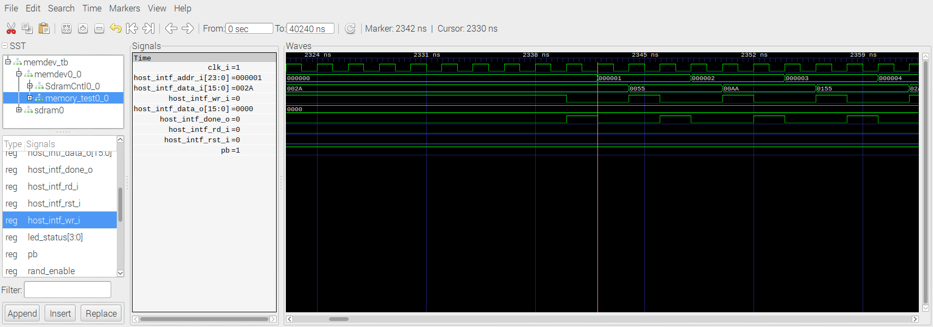
Read function

The 24 bit memdev0_SdramCntl0_host_intf_addr_i is set on the raising edge of clk. One clk later the 16 bit memdev0_SdramCntl0_host_intf_rd_i goes hi. Five clk later the memdev0_SdramCntl0_host_intf_done_o goes hi, memdev0_SdramCntl0_host_intf_data_o is valid and the memdev0_SdramCntl0_host_intf_rd_i goes lo.

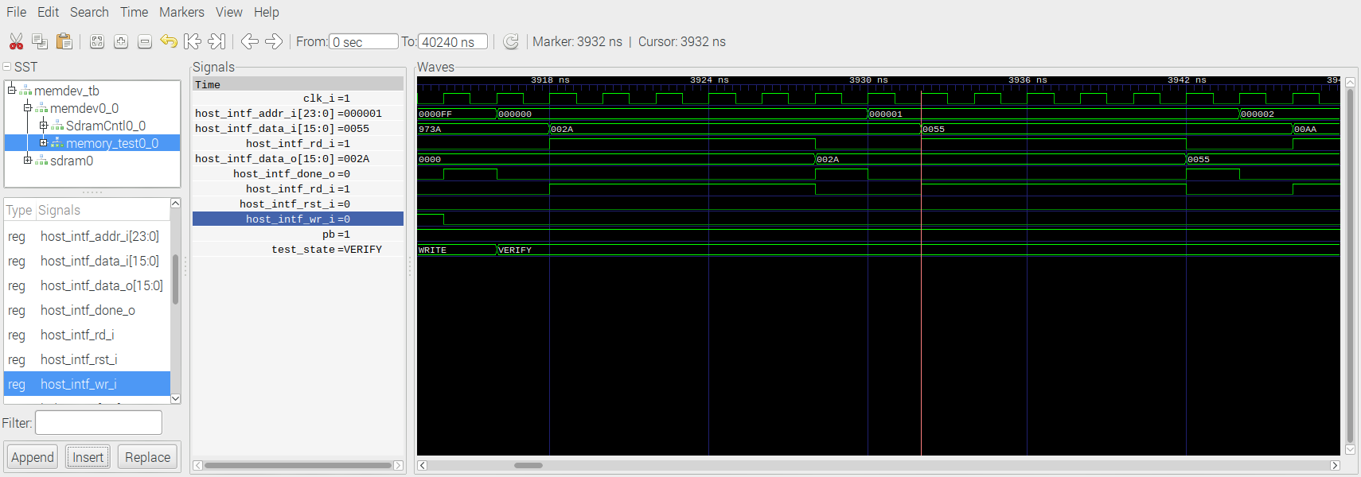
During the first part of the memory_test Write takes place.

python memdev.py

make
sudo config_cat top.bin

2^24 16777216 0x000000 0xFFFFFF 16Bits
@PREFIX=sdram
@DEVID=SDRAM
@$LGMEMSZ=24
@LGMEMSZ.FORMAT=%d
@$NADDR=(1<<(@$THIS.LGMEMSZ-2))
@$NBYTES=(1<<(@$THIS.LGMEMSZ))
@NBYTES.FORMAT=0x%08x
@ACCESS=@$(DEVID)_ACCESS
@SLAVE.TYPE=MEMORY
@SLAVE.BUS=wb
@LD.PERM=wx
#!/bin/bash

Appendix A: Script that executes the arm-wbregs commands sim_hw_test.sh

#!/bin/bash

echo "The date built"
./arm-wbregs version
sleep 2
./arm-wbregs 0x700 0x10000001
sleep 2
./arm-wbregs 0x704 0x10000002
sleep 2
./arm-wbregs 0x708 0x10000003
sleep 2
./arm-wbregs 0x70c 0x10000004
sleep 2
./arm-wbregs 0x700
sleep 2
./arm-wbregs 0x704
sleep 2
./arm-wbregs 0x708
sleep 2
./arm-wbregs 0x70c
sleep 2
echo "Turning on the 4th led "
./arm-wbregs gpio 0x00010001
sleep 2
echo "Turning on the 1st led "
./arm-wbregs gpio 0x00020002
sleep 2
echo "Turning on the 2nd led "
./arm-wbregs gpio 0x00040004
sleep 5
echo "Turning off the leds "
./arm-wbregs gpio 0x00070000

Appendix B: CATZIP testing the verilator simulation.
./arm-main_tb
Listening on port 8363
Listening on port 8364
Accepted CMD connection
POLL = 1
RCVD: 6 bytes
< A611R
> A00000611R20180812
POLL = 1
RCVD: 0 bytes
< [CLOSED]
Accepted CMD connection
POLL = 1
RCVD: 14 bytes
< A701W10000001
> A00000701
> K00000000
POLL = 1
RCVD: 0 bytes
< [CLOSED]
Accepted CMD connection
POLL = 1
RCVD: 14 bytes
< A705W10000002
> A00000705
> K00000000
POLL = 1
RCVD: 0 bytes
< [CLOSED]
Accepted CMD connection
POLL = 1
RCVD: 14 bytes
< A709W10000003
> A00000709
> K00000000
POLL = 1
RCVD: 0 bytes
< [CLOSED]
Accepted CMD connection
POLL = 1
RCVD: 14 bytes
< A70dW10000004
> A0000070d
> K00000000
POLL = 1
RCVD: 0 bytes
< [CLOSED]
Accepted CMD connection
POLL = 1
RCVD: 6 bytes
< A701R
> A00000701R10000001
POLL = 1
RCVD: 0 bytes
< [CLOSED]
Accepted CMD connection
POLL = 1
RCVD: 6 bytes
< A705R
> A00000705R10000002
POLL = 1
RCVD: 0 bytes
< [CLOSED]
Accepted CMD connection
POLL = 1
RCVD: 6 bytes
< A709R
> A00000709R10000003
POLL = 1
RCVD: 0 bytes
< [CLOSED]
Accepted CMD connection
POLL = 1
RCVD: 6 bytes
< A70dR
> A0000070dR10000004
POLL = 1
RCVD: 0 bytes
< [CLOSED]
Accepted CMD connection
POLL = 1
RCVD: 11 bytes
< A609W10001
> A00000609K00000000
POLL = 1
RCVD: 0 bytes
< [CLOSED]
Accepted CMD connection
POLL = 1
RCVD: 11 bytes
< A609W20002
> A00000609K00000000
POLL = 1
RCVD: 0 bytes
< [CLOSED]
Accepted CMD connection
POLL = 1
RCVD: 11 bytes
< A609W40004
> A00000609K00000000
POLL = 1
RCVD: 0 bytes
< [CLOSED]
Accepted CMD connection
POLL = 1
RCVD: 11 bytes
< A609W70000
> A00000609K00000000
POLL = 1
RCVD: 0 bytes
< [CLOSED]
> Z
CMD: Only sent 0 bytes of 3
^C
Appendix C: CATZIP testing the verilator simulation running wbregs command from the script
sim_hw_test.sh .
The date built
00000610 ( VERSION) : [....] 20180812
00000700 ( RAM)-> 10000001
00000704 ( )-> 10000002
00000708 ( )-> 10000003
0000070c ( )-> 10000004
00000700 ( RAM) : [....] 10000001
00000704 ( ) : [....] 10000002
00000708 ( ) : [....] 10000003
0000070c ( ) : [....] 10000004
Turning on the 4th led
00000608 ( GPIO)-> 00010001
Turning on the 1st led
00000608 ( GPIO)-> 00020002
Turning on the 2nd led
00000608 ( GPIO)-> 00040004
Turning off the leds
00000608 ( GPIO)-> 00070000
Chgs after adding sdcntl.txt & sdramdev.txt blkram move from 0x700 to 0x00800000
The date built
00600010 ( VERSION) : [....] 20180812
00800000 ( RAM)-> 10000001
00800004 ( )-> 10000002
00800008 ( )-> 10000003
0080000c ( )-> 10000004
00800000 ( RAM) : [....] 10000001
00800004 ( ) : [....] 10000002
00800008 ( ) : [....] 10000003
0080000c ( ) : [....] 10000004
Turning on the 4th led
00600008 ( GPIO)-> 00010001
Turning on the 1st led
00600008 ( GPIO)-> 00020002
Turning on the 2nd led
00600008 ( GPIO)-> 00040004
Turning off the leds
00600008 ( GPIO)-> 00070000

Appendix D: Disassemble of testbuilds/catzip_simulation/catzip/sim/verilated/arm-main_tb where the SDRAMSIM
00024654 <_ZN8SDRAMSIMclEiiiiiiijiss>:
2466c: 1a000004 bne 24684 <_ZN8SDRAMSIMclEiiiiiiijiss+0x30>
24678: 1a000002 bne 24688 <_ZN8SDRAMSIMclEiiiiiiijiss+0x34>
24680: ea00001e b 24700 <_ZN8SDRAMSIMclEiiiiiiijiss+0xac>
24698: 0a00001a beq 24708 <_ZN8SDRAMSIMclEiiiiiiijiss+0xb4>
246a4: ca0000c3 bgt 249b8 <_ZN8SDRAMSIMclEiiiiiiijiss+0x364>
246ac: 1a000034 bne 24784 <_ZN8SDRAMSIMclEiiiiiiijiss+0x130>
246c4: 1a000038 bne 247ac <_ZN8SDRAMSIMclEiiiiiiijiss+0x158>
246cc: 0a000031 beq 24798 <_ZN8SDRAMSIMclEiiiiiiijiss+0x144>
246d8: 0a00002e beq 24798 <_ZN8SDRAMSIMclEiiiiiiijiss+0x144>
246e4: 0a00002b beq 24798 <_ZN8SDRAMSIMclEiiiiiiijiss+0x144>
24708: e59f496c ldr r4, [pc, #2412] ; 2507c <_ZN8SDRAMSIMclEiiiiiiijiss+0xa28>
24718: e59f0960 ldr r0, [pc, #2400] ; 25080 <_ZN8SDRAMSIMclEiiiiiiijiss+0xa2c>
24724: e59f1958 ldr r1, [pc, #2392] ; 25084 <_ZN8SDRAMSIMclEiiiiiiijiss+0xa30>
24734: e59f194c ldr r1, [pc, #2380] ; 25088 <_ZN8SDRAMSIMclEiiiiiiijiss+0xa34>
24744: e59f1940 ldr r1, [pc, #2368] ; 2508c <_ZN8SDRAMSIMclEiiiiiiijiss+0xa38>
24754: e59f1934 ldr r1, [pc, #2356] ; 25090 <_ZN8SDRAMSIMclEiiiiiiijiss+0xa3c>
24764: e59f1928 ldr r1, [pc, #2344] ; 25094 <_ZN8SDRAMSIMclEiiiiiiijiss+0xa40>
24770: e59f3920 ldr r3, [pc, #2336] ; 25098 <_ZN8SDRAMSIMclEiiiiiiijiss+0xa44>
24778: e59f191c ldr r1, [pc, #2332] ; 2509c <_ZN8SDRAMSIMclEiiiiiiijiss+0xa48>
2477c: e59f091c ldr r0, [pc, #2332] ; 250a0 <_ZN8SDRAMSIMclEiiiiiiijiss+0xa4c>
24784: e59f390c ldr r3, [pc, #2316] ; 25098 <_ZN8SDRAMSIMclEiiiiiiijiss+0xa44>
2478c: e59f1908 ldr r1, [pc, #2312] ; 2509c <_ZN8SDRAMSIMclEiiiiiiijiss+0xa48>
24790: e59f090c ldr r0, [pc, #2316] ; 250a4 <_ZN8SDRAMSIMclEiiiiiiijiss+0xa50>
24798: e59f38f8 ldr r3, [pc, #2296] ; 25098 <_ZN8SDRAMSIMclEiiiiiiijiss+0xa44>
247a0: e59f18f4 ldr r1, [pc, #2292] ; 2509c <_ZN8SDRAMSIMclEiiiiiiijiss+0xa48>
247a4: e59f08fc ldr r0, [pc, #2300] ; 250a8 <_ZN8SDRAMSIMclEiiiiiiijiss+0xa54>
247b0: 0a000019 beq 2481c <_ZN8SDRAMSIMclEiiiiiiijiss+0x1c8>
247b8: 0a000028 beq 24860 <_ZN8SDRAMSIMclEiiiiiiijiss+0x20c>
247c0: 0a000042 beq 248d0 <_ZN8SDRAMSIMclEiiiiiiijiss+0x27c>
247c8: 0a000057 beq 2492c <_ZN8SDRAMSIMclEiiiiiiijiss+0x2d8>
247d0: 1affffc8 bne 246f8 <_ZN8SDRAMSIMclEiiiiiiijiss+0xa4>
247d8: 1a000071 bne 249a4 <_ZN8SDRAMSIMclEiiiiiiijiss+0x350>
247e0: 1a00006f bne 249a4 <_ZN8SDRAMSIMclEiiiiiiijiss+0x350>
247ec: 1a00006c bne 249a4 <_ZN8SDRAMSIMclEiiiiiiijiss+0x350>
247f8: 0a000069 beq 249a4 <_ZN8SDRAMSIMclEiiiiiiijiss+0x350>
24804: 1affffbb bne 246f8 <_ZN8SDRAMSIMclEiiiiiiijiss+0xa4>
24818: ea00005d b 24994 <_ZN8SDRAMSIMclEiiiiiiijiss+0x340>
24820: 1affffb4 bne 246f8 <_ZN8SDRAMSIMclEiiiiiiijiss+0xa4>
24828: 1affffb2 bne 246f8 <_ZN8SDRAMSIMclEiiiiiiijiss+0xa4>
24834: 0affffaf beq 246f8 <_ZN8SDRAMSIMclEiiiiiiijiss+0xa4>
24840: 1affffac bne 246f8 <_ZN8SDRAMSIMclEiiiiiiijiss+0xa4>
2485c: eaffffa5 b 246f8 <_ZN8SDRAMSIMclEiiiiiiijiss+0xa4>
24868: 1a000009 bne 24894 <_ZN8SDRAMSIMclEiiiiiiijiss+0x240>
2487c: aaffff9d bge 246f8 <_ZN8SDRAMSIMclEiiiiiiijiss+0xa4>
24884: e59f1820 ldr r1, [pc, #2080] ; 250ac <_ZN8SDRAMSIMclEiiiiiiijiss+0xa58>
24890: eafffff7 b 24874 <_ZN8SDRAMSIMclEiiiiiiijiss+0x220>
24898: 1a000007 bne 248bc <_ZN8SDRAMSIMclEiiiiiiijiss+0x268>
248a0: 1a000005 bne 248bc <_ZN8SDRAMSIMclEiiiiiiijiss+0x268>
248ac: 1a000002 bne 248bc <_ZN8SDRAMSIMclEiiiiiiijiss+0x268>
248b8: 1affff8e bne 246f8 <_ZN8SDRAMSIMclEiiiiiiijiss+0xa4>
248bc: e59f37d4 ldr r3, [pc, #2004] ; 25098 <_ZN8SDRAMSIMclEiiiiiiijiss+0xa44>
248c4: e59f17d0 ldr r1, [pc, #2000] ; 2509c <_ZN8SDRAMSIMclEiiiiiiijiss+0xa48>
248c8: e59f07e0 ldr r0, [pc, #2016] ; 250b0 <_ZN8SDRAMSIMclEiiiiiiijiss+0xa5c>
248d4: 1affff87 bne 246f8 <_ZN8SDRAMSIMclEiiiiiiijiss+0xa4>
248dc: 1affff85 bne 246f8 <_ZN8SDRAMSIMclEiiiiiiijiss+0xa4>
248e8: 1affff82 bne 246f8 <_ZN8SDRAMSIMclEiiiiiiijiss+0xa4>
248f4: 1affff7f bne 246f8 <_ZN8SDRAMSIMclEiiiiiiijiss+0xa4>
24900: 1a000004 bne 24918 <_ZN8SDRAMSIMclEiiiiiiijiss+0x2c4>
24914: eaffff77 b 246f8 <_ZN8SDRAMSIMclEiiiiiiijiss+0xa4>
24918: e59f3778 ldr r3, [pc, #1912] ; 25098 <_ZN8SDRAMSIMclEiiiiiiijiss+0xa44>
24920: e59f1774 ldr r1, [pc, #1908] ; 2509c <_ZN8SDRAMSIMclEiiiiiiijiss+0xa48>
24924: e59f0788 ldr r0, [pc, #1928] ; 250b4 <_ZN8SDRAMSIMclEiiiiiiijiss+0xa60>
24930: 0a000007 beq 24954 <_ZN8SDRAMSIMclEiiiiiiijiss+0x300>
2493c: 1a000009 bne 24968 <_ZN8SDRAMSIMclEiiiiiiijiss+0x314>
24950: eaffff68 b 246f8 <_ZN8SDRAMSIMclEiiiiiiijiss+0xa4>
24954: e59f373c ldr r3, [pc, #1852] ; 25098 <_ZN8SDRAMSIMclEiiiiiiijiss+0xa44>
2495c: e59f1738 ldr r1, [pc, #1848] ; 2509c <_ZN8SDRAMSIMclEiiiiiiijiss+0xa48>
24960: e59f0750 ldr r0, [pc, #1872] ; 250b8 <_ZN8SDRAMSIMclEiiiiiiijiss+0xa64>
2496c: 0affff61 beq 246f8 <_ZN8SDRAMSIMclEiiiiiiijiss+0xa4>
24970: e59f3720 ldr r3, [pc, #1824] ; 25098 <_ZN8SDRAMSIMclEiiiiiiijiss+0xa44>
24978: e59f171c ldr r1, [pc, #1820] ; 2509c <_ZN8SDRAMSIMclEiiiiiiijiss+0xa48>
2497c: e59f0738 ldr r0, [pc, #1848] ; 250bc <_ZN8SDRAMSIMclEiiiiiiijiss+0xa68>
24988: e59f171c ldr r1, [pc, #1820] ; 250ac <_ZN8SDRAMSIMclEiiiiiiijiss+0xa58>
2499c: bafffff8 blt 24984 <_ZN8SDRAMSIMclEiiiiiiijiss+0x330>
249a0: eaffff54 b 246f8 <_ZN8SDRAMSIMclEiiiiiiijiss+0xa4>
249a4: e59f36ec ldr r3, [pc, #1772] ; 25098 <_ZN8SDRAMSIMclEiiiiiiijiss+0xa44>
249ac: e59f16e8 ldr r1, [pc, #1768] ; 2509c <_ZN8SDRAMSIMclEiiiiiiijiss+0xa48>
249b0: e59f0708 ldr r0, [pc, #1800] ; 250c0 <_ZN8SDRAMSIMclEiiiiiiijiss+0xa6c>
249c4: aa000005 bge 249e0 <_ZN8SDRAMSIMclEiiiiiiijiss+0x38c>
249dc: eafffff6 b 249bc <_ZN8SDRAMSIMclEiiiiiiijiss+0x368>
249e4: ea000000 b 249ec <_ZN8SDRAMSIMclEiiiiiiijiss+0x398>
249f0: ca00001a bgt 24a60 <_ZN8SDRAMSIMclEiiiiiiijiss+0x40c>
24a2c: 0affffed beq 249e8 <_ZN8SDRAMSIMclEiiiiiiijiss+0x394>
24a48: aaffffe6 bge 249e8 <_ZN8SDRAMSIMclEiiiiiiijiss+0x394>
24a4c: e59f3644 ldr r3, [pc, #1604] ; 25098 <_ZN8SDRAMSIMclEiiiiiiijiss+0xa44>
24a54: e59f1640 ldr r1, [pc, #1600] ; 2509c <_ZN8SDRAMSIMclEiiiiiiijiss+0xa48>
24a58: e59f0664 ldr r0, [pc, #1636] ; 250c4 <_ZN8SDRAMSIMclEiiiiiiijiss+0xa70>
24a78: 0a000003 beq 24a8c <_ZN8SDRAMSIMclEiiiiiiijiss+0x438>
24a88: 0a000048 beq 24bb0 <_ZN8SDRAMSIMclEiiiiiiijiss+0x55c>
24a94: da000010 ble 24adc <_ZN8SDRAMSIMclEiiiiiiijiss+0x488>
24aa0: 0a00000d beq 24adc <_ZN8SDRAMSIMclEiiiiiiijiss+0x488>
24ac8: 1a000040 bne 24bd0 <_ZN8SDRAMSIMclEiiiiiiijiss+0x57c>
24af4: 1a000040 bne 24bfc <_ZN8SDRAMSIMclEiiiiiiijiss+0x5a8>
24b20: 1a000046 bne 24c40 <_ZN8SDRAMSIMclEiiiiiiijiss+0x5ec>
24b28: 1a000044 bne 24c40 <_ZN8SDRAMSIMclEiiiiiiijiss+0x5ec>
24b34: 1a000041 bne 24c40 <_ZN8SDRAMSIMclEiiiiiiijiss+0x5ec>
24b40: 0a00003e beq 24c40 <_ZN8SDRAMSIMclEiiiiiiijiss+0x5ec>
24b4c: e59f1558 ldr r1, [pc, #1368] ; 250ac <_ZN8SDRAMSIMclEiiiiiiijiss+0xa58>
24b74: 1a000022 bne 24c04 <_ZN8SDRAMSIMclEiiiiiiijiss+0x5b0>
24b80: 1a000024 bne 24c18 <_ZN8SDRAMSIMclEiiiiiiijiss+0x5c4>
24b8c: 1a000026 bne 24c2c <_ZN8SDRAMSIMclEiiiiiiijiss+0x5d8>
24b98: 0afffed8 beq 24700 <_ZN8SDRAMSIMclEiiiiiiijiss+0xac>
24b9c: e59f34f4 ldr r3, [pc, #1268] ; 25098 <_ZN8SDRAMSIMclEiiiiiiijiss+0xa44>
24ba4: e59f14f0 ldr r1, [pc, #1264] ; 2509c <_ZN8SDRAMSIMclEiiiiiiijiss+0xa48>
24ba8: e59f0518 ldr r0, [pc, #1304] ; 250c8 <_ZN8SDRAMSIMclEiiiiiiijiss+0xa74>
24bb0: e59f34c4 ldr r3, [pc, #1220] ; 2507c <_ZN8SDRAMSIMclEiiiiiiijiss+0xa28>
24bc0: e59f0504 ldr r0, [pc, #1284] ; 250cc <_ZN8SDRAMSIMclEiiiiiiijiss+0xa78>
24bd4: 0affffbd beq 24ad0 <_ZN8SDRAMSIMclEiiiiiiijiss+0x47c>
24be8: 0affffb8 beq 24ad0 <_ZN8SDRAMSIMclEiiiiiiijiss+0x47c>
24bf8: eaffffb4 b 24ad0 <_ZN8SDRAMSIMclEiiiiiiijiss+0x47c>
24c00: eaffffc0 b 24b08 <_ZN8SDRAMSIMclEiiiiiiijiss+0x4b4>
24c04: e59f348c ldr r3, [pc, #1164] ; 25098 <_ZN8SDRAMSIMclEiiiiiiijiss+0xa44>
24c0c: e59f1488 ldr r1, [pc, #1160] ; 2509c <_ZN8SDRAMSIMclEiiiiiiijiss+0xa48>
24c10: e59f04b8 ldr r0, [pc, #1208] ; 250d0 <_ZN8SDRAMSIMclEiiiiiiijiss+0xa7c>
24c18: e59f3478 ldr r3, [pc, #1144] ; 25098 <_ZN8SDRAMSIMclEiiiiiiijiss+0xa44>
24c20: e59f1474 ldr r1, [pc, #1140] ; 2509c <_ZN8SDRAMSIMclEiiiiiiijiss+0xa48>
24c24: e59f04a8 ldr r0, [pc, #1192] ; 250d4 <_ZN8SDRAMSIMclEiiiiiiijiss+0xa80>
24c2c: e59f3464 ldr r3, [pc, #1124] ; 25098 <_ZN8SDRAMSIMclEiiiiiiijiss+0xa44>
24c34: e59f1460 ldr r1, [pc, #1120] ; 2509c <_ZN8SDRAMSIMclEiiiiiiijiss+0xa48>
24c38: e59f0498 ldr r0, [pc, #1176] ; 250d8 <_ZN8SDRAMSIMclEiiiiiiijiss+0xa84>
24c44: 1a000025 bne 24ce0 <_ZN8SDRAMSIMclEiiiiiiijiss+0x68c>
24c4c: 1a000023 bne 24ce0 <_ZN8SDRAMSIMclEiiiiiiijiss+0x68c>
24c58: 0a000020 beq 24ce0 <_ZN8SDRAMSIMclEiiiiiiijiss+0x68c>
24c64: 1a00001d bne 24ce0 <_ZN8SDRAMSIMclEiiiiiiijiss+0x68c>
24c70: 0a00000b beq 24ca4 <_ZN8SDRAMSIMclEiiiiiiijiss+0x650>
24c7c: cafffe9f bgt 24700 <_ZN8SDRAMSIMclEiiiiiiijiss+0xac>
24ca0: eafffff3 b 24c74 <_ZN8SDRAMSIMclEiiiiiiijiss+0x620>
24cac: 1a000006 bne 24ccc <_ZN8SDRAMSIMclEiiiiiiijiss+0x678>
24cc8: eafffe8c b 24700 <_ZN8SDRAMSIMclEiiiiiiijiss+0xac>
24ccc: e59f33c4 ldr r3, [pc, #964] ; 25098 <_ZN8SDRAMSIMclEiiiiiiijiss+0xa44>
24cd4: e59f13c0 ldr r1, [pc, #960] ; 2509c <_ZN8SDRAMSIMclEiiiiiiijiss+0xa48>
24cd8: e59f03fc ldr r0, [pc, #1020] ; 250dc <_ZN8SDRAMSIMclEiiiiiiijiss+0xa88>
24ce4: 1a000032 bne 24db4 <_ZN8SDRAMSIMclEiiiiiiijiss+0x760>
24cec: 1a000030 bne 24db4 <_ZN8SDRAMSIMclEiiiiiiijiss+0x760>
24cf8: 0a00002d beq 24db4 <_ZN8SDRAMSIMclEiiiiiiijiss+0x760>
24d04: 0a00002a beq 24db4 <_ZN8SDRAMSIMclEiiiiiiijiss+0x760>
24d10: 1a000016 bne 24d70 <_ZN8SDRAMSIMclEiiiiiiijiss+0x71c>
24d28: 1a000019 bne 24d94 <_ZN8SDRAMSIMclEiiiiiiijiss+0x740>
24d50: e59f2388 ldr r2, [pc, #904] ; 250e0 <_ZN8SDRAMSIMclEiiiiiiijiss+0xa8c>
24d6c: eafffe63 b 24700 <_ZN8SDRAMSIMclEiiiiiiijiss+0xac>
24d78: e59f32fc ldr r3, [pc, #764] ; 2507c <_ZN8SDRAMSIMclEiiiiiiijiss+0xa28>
24d88: e59f0354 ldr r0, [pc, #852] ; 250e4 <_ZN8SDRAMSIMclEiiiiiiijiss+0xa90>
24d90: eaffffe5 b 24d2c <_ZN8SDRAMSIMclEiiiiiiijiss+0x6d8>
24d98: e59f1348 ldr r1, [pc, #840] ; 250e8 <_ZN8SDRAMSIMclEiiiiiiijiss+0xa94>
24d9c: e59f02d8 ldr r0, [pc, #728] ; 2507c <_ZN8SDRAMSIMclEiiiiiiijiss+0xa28>
24db0: eaffffdd b 24d2c <_ZN8SDRAMSIMclEiiiiiiijiss+0x6d8>
24db8: 1a00008a bne 24fe8 <_ZN8SDRAMSIMclEiiiiiiijiss+0x994>
24dc0: 0a000088 beq 24fe8 <_ZN8SDRAMSIMclEiiiiiiijiss+0x994>
24dcc: 1a000085 bne 24fe8 <_ZN8SDRAMSIMclEiiiiiiijiss+0x994>
24dd8: 1a00003c bne 24ed0 <_ZN8SDRAMSIMclEiiiiiiijiss+0x87c>
24de4: 1a00002a bne 24e94 <_ZN8SDRAMSIMclEiiiiiiijiss+0x840>
24dfc: 0a000029 beq 24ea8 <_ZN8SDRAMSIMclEiiiiiiijiss+0x854>
24e30: 0a000021 beq 24ebc <_ZN8SDRAMSIMclEiiiiiiijiss+0x868>
24e60: 0afffe26 beq 24700 <_ZN8SDRAMSIMclEiiiiiiijiss+0xac>
24e88: e59f3250 ldr r3, [pc, #592] ; 250e0 <_ZN8SDRAMSIMclEiiiiiiijiss+0xa8c>
24e90: eafffe1a b 24700 <_ZN8SDRAMSIMclEiiiiiiijiss+0xac>
24e94: e59f31fc ldr r3, [pc, #508] ; 25098 <_ZN8SDRAMSIMclEiiiiiiijiss+0xa44>
24e9c: e59f11f8 ldr r1, [pc, #504] ; 2509c <_ZN8SDRAMSIMclEiiiiiiijiss+0xa48>
24ea0: e59f0234 ldr r0, [pc, #564] ; 250dc <_ZN8SDRAMSIMclEiiiiiiijiss+0xa88>
24ea8: e59f31e8 ldr r3, [pc, #488] ; 25098 <_ZN8SDRAMSIMclEiiiiiiijiss+0xa44>
24eb0: e59f11e4 ldr r1, [pc, #484] ; 2509c <_ZN8SDRAMSIMclEiiiiiiijiss+0xa48>
24eb4: e59f0230 ldr r0, [pc, #560] ; 250ec <_ZN8SDRAMSIMclEiiiiiiijiss+0xa98>
24ebc: e59f31d4 ldr r3, [pc, #468] ; 25098 <_ZN8SDRAMSIMclEiiiiiiijiss+0xa44>
24ec4: e59f11d0 ldr r1, [pc, #464] ; 2509c <_ZN8SDRAMSIMclEiiiiiiijiss+0xa48>
24ec8: e59f0220 ldr r0, [pc, #544] ; 250f0 <_ZN8SDRAMSIMclEiiiiiiijiss+0xa9c>
24ed8: 1a000033 bne 24fac <_ZN8SDRAMSIMclEiiiiiiijiss+0x958>
24ef0: 0a000032 beq 24fc0 <_ZN8SDRAMSIMclEiiiiiiijiss+0x96c>
24f04: e59f21e8 ldr r2, [pc, #488] ; 250f4 <_ZN8SDRAMSIMclEiiiiiiijiss+0xaa0>
24f28: 1a000029 bne 24fd4 <_ZN8SDRAMSIMclEiiiiiiijiss+0x980>
24f7c: 0afffddf beq 24700 <_ZN8SDRAMSIMclEiiiiiiijiss+0xac>
24fa0: e59f3138 ldr r3, [pc, #312] ; 250e0 <_ZN8SDRAMSIMclEiiiiiiijiss+0xa8c>
24fa8: eafffdd4 b 24700 <_ZN8SDRAMSIMclEiiiiiiijiss+0xac>
24fac: e59f30e4 ldr r3, [pc, #228] ; 25098 <_ZN8SDRAMSIMclEiiiiiiijiss+0xa44>
24fb4: e59f10e0 ldr r1, [pc, #224] ; 2509c <_ZN8SDRAMSIMclEiiiiiiijiss+0xa48>
24fb8: e59f011c ldr r0, [pc, #284] ; 250dc <_ZN8SDRAMSIMclEiiiiiiijiss+0xa88>
24fc0: e59f30d0 ldr r3, [pc, #208] ; 25098 <_ZN8SDRAMSIMclEiiiiiiijiss+0xa44>
24fc8: e59f10cc ldr r1, [pc, #204] ; 2509c <_ZN8SDRAMSIMclEiiiiiiijiss+0xa48>
24fcc: e59f0118 ldr r0, [pc, #280] ; 250ec <_ZN8SDRAMSIMclEiiiiiiijiss+0xa98>
24fd4: e59f30bc ldr r3, [pc, #188] ; 25098 <_ZN8SDRAMSIMclEiiiiiiijiss+0xa44>
24fdc: e59f10b8 ldr r1, [pc, #184] ; 2509c <_ZN8SDRAMSIMclEiiiiiiijiss+0xa48>
24fe0: e59f0110 ldr r0, [pc, #272] ; 250f8 <_ZN8SDRAMSIMclEiiiiiiijiss+0xaa4>
24fec: 1afffdc3 bne 24700 <_ZN8SDRAMSIMclEiiiiiiijiss+0xac>
24ff4: 0a000005 beq 25010 <_ZN8SDRAMSIMclEiiiiiiijiss+0x9bc>
25000: 0a000002 beq 25010 <_ZN8SDRAMSIMclEiiiiiiijiss+0x9bc>
2500c: 1afffdbb bne 24700 <_ZN8SDRAMSIMclEiiiiiiijiss+0xac>
25010: e59f4064 ldr r4, [pc, #100] ; 2507c <_ZN8SDRAMSIMclEiiiiiiijiss+0xa28>
25020: e59f00d4 ldr r0, [pc, #212] ; 250fc <_ZN8SDRAMSIMclEiiiiiiijiss+0xaa8>
2502c: e59f1054 ldr r1, [pc, #84] ; 25088 <_ZN8SDRAMSIMclEiiiiiiijiss+0xa34>
2503c: e59f1048 ldr r1, [pc, #72] ; 2508c <_ZN8SDRAMSIMclEiiiiiiijiss+0xa38>
2504c: e59f103c ldr r1, [pc, #60] ; 25090 <_ZN8SDRAMSIMclEiiiiiiijiss+0xa3c>
2505c: e59f1030 ldr r1, [pc, #48] ; 25094 <_ZN8SDRAMSIMclEiiiiiiijiss+0xa40>
25068: e59f3028 ldr r3, [pc, #40] ; 25098 <_ZN8SDRAMSIMclEiiiiiiijiss+0xa44>
25070: e59f1024 ldr r1, [pc, #36] ; 2509c <_ZN8SDRAMSIMclEiiiiiiijiss+0xa48>
25074: e59f0084 ldr r0, [pc, #132] ; 25100 <_ZN8SDRAMSIMclEiiiiiiijiss+0xaac>

