********************Draft********************
LogicAnalyzer
10/26/26
********************Draft********************

devel@pi5-90:~/Downloads/logic-ana $ ls -la LogicAnalyzer
-rwxrwxrwx 1 devel devel 72544 Feb 1 2025 LogicAnalyzer

devel@pi5-90:~/Downloads/logic-ana $ shasum LogicAnalyzer
a1e4c29e24281a9130d7b920428a36df8d9bc678 LogicAnalyzer

devel@pi5-90:~/Downloads/logic-ana-uf2-files $ ls ../logic-ana-zip-files/
all-in-one_v6.0.0.0-linux-arm64.zip
logic-analyzer-firmware_v6.0.0_BOARD_PICO_2.zip
logic-analyzer-firmware_v6.0.0_BOARD_PICO.zip

devel@pi5-90:~/Downloads/logic-ana-uf2-files $ shasum *.uf2
7b6560f65293cb46d48c35082840644bc3d037c7 logic-analyzer-firmware_v6.0.0_BOARD_PICO_2.uf2
66d821fd7da3a750fbb0b8944c1fd0db5e7a458a logic-analyzer-firmware_v6.0.0_BOARD_PICO.uf2

devel@pi5-90:~/Downloads/logic-ana-uf2-files $ mkdir logic-ana-uf2-files
devel@pi5-90:~/Downloads/logic-ana-uf2-files $ ls
logic-analyzer-firmware_v6.0.0_BOARD_PICO_2.uf2
logic-analyzer-firmware_v6.0.0_BOARD_PICO.uf2
devel@pi5-90:~/Downloads/logic-ana $ unzip all-in-one_v6.0.0.0-linux-arm64.zip

devel@pi5-90:~/Downloads/logic-ana $ sudo ./LogicAnalyzer

forked from gusmanb/logicanalyzer
created test-dev branch

https://github.com/develone/logicanalyzer.git

Note:
devel@pi5-70:~/master-repos/logicanalyzer $ git push
Enumerating objects: 10, done.
Counting objects: 100% (10/10), done.
Delta compression using up to 4 threads
Compressing objects: 100% (9/9), done.
Writing objects: 100% (9/9), 50.55 MiB | 1.02 MiB/s, done.
Total 9 (delta 1), reused 0 (delta 0), pack-reused 0
remote: Resolving deltas: 100% (1/1), completed with 1 local object.
remote: warning: See https://gh.io/lfs for more information.
remote: warning: File logic-ana-zip-files/all-in-one_v6.0.0.0-linux-arm64.zip is 50.98 MB; this is larger than GitHub's recommended maximum file size of 50.00 MB
remote: warning: GH001: Large files detected. You may want to try Git Large File Storage - https://git-lfs.github.com.
To github.com:develone/logicanalyzer.git
4e88df7..7a2804e test-dev -> test-dev

devel@pi5-70:~/master-repos $ git clone -b test-dev git@github.com:develone/logicanalyzer.git

Video1 https://youtu.be/HFjRKLNqP-8?
Video2 https://www.youtube.com/watch?v=Obd1PiW7RO8

devel@pi5-90:~/Downloads/logic-ana $ sudo ./LogicAnalyzer

pg1

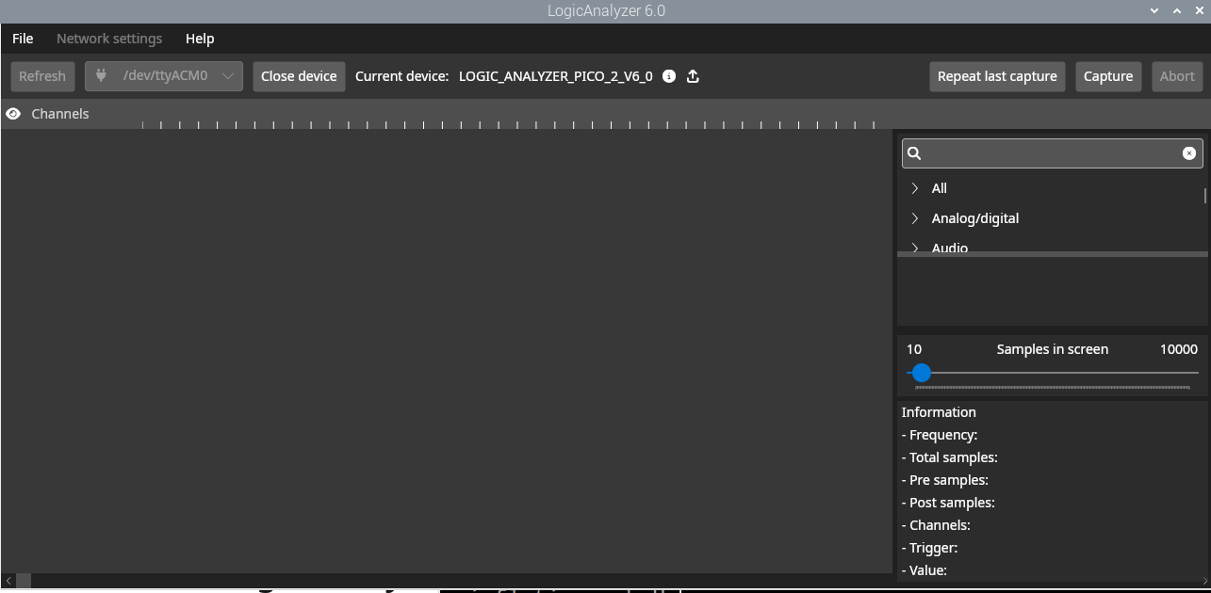
Basic Information
The version providess
Eight Channels 393216 samples
Sixteen Channels 196608 samples
Twenty-four Channels 98304 samples

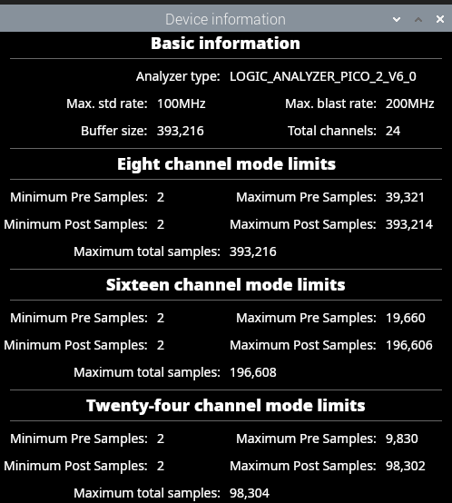
Capture Settings
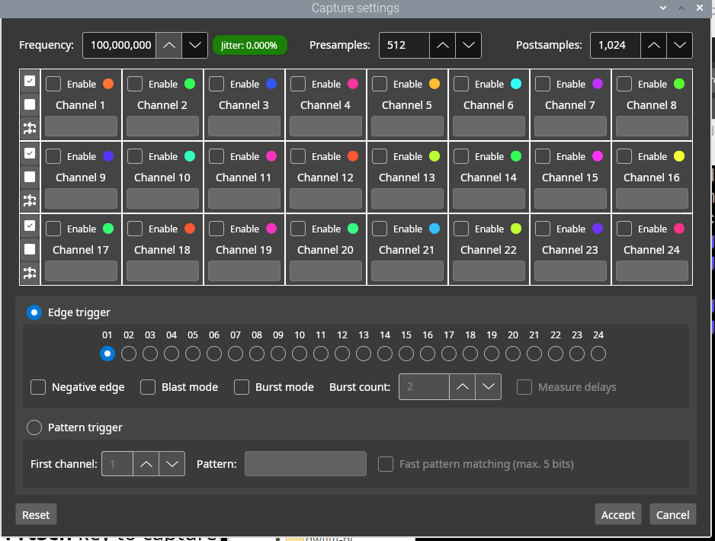
Capture Settings

