************Draft************
GATT_Server VGA testing
with logicAnalyer 6.0.0
by
Dr. Agustín Gimenez Bernad
10/26/26
************Draft************
Programmed a pico2 with logic-analyzer-firmware_v6.0.0_BOARD_PICO.uf2

Programmed a pico2_w with GATT_Server.uf2 which is Bluetooth Server with VGA.
Initial test are 4 signals Vsync, Hsync, red, and blue.

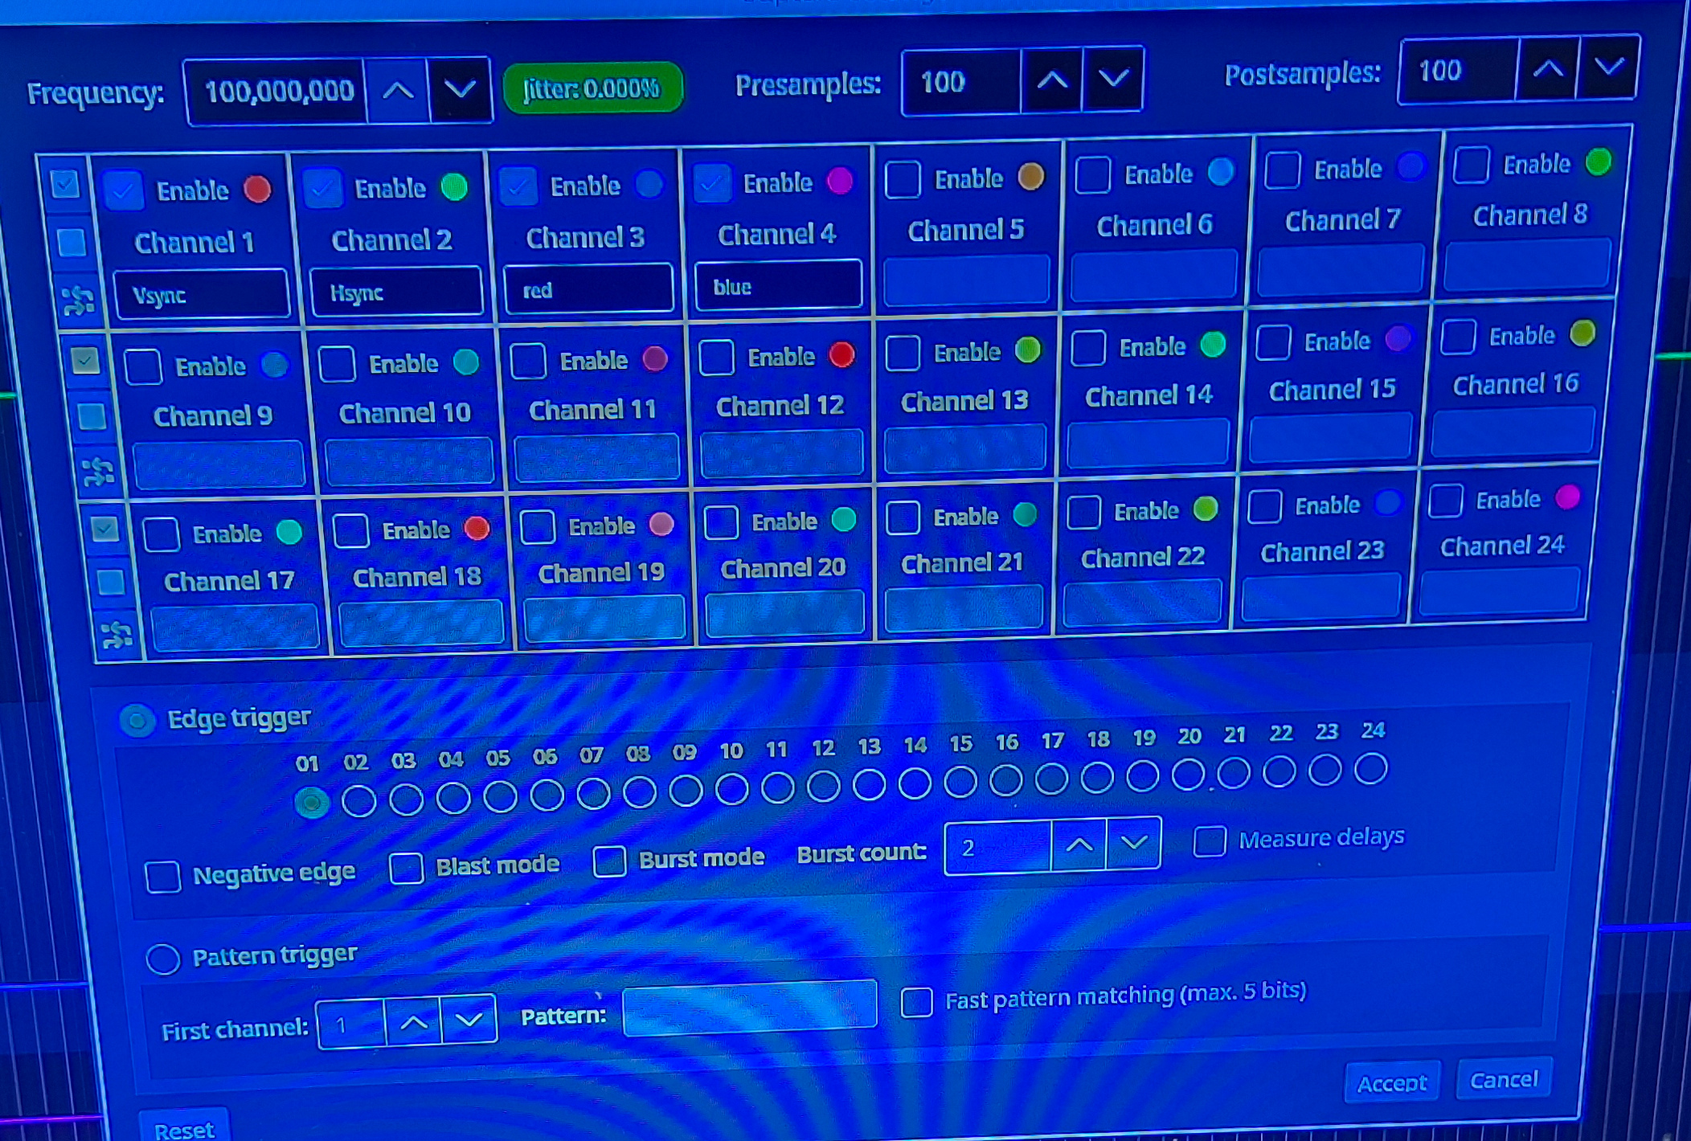
This was not working until I connected a Digilent VGA pmod instead of 3 330 ohm resistors.

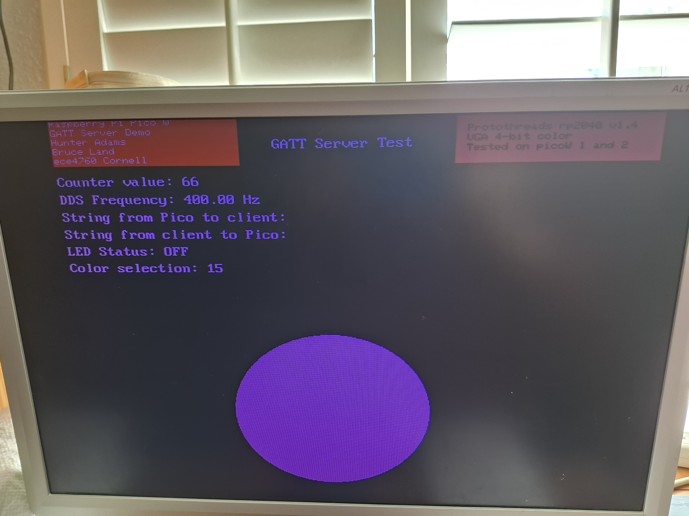
VGA GATT_Server.

The trigger was the Vsync. The blue signal went hi after the Hsync.
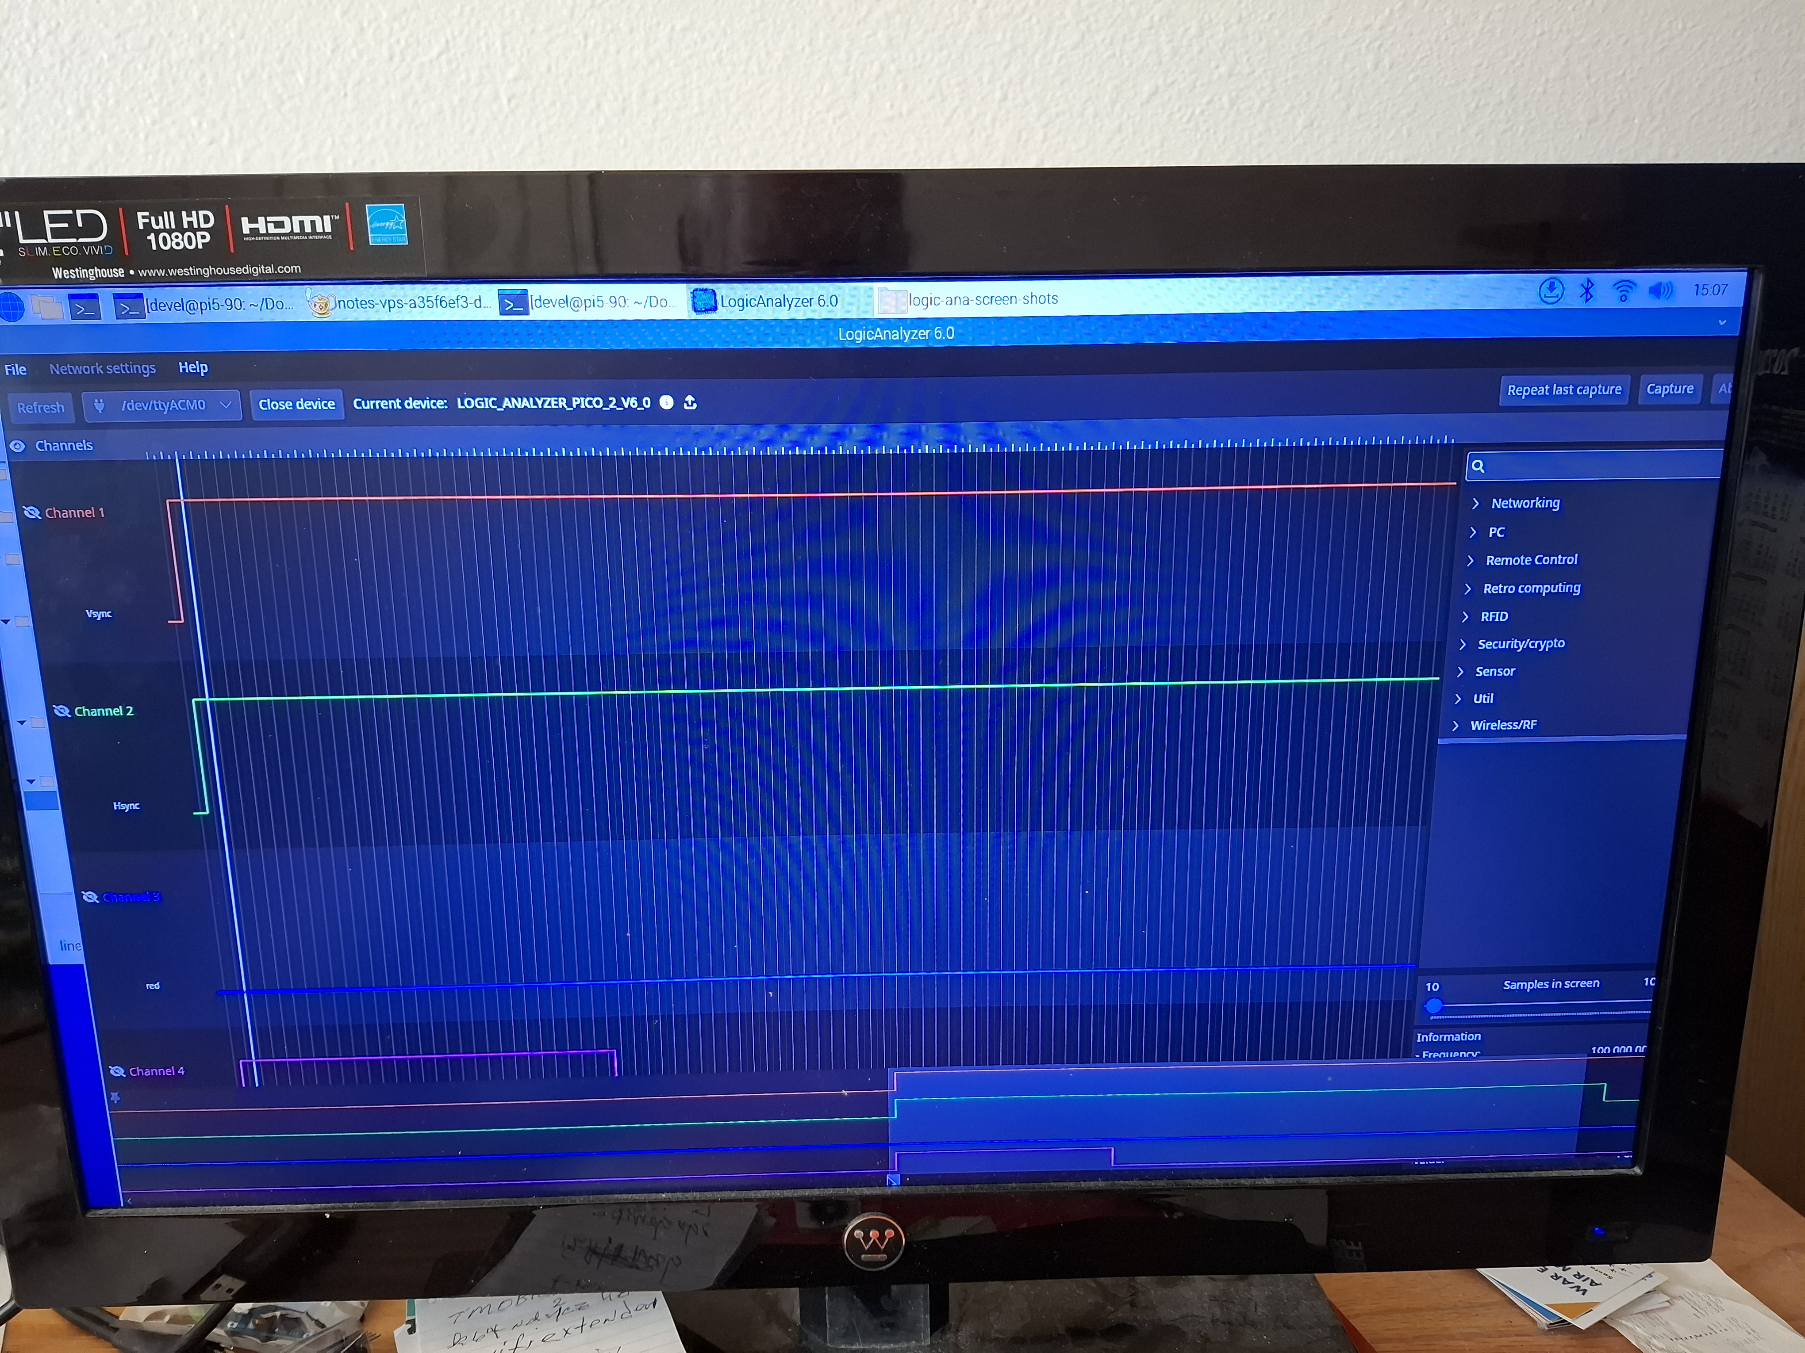
xx

