Ml-nn
notes-ml-nn.txt
07/13/21

Using the .ssh/id_rsa.pub to create the github key.

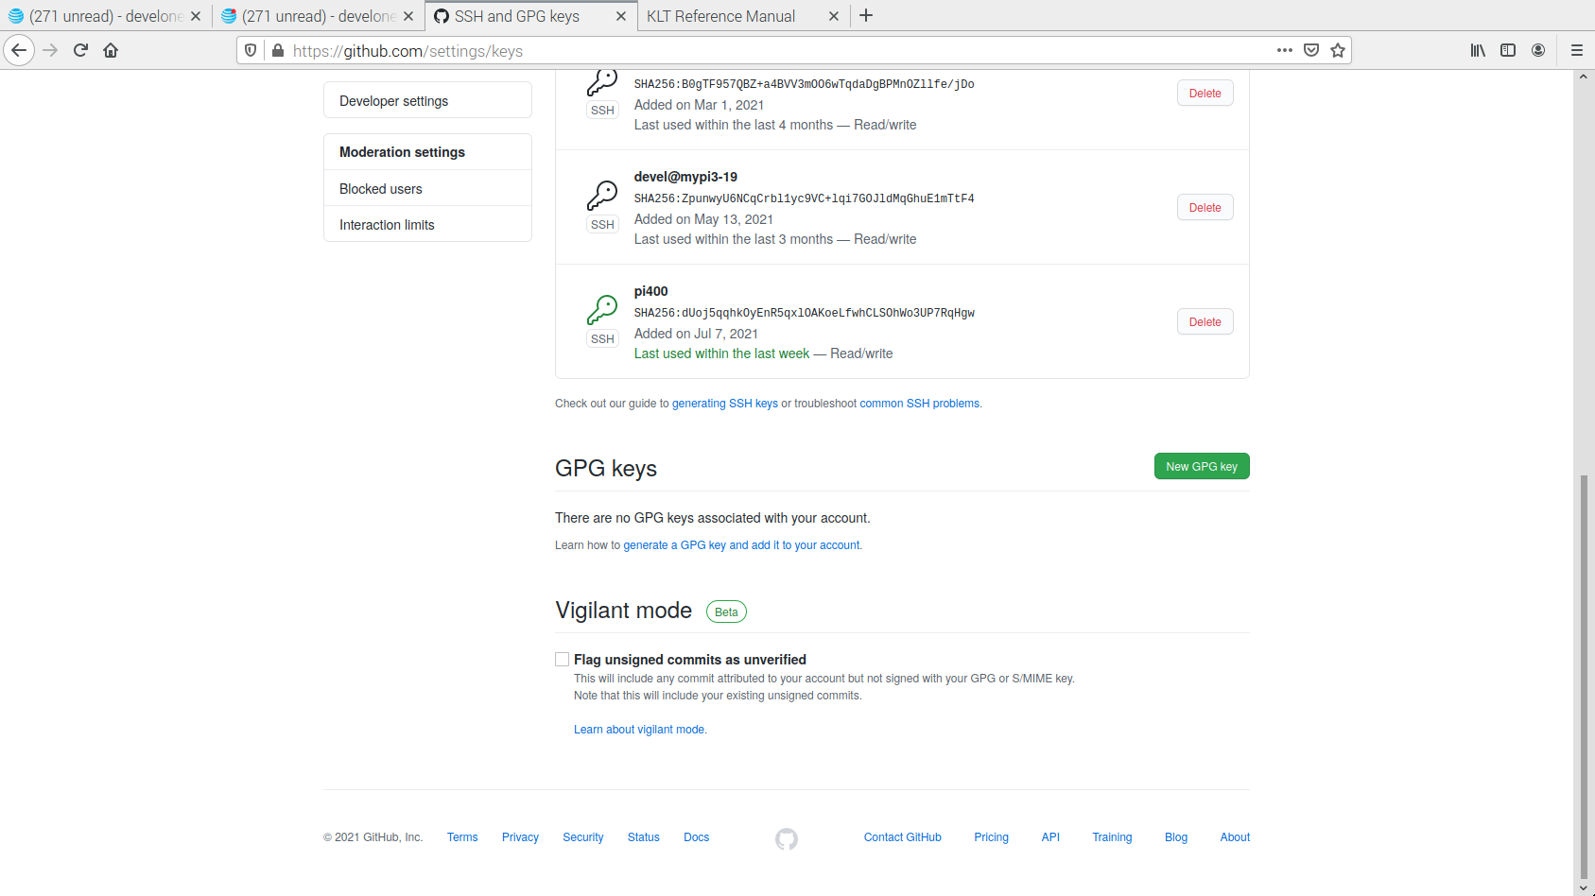
created a new repo

devel@pi400-1:~/klt-feature-detect $ git log
commit 925cf5b48b023317c61615e41e9dca24e20a57e9 (HEAD -> master, origin/master)
Author: Ed Vidal Jr <develone@sbcglobal.net>
Date: Wed Jul 14 06:27:35 2021 -0600

These are the files extracted klt1.3.4.zip downloaded from
https://cecas.clemson.edu/~stb/klt/ref/index.html

devel@pi400-1:~/klt-feature-detect $ less .git/config
[core]
repositoryformatversion = 0
filemode = true
bare = false
logallrefupdates = true
[remote "origin"]
url = git@github.com:develone/klt-feature-detect.git
fetch = +refs/heads/*:refs/remotes/origin/*
[branch "master"]
remote = origin
merge = refs/heads/master

cd klt-feature-detect/klt/

Coompile the code.

devel@pi400-1:~/klt-feature-detect/klt $ make
gcc -c -DNDEBUG convolve.c
gcc -c -DNDEBUG error.c
gcc -c -DNDEBUG pnmio.c
gcc -c -DNDEBUG pyramid.c
gcc -c -DNDEBUG selectGoodFeatures.c
gcc -c -DNDEBUG storeFeatures.c
gcc -c -DNDEBUG trackFeatures.c
gcc -c -DNDEBUG klt.c
gcc -c -DNDEBUG klt_util.c
gcc -c -DNDEBUG writeFeatures.c
rm -f libklt.a
ar ruv libklt.a convolve.o error.o pnmio.o pyramid.o selectGoodFeatures.o storeFeatures.o trackFeatures.o klt.o klt_util.o writeFeatures.o
ar: `u' modifier ignored since `D' is the default (see `U')
ar: creating libklt.a
a - convolve.o
a - error.o
a - pnmio.o
a - pyramid.o
a - selectGoodFeatures.o
a - storeFeatures.o
a - trackFeatures.o
a - klt.o
a - klt_util.o
a - writeFeatures.o
rm -f *.o
gcc -O3 -DNDEBUG -o example1 example1.c -L. -lklt -L/usr/local/lib -L/usr/lib -lm
gcc -O3 -DNDEBUG -o example2 example2.c -L. -lklt -L/usr/local/lib -L/usr/lib -lm
gcc -O3 -DNDEBUG -o example3 example3.c -L. -lklt -L/usr/local/lib -L/usr/lib -lm
gcc -O3 -DNDEBUG -o example4 example4.c -L. -lklt -L/usr/local/lib -L/usr/lib -lm
gcc -O3 -DNDEBUG -o example5 example5.c -L. -lklt -L/usr/local/lib -L/usr/lib -lm

Test the first example.

devel@pi400-1:~/klt-feature-detect/klt $ ./example1

Tracking context:

mindist = 10
window_width = 7
window_height = 7
sequentialMode = FALSE
smoothBeforeSelecting = TRUE
writeInternalImages = FALSE
min_eigenvalue = 1
min_determinant = 0.010000
min_displacement = 0.100000
max_iterations = 10
max_residue = 10.000000
grad_sigma = 1.000000
smooth_sigma_fact = 0.100000
pyramid_sigma_fact = 0.900000
nSkippedPixels = 0
borderx = 24
bordery = 24
nPyramidLevels = 2
subsampling = 4

pyramid_last = NULL
pyramid_last_gradx = NULL
pyramid_last_grady = NULL

(KLT) Selecting the 100 best features from a 320 by 240 image...
100 features found.

In first image:
Feature #0: (86.000000,71.000000) with value of 30785
Feature #1: (25.000000,137.000000) with value of 26254
Feature #2: (257.000000,97.000000) with value of 26179
Feature #3: (247.000000,89.000000) with value of 23658
Feature #4: (274.000000,73.000000) with value of 23339
Feature #5: (98.000000,138.000000) with value of 22970
Feature #6: (281.000000,146.000000) with value of 22602
Feature #7: (261.000000,73.000000) with value of 21562
Feature #8: (241.000000,72.000000) with value of 20968
Feature #9: (98.000000,117.000000) with value of 20894
Feature #10: (271.000000,92.000000) with value of 20086
Feature #11: (260.000000,145.000000) with value of 18628
Feature #12: (251.000000,73.000000) with value of 18466
Feature #13: (290.000000,196.000000) with value of 18380
Feature #14: (150.000000,122.000000) with value of 16856
Feature #15: (292.000000,84.000000) with value of 16443
Feature #16: (284.000000,74.000000) with value of 16180
Feature #17: (138.000000,122.000000) with value of 15954
Feature #18: (173.000000,189.000000) with value of 15545
Feature #19: (111.000000,112.000000) with value of 15398
Feature #20: (282.000000,89.000000) with value of 14747
Feature #21: (112.000000,141.000000) with value of 14339
Feature #22: (258.000000,109.000000) with value of 14158
Feature #23: (94.000000,166.000000) with value of 13366
Feature #24: (92.000000,90.000000) with value of 13192
Feature #25: (291.000000,113.000000) with value of 12843
Feature #26: (142.000000,98.000000) with value of 12619
Feature #27: (94.000000,177.000000) with value of 12395
Feature #28: (118.000000,59.000000) with value of 12295
Feature #29: (113.000000,213.000000) with value of 11954
Feature #30: (151.000000,60.000000) with value of 11689
Feature #31: (94.000000,148.000000) with value of 11458
Feature #32: (131.000000,207.000000) with value of 11096
Feature #33: (287.000000,160.000000) with value of 10966
Feature #34: (102.000000,214.000000) with value of 10641
Feature #35: (268.000000,106.000000) with value of 10529
Feature #36: (52.000000,64.000000) with value of 10204
Feature #37: (160.000000,195.000000) with value of 10007
Feature #38: (157.000000,103.000000) with value of 9594
Feature #39: (277.000000,203.000000) with value of 9170
Feature #40: (254.000000,184.000000) with value of 9137
Feature #41: (204.000000,37.000000) with value of 8690
Feature #42: (277.000000,214.000000) with value of 7976
Feature #43: (203.000000,70.000000) with value of 7886
Feature #44: (139.000000,58.000000) with value of 7794
Feature #45: (288.000000,215.000000) with value of 7778
Feature #46: (162.000000,60.000000) with value of 7748
Feature #47: (260.000000,210.000000) with value of 7459
Feature #48: (92.000000,104.000000) with value of 7224
Feature #49: (222.000000,200.000000) with value of 7133
Feature #50: (133.000000,154.000000) with value of 6685
Feature #51: (263.000000,128.000000) with value of 6230
Feature #52: (62.000000,139.000000) with value of 6219
Feature #53: (204.000000,198.000000) with value of 6211
Feature #54: (73.000000,128.000000) with value of 6004
Feature #55: (284.000000,130.000000) with value of 5975
Feature #56: (183.000000,47.000000) with value of 5903
Feature #57: (292.000000,94.000000) with value of 5782
Feature #58: (82.000000,188.000000) with value of 5408
Feature #59: (55.000000,150.000000) with value of 5367
Feature #60: (56.000000,127.000000) with value of 4999
Feature #61: (183.000000,115.000000) with value of 4869
Feature #62: (249.000000,204.000000) with value of 4679
Feature #63: (170.000000,204.000000) with value of 4468
Feature #64: (232.000000,202.000000) with value of 4449
Feature #65: (75.000000,150.000000) with value of 4414
Feature #66: (225.000000,57.000000) with value of 4402
Feature #67: (111.000000,131.000000) with value of 4337
Feature #68: (184.000000,101.000000) with value of 4184
Feature #69: (76.000000,138.000000) with value of 4167
Feature #70: (43.000000,116.000000) with value of 4050
Feature #71: (137.000000,77.000000) with value of 3854
Feature #72: (257.000000,87.000000) with value of 3842
Feature #73: (255.000000,165.000000) with value of 3596
Feature #74: (225.000000,212.000000) with value of 3560
Feature #75: (32.000000,71.000000) with value of 3534
Feature #76: (104.000000,151.000000) with value of 3520
Feature #77: (160.000000,118.000000) with value of 3401
Feature #78: (72.000000,188.000000) with value of 3349
Feature #79: (121.000000,115.000000) with value of 3281
Feature #80: (121.000000,203.000000) with value of 3278
Feature #81: (222.000000,71.000000) with value of 3261
Feature #82: (237.000000,212.000000) with value of 3236
Feature #83: (95.000000,42.000000) with value of 3223
Feature #84: (281.000000,115.000000) with value of 3171
Feature #85: (31.000000,105.000000) with value of 3129
Feature #86: (203.000000,187.000000) with value of 3114
Feature #87: (152.000000,90.000000) with value of 3112
Feature #88: (168.000000,70.000000) with value of 2979
Feature #89: (76.000000,173.000000) with value of 2897
Feature #90: (138.000000,88.000000) with value of 2814
Feature #91: (88.000000,213.000000) with value of 2768
Feature #92: (184.000000,87.000000) with value of 2712
Feature #93: (52.000000,140.000000) with value of 2658
Feature #94: (245.000000,101.000000) with value of 2561
Feature #95: (226.000000,40.000000) with value of 2561
Feature #96: (82.000000,198.000000) with value of 2527
Feature #97: (215.000000,190.000000) with value of 2506
Feature #98: (169.000000,129.000000) with value of 2406
Feature #99: (134.000000,197.000000) with value of 2403
(KLT) Writing 100 features to PPM file: 'feat1.ppm'
(KLT) Writing feature list to text file: 'feat1.txt'
(KLT) Tracking 100 features in a 320 by 240 image...
92 features successfully tracked.

In second image:
Feature #0: (81.302605,70.944870) with value of 0
Feature #1: (-1.000000,-1.000000) with value of -4
Feature #2: (254.788879,97.014748) with value of 0
Feature #3: (244.883026,88.973701) with value of 0
Feature #4: (271.856445,72.978897) with value of 0
Feature #5: (95.021667,137.890747) with value of 0
Feature #6: (277.132172,145.989700) with value of 0
Feature #7: (258.880585,72.965683) with value of 0
Feature #8: (238.868896,71.956512) with value of 0
Feature #9: (94.967659,116.965111) with value of 0
Feature #10: (268.881744,92.020027) with value of 0
Feature #11: (256.343811,144.964600) with value of 0
Feature #12: (248.889450,72.987656) with value of 0
Feature #13: (286.188477,196.226318) with value of 0
Feature #14: (147.814362,121.970627) with value of 0
Feature #15: (287.881714,84.073189) with value of 0
Feature #16: (-1.000000,-1.000000) with value of -5
Feature #17: (135.421371,122.046097) with value of 0
Feature #18: (168.281799,188.875595) with value of 0
Feature #19: (108.030823,111.970757) with value of 0
Feature #20: (-1.000000,-1.000000) with value of -5
Feature #21: (109.104355,140.874344) with value of 0
Feature #22: (255.896729,109.032486) with value of 0
Feature #23: (89.426338,165.949585) with value of 0
Feature #24: (87.377823,89.914398) with value of 0
Feature #25: (286.920074,113.012115) with value of 0
Feature #26: (139.849060,97.929680) with value of 0
Feature #27: (89.476891,176.953064) with value of 0
Feature #28: (-1.000000,-1.000000) with value of -5
Feature #29: (109.148315,212.872894) with value of 0
Feature #30: (148.834564,60.006748) with value of 0
Feature #31: (-1.000000,-1.000000) with value of -5
Feature #32: (126.911720,206.862915) with value of 0
Feature #33: (283.166748,160.222382) with value of 0
Feature #34: (98.148972,213.838562) with value of 0
Feature #35: (265.895355,106.037094) with value of 0
Feature #36: (49.456223,63.923912) with value of 0
Feature #37: (155.356796,194.910217) with value of 0
Feature #38: (154.875259,102.944420) with value of 0
Feature #39: (271.972382,203.133194) with value of 0
Feature #40: (250.653229,184.177277) with value of 0
Feature #41: (202.943558,37.043285) with value of 0
Feature #42: (271.932800,214.117355) with value of 0
Feature #43: (201.899460,69.959465) with value of 0
Feature #44: (136.726578,58.020802) with value of 0
Feature #45: (-1.000000,-1.000000) with value of -4
Feature #46: (159.854385,60.019398) with value of 0
Feature #47: (254.867065,210.106445) with value of 0
Feature #48: (87.368988,103.632454) with value of 0
Feature #49: (216.437866,200.280579) with value of 0
Feature #50: (130.232788,153.868240) with value of 0
Feature #51: (260.846924,128.028000) with value of 0
Feature #52: (57.064514,138.808441) with value of 0
Feature #53: (198.573975,197.978500) with value of 0
Feature #54: (68.068077,127.907043) with value of 0
Feature #55: (-1.000000,-1.000000) with value of -5
Feature #56: (180.812210,47.013153) with value of 0
Feature #57: (287.973236,94.098656) with value of 0
Feature #58: (77.215683,187.751831) with value of 0
Feature #59: (50.141533,149.743866) with value of 0
Feature #60: (51.143139,126.891220) with value of 0
Feature #61: (180.811417,114.273514) with value of 0
Feature #62: (243.929230,204.112976) with value of 0
Feature #63: (165.072083,203.948441) with value of 0
Feature #64: (226.844315,202.208405) with value of 0
Feature #65: (70.137367,149.764450) with value of 0
Feature #66: (222.973587,56.942390) with value of 0
Feature #67: (108.080177,130.973099) with value of 0
Feature #68: (181.646454,100.923889) with value of 0
Feature #69: (71.114609,137.844147) with value of 0
Feature #70: (38.088856,115.859146) with value of 0
Feature #71: (134.784775,76.992371) with value of 0
Feature #72: (254.826309,86.972572) with value of 0
Feature #73: (251.700668,165.345245) with value of 0
Feature #74: (219.322723,212.319382) with value of 0
Feature #75: (27.369162,70.938232) with value of 0
Feature #76: (101.051392,150.902924) with value of 0
Feature #77: (157.797058,117.902252) with value of 0
Feature #78: (67.165718,187.783829) with value of 0
Feature #79: (118.093239,114.976646) with value of 0
Feature #80: (117.333138,202.915024) with value of 0
Feature #81: (220.160950,69.993088) with value of 0
Feature #82: (231.863235,212.076080) with value of 0
Feature #83: (92.226120,41.897926) with value of 0
Feature #84: (277.030090,115.755394) with value of 0
Feature #85: (26.324064,104.816154) with value of 0
Feature #86: (197.876221,186.971313) with value of 0
Feature #87: (149.866440,89.982376) with value of 0
Feature #88: (165.780548,69.987434) with value of 0
Feature #89: (71.168991,172.850998) with value of 0
Feature #90: (135.796555,87.768066) with value of 0
Feature #91: (83.384995,212.809555) with value of 0
Feature #92: (181.718719,86.954895) with value of 0
Feature #93: (47.215267,139.760010) with value of 0
Feature #94: (241.389175,100.243759) with value of 0
Feature #95: (223.954041,40.009640) with value of 0
Feature #96: (77.201675,197.688293) with value of 0
Feature #97: (209.735764,190.137390) with value of 0
Feature #98: (164.943893,129.196304) with value of 0
Feature #99: (-1.000000,-1.000000) with value of -5
(KLT) Writing 92 features to PPM file: 'feat2.ppm'
(KLT) Writing feature list to binary file: 'feat2.fl'
(KLT) Writing feature list to text file: 'feat2.txt

img0.pgm



feat1.ppm

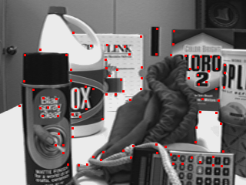

feat2,ppm

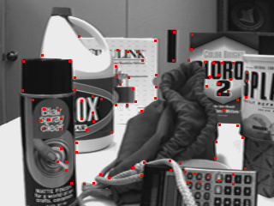

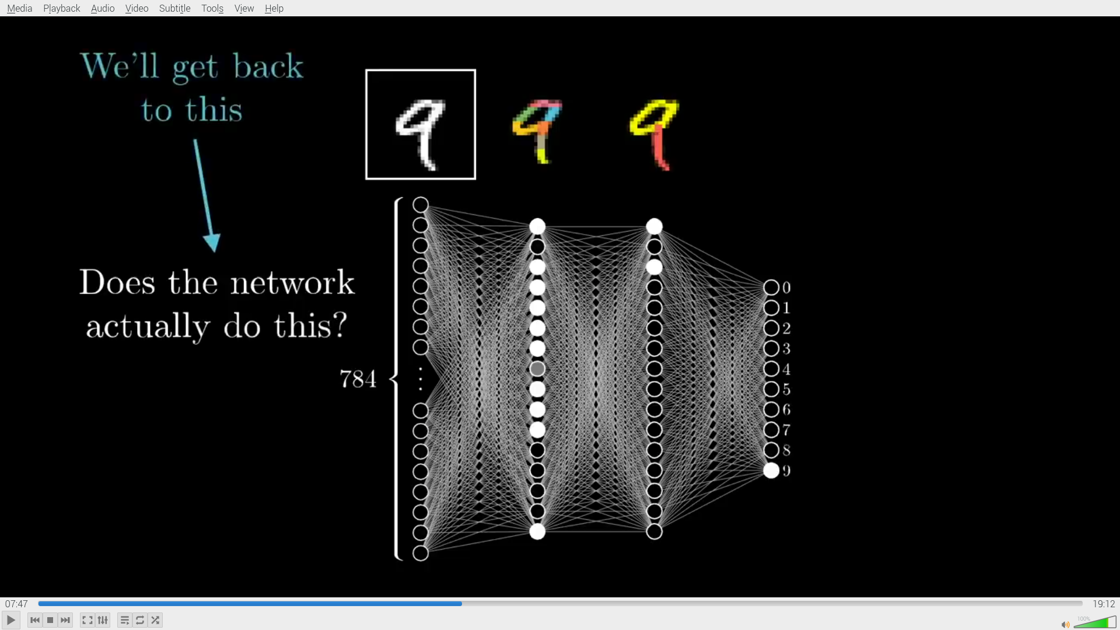

2

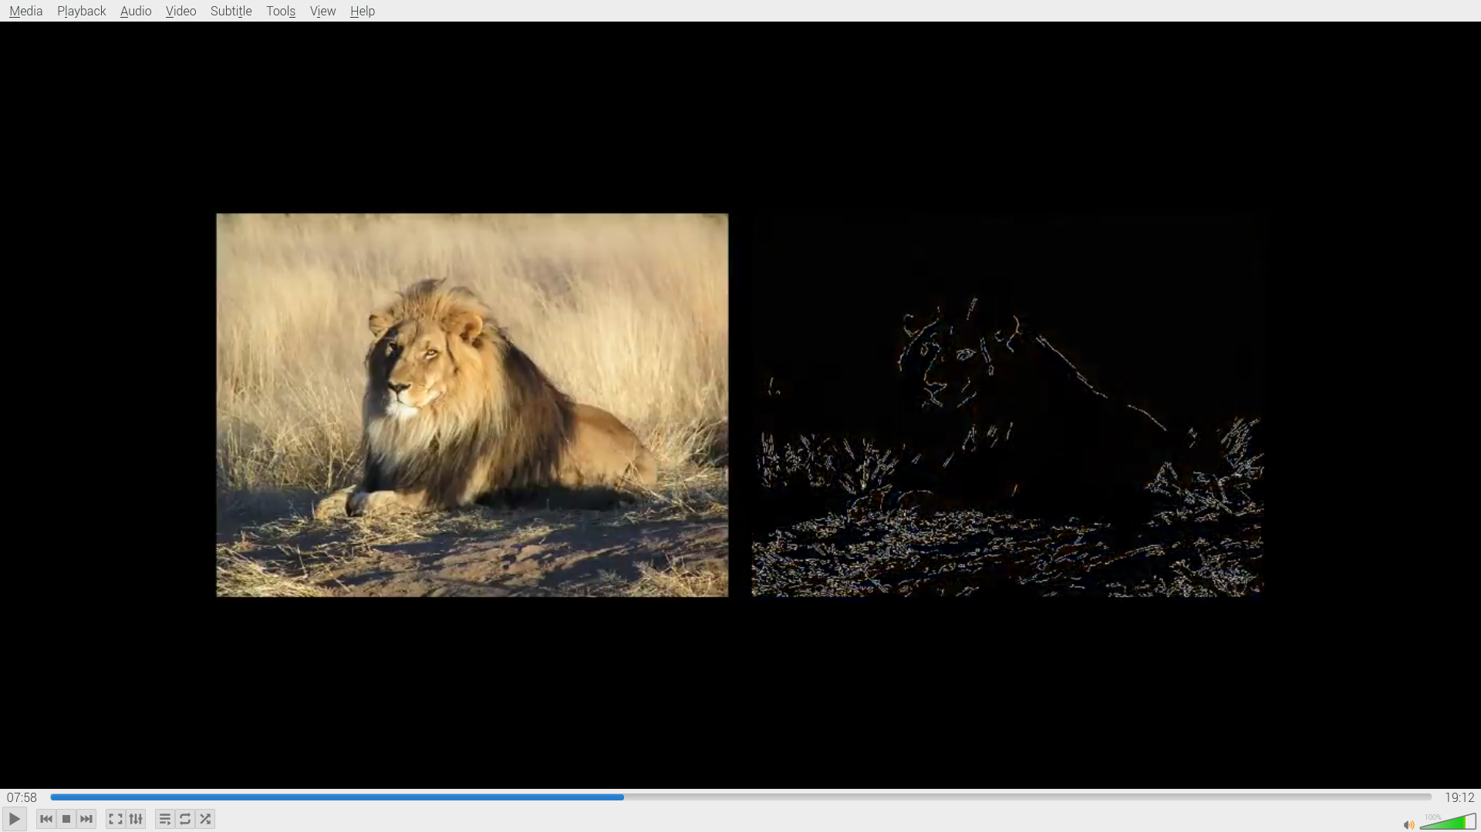

3

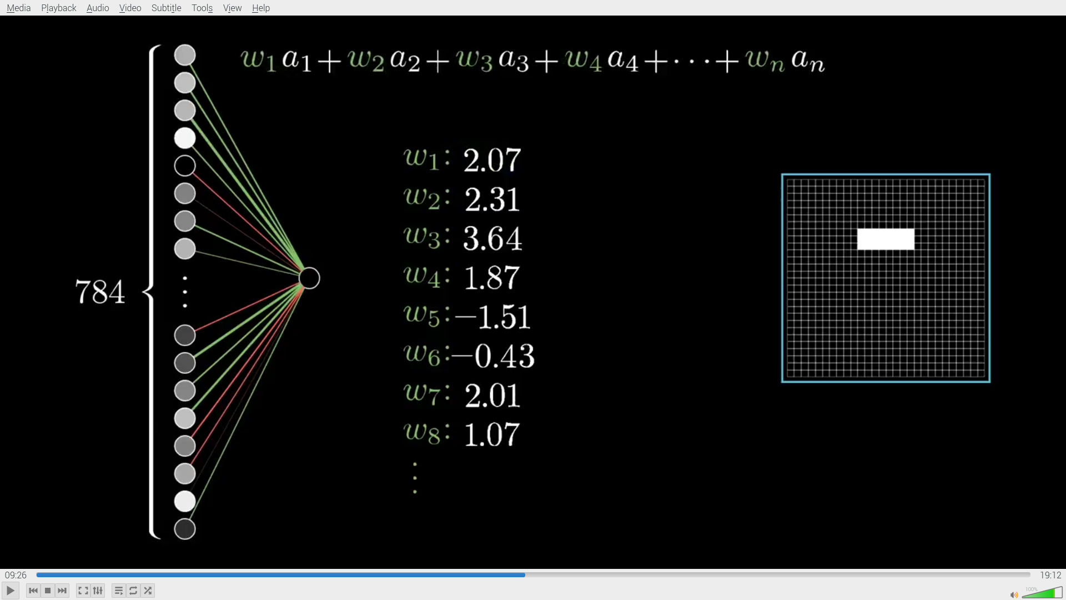
5

sobel

