*****************************Draft*****************************
github example
07/10/21
*****************************Draft*****************************

I am going to use the document to provided pibuild.pdf an example of using git.

Revison Control is very important in Software Developement. Having a way to share code with others is
very helpful. Github provides for free open source use. When you are developing code that you want
only your group to see they provide private access for a free. Your need an account at github.com.

Created a new repo at https://github.com/develone/metatianawrk

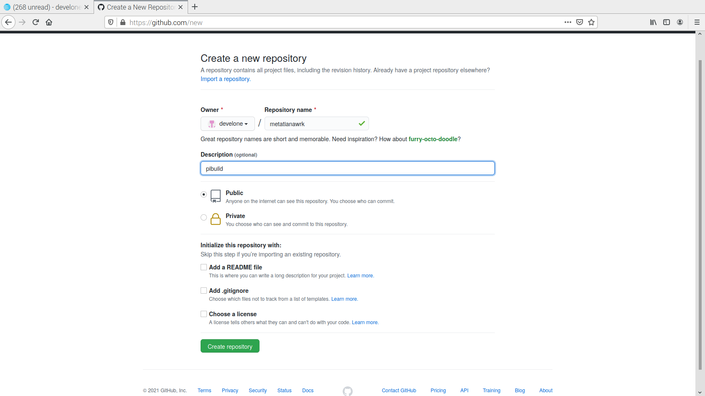
git clone git@github.com:develone/metatianawrk.git

cd metatianawrk/

mkdir doc

cp pibuild.* ~/metatianawrk/doc/

git add doc

git status | less

On branch master

No commits yet

Changes to be committed:
(use "git rm --cached <file>..." to unstage)

new file: doc/pibuild.odt
new file: doc/pibuild.pdf

git commit -a

# Please enter the commit message for your changes. Lines starting
# with '#' will be ignored, and an empty message aborts the commit.
#
# On branch master
#
# Initial commit
#
# Changes to be committed:
# new file: doc/pibuild.odt
# new file: doc/pibuild.pdf

git log
commit af9a18887b3a96e1c7425f6097154fe157084824 (HEAD -> master)
Author: Edward Vidal Jr <develone@sbcglobal.net>
Date: Sat Jul 10 06:21:52 2021 -0600

Initial Example using pibuild a document sent in a pdf file now adding odt
file such that changes can be done by user.

I added a text file notes-github.txt to doc

git status | less

On branch master
Your branch is based on 'origin/master', but the upstream is gone.
(use "git branch --unset-upstream" to fixup)

Untracked files:
(use "git add <file>..." to include in what will be committed)

doc/notes-github.txt

nothing added to commit but untracked files present (use "git add" to track)

git add doc/notes-github.txt

git commit doc/notes-github.txt

git status | less

On branch master
Your branch is based on 'origin/master', but the upstream is gone.
(use "git branch --unset-upstream" to fixup)

Changes not staged for commit:
(use "git add <file>..." to update what will be committed)
(use "git checkout -- <file>..." to discard changes in working directory)

modified: doc/notes-github.txt

no changes added to commit (use "git add" and/or "git commit -a")

git push
Enumerating objects: 13, done.
Counting objects: 100% (13/13), done.
Delta compression using up to 4 threads
Compressing objects: 100% (10/10), done.
Writing objects: 100% (13/13), 690.80 KiB | 5.66 MiB/s, done.
Total 13 (delta 1), reused 0 (delta 0)
remote: Resolving deltas: 100% (1/1), done.
To github.com:develone/metatianawrk.git
* [new branch] master -> master

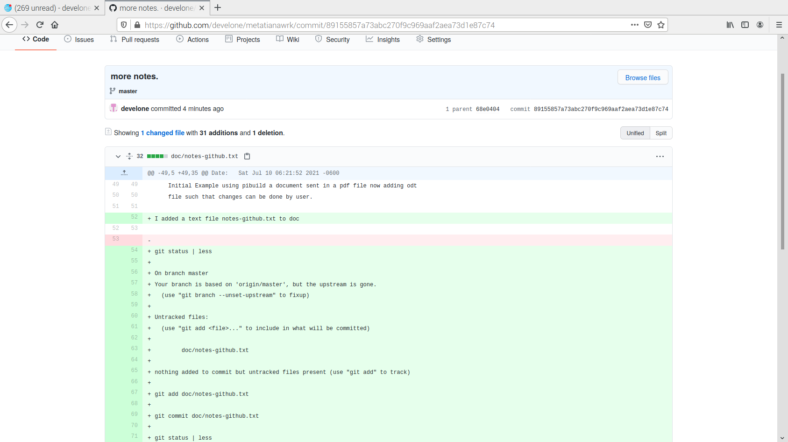
You can see the history at github

