*****************************Draft*****************************
pibuild
07/09/21
*****************************Draft*****************************

This micro sd will run on Rpi3 a Rpi4 4Gb or Rpi4 8Gb PI400 will provide better results.

The standard software provides a lot of software VLC. Libreoffice, Editors, Image viewers, GIMP.
Videos can be download and play using VLC.

This version provides the software to learn about FPGAs and Bare Metal by adding 481 packages and several compiled C & Python Tools (autofpga, icestorm, nextpnr, yosys, zipcpu, and verilator).
In additons the dependencies (libgtk2.0-dev libcairo2-dev libpango1.0-dev libgdk-pixbuf2.0-dev libatk1.0-dev libghc-x11-dev) for Lazarus IDE (Ultibo-Edition). With https://github.com/develone/Ultibo_Projects you can compile Bare Metal applications for Rpi, Rpi2, Rpi3, and RPi4.

After connecting a keyboard/mouse, usb pwr, supply and HDMI TV. The system will boot to Login screen. These are a few screenshots of a Raspberry Pi that I recently built. This version has additional software installed to support Bare Metal development. This also has the software to
do Synthesis of Verilog Code using Yosys. yosys -V
Yosys 0.9+4052 (git sha1 0ccc7229, gcc 8.3.0-6+rpi1 -fPIC -Os). The Synthesis output needs to Placed & Routed using nextpnr. nextpnr-ice40 -V
nextpnr-ice40 -- Next Generation Place and Route (Version 4419c36d). The output of nextpnr creates a catzip.bin bitstream which can be used to program the FPGA. The catzip.bin needs to be tested if the clock frequency is not to high using icestorm. icetime -d hx8k -c 40 catzip.asc
// Reading input .asc file..
// Reading 8k chipdb file..
// Creating timing netlist..
// Timing estimate: 18.37 ns (54.44 MHz)
// Checking 25.00 ns (40.00 MHz) clock constraint: PASSED.

These are software packages needed to work with FPGAs autofpga, icestorm, nextpnr, yosys, zipcpu, and verilator.

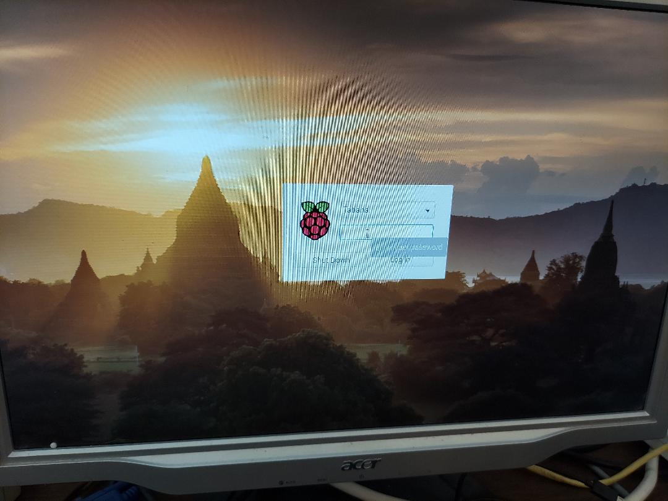

After entering the correct passwd user devel will be logged in to DeskTop.

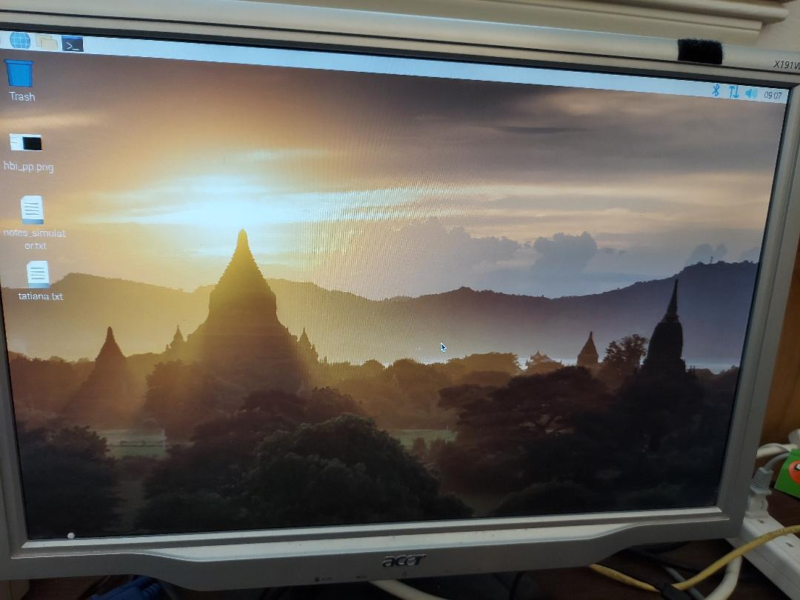
Users can use ssh to make remote connection to the newly created Raspberry Pi.

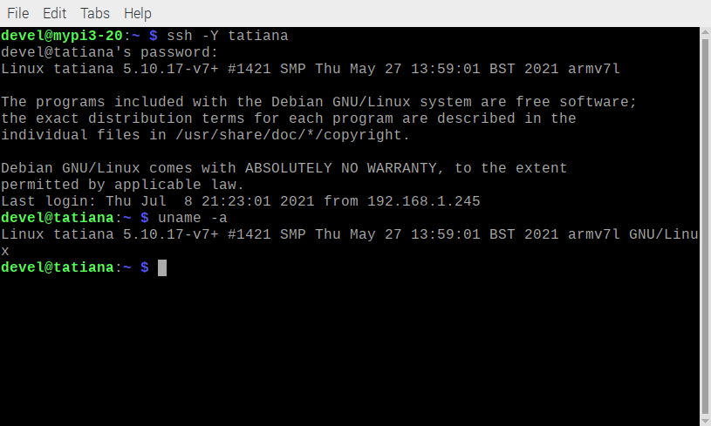
This does require enabling using Preferences/Raspberry Pi Configuration.
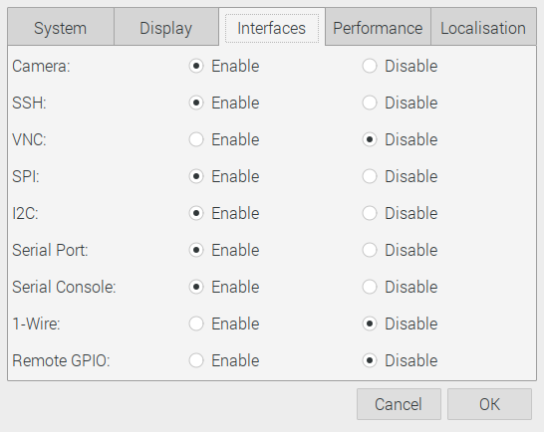

This is also where the Hostname and if a prompt is required to Log in is performed.

I also have a simulation of the software in the FPGA.

To start the simulator with no trace ./arm-main.tb is run ~/pi400/catzip/sim/verilated
if the -d option is used the VCD file trace.vcd is generated.

Shell 1

./arm-main_tb
Listening on port 8363
Listening on port 8364
> T
> Z
Accepted CMD connection
< A01000015R
> A01000015R20210707
< [CLOSED]

Shell 2

./arm-wbregs version
01000014 ( VERSION) : [.!..] 20210707

The VCD file was created by using the simulator with -d option and the command ./arm-wbregs version

