************Draft************
Mosquitto Testing Raspbain
04/11/20
************Draft************

MQTT[2] (Message Queuing Telemetry Transport) is an open OASIS and ISO standard (ISO/IEC 20922)[3] lightweight, publish-subscribe network protocol that transports messages between devices. The protocol usually runs over TCP/IP; however, any network protocol that provides ordered, lossless, bi-directional connections can support MQTT.[4] It is designed for connections with remote locations where a "small code footprint" is required or the network bandwidth is limited

Steps to install mosquitto mq-tt
sudo apt update
sudo apt install -y mosquitto mosquitto-clients

sudo systemctl enable mosquitto.service

mosquitto_sub

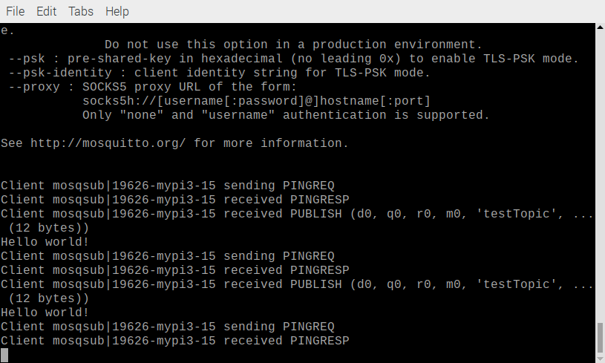
This is done first.

devel@mypi3-15:~ $ mosquitto_sub -d -t testTopic

The command is what creates the message on mypi3-15

devel@mypi3-13:~ $ mosquitto_pub -h mypi3-15 -d -t testTopic -m "Hello world!"

