********Draft********
ZeroMQ
04/11/20
********Draft********

ZeroMQ requires libsodium

NaCl (pronounced "salt") is an abbreviation for "Networking and Cryptography library", a public domain "...high-speed software library for network communication, encryption, decryption, signatures, etc".[2]

NaCl was created by the mathematician and programmer Daniel J. Bernstein who is best known for the creation of qmail and Curve25519.

Compile, link, and installed libsodium.

wget https://github.com/jedisct1/libsodium/releases/download/1.0.3/libsodium-1.0.3.tar.gz
tar -zxvf libsodium-1.0.3.tar.gz
cd libsodium-1.0.3/
./configure
make
sudo make install

Compile, link, and installed libzmq

wget https://github.com/zeromq/libzmq/releases/download/v4.3.2/zeromq-4.3.2.tar.gz
tar -zxvf zeromq-4.3.2.tar.gz
cd zeromq-4.3.2/
./configure
make
sudo make install
sudo ldconfig

Hellowserver

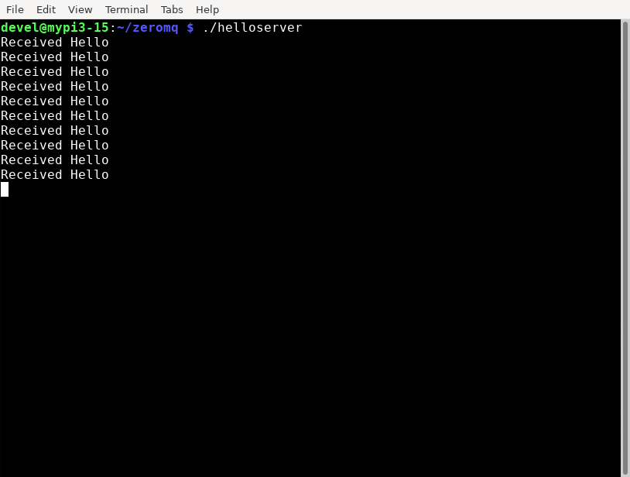

client

