*************Draft*************
20 Core RPi4B, RPi3B, and RPi3B+
MPICH Cluster
04/09/20
*************Draft*************

The software used “mpich-3.3.2.tar.gz” was downloaded from “http://www.mpich.org/downloads/”. This was compiled and installed “/home/devel/mpi/local” on a RPi4B.

With rsync was copied to the other 4 nodes.

Step1.
devel@mypi3-15:~/mpich-3.3.2 $ tar xvf mpich-3.3.2.tar.gz

Step2.
cd mpich-3.3.2
./configure –prefix=/home/devel/mpi/local

Step3.
make
make install

Step4.
Install ssh keys on all nodes. This will allow login without having to provide a pass word.
The commands used were “ssh-keygen -t rsa” & “ssh-copy-id mypi3-xx”.

Step5.
This that the software was built.
mpiexec --version

mpiexec (OpenRTE) 3.1.3

Step6.

rsync -avl –delete mpi mypi3-xx:~/

rsync -avl –delete mpich-3.3.2 mypi3-xx:~/

Step7.
Need provide a script that will provide a PATH to where the mpi software was installed.

The file “setmpipath.sh”

#!/bin/bash
echo $PATH
export PATH=/home/devel/mpi/local/bin:$PATH
echo $PATH

The file “machinefile” is used to ID the systems in the cluster and the number of jobs.

mypi3-15:4
mypi3-13:4
mypi3-8:4
mypi3-11:4
mypi3-12:4

The image below is initizing all the nodes.

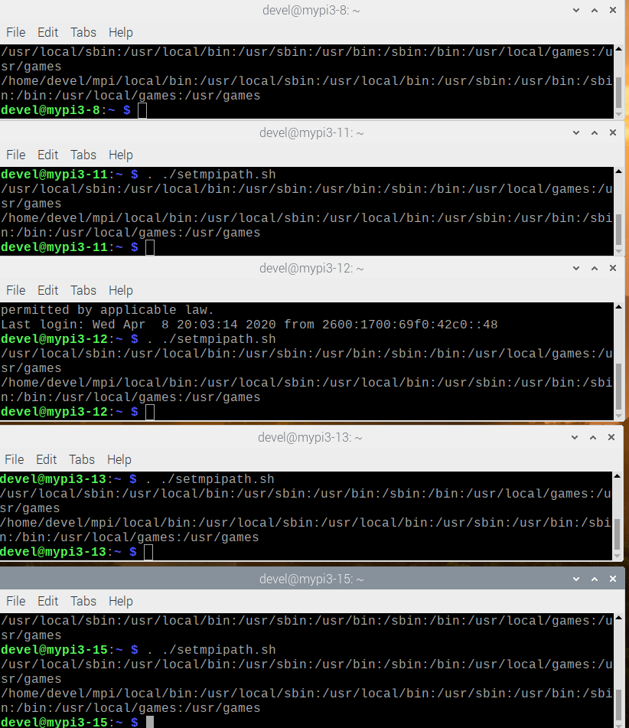

The image below is testing hellow all the nodes.

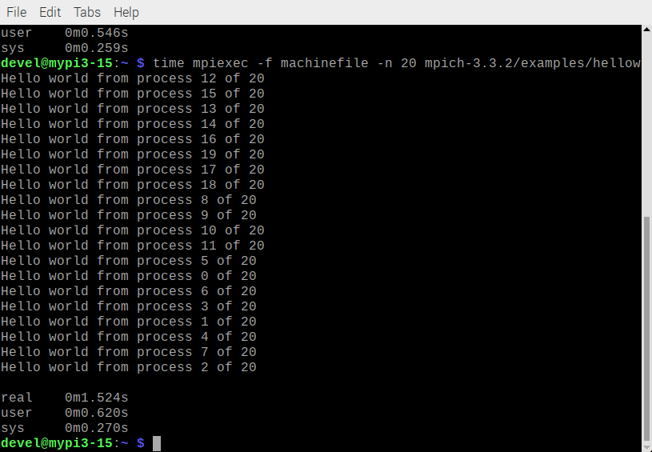
In the example below the program cpi uses 10000 steps to compute the value of Pi.

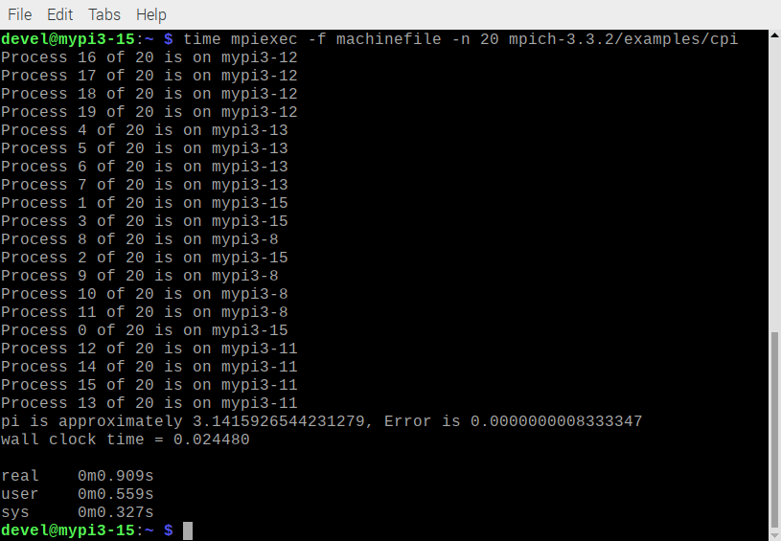
Appendix B. Source of hellow.c

/* -*- Mode: C; c-basic-offset:4 ; indent-tabs-mode:nil ; -*- */
/*
* (C) 2001 by Argonne National Laboratory.
* See COPYRIGHT in top-level directory.
*/

#include <stdio.h>
#include "mpi.h"

int main(int argc, char *argv[])
{
int rank;
int size;

MPI_Init(0, 0);
MPI_Comm_rank(MPI_COMM_WORLD, &rank);
MPI_Comm_size(MPI_COMM_WORLD, &size);
printf("Hello world from process %d of %d\n", rank, size);
MPI_Finalize();
return 0;
}

Appendix B. Source of cpi.c

/* -*- Mode: C; c-basic-offset:4 ; indent-tabs-mode:nil ; -*- */
/*
* (C) 2001 by Argonne National Laboratory.
* See COPYRIGHT in top-level directory.
*/

#include "mpi.h"
#include <stdio.h>
#include <math.h>

double f(double);

double f(double a)
{
return (4.0 / (1.0 + a * a));
}

int main(int argc, char *argv[])
{
int n, myid, numprocs, i;
double PI25DT = 3.141592653589793238462643;
double mypi, pi, h, sum, x;
double startwtime = 0.0, endwtime;
int namelen;
char processor_name[MPI_MAX_PROCESSOR_NAME];

MPI_Init(&argc, &argv);
MPI_Comm_size(MPI_COMM_WORLD, &numprocs);
MPI_Comm_rank(MPI_COMM_WORLD, &myid);
MPI_Get_processor_name(processor_name, &namelen);

fprintf(stdout, "Process %d of %d is on %s\n", myid, numprocs, processor_name);
fflush(stdout);

n = 10000; /* default # of rectangles */
if (myid == 0)
startwtime = MPI_Wtime();

MPI_Bcast(&n, 1, MPI_INT, 0, MPI_COMM_WORLD);

h = 1.0 / (double) n;
sum = 0.0;
/* A slightly better approach starts from large i and works back */
for (i = myid + 1; i <= n; i += numprocs) {
x = h * ((double) i - 0.5);
sum += f(x);
}
mypi = h * sum;

MPI_Reduce(&mypi, &pi, 1, MPI_DOUBLE, MPI_SUM, 0, MPI_COMM_WORLD);

if (myid == 0) {
endwtime = MPI_Wtime();
printf("pi is approximately %.16f, Error is %.16f\n", pi, fabs(pi - PI25DT));
printf("wall clock time = %f\n", endwtime - startwtime);
fflush(stdout);
}

MPI_Finalize();
return 0;
}

