**********************Draft**********************
Modifng Computing Options
04/16/20
**********************Draft**********************

This the temperature with a top around 4.

sudo cat /sys/class/thermal/thermal_zone0/temp
55991 55.991 is the temperature C.

Simple View. (default)

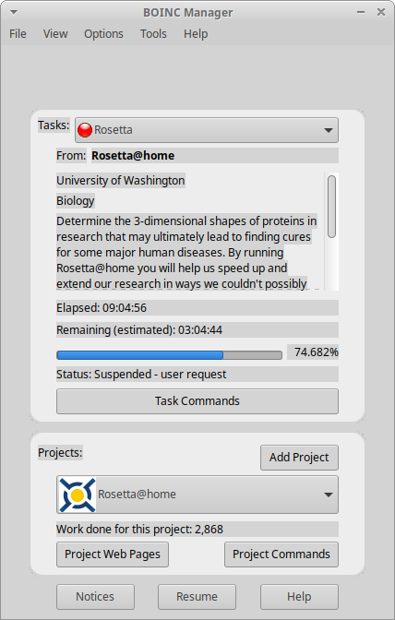

Advance View.

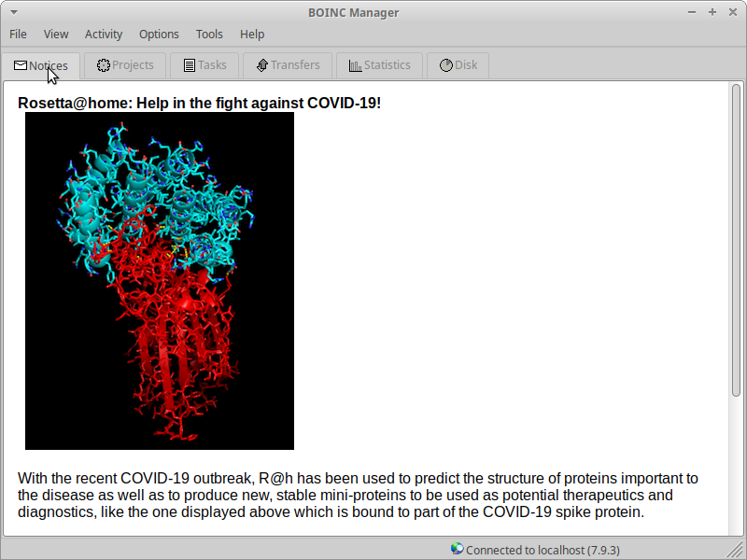
Computing options (default)

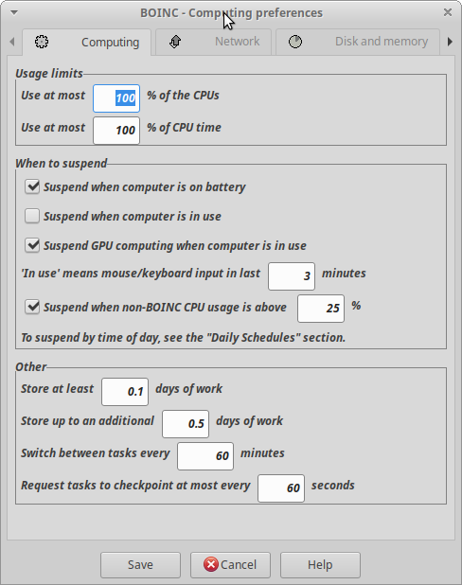

2of4 CPUs.

