**********************Default**********************
Programming Pico with Ardiuno IDE
for Nano-RP2040-Connect
Ultra Sonic sensor with PIO

generating trigger
and receiving echo
10/16/22
**********************Default**********************

Arduino Library Manager

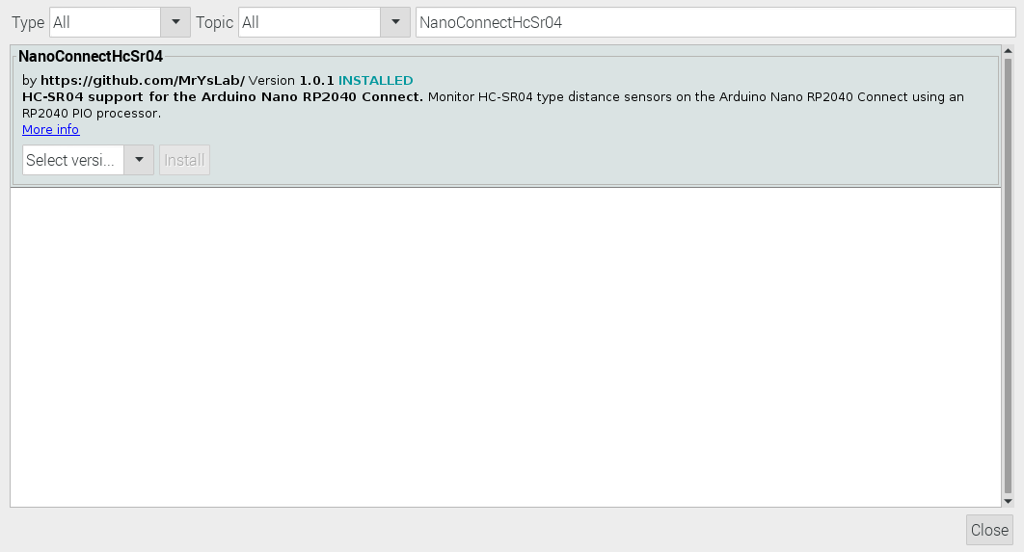

Github

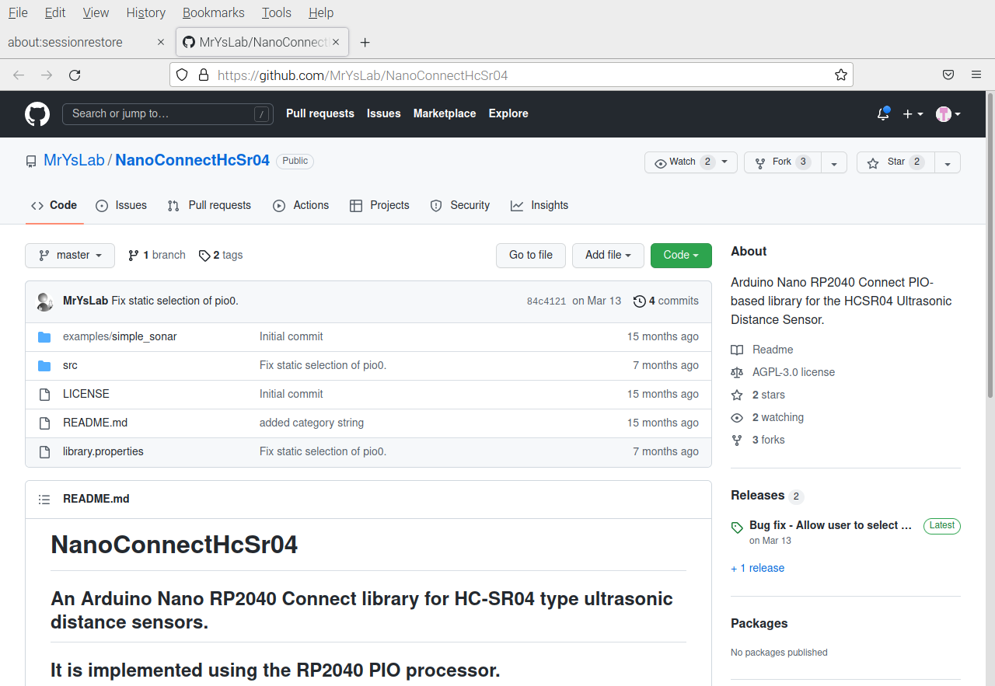

https://github.com/MrYsLab/NanoConnectHcSr04/blob/master/src/NanoConnectHcSr04.pio.h

https://github.com/MrYsLab/NanoConnectHcSr04/blob/master/src/NanoConnectHcSr04.cpp

This sketch uses NanoConnectHcSr04 library

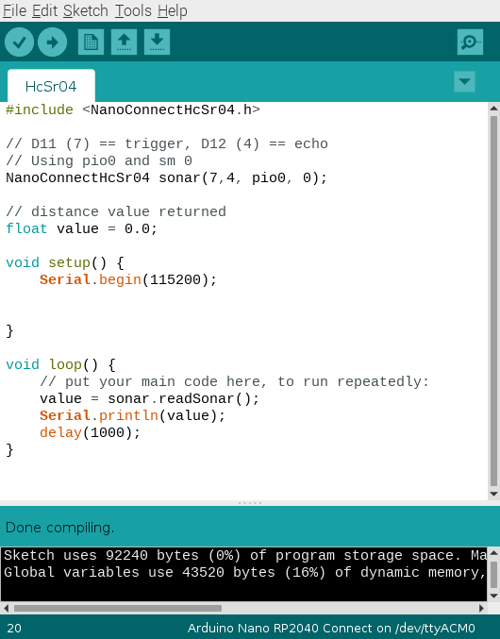

For the pico gpio 7 is pin 10 gpio 4 is pin 6

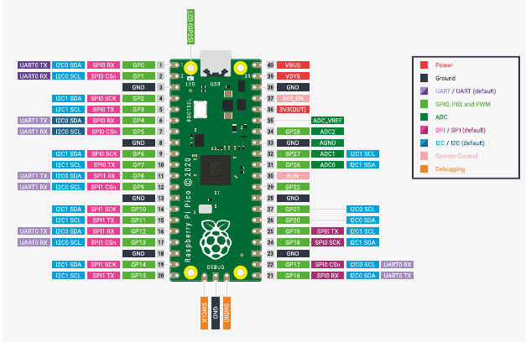

For the nano-rp2040-connect gpio 7 is pin 12 gpio 4 is pin 11

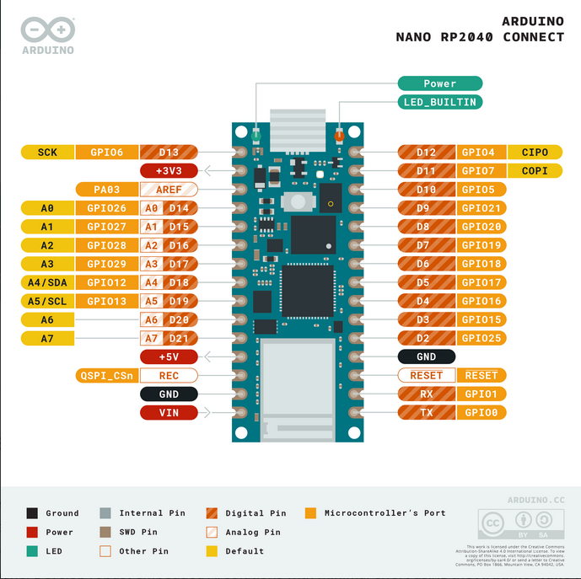
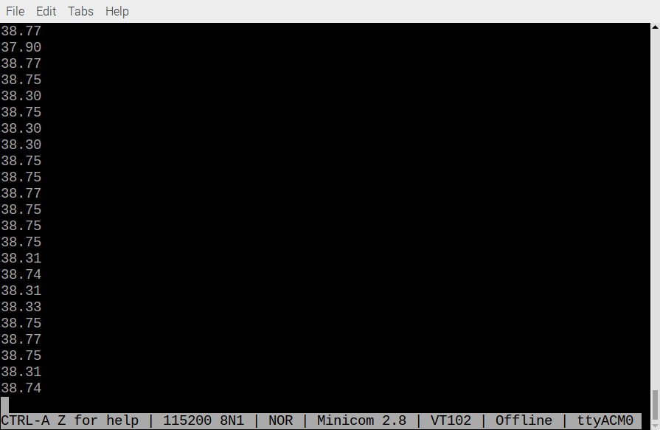
Serial Port configuration

