*******************Draft*******************
First video on ML
10/07/22
*******************Draft*******************

Video on youtube Laurence Moroney

https://www.youtube.com/watch?v=KNAWp2S3w94&list=PLZKsYDC2S5rM6yKBs5ParXS6RWda6iAnK

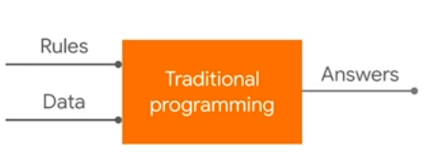
xx

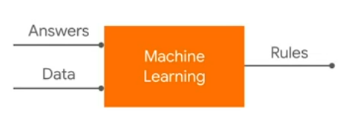
Epoch 1/500
^M^M1/1 [==============================] - 1s 831ms/step - loss: 24.4342
Epoch 2/500
^M^M1/1 [==============================] - 0s 4ms/step - loss: 19.5113
Epoch 3/500

.
.
.
Epoch 498/500
1/1 [==============================] - 0s 4ms/step - loss: 4.9466e-05
Epoch 499/500
1/1 [==============================] - 0s 4ms/step - loss: 4.8449e-05
Epoch 500/500
1/1 [==============================] - 0s 4ms/step - loss: 4.7454e-05

x = -1.0, 0.0, 1.0, 2.0, 3.0, 4.0
y = -3.0, -1.0, 1.0, 3.0, 5.0, 7.0

# https://www.youtube.com/watch?v=KNAWp2S3w94&list=PLZKsYDC2S5rM6yKBs5ParXS6RWda6iAnK
# Define paths to model files
import os
MODELS_DIR = 'models/'
if not os.path.exists(MODELS_DIR):
os.mkdir(MODELS_DIR)
MODEL_TF = MODELS_DIR + 'model'
MODEL_NO_QUANT_TFLITE = MODELS_DIR + 'model_no_quant.tflite'
MODEL_TFLITE = MODELS_DIR + 'model.tflite'
MODEL_TFLITE_MICRO = MODELS_DIR + 'model.cc'

import tensorflow as tf
from tensorflow import keras
import numpy as np

model = tf.keras.Sequential([keras.layers.Dense(units=1, input_shape=[1])])
model.compile(optimizer='sgd',loss='mean_squared_error')

# x = -1.0, 0.0, 1.0, 2.0, 3.0, 4.0
# y = -3.0, -1.0, 1.0, 3.0, 5.0, 7.0

xs = np.array([-1.0, 0.0, 1.0, 2.0, 3.0, 4.0], dtype=float)
ys = np.array([-3.0, -1.0, 1.0, 3.0, 5.0, 7.0], dtype=float)
# y= 2x -1
model.fit(xs,ys,epochs=500)

print(model.predict([10.0]))

# [[18.978554]]
print(model.predict([20.0]))
# [[38.94747]]
print(model.predict([-2.4]))
# [[-5.7845263]]

