**********************Default**********************
pico_w or
nano-rp2040-connect
access point
for pico_w
11/14/22
**********************Default**********************

This needs to be appended to the end of .bashrc file.
export PICO_SDK_PATH=/home/devel/sdk/pico-sdk
The pico-sdk is requited in this folder with its sub modules.
The submodules are tinyusb and the wifi lib
The FreeRTOS-Kernel is needed in /home/devel/FreeRTOS-Kernel
Several of files need modifications when you want to change the WIFI_SSID and
WIFI_PASSWORD if the first character WIFI_PASSWORD is not a number it can be put in the pw_ssid.h file

modified: pico_w/freertos/iperf/picow_freertos_iperf.c
modified: pico_w/freertos/iperf/pw_ssid.h
modified: pico_w/freertos/ping/picow_freertos_ping.c
modified: pico_w/freertos/ping/pw_ssid.h
modified: pico_w/iperf/picow_iperf.c
modified: pico_w/iperf/pw_ssid.h
modified: pico_w/ntp_client/picow_ntp_client.c
modified: pico_w/ntp_client/pw_ssid.h
modified: pico_w/tcp_client/picow_tcp_client.c
modified: pico_w/tcp_client/pw_ssid.h
modified: pico_w/tcp_server/picow_tcp_server.c
modified: pico_w/tcp_server/pw_ssid.h

Either the pico_w or the Arduino Nano-RP2040-connect can be be used as the access -point.

This will require minor changes in the file pico-examples/pico_w/access_point
line 130 const char *ap_name = "picow_test"; –> const char *ap_name = "nanotest";
line 132 const char *password = "password"; –> const char *password = "12345678";
line 140 IP4_ADDR(&gw, 192, 168, 4, 1); –> IP4_ADDR(&gw, 10, 0, 1, 10);

Pico_W

https://www.amazon.com/Vis-Viva-Raspberry-Basic-PICO-W/dp/B0BDSPXP2R/ref=mp_s_a_1_2?crid=2RQUZH6WT21DV&keywords=pico_w&qid=1666627291&sprefix=pico_w%2Caps%2C269&sr=8-2

$17,95

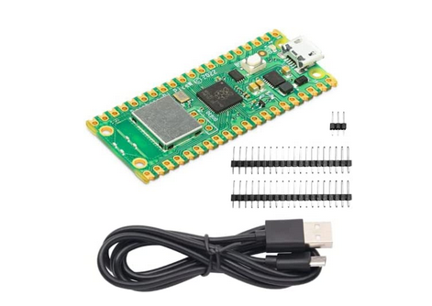
pico_w pins

git clone https://github.com/develone/FreeRTOS-Kernel.git

git clone https://github.com/develone/pico_w-remotes.git

cd pico_w-remotes

./5remotes.sh
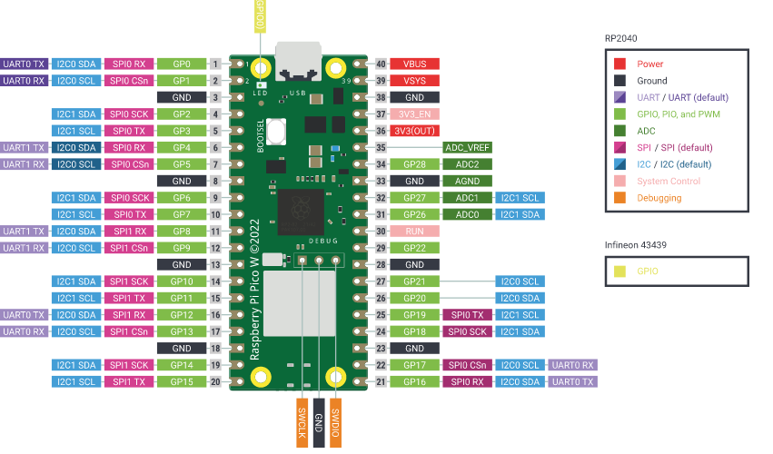
xx
Arduino Nano-RP2040-Connect

https://www.amazon.com/Arduino-Nano-RP2040-Connect-Headers/dp/B095J4KFVT/ref=asc_df_B095J4KFVT/?tag=hyprod-20&linkCode=df0&hvadid=533458241275&hvpos=&hvnetw=g&hvrand=11004597131761763700&hvpone=&hvptwo=&hvqmt=&hvdev=m&hvdvcmdl=&hvlocint=&hvlocphy=9028705&hvtargid=pla-1588131359952&psc=1

$34.99

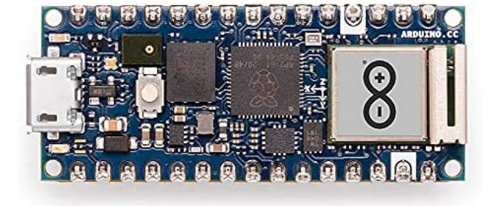

xx

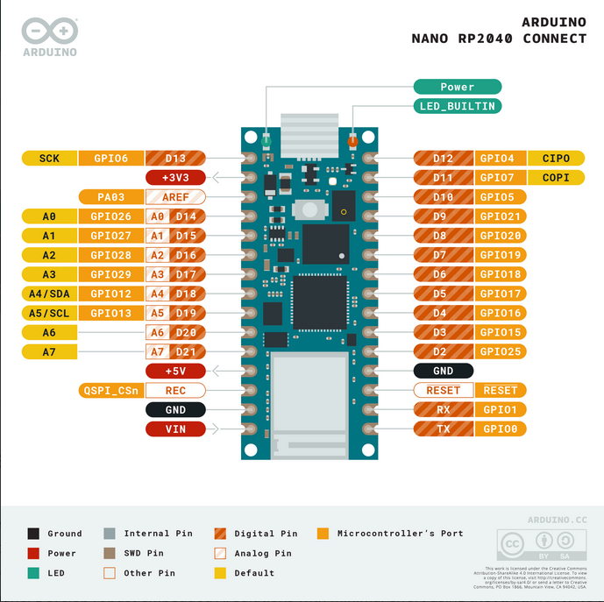

Programmed the Arduino Nano-RP2040-Connect as WIFI access point. This provides a DHCP server.

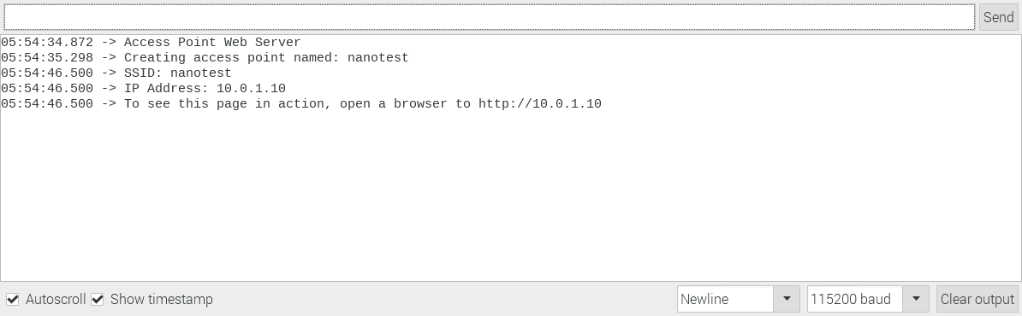

Two Raspberry Pi3B with 7 in displats were used as remotes on this network. The IP assigned to pi3-10 was 10.0.1.11. The IP assigned to pi3-11 was 10.0.1.12.

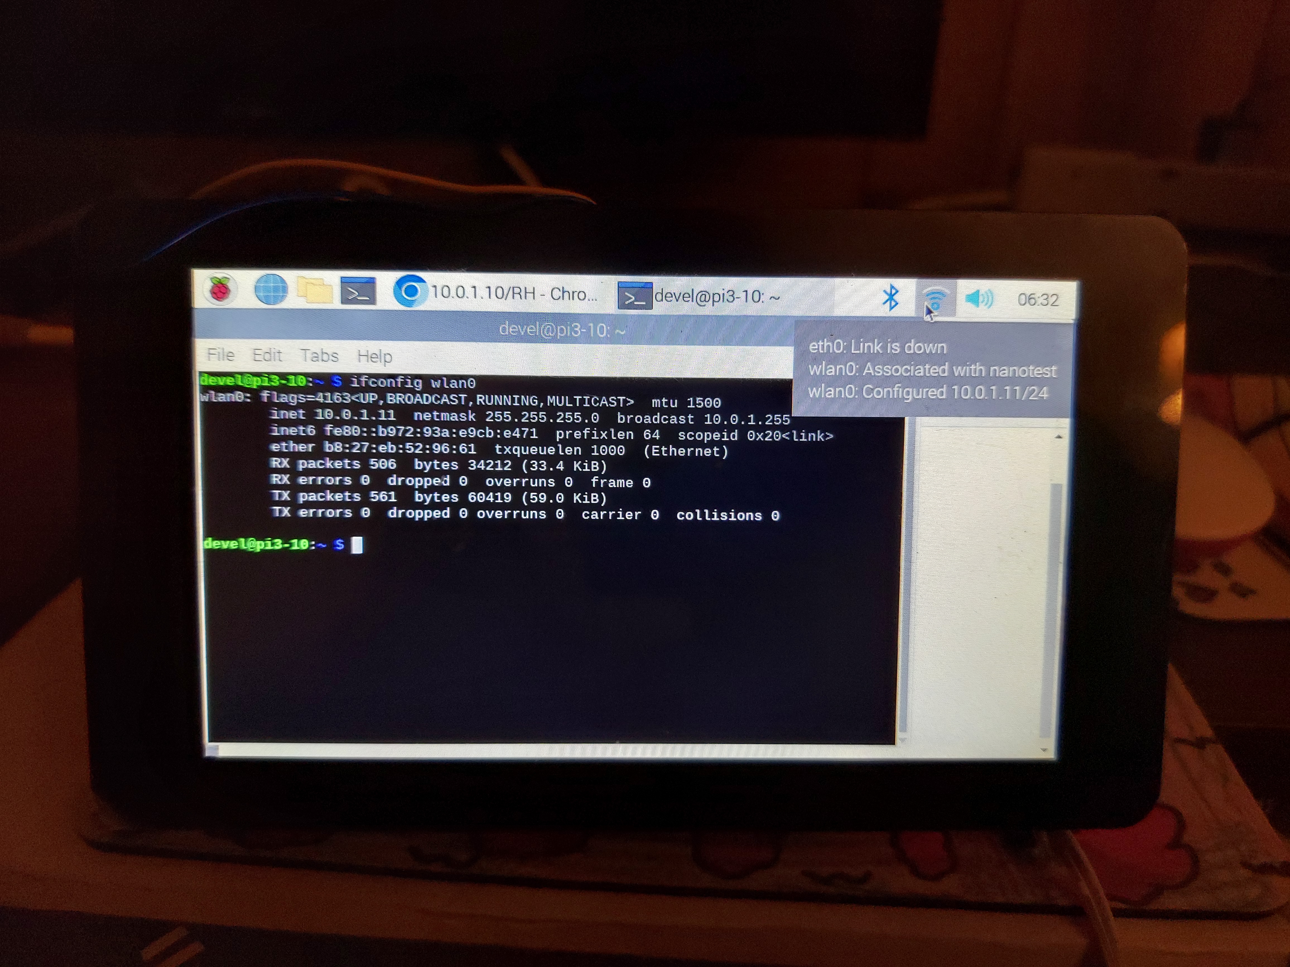

The access point also provides a web server to control the RGB Led on the Nano-RP2040-Connect.

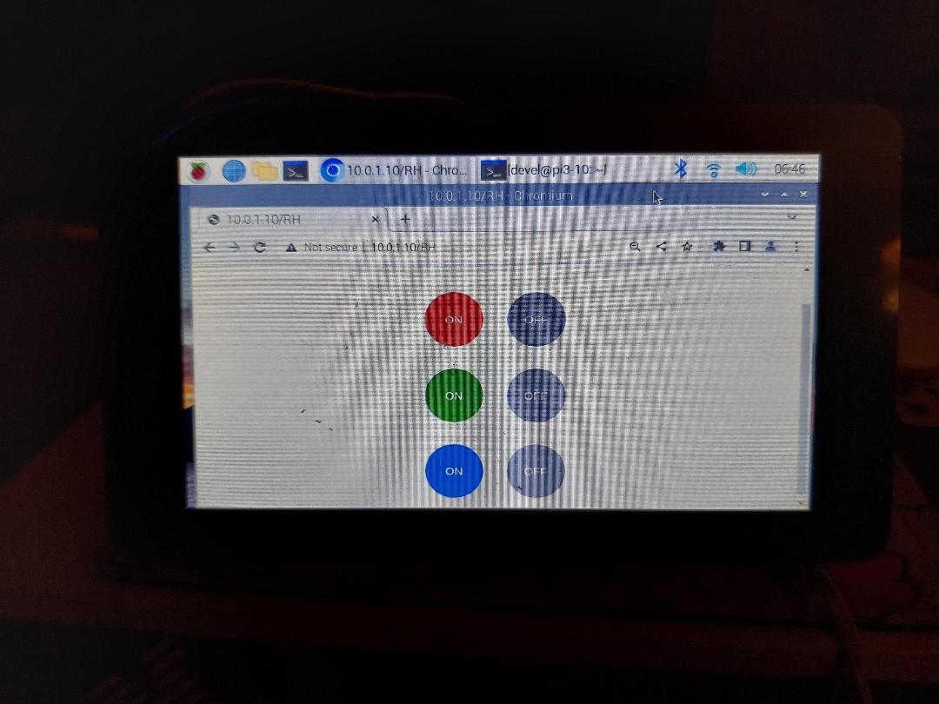

Adding a virtual keyboard will make it easier to do the field tests.

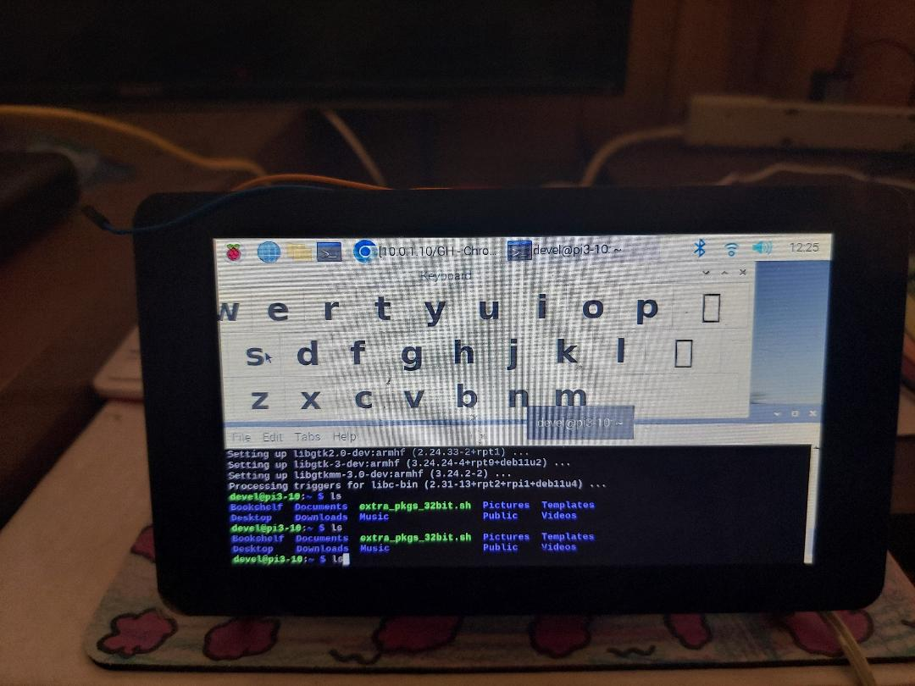
xx

Press CTRL-A Z for help on special keys

Connecting to WiFi...
Connected.

Ready, running iperf server at 10.0.1.13
Completed iperf transfer of 10 MBytes @ 8.3 Mbits/sec
Total iperf megabytes since start 10 Mbytes

iperf -c 10.0.1.13
------------------------------------------------------------
Client connecting to 10.0.1.13, TCP port 5001
TCP window size: 43.8 KByte (default)
------------------------------------------------------------
[ 3] local 10.0.1.11 port 43808 connected with 10.0.1.13 port 5001
[ ID] Interval Transfer Bandwidth
[ 3] 0.0000-10.0892 sec 10.0 MBytes 8.31 Mbits/sec

Client/Server
In the command below note: -DTEST_TCP_SERVER_IP="10.0.1.13" -DWIFI_SSID="nanotest" -DWIFI_PASSWORD="12345678" are dependent on your WiFi.
cmake -DPICO_BOARD=pico_w -DTEST_TCP_SERVER_IP="10.0.1.13" -DWIFI_SSID="nanotest" -DWIFI_PASSWORD="12345678" -DFREERTOS_KERNEL_PATH="/home/devel/FreeRTOS-Kernel" ..

openocd -f interface/raspberrypi-swd.cfg -f target/rp2040.cfg -c "program pico_w/wifi_scan/picow_wifi_scan_poll.elf verify reset exit"

Press CTRL-A Z for help on special keys

Performing wifi scan
ssid: nanotest rssi: -50 chan: 3 mac: 30:c6:f7:01:8f7
ssid: ATTtpHTfPi rssi: -11 chan: 1 mac: cc:ab:2c:c7:5e5
ssid: ATT3TV6WQs rssi: -70 chan: 1 mac: c8:52:61:4e:d25
ssid: ATTtpHTfPi rssi: -12 chan: 1 mac: cc:ab:2c:c7:5e5
ssid: nanotest rssi: -51 chan: 3 mac: 30:c6:f7:01:8f7
ssid: ATT3TV6WQs rssi: -71 chan: 1 mac: c8:52:61:4e:d25
ssid: House rssi: -74 chan: 3 mac: c4:41:1e:4e:c35
ssid: nanotest rssi: -53 chan: 3 mac: 30:c6:f7:01:8f7
ssid: nanotest rssi: -51 chan: 3 mac: 30:c6:f7:01:8f7
ssid: rssi: -71 chan: 3 mac: ca:41:1e:4e:c35
ssid: rssi: -76 chan: 3 mac: ca:41:1e:4e:c35
ssid: ATTjw8tqXi rssi: -82 chan: 6 mac: f4:17:b8:de:a65
ssid: ATTtpHTfPi rssi: -46 chan: 1 mac: cc:ab:2c:c7:5e5
ssid: ATT47CJH5z_EXT rssi: -70 chan: 11 mac: 3c:84:6a:46:987
ssid: ATT47CJH5z_EXT rssi: -73 chan: 11 mac: 3c:84:6a:46:987
ssid: ATT47CJH5z_EXT rssi: -73 chan: 11 mac: 3c:84:6a:46:987
ssid: ATT47CJH5z_EXT rssi: -71 chan: 11 mac: 3c:84:6a:46:987
ssid: ATT47CJH5z_EXT rssi: -74 chan: 11 mac: 3c:84:6a:46:987

openocd -f interface/raspberrypi-swd.cfg -f target/rp2040.cfg -c "program pico_w/iperf/picow_iperf_server_background.elf verify reset exit"

openocd -f interface/raspberrypi-swd.cfg -f target/rp2040.cfg -c "program pico_w/tcp_server/picow_tcpip_server_background.elf verify reset exit"

Back from buildCRCTable
0xd3 0x1 0x2e
Connecting to WiFi...
Connected.
Starting server at 10.0.1.13 on port 4242
Client connected
Writing 2048 bytes to client
tcp_server_sent 1460
tcp_server_sent 588
Waiting for buffer from client
tcp_server_recv 1460/0 err 0
tcp_server_recv 588/1460 err 0
tcp_server_recv buffer ok
Writing 2048 bytes to client
tcp_server_sent 1460
tcp_server_sent 588
Waiting for buffer from client
tcp_server_recv 1460/0 err 0
tcp_server_recv 588/1460 err 0
tcp_server_recv buffer ok
Writing 2048 bytes to client
tcp_server_sent 1460
tcp_server_sent 588
Waiting for buffer from client
tcp_server_recv 1460/0 err 0
tcp_server_recv 588/1460 err 0
tcp_server_recv buffer ok
Writing 2048 bytes to client
tcp_server_sent 1460
tcp_server_sent 588
Waiting for buffer from client
tcp_server_recv 1460/0 err 0
tcp_server_recv 588/1460 err 0
tcp_server_recv buffer ok
Writing 2048 bytes to client
tcp_server_sent 1460
tcp_server_sent 588
Waiting for buffer from client
tcp_server_recv 1460/0 err 0
tcp_server_recv 588/1460 err 0
tcp_server_recv buffer ok
Writing 2048 bytes to client
tcp_server_sent 1460
tcp_server_sent 588
Waiting for buffer from client
tcp_server_recv 1460/0 err 0
tcp_server_recv 588/1460 err 0
tcp_server_recv buffer ok
Writing 2048 bytes to client
tcp_server_sent 1460
tcp_server_sent 588
Waiting for buffer from client
tcp_server_recv 1460/0 err 0
tcp_server_recv 588/1460 err 0
tcp_server_recv buffer ok
Writing 2048 bytes to client
tcp_server_sent 1460
tcp_server_sent 588
Waiting for buffer from client
tcp_server_recv 1460/0 err 0
tcp_server_recv 588/1460 err 0
tcp_server_recv buffer ok
Writing 2048 bytes to client
tcp_server_sent 1460
tcp_server_sent 588
Waiting for buffer from client
tcp_server_recv 1460/0 err 0
tcp_server_recv 588/1460 err 0
tcp_server_recv buffer ok
Writing 2048 bytes to client
tcp_server_sent 1460
tcp_server_sent 588
Waiting for buffer from client
tcp_server_recv 1460/0 err 0
tcp_server_recv 588/1460 err 0
tcp_server_recv buffer ok
test success

openocd -f interface/raspberrypi-swd.cfg -f target/rp2040.cfg -c "program pico_w/tcp_client/picow_tcpip_client_background.elf verify reset exit"

Connecting to WiFi...
Connected.
Connecting to 10.0.1.13 port 4242
Waiting for buffer from server
recv 1460 err 0
recv 588 err 0
Writing 2048 bytes to server
tcp_client_sent 1460
tcp_client_sent 588
Waiting for buffer from server
recv 1460 err 0
recv 588 err 0
Writing 2048 bytes to server
tcp_client_sent 1460
tcp_client_sent 588
Waiting for buffer from server
recv 1460 err 0
recv 588 err 0
Writing 2048 bytes to server
tcp_client_sent 1460
tcp_client_sent 588
Waiting for buffer from server
recv 1460 err 0
recv 588 err 0
Writing 2048 bytes to server
tcp_client_sent 1460
tcp_client_sent 588
Waiting for buffer from server
recv 1460 err 0
recv 588 err 0
Writing 2048 bytes to server
tcp_client_sent 1460
tcp_client_sent 588
Waiting for buffer from server
recv 1460 err 0
recv 588 err 0
Writing 2048 bytes to server
tcp_client_sent 1460
tcp_client_sent 588
Waiting for buffer from server
recv 1460 err 0
recv 588 err 0
Writing 2048 bytes to server
tcp_client_sent 1460
tcp_client_sent 588
Waiting for buffer from server
recv 1460 err 0
recv 588 err 0
Writing 2048 bytes to server
tcp_client_sent 1460
tcp_client_sent 588
Waiting for buffer from server
recv 1460 err 0
recv 588 err 0
Writing 2048 bytes to server
tcp_client_sent 1460
tcp_client_sent 588
Waiting for buffer from server
recv 1460 err 0
recv 588 err 0
Writing 2048 bytes to server
tcp_client_sent 1460
tcp_client_sent 588
test success

openocd -f interface/raspberrypi-swd.cfg -f target/rp2040.cfg -c "program pico_w/freertos/iperf/picow_freertos_iperf_server_sys.elf verify reset exit"

Welcome to minicom 2.8

OPTIONS: I18n
Port /dev/ttyUSB0, 05:23:50

Press CTRL-A Z for help on special keys

Back from buildCRCTable
0xd3 0x1 0x2e
Starting FreeRTOS on core 0:
Connecting to WiFi...
Connected.

Ready, running iperf server at 10.0.1.13
blink_task starts

iperf -c 10.0.1.13
------------------------------------------------------------
Client connecting to 10.0.1.13, TCP port 5001
TCP window size: 43.8 KByte (default)
------------------------------------------------------------
[ 3] local 10.0.1.12 port 47696 connected with 10.0.1.13 port 5001
[ ID] Interval Transfer Bandwidth
[ 3] 0.0000-10.3064 sec 7.13 MBytes 5.80 Mbits/sec
devel@pi3-11:~ $ iperf -c 10.0.1.13
------------------------------------------------------------
Client connecting to 10.0.1.13, TCP port 5001
TCP window size: 43.8 KByte (default)
------------------------------------------------------------
[ 3] local 10.0.1.11 port 50480 connected with 10.0.1.13 port 5001
[ ID] Interval Transfer Bandwidth
[ 3] 0.0000-10.1188 sec 7.50 MBytes 6.22 Mbits/sec

Completed iperf transfer of 7 MBytes @ 6.2 Mbits/sec
Total iperf megabytes since start 7 Mbytes

openocd -f interface/raspberrypi-swd.cfg -f target/rp2040.cfg -c "program pico_w/freertos/iperf/picow_freertos_iperf_server_nosys.elf verify reset exit"

Welcome to minicom 2.8

OPTIONS: I18n
Port /dev/ttyUSB0, 05:23:50

Press CTRL-A Z for help on special keys

Back from buildCRCTable
0xd3 0x1 0x2e
Starting FreeRTOS on core 0:
Connecting to WiFi...
Connected.

Ready, running iperf server at 10.0.1.13
blink_task starts

iperf -c 10.0.1.13
------------------------------------------------------------
Client connecting to 10.0.1.13, TCP port 5001
TCP window size: 43.8 KByte (default)
------------------------------------------------------------
[ 3] local 10.0.1.11 port 50480 connected with 10.0.1.13 port 5001
[ ID] Interval Transfer Bandwidth
[ 3] 0.0000-10.1188 sec 7.50 MBytes 6.22 Mbits/sec
devel@pi3-11:~ $ iperf -c 10.0.1.13
------------------------------------------------------------
Client connecting to 10.0.1.13, TCP port 5001
TCP window size: 43.8 KByte (default)
------------------------------------------------------------
[ 3] local 10.0.1.11 port 60174 connected with 10.0.1.13 port 5001
[ ID] Interval Transfer Bandwidth
[ 3] 0.0000-10.2288 sec 7.88 MBytes 6.46 Mbits/sec

Completed iperf transfer of 7 MBytes @ 6.4 Mbits/sec
Total iperf megabytes since start 7 Mbytes

openocd -f interface/raspberrypi-swd.cfg -f target/rp2040.cfg -c "program pico_w/freertos/ping/picow_freertos_ping_nosys.elf verify reset exit"

Starting FreeRTOS on core 0:
Connecting to WiFi...
Connected.
ping 10.0.1.10 10.0.1.10
ping 10.0.1.10 10.0.1.10
ping 10.0.1.10 10.0.1.10
ping 10.0.1.10 10.0.1.10
ping 10.0.1.10 10.0.1.10
ping 10.0.1.10 10.0.1.10

