******************Default******************
pico_w publisher
ultibo-mqtt
mosqiitto broker

12/03/22
******************Default******************

mosquitto -c /etc/mosquitto/mosquitto.conf

'7' :
begin
MQC.Host := '192.168.1.229';
MQC.Username := 'testuser';
MQC.Password := 'password123';
MQC.LocalBounce := false;
MQC.Activate (true);
end;
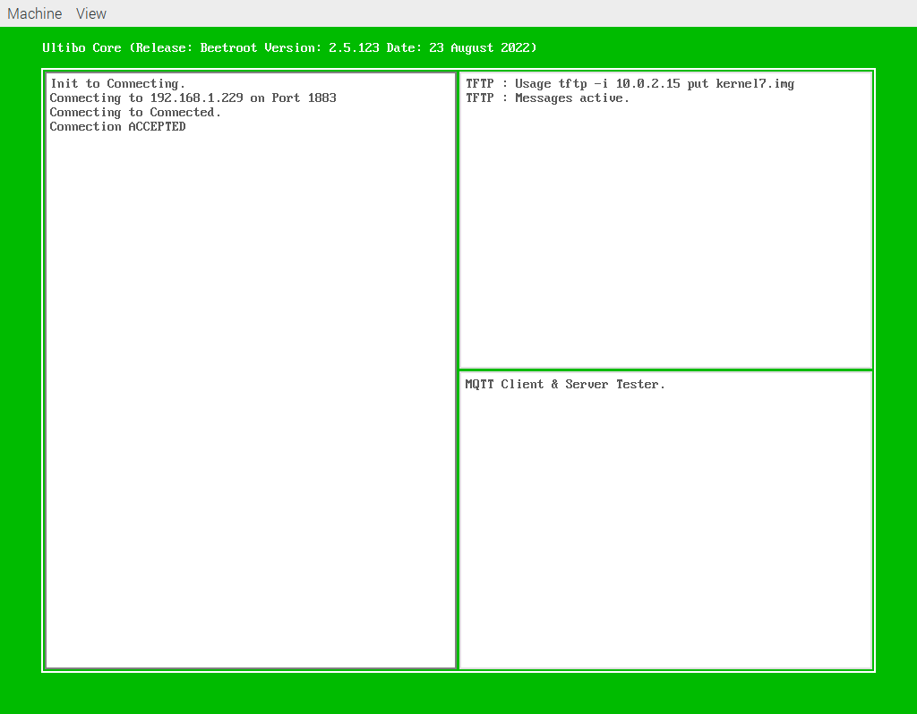
This is a subscriber on a RPi4B
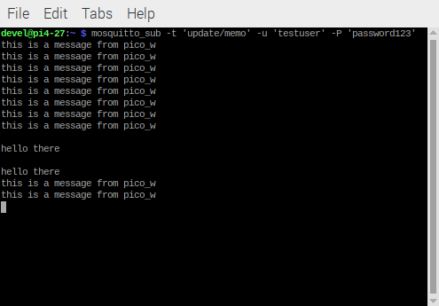

Testing the pico_w mqtt as a publisher

mqtt_request_cb_t pub_mqtt_request_cb_t;

mqtt_example_init

char PUB_PAYLOAD[] = "this is a message from pico_w";
printf("%s %d \n",PUB_PAYLOAD,sizeof(PUB_PAYLOAD));

mqtt_publish(mqtt_client,"update/memo",PUB_PAYLOAD,sizeof(PUB_PAYLOAD),2,0,pub_mqtt_request_cb_t,"test");

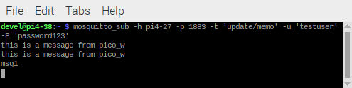
The publisher on RPi4B

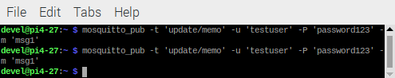
ultibo receives message from pico_w
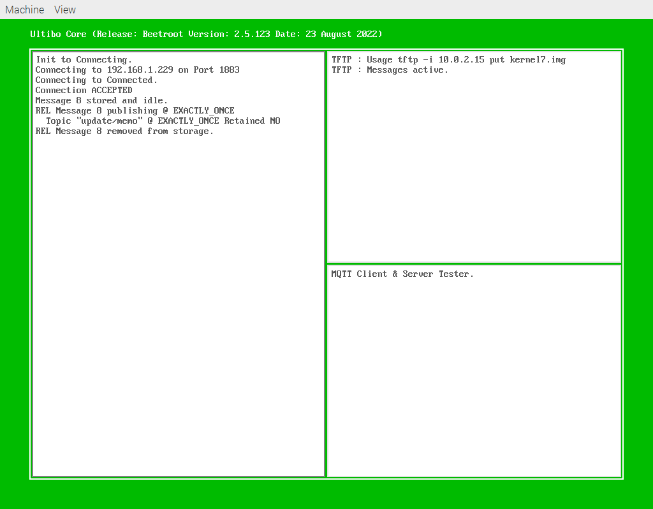
several messages received from multiple publisher.

