******************Default******************
testing outdated repo pico-tflmicro
forked from https://github.com/raspberrypi/pico-tflmicro
https://github.com/develone/pico-tflmicro-090222
magic_wand
09/15/22

******************Default******************

openocd -f interface/raspberrypi-swd.cfg -f target/rp2040.cfg -c "program examples/magic_wand/gesture_output_handler_test.elf verify reset exit"
gesture_output_handler_test

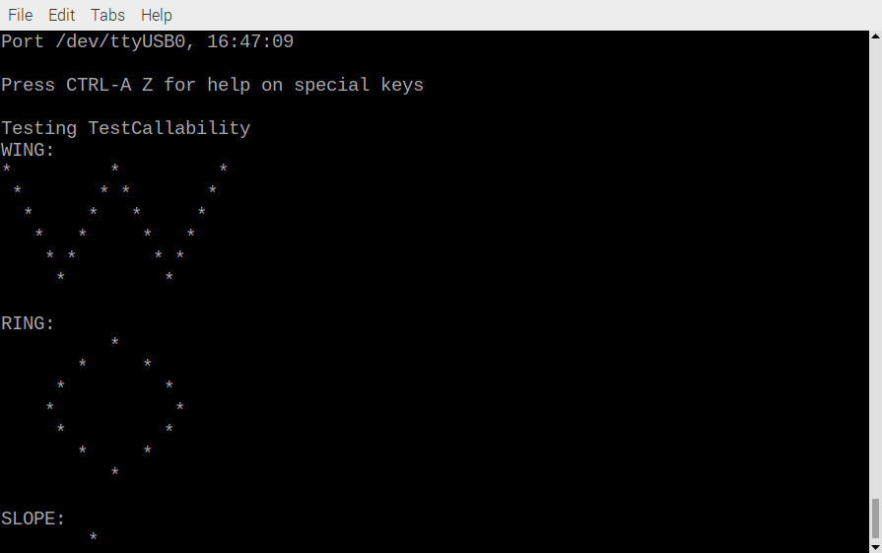
2nd set of outputs
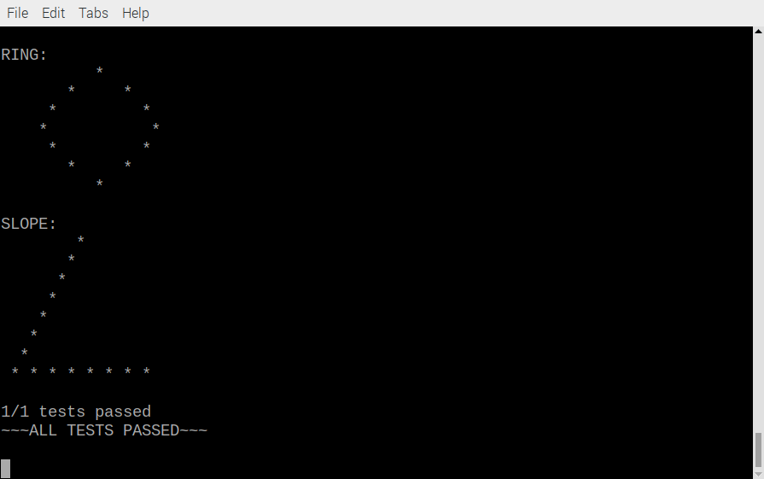
openocd -f interface/raspberrypi-swd.cfg -f target/rp2040.cfg -c "program examples/magic_wand/magic_wand_test.elf verify reset exit"

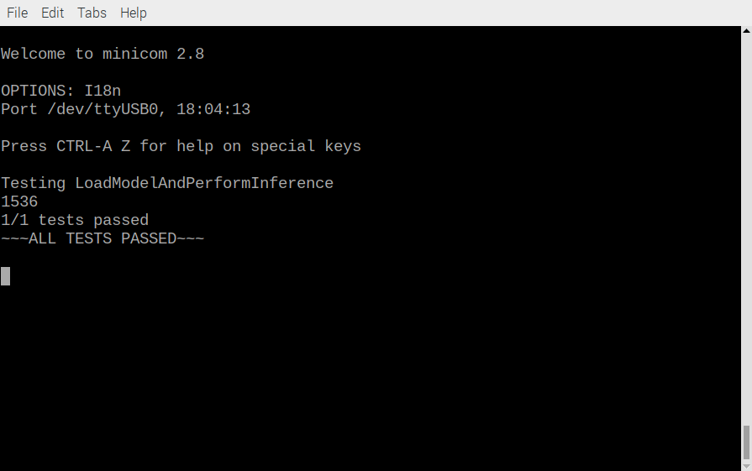
openocd -f interface/raspberrypi-swd.cfg -f target/rp2040.cfg -c "program examples/magic_wand/gesture_accelerometer_handler_test.elf verify reset exit"

