*****************Draft*****************
Arduino IDE
1,18.19
RPi4B 8Gb
Raspbery Pi 32 Bit OS
Nano RP2040 Connect
09/30/22
*****************Draft*****************

arduino-1.8.19-linuxarm.tar.xz

arduino-linux-setup.sh

Board “Arduino Nano RP2040 Connect”
Arduino Mbed OS Nano Boards
Arduino Nano RP2040 Connect

sudo su
root@pi4-27:/home/devel# cd Downloads/arduino-1.8.19
root@pi4-27:/home/devel/Downloads/arduino-1.8.19# ./arduino
Picked up JAVA_TOOL_OPTIONS:

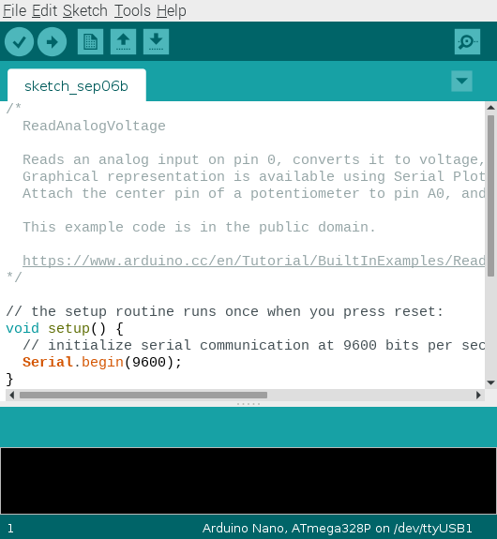

https://www.youtube.com/watch?v=z8s3nl_C5sg
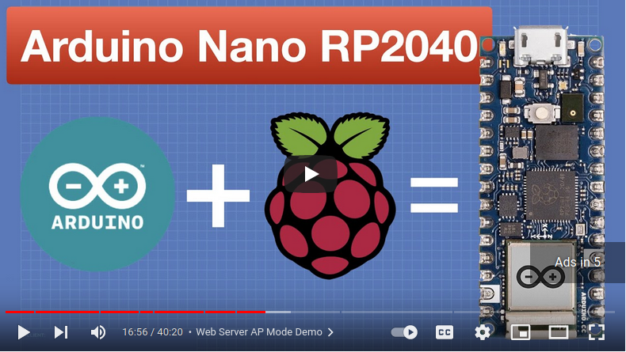
He indicated that when uploading getting and error.
This script might be a fix
/root/.arduino15/packages/arduino/hardware/mbed_nano/3.3.0/post_install.sh

Describes install the
Nano RP2040 Connect
Arduino Mbed OSNano Boards

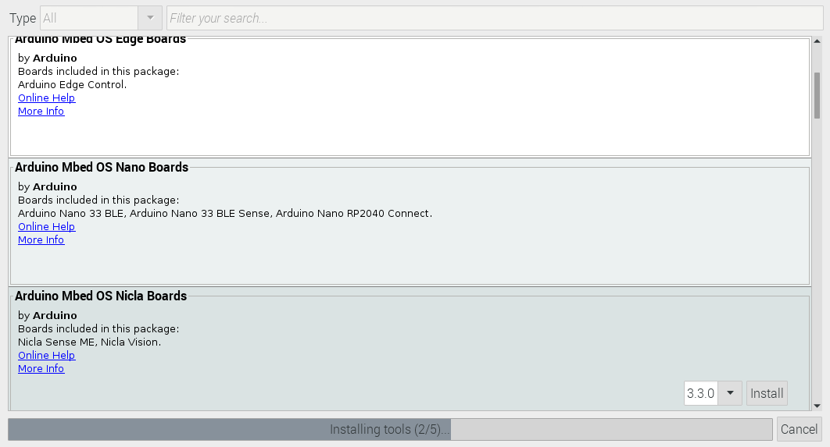
This can be removed if needed.
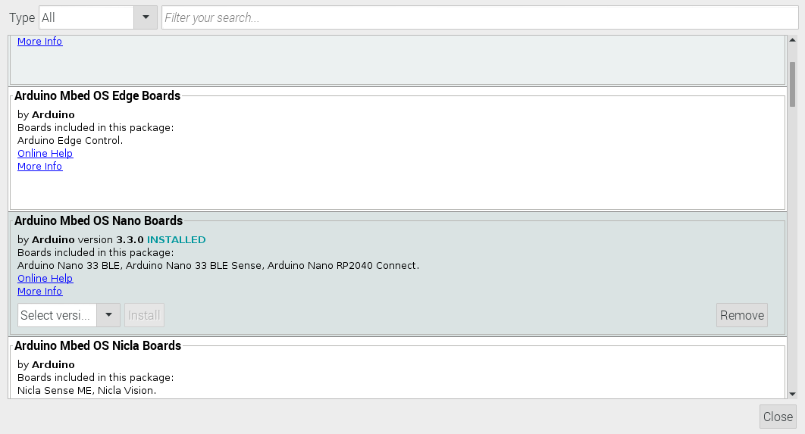
Xx
WiFiNINA
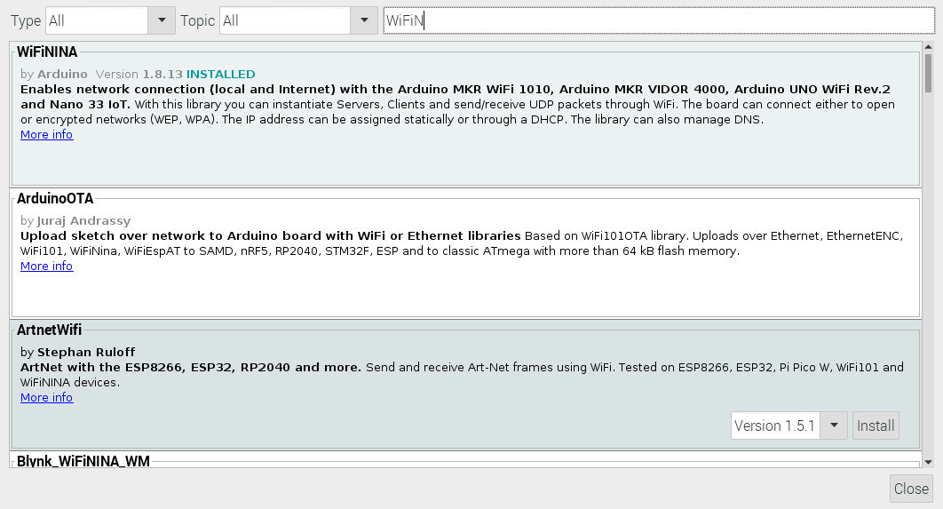

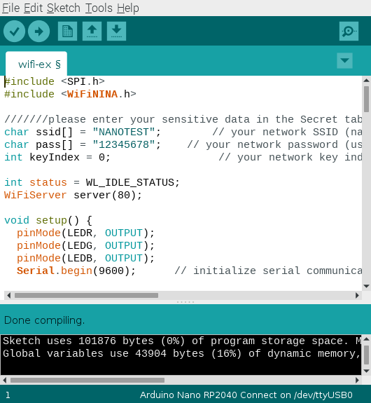
xxx

https://docs.arduino.cc/tutorials/nano-rp2040-connect/rp2040-imu-basics

Arduino_LSM6DSOX STM32duino X-NUCLEO-IKS01A3

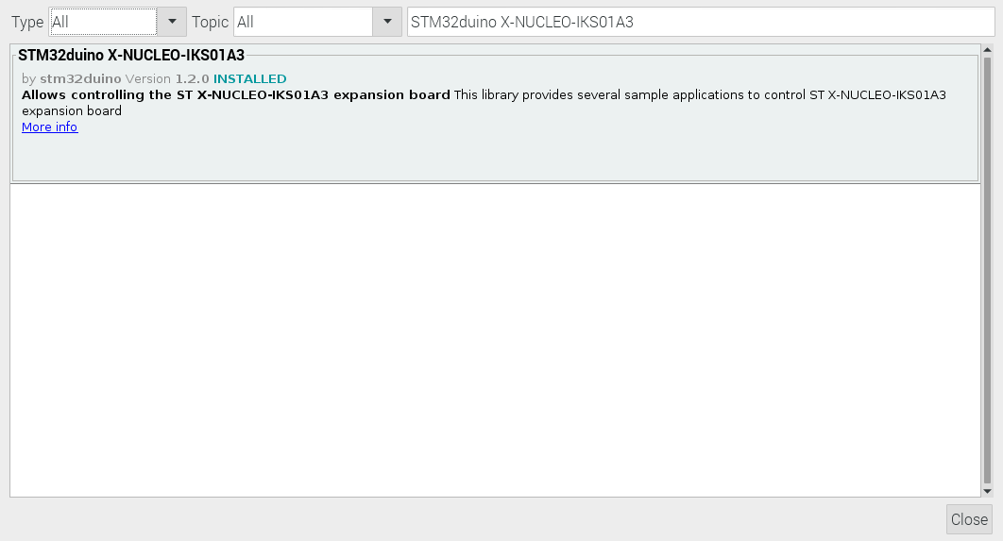
In line 47 added #define INT_1 INT_IMU per the video
//#define INT_1 A5
