************************Draft************************
Relook Ultibo
05/08/26
************************Draft************************

In 2013 I tried working with FPGA.
see
https://github.com/develone/zedboard_yocto/blob/master/doc/Zedboard_Yocto_test.pdf

see
https://github.com/develone/07118catzip/blob/master/doc/zipcpu.pdf

see
https://github.com/develone/102121icozip/blob/catzip/doc/Working-Software-092821.pdf

I started working with Ultibo since 2016.
x
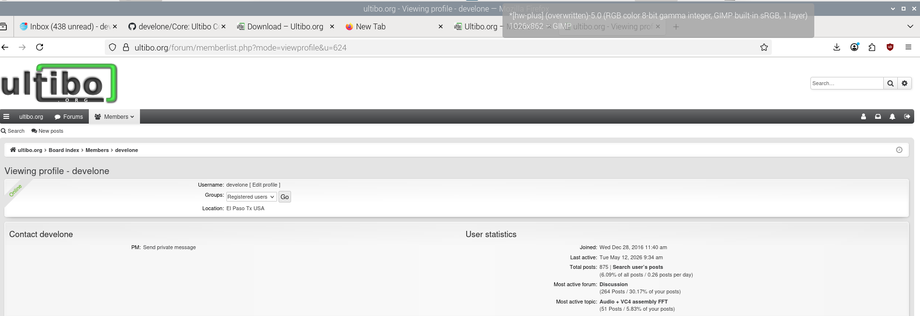
This was shortly after the projected started in 2015,

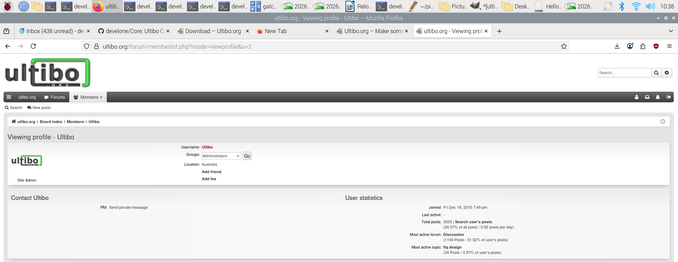
x
2025-11-24-raspios-bookworm-arm64.img
Installed bookworm release on Raspberry Pi4 4Gb pi4-50

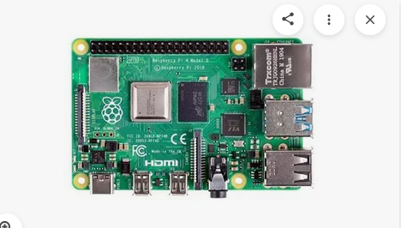
x
devel@pi4-50:~ $ shasum extra64.sh
1d92b567c492321c21ce7baaeebfd7e0cf83db3d extra64.sh

curl https://pyenv.run | bash
05/12/26
devel@pi5-90:/media/devel/1b763776-4e1d-499c-9f24-a116a58c161f $ ls 64bit-pi4-26/
extra_pkgs.sh extra_pkgs.sh.orig
installed-openocd082722-228ede-64bit.img
openocd082722-228ede-64bit.img
qemu-6.2.0-64bit.img qemu-6.2.0-rpios-64bit.img
devel@pi4-50:~ $ sudo unsquashfs -d qemu-6.2.0 qemu-6.2.0-64bit.img
devel@pi4-50:~ $ sudo unsquashfs -d qemu-6.2.0-rpios qemu-6.2.0-rpios-64bit.img
qemu.sh
#!/bin/bash
export QEMU_PATH=$HOME/qemu-6.2.0-rpios/bin
export PATH=$QEMU_PATH:$PATH
echo $PATH

devel@pi4-50:~ $ ./ultiboinstaller.sh
Linux installer for Free Pascal and Lazarus (Ultibo edition)
------------------------------------------------------------
This installation will download the sources for:
Ultibo core
Ultibo tools
Ultibo examples
Free Pascal (Ultibo edition)
Lazarus IDE (Ultibo edition)

Then it will build all of the above, this will take several
minutes to complete depending on the speed of your system.

The installation will not interfere with any existing
development environments including other installations
of Free Pascal and Lazarus.

Continue (y/n)?
Do you want to build and install the Lazarus IDE (y/n)?
These can be installed on Debian based distributions using:

sudo apt-get install build-essential gdb-minimal unzip

Lazarus IDE requires the GTK2 and X11 dev packages which
can be installed on Debian based distributions by using:

sudo apt-get install libgtk2.0-dev libcairo2-dev \
libpango1.0-dev libgdk-pixbuf2.0-dev libatk1.0-dev \
libghc-x11-dev

(On some distributions libgdk-pixbuf2.0-dev might
have been replaced by libgdk-pixbuf-xlib-2.0-dev)

Cross compiling Ultibo applications from Linux requires the
arm-none-eabi and aarch64-linux-gnu builds of the binutils
package, these can be installed on Debian based distributions
using:

sudo apt-get install binutils-arm-none-eabi \
binutils-aarch64-linux-gnu

Press return to check for these prerequisites

Enter an installation folder or press return to
accept the default install location

[/home/devel/ultibo/core]:
The install folder will be:
/home/devel/ultibo/core

Continue? (y,n):
After install do you want a shortcut created in:
/home/devel/.local/share/applications (y/n)?
Do you want to build the Hello World examples (y/n)?

Tested Raspbery Pi-Zero
x
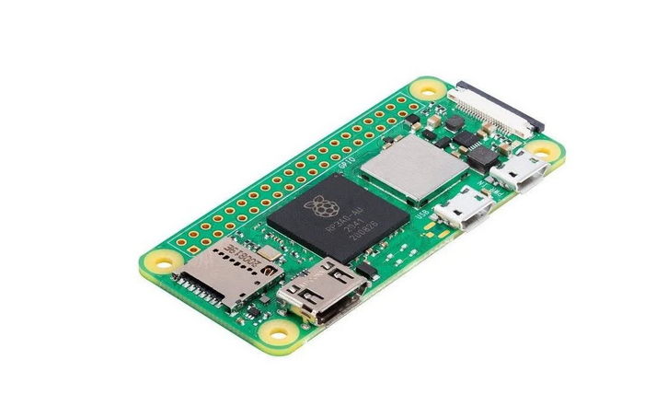
x
This is an example of the HelloWorld for the Raspberry Pi-Zero.
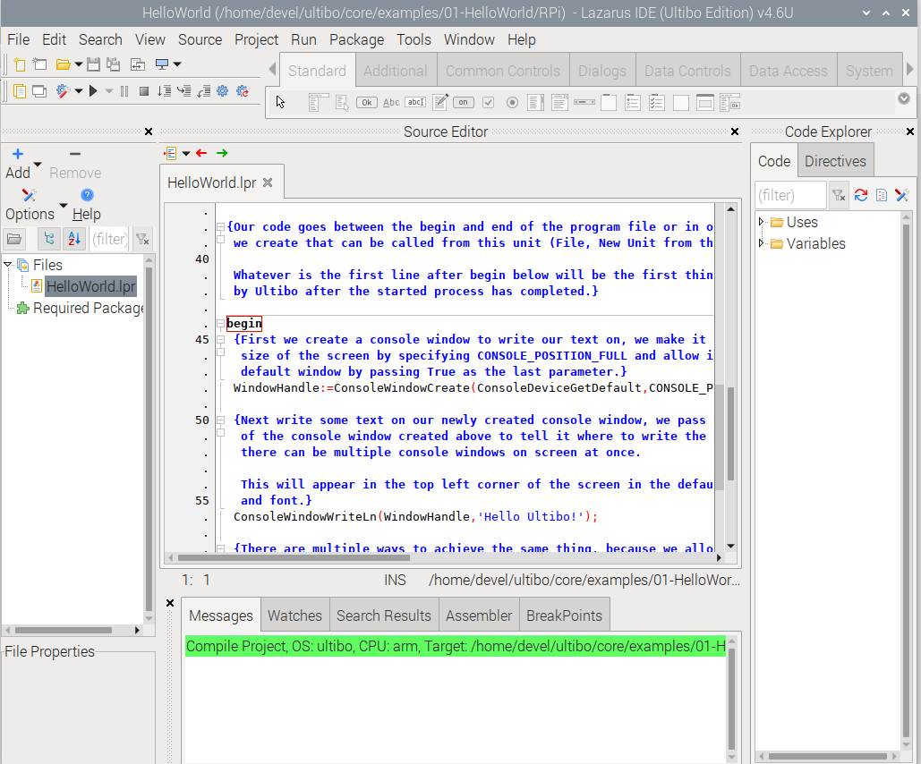

Green bar indicates that he prog rom compile ok.
X

x
devel@pi4-50:~/Ultibo_Projects/HelloWorld-plus/RPi $ diff HelloWorld.lpr ~/ultibo/core/examples/01-HelloWorld/RPi/HelloWorld.lpr
57,62c57
< ConsoleWindowWriteLn(WindowHandle,'This program was compiled using');
< ConsoleWindowWriteLn(WindowHandle,'on a Raspberry Pi4 4GB');
< ConsoleWindowWriteLn(WindowHandle,'running Lazarus IDE Ultibo Edition');
< ConsoleWindowWriteLn(WindowHandle,'These 4 files below plus kernel.img');
< ConsoleWindowWriteLn(WindowHandle,'Are all that are required for the rpi-zero');
< ConsoleWindowWriteLn(WindowHandle,'bootcode.bin fixup.dat fixup_x.dat start4x.elf start.elf');
---
>
Green bar indicates that he prog rom compile ok.
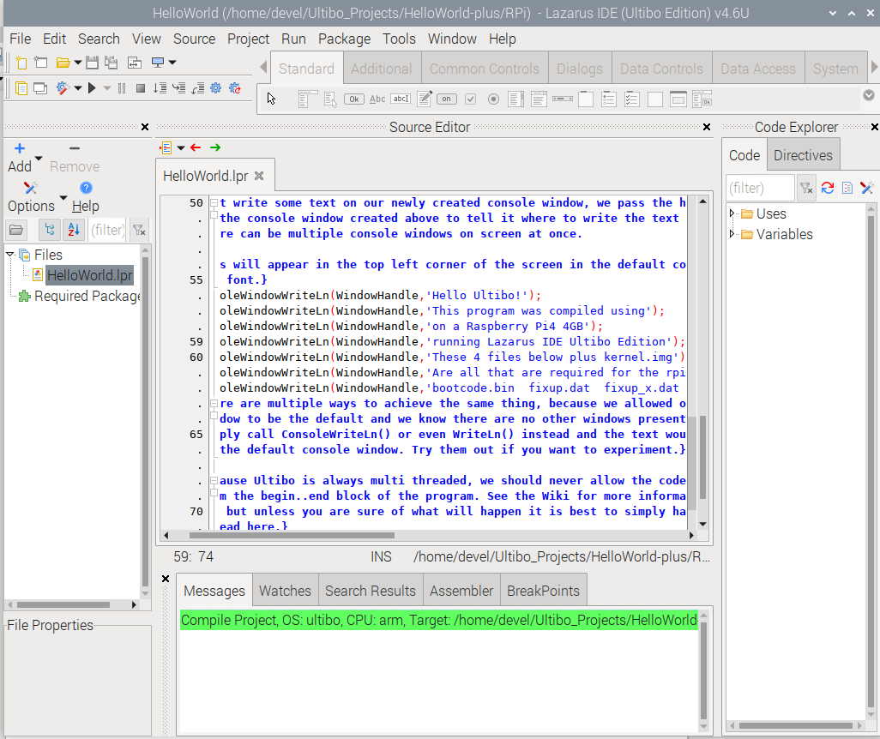
devel@pi4-50:~/ultibo/core/examples/01-HelloWorld/RPi $ ls ~/firmwar_for_ultibo/112221/
bootcode.bin fixup.dat fixup_x.dat start4x.elf start.elf plus kernel.img
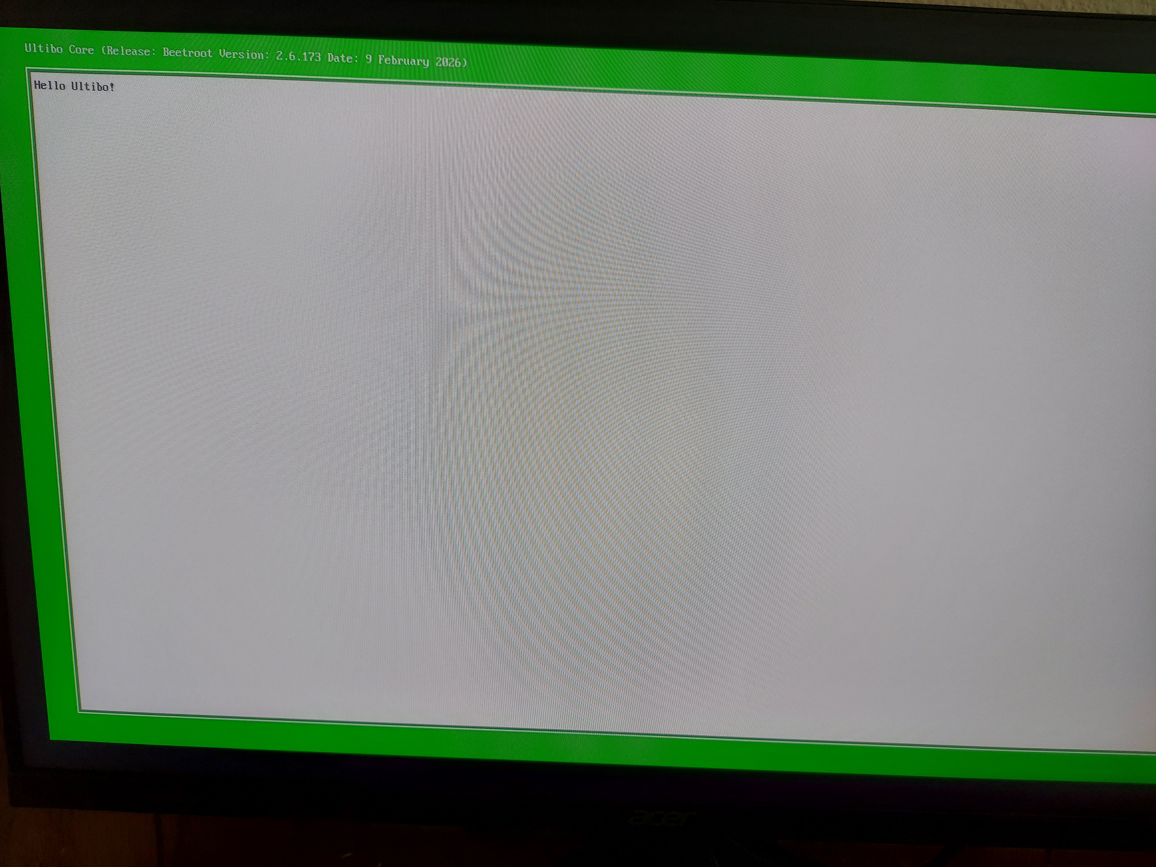
devel@pi4-50:~/ultibo/core/examples/01-HelloWorld/RPi $ ls ~/firmwar_for_ultibo/112221/
bootcode.bin fixup.dat fixup_x.dat start4x.elf start.elf plus kernel.img
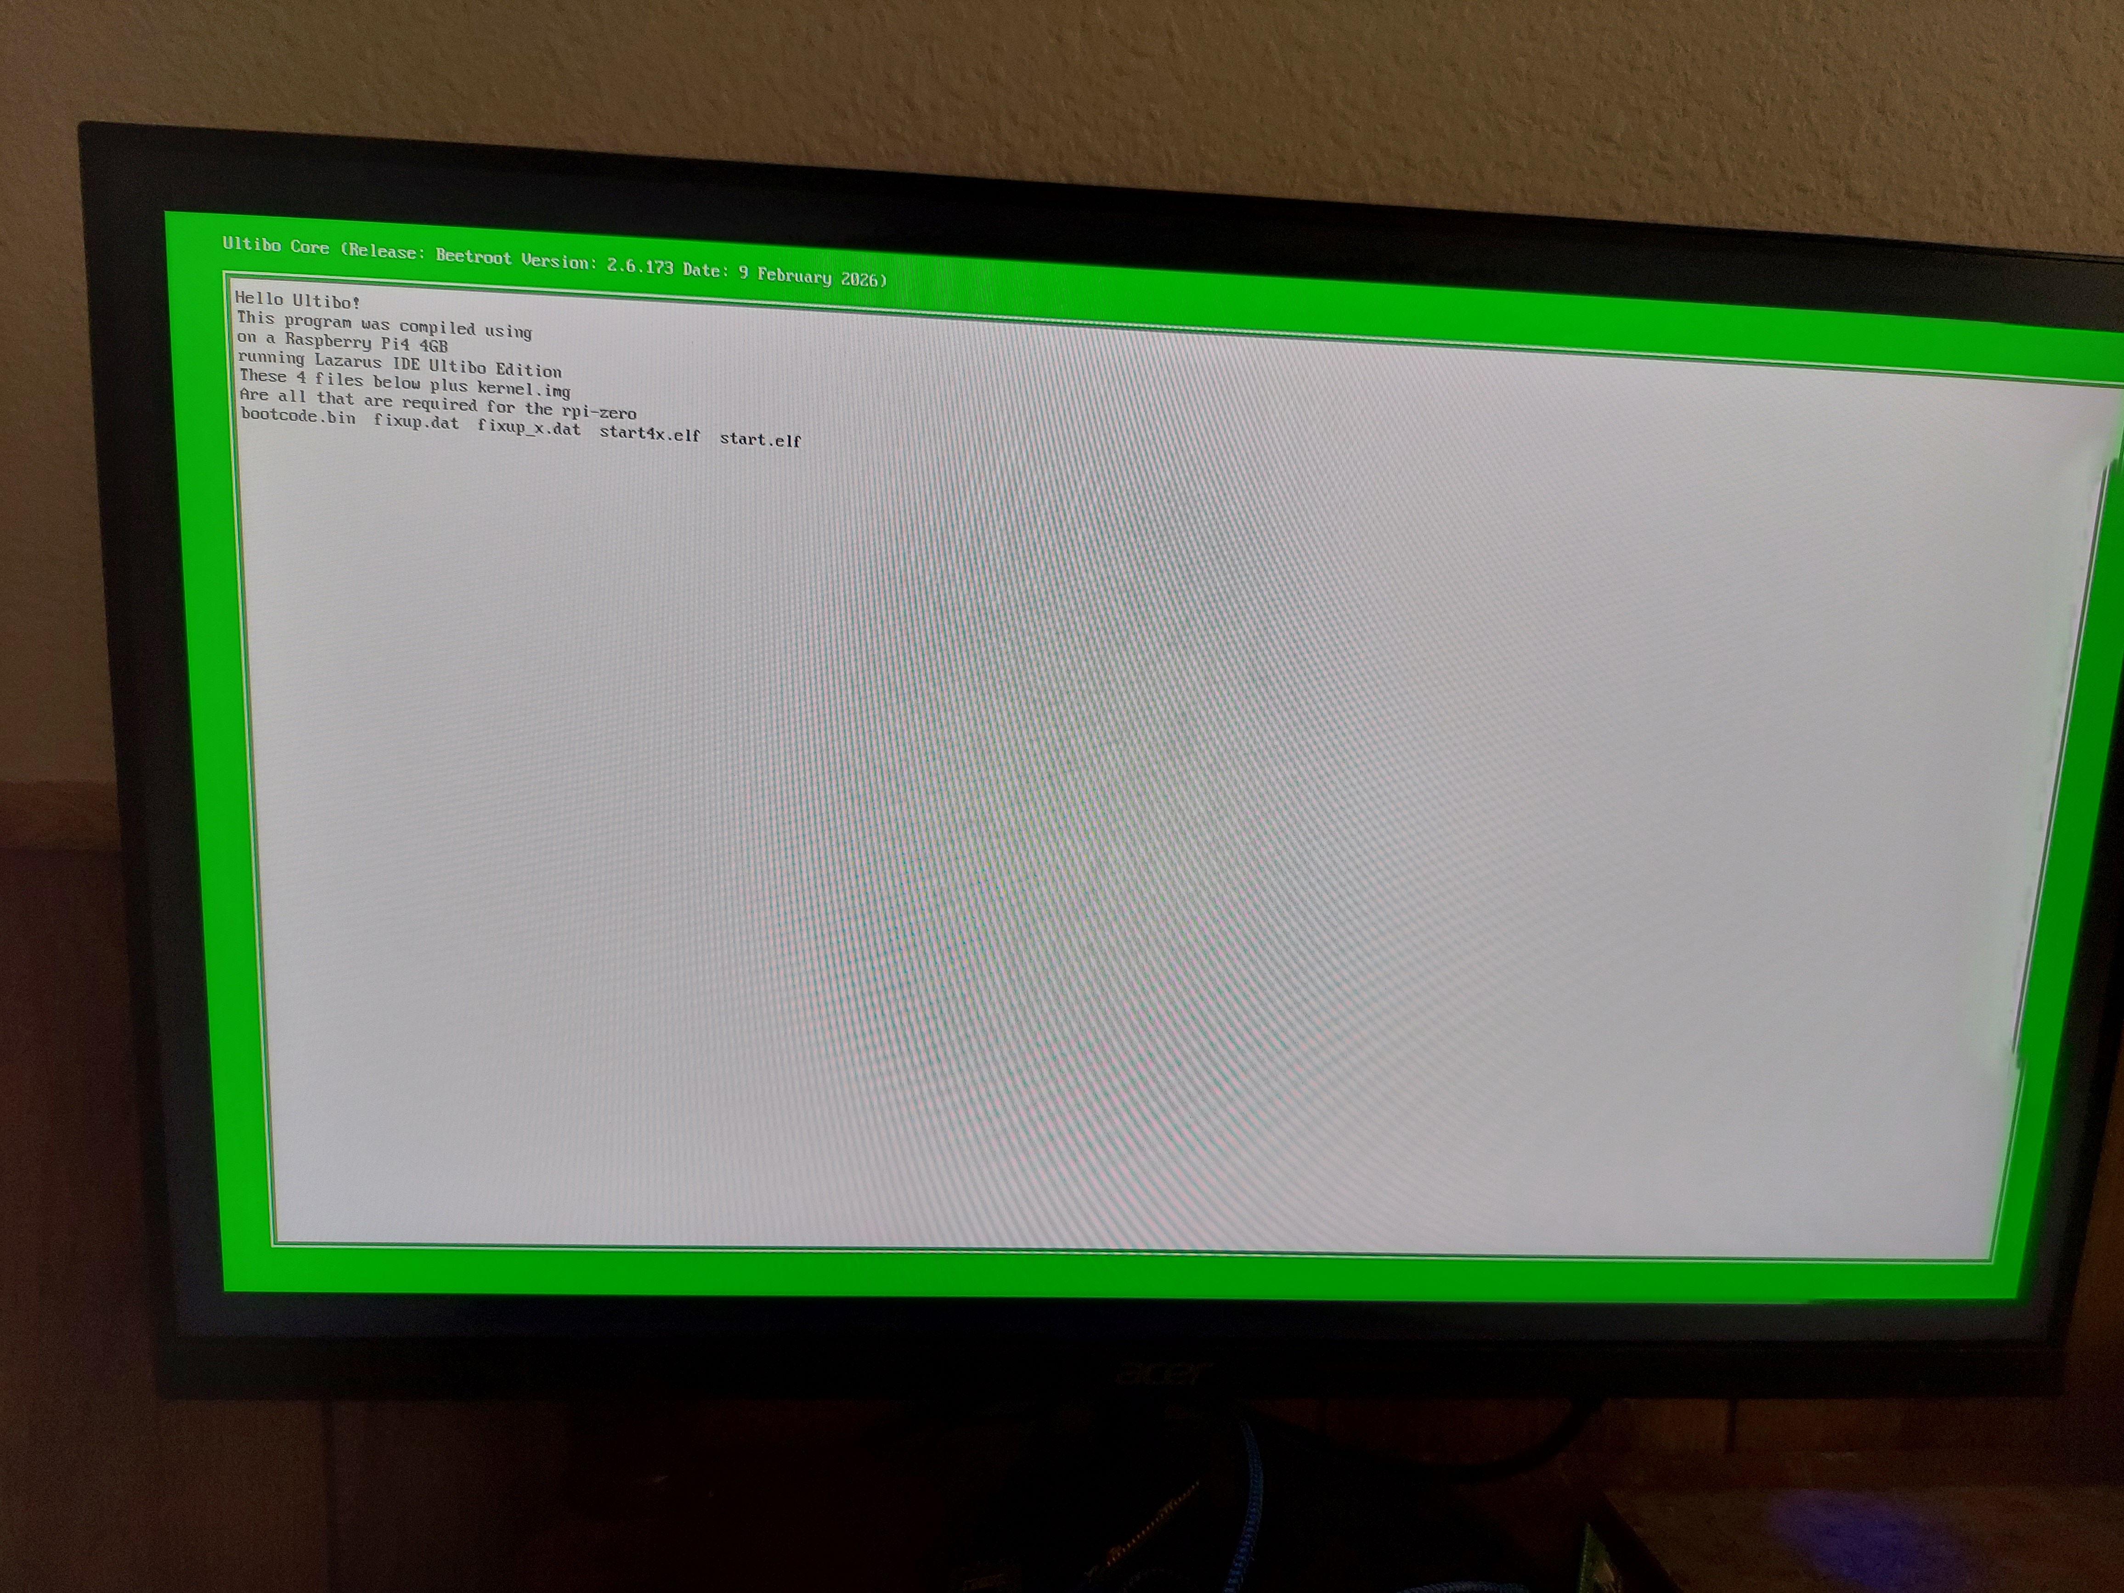
x
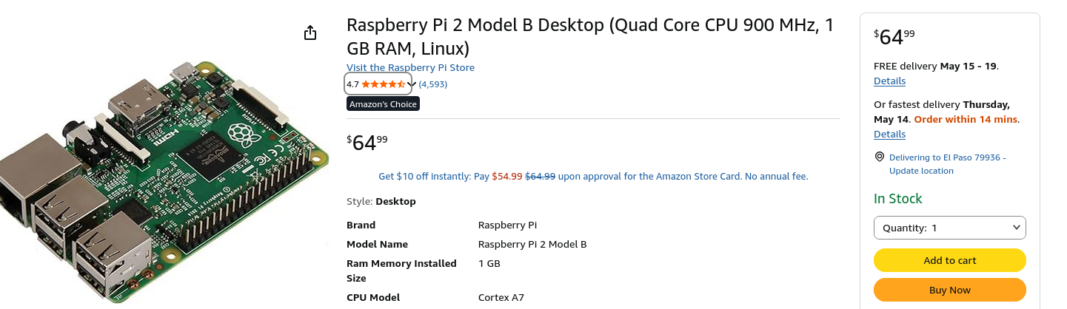
x

devel@pi4-50:~/Ultibo_Projects/jpeg2000/src $ ./compile_ultibo.sh

devel@pi4-50:~/Ultibo_Projects/jpeg2000/src $ ls *.c | wc
22 22 182

devel@pi4-50:~/Ultibo_Projects/jpeg2000/src $ ls *.c
bio.c invert.c opj_clock.c t2.c
cio.c j2k.c opj_malloc.c tcd.c
dwt.c jp2.c pi.c tgt.c
event.c mct.c rd-wr-ops.c thread.c
function_list.c mqc.c sparse_array.c
image.c openjpeg.c t1.c

devel@pi4-50:~/Ultibo_Projects/jpeg2000/QEMU $ ./libbuild.sh
dwtlift.c: In function 'decompress':
dwtlift.c:658:17: warning: implicit declaration of function 'octave_write_byte' [-Wimplicit-function-declaration]
658 | octave_write_byte(r_decompress_fn,r_decompress,da_x1*da_y1);
| ^~~~~~~~~~~~~~~~~
when ./libbuild.sh is executed should be 23
23 23 192 libdwtlift_obj.txt

x

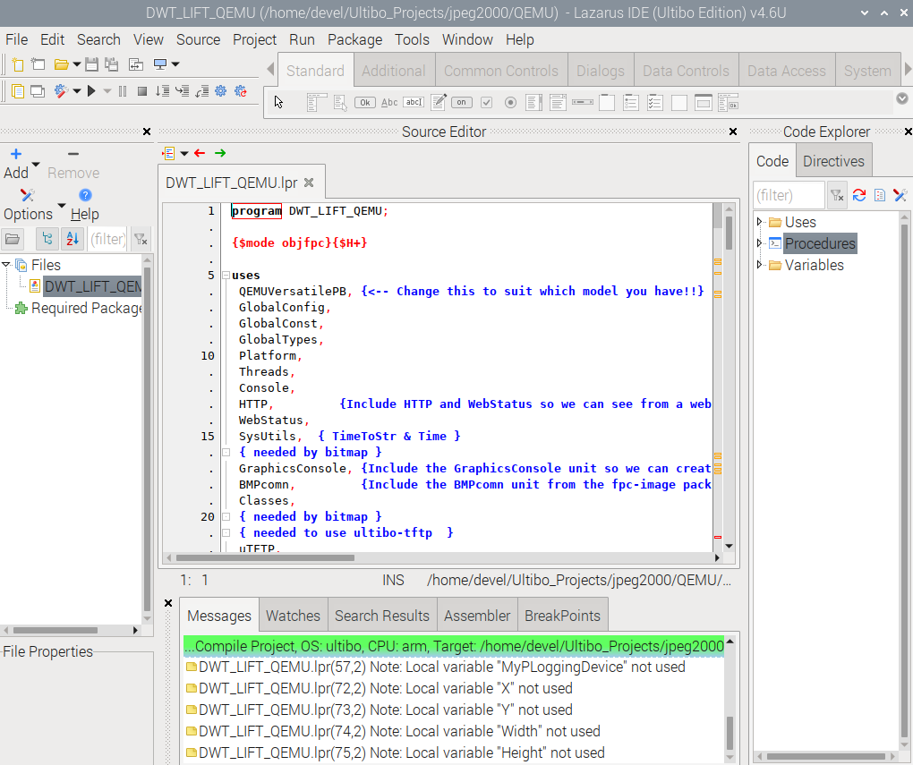
x

devel@pi4-50:~/Ultibo_Projects/jpeg2000/QEMU $ . ~/qemu.sh
/home/devel/qemu-6.2.0-rpios/bin:/home/devel/.pyenv/plugins/pyenv-virtualenv/shims:/home/devel/.pyenv/shims:/home/devel/.pyenv/bin:/home/devel/local/openocd/bin:/usr/local/sbin:/usr/local/bin:/usr/sbin:/usr/bin:/sbin:/bin:/usr/local/games:/usr/games
devel@pi4-50:~/Ultibo_Projects/jpeg2000/QEMU $ ./startqemu.sh
x
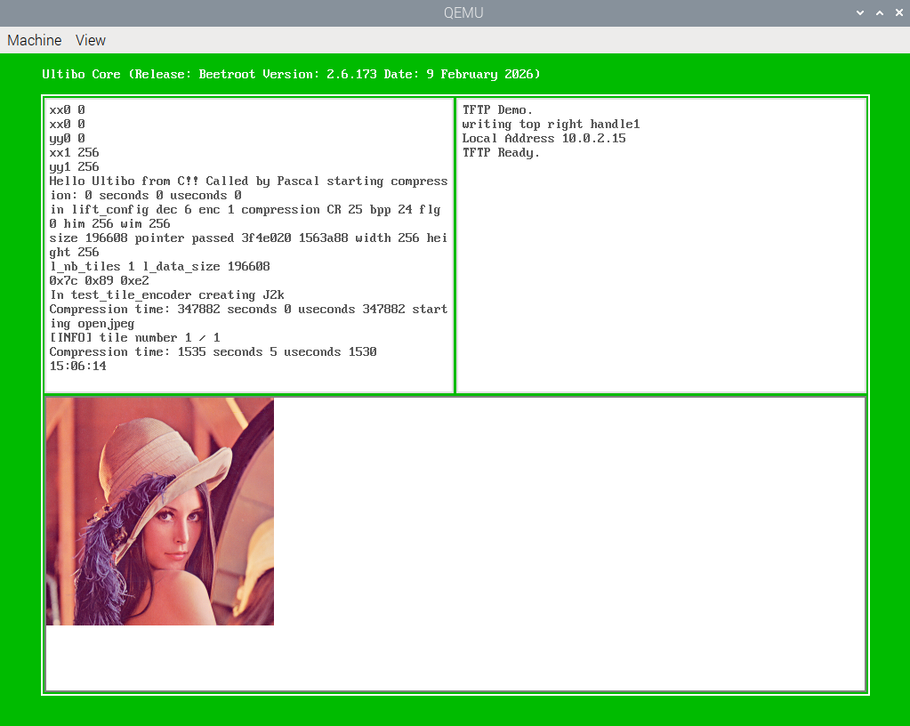
The image above indicates that kernel7.img.jpeg is the file kernel7.img

devel@pi5-70:~ $ telnet 192.168.12.161

C:\> dir
Ultibo Core (Release: Beetroot Version: 2.6.173 Date: 9 February 2026)
(Type HELP for a list of available commands)
Directory of C:\

2026-05-11 22:42:30 24 config-1.txt
2026-05-09 16:12:42 52460 bootcode.bin
2026-05-09 16:12:42 7221 fixup.dat
2026-05-09 16:12:42 10197 fixup_x.dat
2026-05-09 16:12:42 2963616 start.elf
2026-05-09 16:12:42 2991400 start4x.elf
2026-05-09 16:10:36 24 256com
2026-05-09 16:10:36 24 256decom
2026-05-09 16:10:36 196730 lena_rgb_256.bmp
2026-05-11 18:33:08 24 testfile
2026-05-12 21:19:09 7848 test.j2k
2026-05-11 18:32:30 196730 MyBitmap.bmp
2026-05-11 18:19:28 3787872 kernel7.img
2026-05-12 01:36:28 2996612 kernel7.img.dwt
2026-05-11 18:19:28 3787872 kernel7.img.jpeg
2026-05-12 01:39:28 196662 MySavedBitmap.bmp
16 file(s) 17195316 bytes
0 dir(s)

C:\> del kernel7.img
C:\> copy kernel7.img.dwt kernel7.img
1 file(s) copied
C:\> dir
Directory of C:\

2026-05-11 22:42:30 24 config-1.txt
2026-05-09 16:12:42 52460 bootcode.bin
2026-05-09 16:12:42 7221 fixup.dat
2026-05-09 16:12:42 10197 fixup_x.dat
2026-05-09 16:12:42 2963616 start.elf
2026-05-09 16:12:42 2991400 start4x.elf
2026-05-09 16:10:36 24 256com
2026-05-09 16:10:36 24 256decom
2026-05-09 16:10:36 196730 lena_rgb_256.bmp
2026-05-11 18:33:08 24 testfile
2026-05-12 21:19:09 7848 test.j2k
2026-05-11 18:32:30 196730 MyBitmap.bmp
2026-05-12 01:36:28 2996612 kernel7.img.dwt
2026-05-11 18:19:28 3787872 kernel7.img.jpeg
2026-05-12 01:39:28 196662 MySavedBitmap.bmp
2026-05-12 01:36:28 2996612 kernel7.img
16 file(s) 16404056 bytes
0 dir(s)

The list above indicates that kernel7.img.dwt is the file kernel7.img
C:\ restart
Restarting in 1000 milliseconds
The image below will now be displayed.
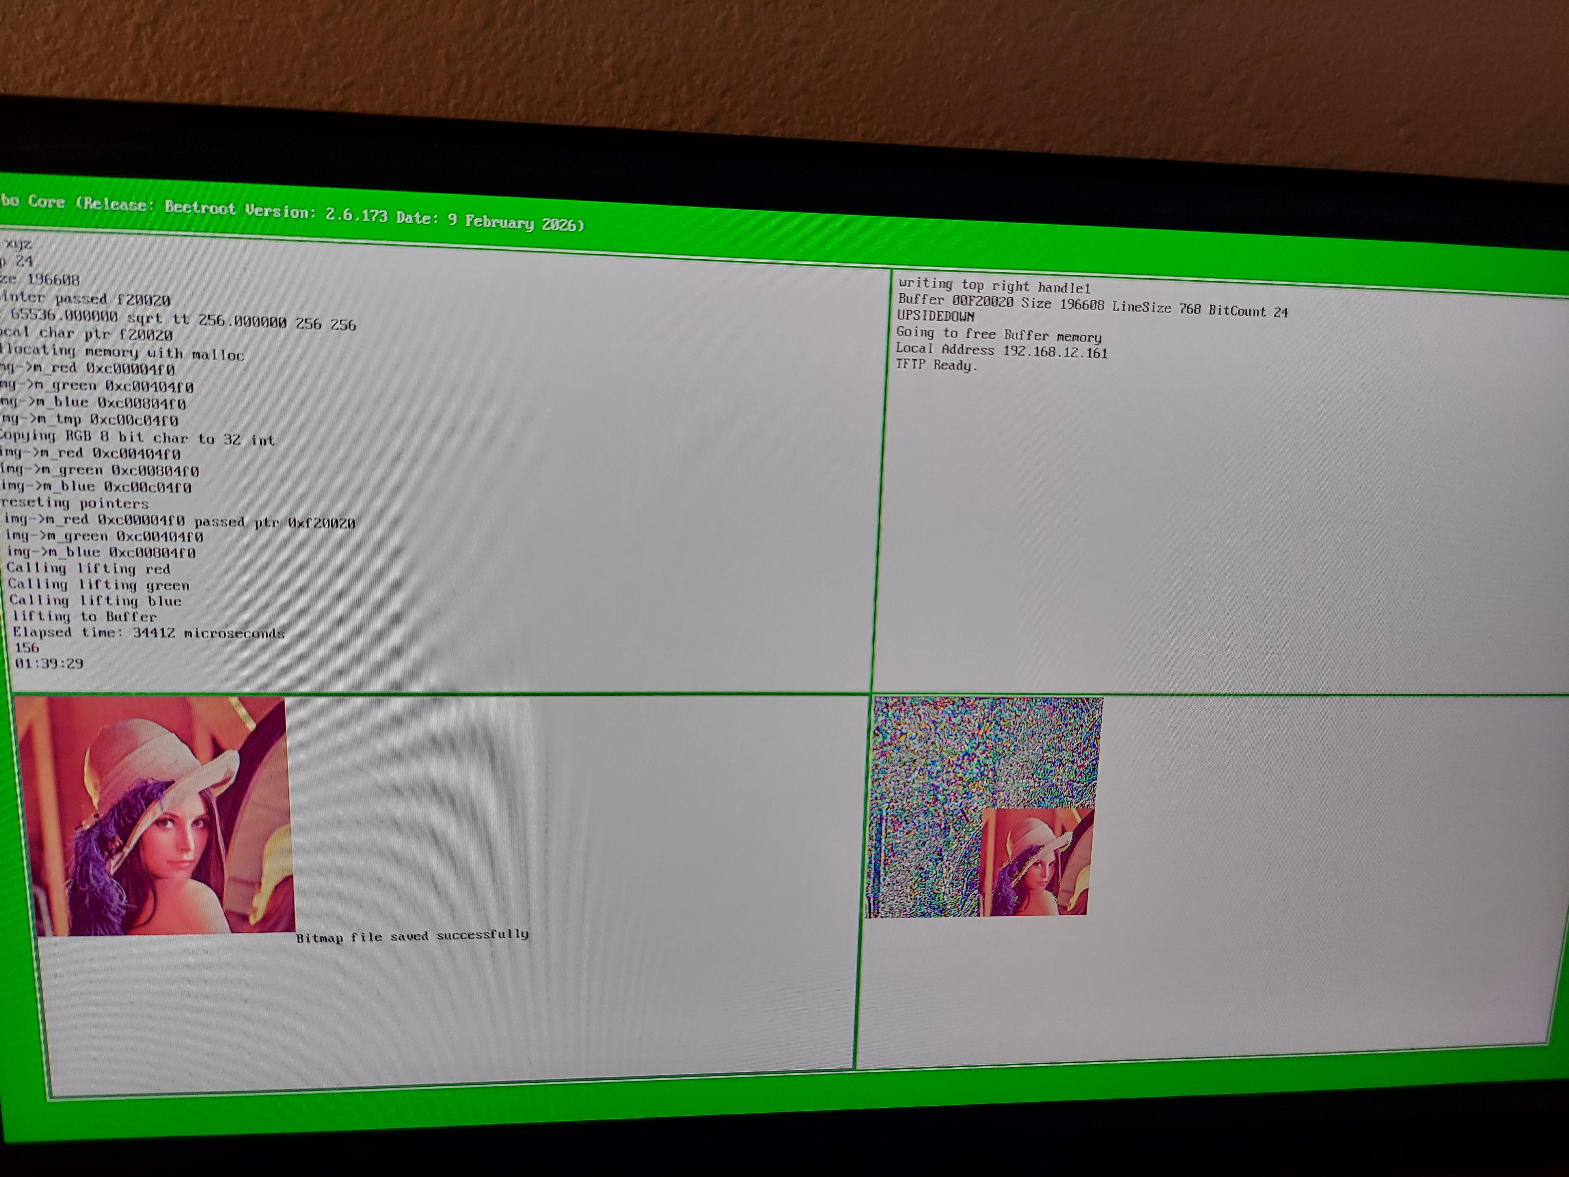
x

