*******************Draft*******************
pico_w with bluetooth support
Built pico-examples on pi4-27 and rsync'ed to pi4-50, pi4-60, and pi4-20.
sm_pairing_central
between
sm_pairing_peripheral
02/11/23
*******************Draft*******************

https://www.cnx-software.com/2023/02/11/raspberry-pi-pico-w-bluetooth-le-support/

2 Raspberry Pi 4

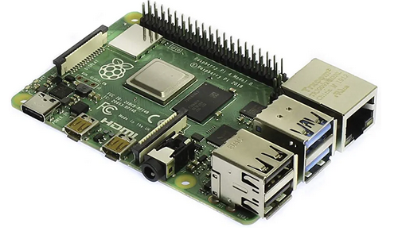

2 pico_w

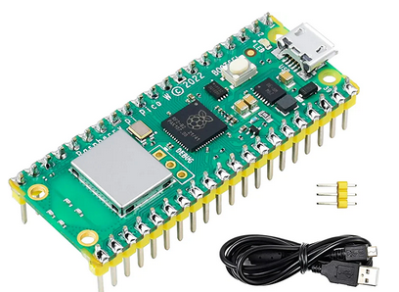
2 USB

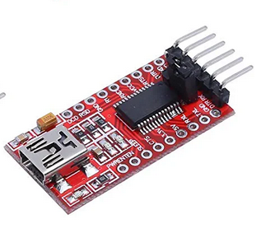

Updated pico-sdk from Jun 29 22 SDK 1.4.0 release to Feb 10 23
release SDK 1.5.0

cd sdk/

git clone https://github.com/develone/pico-sdk.git

cd pico-sdk

git submodule update --init

release SDK 1.5.0

cd ~/

git clone https://github.com/develone/pico-examples.git

cd pico-examples

mkdir build

Need to modify the following files with
#include "pw_ssid.h"
if (cyw43_arch_wifi_connect_timeout_ms("your wifi ssid", WIFI_PASSWORD, CYW43_AUTH_W
modified: pico_w/bt/standalone/server_with_wifi.c
modified: pico_w/wifi/freertos/iperf/picow_freertos_iperf.c
modified: pico_w/wifi/freertos/ping/picow_freertos_ping.c
modified: pico_w/wifi/iperf/picow_iperf.c
modified: pico_w/wifi/ntp_client/picow_ntp_client.c
modified: pico_w/wifi/tcp_client/picow_tcp_client.c
modified: pico_w/wifi/tcp_server/CMakeLists.txt
modified: pico_w/wifi/tcp_server/picow_tcp_server.c
modified: pico_w/wifi/tls_client/picow_tls_client.c
modified: pico_w/wifi/udp_beacon/picow_udp_beacon.c
Need to add a files pw_ssid.h
#ifndef _SSID_H
#define _SSID_H

char WIFI_PASSWORD[] = "your wifi password";

#endif
pico_w/wifi/freertos/ping/pw_ssid.h
pico_w/wifi/iperf/pw_ssid.h
pico_w/wifi/ntp_client/pw_ssid.h
pico_w/wifi/tcp_client/pw_ssid.h
pico_w/wifi/tcp_server/pw_ssid.h

pico_w/wifi/tls_client/pw_ssid.h
pico_w/wifi/udp_beacon/pw_ssid.h

cmake -DPICO_BOARD=pico_w -DTEST_TCP_SERVER_IP="xx.xx.xx.xx" -DWIFI_SSID="your ssid" -DWIFI_PASSWORD="your ssid password" -DFREERTOS_KERNEL_PATH:PATH=/home/devel/FreeRTOS-Kernel ..

make

pi4-20

openocd -f interface/raspberrypi-swd.cfg -f target/rp2040.cfg -c "program pico_w/bt/sm_pairing_central/picow_bt_example_sm_pairing_central_background.elf reset exit"

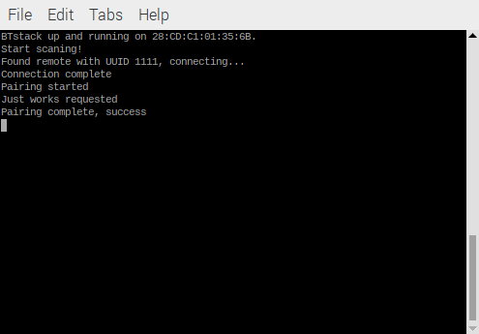

pi4-60

openocd -f interface/raspberrypi-swd.cfg -f target/rp2040.cfg -c "program pico_w/bt/sm_pairing_peripheral/picow_bt_example_sm_pairing_peripheral_background.elf verify reset exit"

