*********************Draft*********************
Arduino Nano RP2040 Connect Test
10/05/22
*********************Draft*********************

adding line 47 #define INT_1 INT_IMU
commenting 62 //#define INT_1 A5
https://docs.arduino.cc/tutorials/nano-rp2040-connect/rp2040-web-server-rgb#programming-the-board
/**
******************************************************************************
* @file X_NUCLEO_IKS01A3_LSM6DSOX_MLC.ino
* @author SRA
* @version V1.1.0
* @date March 2020
* @brief Arduino test application for the STMicrolectronics X-NUCLEO-IKS01A3
* MEMS Inertial and Environmental sensor expansion board.
* This application makes use of C++ classes obtained from the C
* components' drivers.
******************************************************************************
* @attention
*
* <h2><center>&copy; COPYRIGHT(c) 2020 STMicroelectronics</center></h2>
*
* Redistribution and use in source and binary forms, with or without modification,
* are permitted provided that the following conditions are met:
* 1. Redistributions of source code must retain the above copyright notice,
* this list of conditions and the following disclaimer.
* 2. Redistributions in binary form must reproduce the above copyright notice,
* this list of conditions and the following disclaimer in the documentation
* and/or other materials provided with the distribution.
* 3. Neither the name of STMicroelectronics nor the names of its contributors
* may be used to endorse or promote products derived from this software
* without specific prior written permission.
*
* THIS SOFTWARE IS PROVIDED BY THE COPYRIGHT HOLDERS AND CONTRIBUTORS "AS IS"
* AND ANY EXPRESS OR IMPLIED WARRANTIES, INCLUDING, BUT NOT LIMITED TO, THE
* IMPLIED WARRANTIES OF MERCHANTABILITY AND FITNESS FOR A PARTICULAR PURPOSE ARE
* DISCLAIMED. IN NO EVENT SHALL THE COPYRIGHT HOLDER OR CONTRIBUTORS BE LIABLE
* FOR ANY DIRECT, INDIRECT, INCIDENTAL, SPECIAL, EXEMPLARY, OR CONSEQUENTIAL
* DAMAGES (INCLUDING, BUT NOT LIMITED TO, PROCUREMENT OF SUBSTITUTE GOODS OR
* SERVICES; LOSS OF USE, DATA, OR PROFITS; OR BUSINESS INTERRUPTION) HOWEVER
* CAUSED AND ON ANY THEORY OF LIABILITY, WHETHER IN CONTRACT, STRICT LIABILITY,
* OR TORT (INCLUDING NEGLIGENCE OR OTHERWISE) ARISING IN ANY WAY OUT OF THE USE
* OF THIS SOFTWARE, EVEN IF ADVISED OF THE POSSIBILITY OF SUCH DAMAGE.
*
******************************************************************************
*/
//NOTE: This example isn't compatible with Arduino Uno.
//NOTE: For this example you need the STEVAL-MKI197V1 board connected to the DIL24 connector of the X-NUCLEO-IKS01A3

// Includes
#include "LSM6DSOXSensor.h"
#include "lsm6dsox_activity_recognition_for_mobile.h"

#define INT_1 INT_IMU

#ifdef ARDUINO_SAM_DUE
#define DEV_I2C Wire1
#elif defined(ARDUINO_ARCH_STM32)
#define DEV_I2C Wire
#elif defined(ARDUINO_ARCH_AVR)
#define DEV_I2C Wire
#else
#define DEV_I2C Wire
#endif
#define SerialPort Serial

//#define INT_1 A5

//Interrupts.
volatile int mems_event = 0;

// Components
LSM6DSOXSensor AccGyr(&DEV_I2C, LSM6DSOX_I2C_ADD_L);

// MLC
ucf_line_t *ProgramPointer;
int32_t LineCounter;
int32_t TotalNumberOfLine;

void INT1Event_cb();
void printMLCStatus(uint8_t status);

void setup() {
uint8_t mlc_out[8];
// Led.
pinMode(LED_BUILTIN, OUTPUT);

// Force INT1 of LSM6DSOX low in order to enable I2C
pinMode(INT_1, OUTPUT);

digitalWrite(INT_1, LOW);

delay(200);

// Initialize serial for output.
SerialPort.begin(115200);

// Initialize I2C bus.
DEV_I2C.begin();

AccGyr.begin();
AccGyr.Enable_X();
AccGyr.Enable_G();

/* Feed the program to Machine Learning Core */
/* Activity Recognition Default program */
ProgramPointer = (ucf_line_t *)lsm6dsox_activity_recognition_for_mobile;
TotalNumberOfLine = sizeof(lsm6dsox_activity_recognition_for_mobile) / sizeof(ucf_line_t);
SerialPort.println("Activity Recognition for LSM6DSOX MLC");
SerialPort.print("UCF Number Line=");
SerialPort.println(TotalNumberOfLine);

for (LineCounter=0; LineCounter<TotalNumberOfLine; LineCounter++) {
if(AccGyr.Write_Reg(ProgramPointer[LineCounter].address, ProgramPointer[LineCounter].data)) {
SerialPort.print("Error loading the Program to LSM6DSOX at line: ");
SerialPort.println(LineCounter);
while(1) {
// Led blinking.
digitalWrite(LED_BUILTIN, HIGH);
delay(250);
digitalWrite(LED_BUILTIN, LOW);
delay(250);
}
}
}

SerialPort.println("Program loaded inside the LSM6DSOX MLC");

//Interrupts.
pinMode(INT_1, INPUT);
attachInterrupt(INT_1, INT1Event_cb, RISING);

/* We need to wait for a time window before having the first MLC status */
delay(3000);

AccGyr.Get_MLC_Output(mlc_out);
printMLCStatus(mlc_out[0]);
}

void loop() {
if (mems_event) {
mems_event=0;
LSM6DSOX_MLC_Status_t status;
AccGyr.Get_MLC_Status(&status);
if (status.is_mlc1) {
uint8_t mlc_out[8];
AccGyr.Get_MLC_Output(mlc_out);
printMLCStatus(mlc_out[0]);
}
}
}

void INT1Event_cb() {
mems_event = 1;
}

void printMLCStatus(uint8_t status) {
switch(status) {
case 0:
SerialPort.println("Activity: Stationary");
break;
case 1:
SerialPort.println("Activity: Walking");
break;
case 4:
SerialPort.println("Activity: Jogging");
break;
case 8:
SerialPort.println("Activity: Biking");
break;
case 12:
SerialPort.println("Activity: Driving");
break;
default:
SerialPort.println("Activity: Unknown");
break;
}
}

X_NUCLEO_IKS01A3_LSM6DSOX_MLC-1 Nano-RP2040-Connect port is using /dev/ttyACM0 Activity: Stationary
Activity: Jogging
Activity: Walking
Activity: Biking
Activity: Stationary

wifi-rp2040-ap

#include <SPI.h>
#include <WiFiNINA.h>

char ssid[] = "nanotest"; // your network SSID (name)
char pass[] = "12345678"; // your network password (use for WPA, or use as key for WEP)
int keyIndex = 0; // your network key index number (needed only for WEP)

int status = WL_IDLE_STATUS;
WiFiServer server(80);

void setup() {
//Initialize serial and wait for port to open:
Serial.begin(9600);
while (!Serial) {
; // wait for serial port to connect. Needed for native USB port only
}

Serial.println("Access Point Web Server");

pinMode(LEDR, OUTPUT);
pinMode(LEDG, OUTPUT);
pinMode(LEDB, OUTPUT);

// check for the WiFi module:
if (WiFi.status() == WL_NO_MODULE) {
Serial.println("Communication with WiFi module failed!");
// don't continue
while (true);
}

String fv = WiFi.firmwareVersion();
if (fv < WIFI_FIRMWARE_LATEST_VERSION) {
Serial.println("Please upgrade the firmware");
}

// by default the local IP address will be 192.168.4.1
// you can override it with the following:
WiFi.config(IPAddress(10, 0, 1, 10));

// print the network name (SSID);
Serial.print("Creating access point named: ");
Serial.println(ssid);

// Create open network. Change this line if you want to create an WEP network:
status = WiFi.beginAP(ssid, pass);
if (status != WL_AP_LISTENING) {
Serial.println("Creating access point failed");
// don't continue
while (true);
}

// wait 10 seconds for connection:
delay(10000);

// start the web server on port 80
server.begin();

// you're connected now, so print out the status
printWiFiStatus();
}

void loop() {
// compare the previous status to the current status
if (status != WiFi.status()) {
// it has changed update the variable
status = WiFi.status();

if (status == WL_AP_CONNECTED) {
// a device has connected to the AP
Serial.println("Device connected to AP");
} else {
// a device has disconnected from the AP, and we are back in listening mode
Serial.println("Device disconnected from AP");
}
}

WiFiClient client = server.available(); // listen for incoming clients

if (client) { // if you get a client,
Serial.println("new client"); // print a message out the serial port
String currentLine = ""; // make a String to hold incoming data from the client
while (client.connected()) { // loop while the client's connected
if (client.available()) { // if there's bytes to read from the client,
char c = client.read(); // read a byte, then
Serial.write(c); // print it out the serial monitor
if (c == '\n') { // if the byte is a newline character

// if the current line is blank, you got two newline characters in a row.
// that's the end of the client HTTP request, so send a response:
if (currentLine.length() == 0) {
// HTTP headers always start with a response code (e.g. HTTP/1.1 200 OK)
// and a content-type so the client knows what's coming, then a blank line:
client.println("HTTP/1.1 200 OK");
client.println("Content-type:text/html");
client.println();

// the content of the HTTP response follows the header:
client.print("<style>");
client.print(".container {margin: 0 auto; text-align: center; margin-top: 100px;}");
client.print("button {color: white; width: 100px; height: 100px;");
client.print("border-radius: 50%; margin: 20px; border: none; font-size: 20px; outline: none; transition: all 0.2s;}");
client.print(".red{background-color: rgb(196, 39, 39);}");
client.print(".green{background-color: rgb(39, 121, 39);}");
client.print(".blue {background-color: rgb(5, 87, 180);}");
client.print(".off{background-color: grey;}");
client.print("button:hover{cursor: pointer; opacity: 0.7;}");
client.print("</style>");
client.print("<div class='container'>");
client.print("<button class='red' type='submit' onmousedown='location.href=\"/RH\"'>ON</button>");
client.print("<button class='off' type='submit' onmousedown='location.href=\"/RL\"'>OFF</button><br>");
client.print("<button class='green' type='submit' onmousedown='location.href=\"/GH\"'>ON</button>");
client.print("<button class='off' type='submit' onmousedown='location.href=\"/GL\"'>OFF</button><br>");
client.print("<button class='blue' type='submit' onmousedown='location.href=\"/BH\"'>ON</button>");
client.print("<button class='off' type='submit' onmousedown='location.href=\"/BL\"'>OFF</button>");
client.print("</div>");

// The HTTP response ends with another blank line:
client.println();
// break out of the while loop:
break;
} else { // if you got a newline, then clear currentLine:
currentLine = "";
}
} else if (c != '\r') { // if you got anything else but a carriage return character,
currentLine += c; // add it to the end of the currentLine
}

// Check to see if the client request was /X
if (currentLine.endsWith("GET /RH")) {
digitalWrite(LEDR, HIGH);
}
if (currentLine.endsWith("GET /RL")) {
digitalWrite(LEDR, LOW);
}
if (currentLine.endsWith("GET /GH")) {
digitalWrite(LEDG, HIGH);
}
if (currentLine.endsWith("GET /GL")) {
digitalWrite(LEDG, LOW);
}
if (currentLine.endsWith("GET /BH")) {
digitalWrite(LEDB, HIGH);
}
if (currentLine.endsWith("GET /BL")) {
digitalWrite(LEDB, LOW);
}
}
}
// close the connection:
client.stop();
Serial.println("client disconnected");
}
}

void printWiFiStatus() {
// print the SSID of the network you're attached to:
Serial.print("SSID: ");
Serial.println(WiFi.SSID());

// print your WiFi shield's IP address:
IPAddress ip = WiFi.localIP();
Serial.print("IP Address: ");
Serial.println(ip);

// print where to go in a browser:
Serial.print("To see this page in action, open a browser to http://");
Serial.println(ip);

}

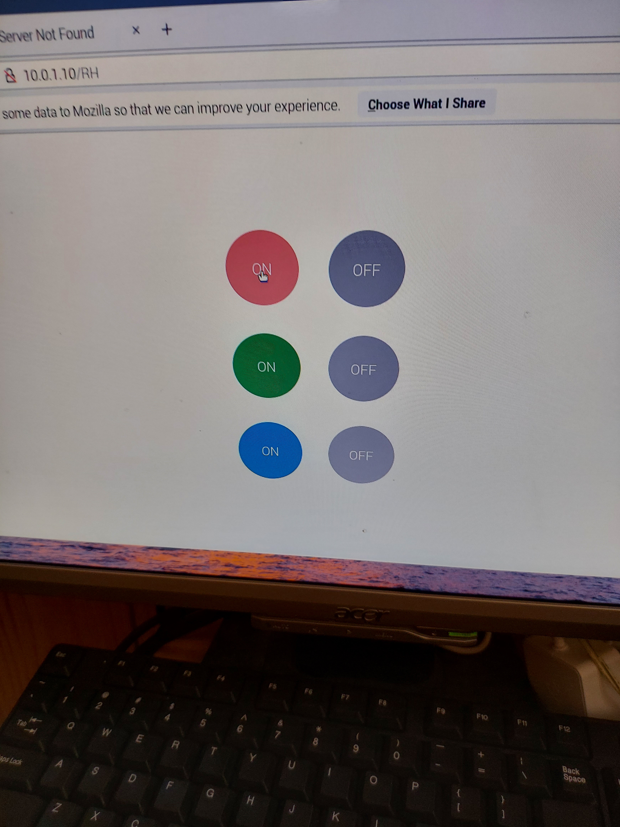
xx

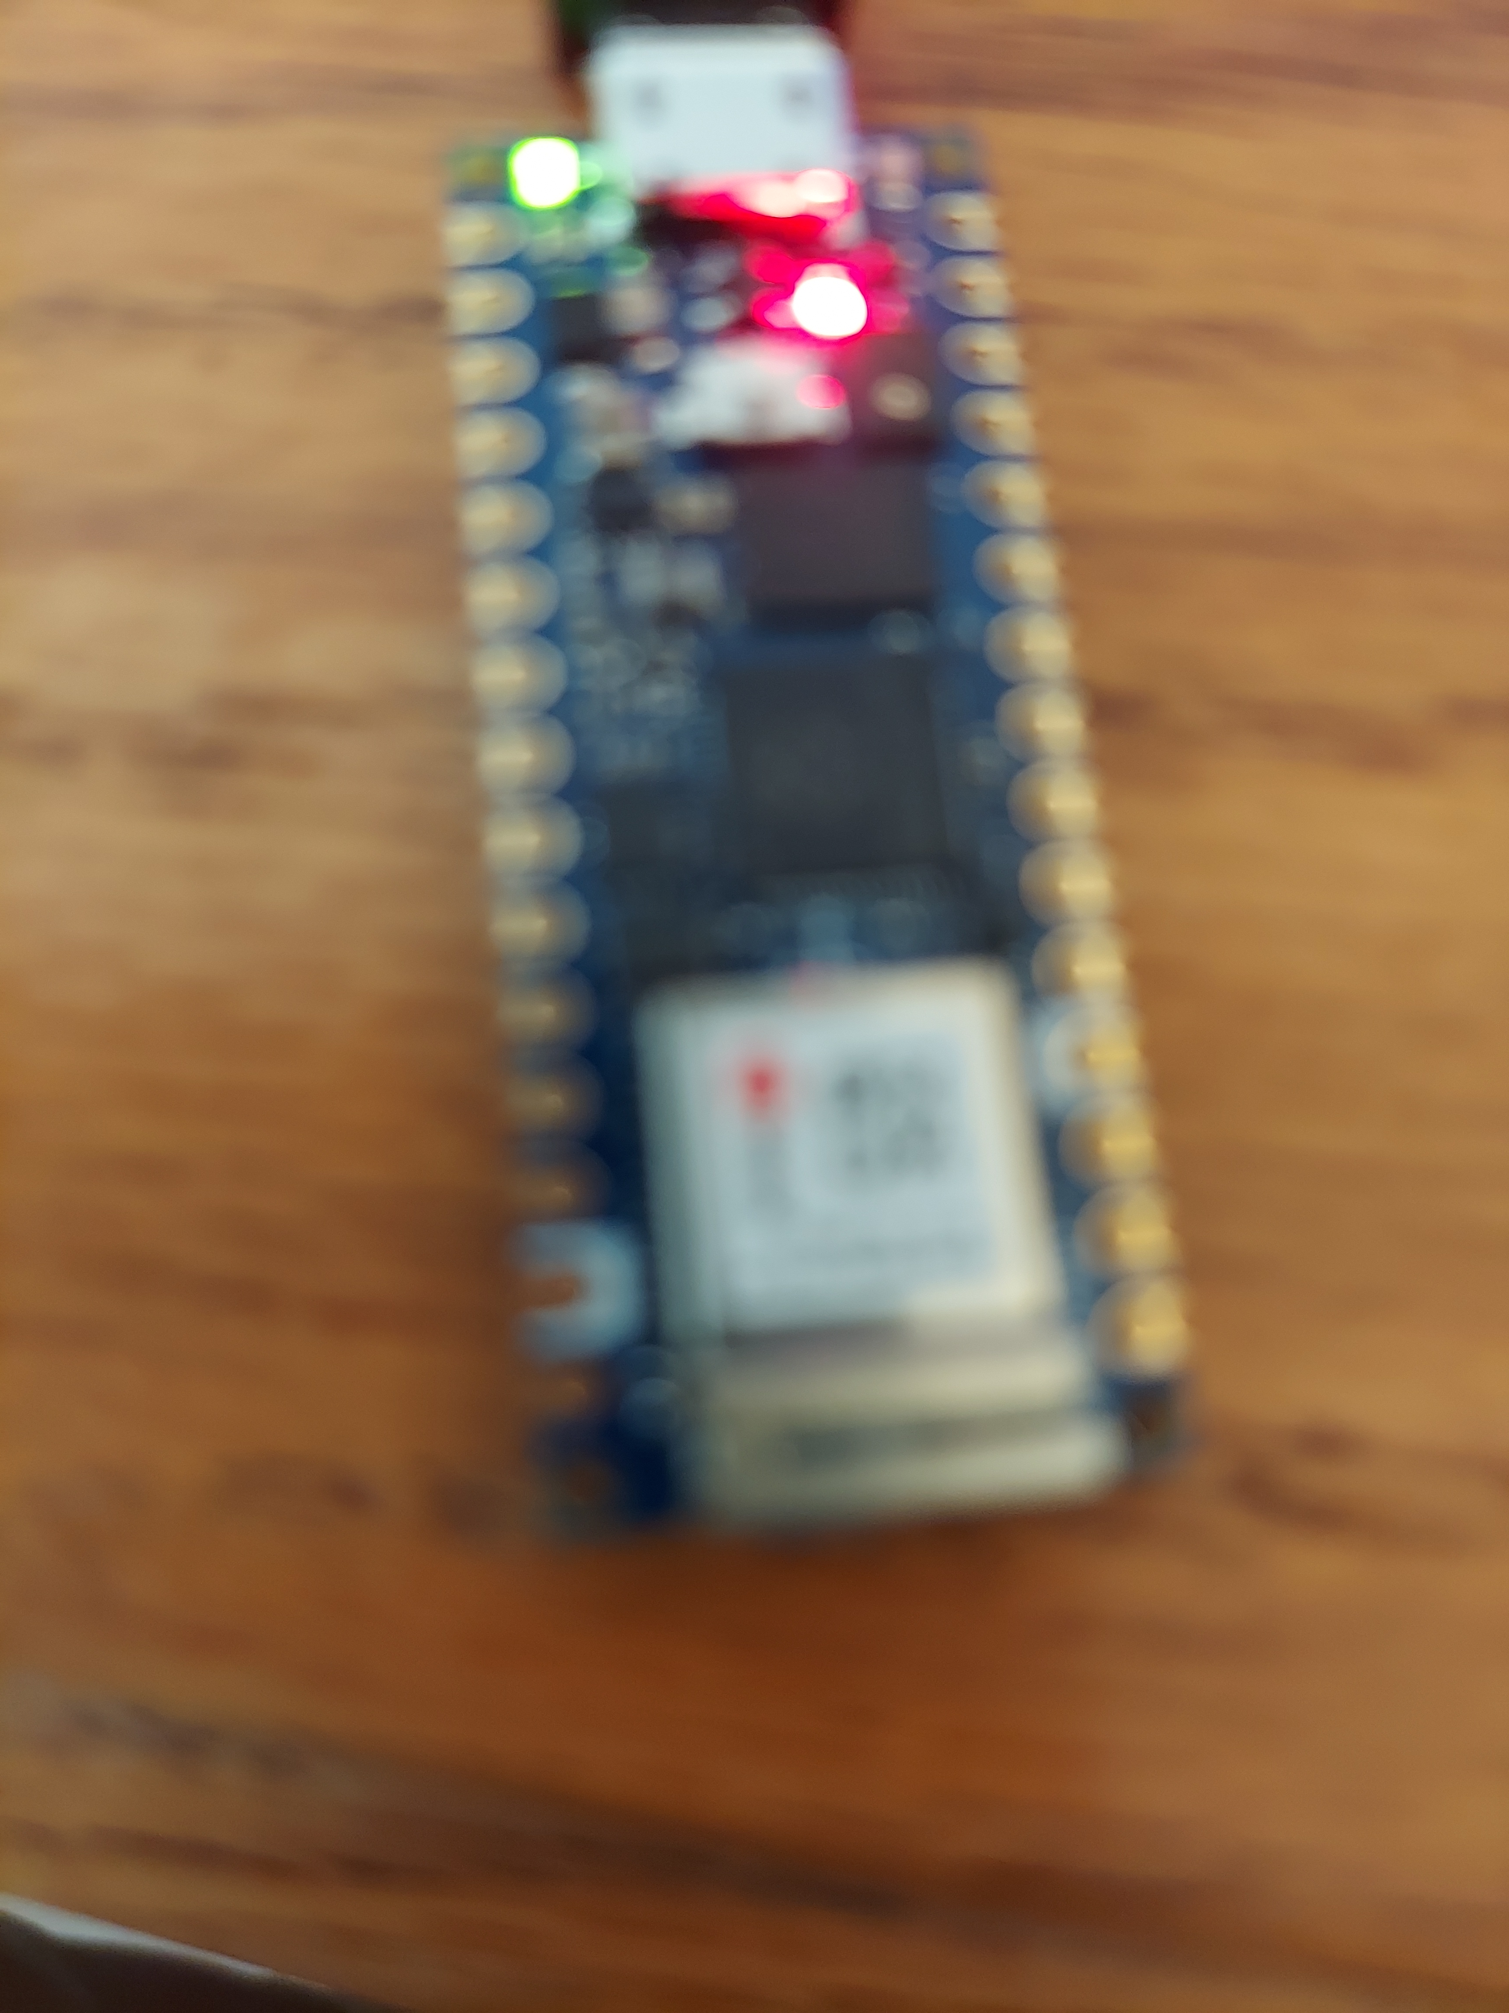
xx
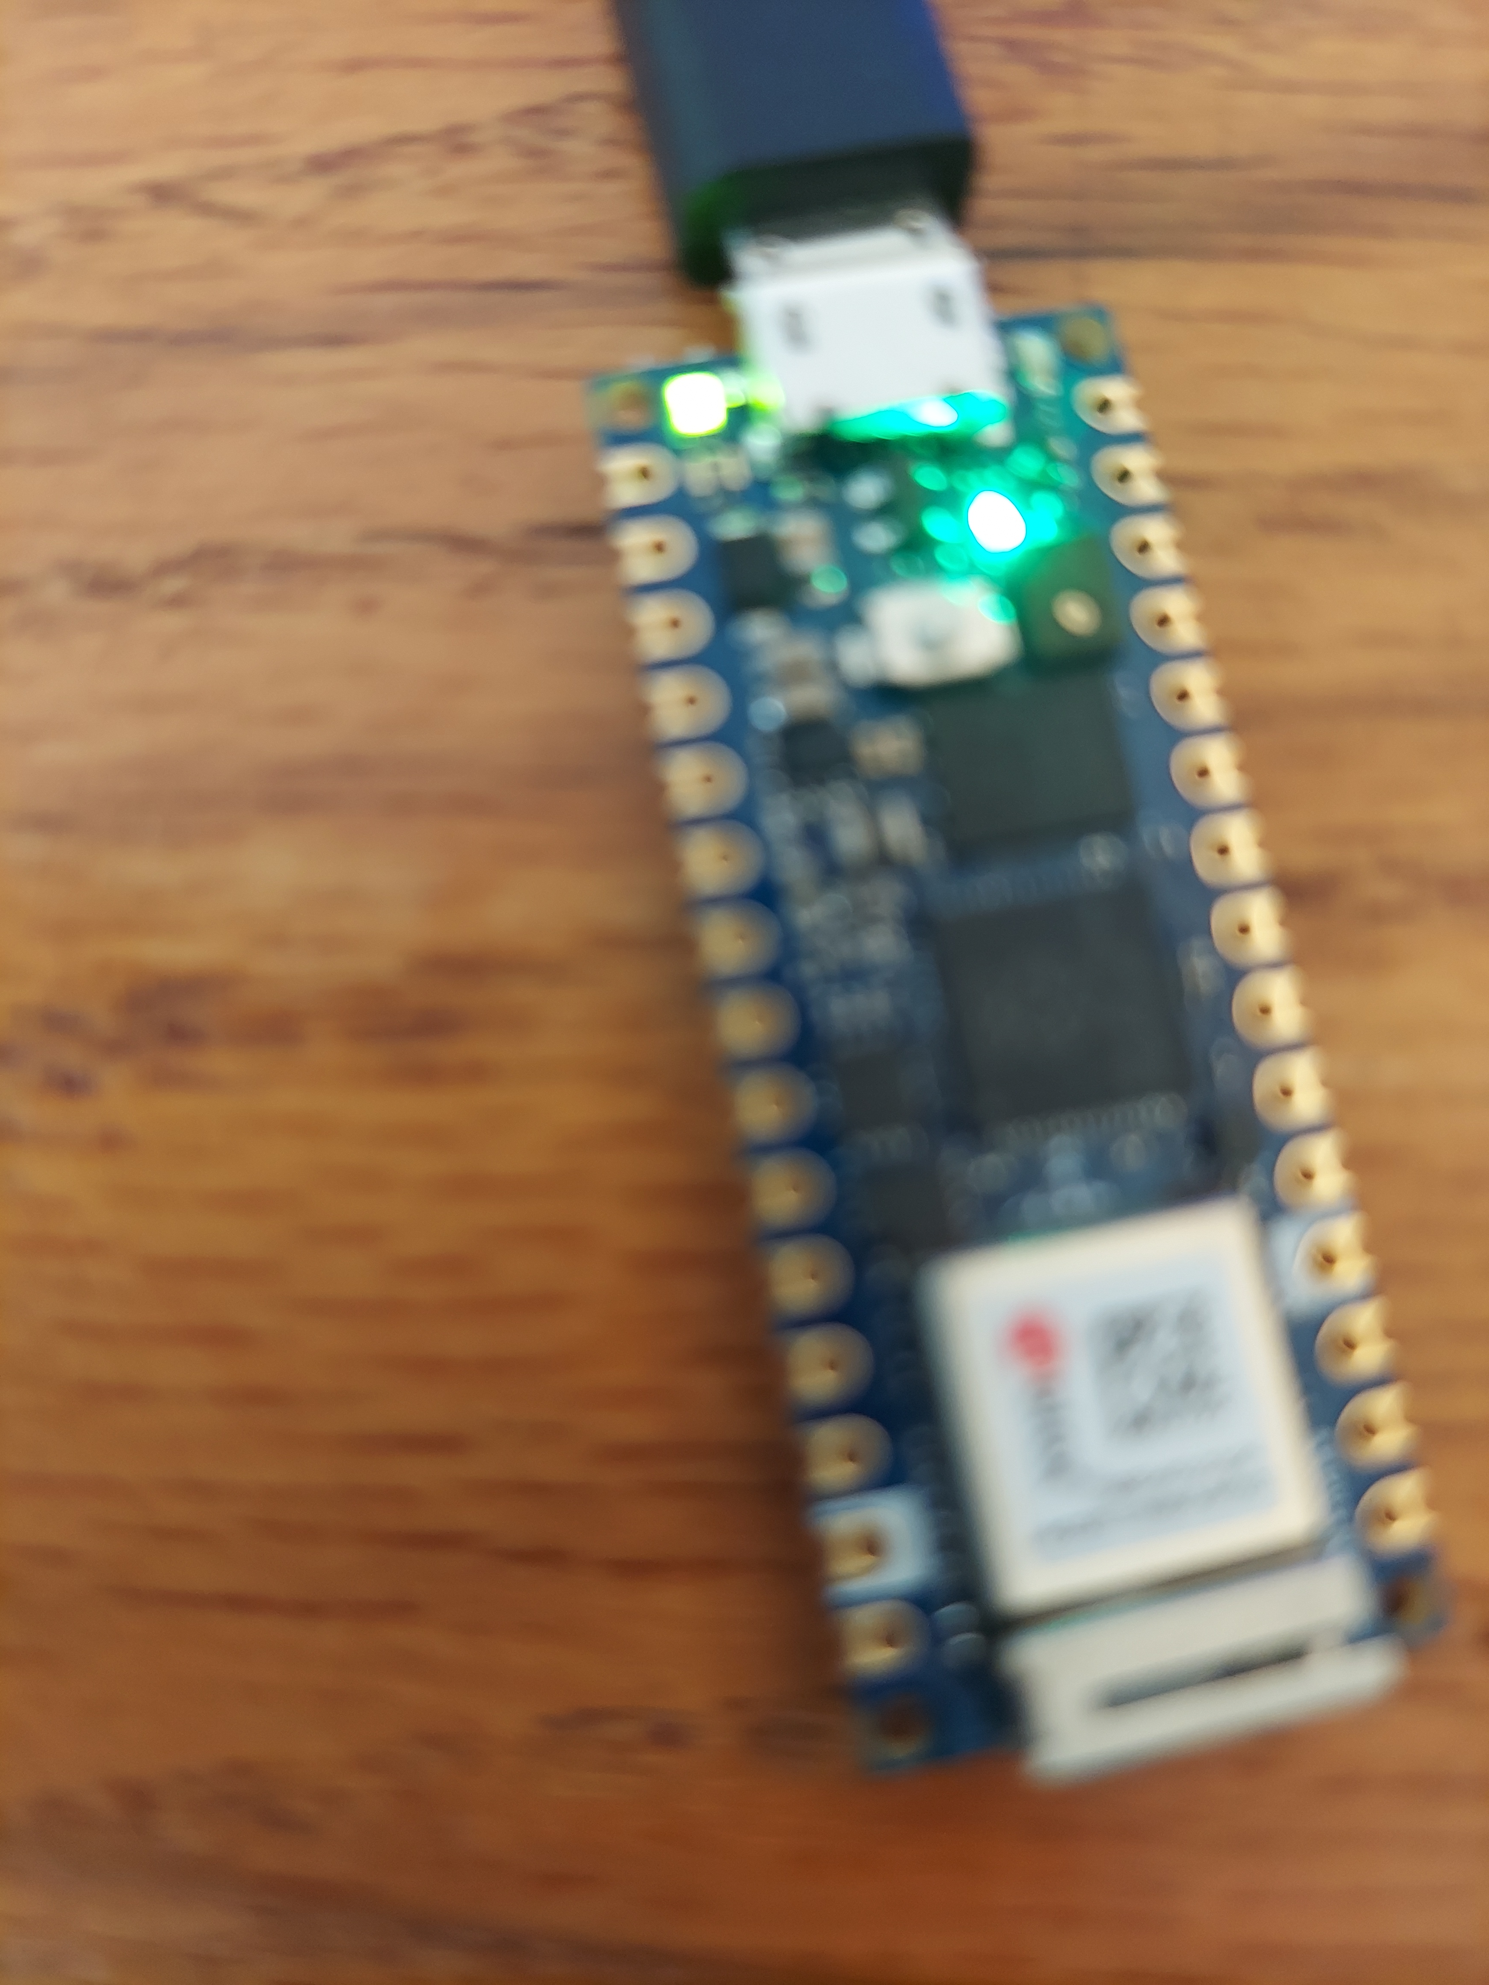
xx



