*********************Draft*********************
TensorFlow Lite for Raspberry Pi 4 64 bit and Raspberry Pi Pico

image_classification
10/21/22
*********************Draft*********************
Image 1 magnifier

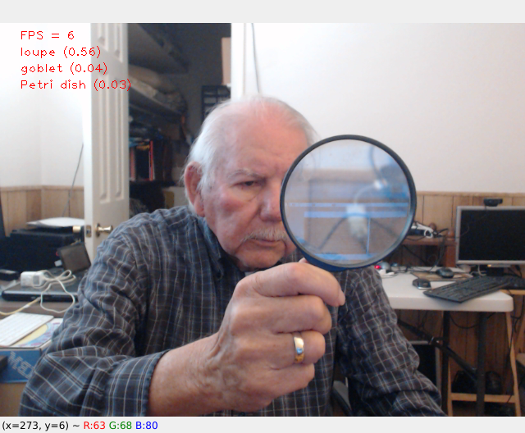

Image 2 coffee mug

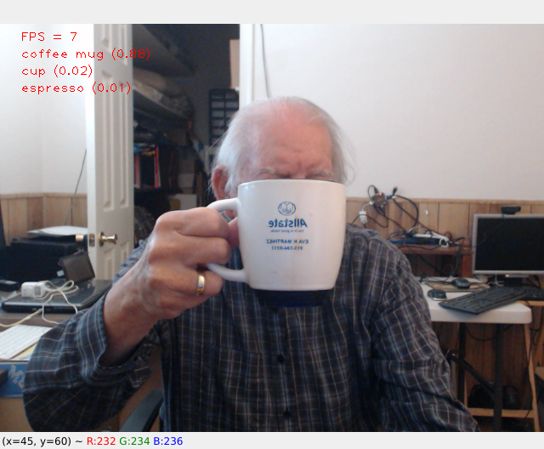
Image 3 remote control

