This test required change the pico_w port to 1883.

A mosquitto client on pi4-38 a 2nd Raspberry Pi 4B and a pico_w remote6 now can connect to MQTT mosquitto running on pi4-27.

“mosquitto_sub -h pi4-27 -p 1883 -t ‘update/memo’ -u ‘testuser’ -P ‘password123’ “
1669925497: New connection from 192.168.1.175:60808 on port 1883.
1669925497: New client connected from 192.168.1.175:60808 as remote6 (p2, c1, k100, u'testuser').

pico_w remote6 192.168.1.175 begin a seq.

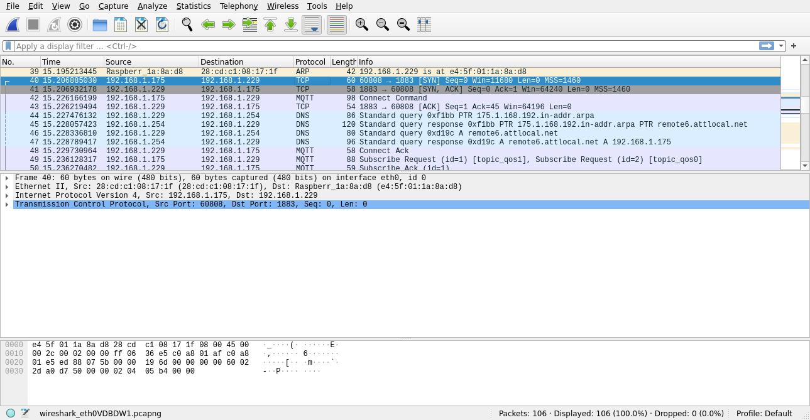
pico_w requests a connection

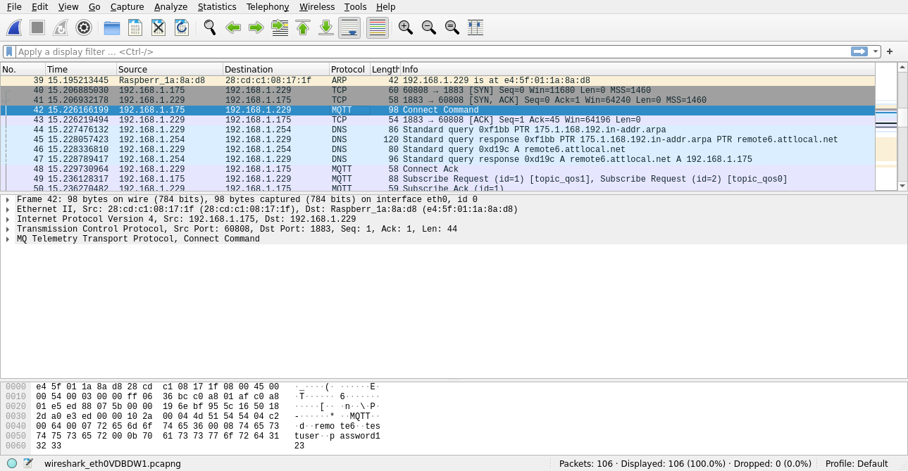
mosquitto sends Ack
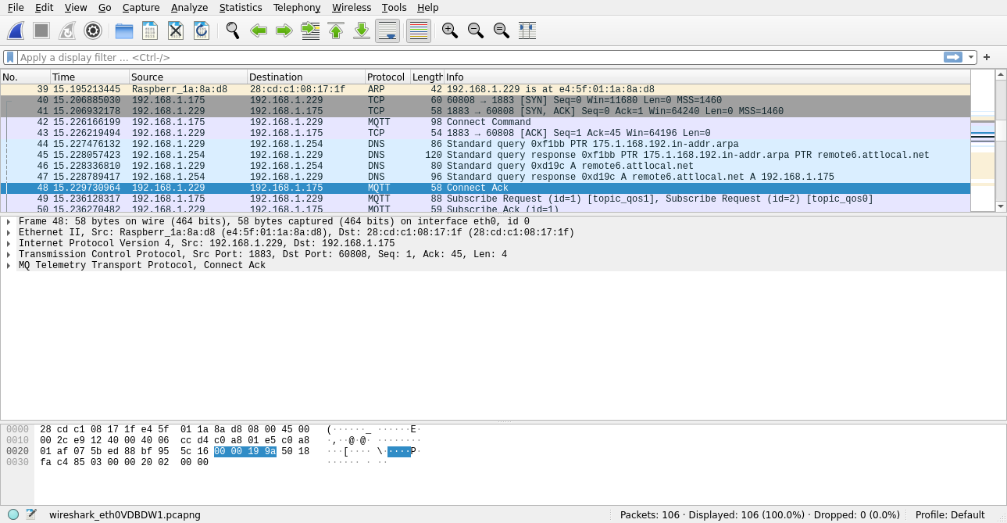
pico_w sub 'topic_qos0' & 'topic_qos1'

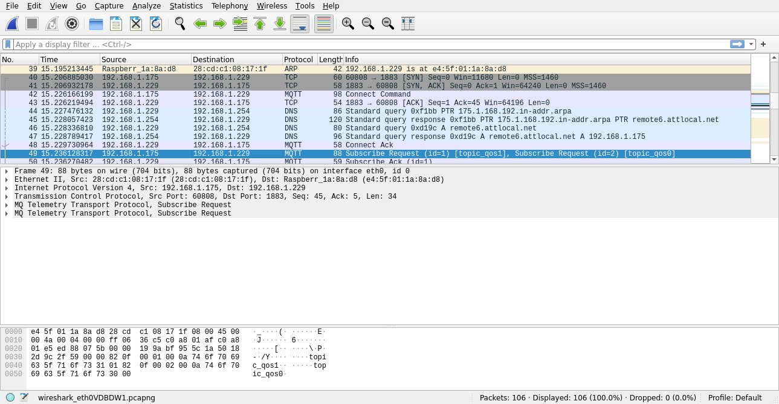
mosquitto sends Ack

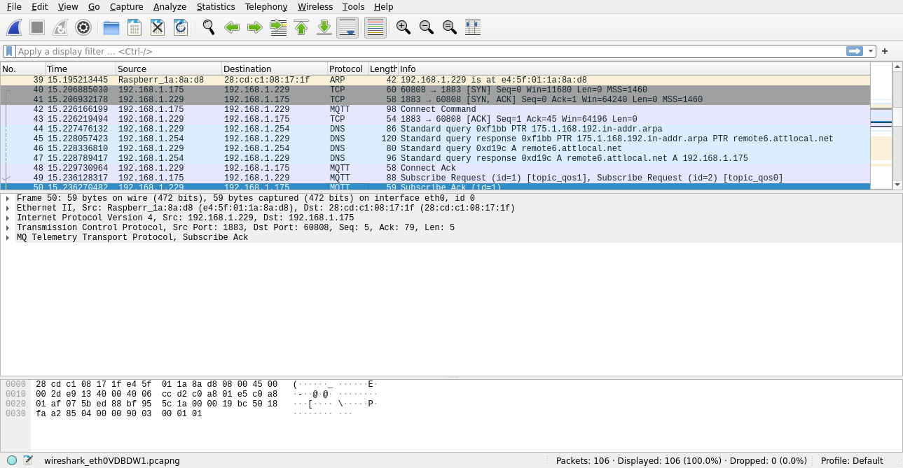
remote6
12/01/22
Uart connected to pi4-28 using port 1883

pico_w remote6 connects with mosquitto pi4-27

adding gpio support to the program
Back from buildCRCTable
0xd3 0x1 0x2e
Starting FreeRTOS on core 0:
Connecting to WiFi...
Connected.
mqtt_port = 1883 &mqtt_port 0x200005a4
mqtt_ip = 0xe501a8c0 &mqtt_ip = 0x200005a0
IPADDR_LOOPBACK = 0x7f000001
mqtt_client 0x20021f50 &mqtt_client 0x20000f5c
mqtt_set_inpub_callback 0x10001359
mqtt_client_connect 0x10001371
gpio_task starts
mqtt_task starts

Ready, running iperf server at 192.168.1.175
blink_task starts
MQTT client "remote6" connection cb: status 0
MQTT client "remote6" request cb: err 0
MQTT client "remote6" request cb: err 0
MQTT client "remote6" publish cb: topic topic_qos1, len 20
MQTT client "remote6" data cb: len 20, flags 1
MQTT client "remote6" publish cb: topic topic_qos1, len 20
MQTT client "remote6" data cb: len 20, flags 1
MQTT client "remote6" publish cb: topic topic_qos1, len 20
MQTT client "remote6" data cb: len 20, flags 1
MQTT client "remote6" connection cb: status 256
devel@pi4-27:~ $ mosquitto_pub -t 'topic_qos1' -u 'testuser' -P 'password123' -m 'hello from mosquitto'
devel@pi4-27:~ $ mosquitto_pub -t 'topic_qos1' -u 'testuser' -P 'password123' -m 'hello from mosquitto'
devel@pi4-27:~ $ mosquitto_pub -t 'topic_qos1' -u 'testuser' -P 'password123' -m 'hello from mosquitto'
devel@pi4-27:~ $ mosquitto_pub -t 'topic_qos1' -u 'testuser' -P 'password123' -m 'hello from mosquitto'

new conect
MQTT client "remote6" publish cb: topic topic_qos0, len 41
MQTT client "remote6" data cb: len 41, flags 1
mosquitto_pub -t 'topic_qos0' -u 'testuser' -P 'password123' -m 'hello from mosquitto hello from mosquitto'

