*********************Draft*********************
TensorFlow for Raspberry Pi 4 64 bit and Raspberry Pi Pico
10/05/22
*********************Draft*********************

pip3 install runipy

pip3 install ipy

ipython3 Copy_of_train_hello_world_model.ipynb

One of the first videos on Tensorflow that I watched was

video link https://www.youtube.com/watch?v=tPYj3fFJGjk&t=339s

TensorFlow 2.0 Complete Course - Python Neural Networks for Beginners Tutorial

About the Author
The author of this course is Tim Ruscica, otherwise known as “Tech With Tim”
from his educational programming YouTube channel. Tim has a passion for
teaching and loves to teach about the world of machine learning and
artificial intelligence.

This has led to a journey of learning.
Spent many hours working on C/C++ using the https://github.com/raspberrypi/pico-tflmicro.
This repository provided and older version of Tensorflow Lite for the Raspberry Pi Pico.
Since then I have managed to update https://github.com/develone/devel-pico-tflmicro
to early Sep 2022,

Installed Tensorflow 2.9 on a 64 bit Raspberry Pi 4 4Gb.
10/3/2022

video link https://youtu.be/QLZWQlg-Pk0

How to Install Tensorflow 2 on a Raspberry Pi

https://www.samwestby.com/tutorials/rpi-tensorflow.html

Sam Westby

This has led to several videos on Game On! - Flatbuffers

uname -m
aarch64

python3 -V
Python 3.9.2

cat /etc/os-release
PRETTY_NAME="Debian GNU/Linux 11 (bullseye)"
NAME="Debian GNU/Linux"
VERSION_ID="11"
VERSION="11 (bullseye)"
VERSION_CODENAME=bullseye
ID=debian
HOME_URL="https://www.debian.org/"
SUPPORT_URL="https://www.debian.org/support"
BUG_REPORT_URL="https://bugs.debian.org/"

sudo apt-get install --yes libssl-dev zlib1g-dev libbz2-dev libreadline-dev libsqlite3-dev llvm libncurses5-dev libncursesw5-dev xz-utils tk-dev libgdbm-dev lzma lzma-dev tcl-dev libxml2-dev libxmlsec1-dev libffi-dev liblzma-dev wget curl make build-essential openssl

sudo apt-get install -y libhdf5-dev libc-ares-dev libeigen3-dev gcc gfortran libgfortran5 libatlas3-base libatlas-base-dev libopenblas-dev libopenblas-base libblas-dev liblapack-dev cython3 libatlas-base-dev openmpi-bin libopenmpi-dev python3-dev

numpy was used to generate a 1000 point sin.
x_values = np.random.uniform(low=0, high=2*math.pi, size=SAMPLES).astype(np.floa
t32)

y_values = np.sin(x_values).astype(np.float32)

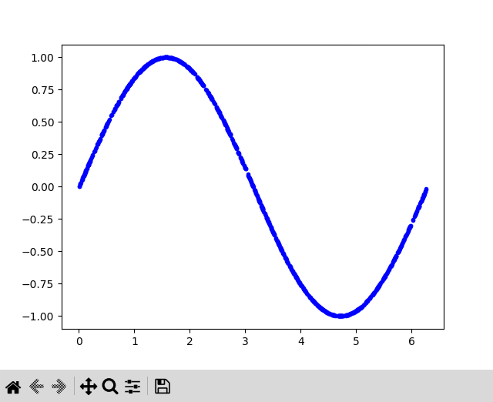

signal with noise.

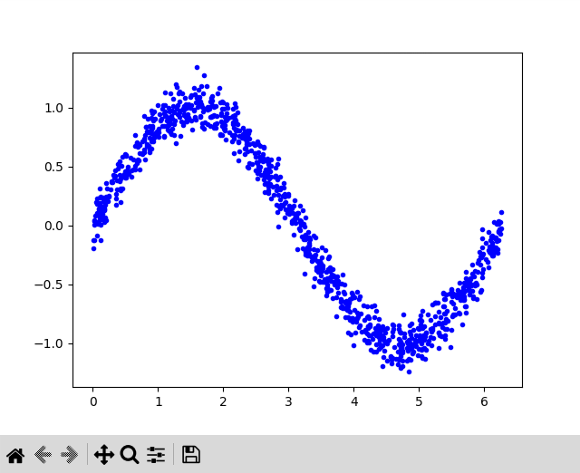

Spiting into three sets Train, Test, and Validate

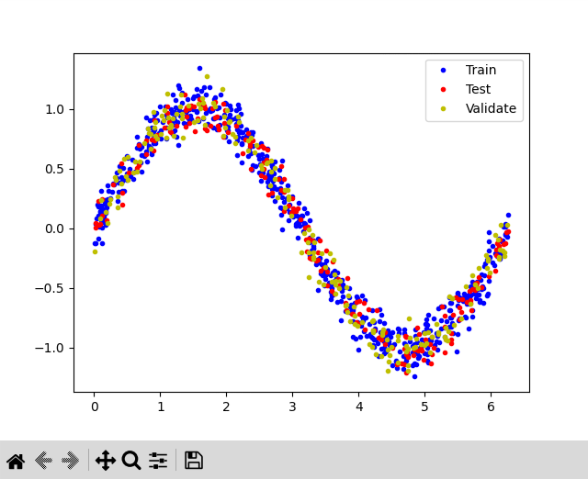

Epoch 1/500
10/10 [==============================] - 2s 55ms/step - loss: 2.7676 - mae: 1.1393 - val_loss: 2.8071 - val_mae: 1.1649
Epoch 2/500
10/10 [==============================] - 0s 10ms/step - loss: 2.6837 - mae: 1.1251 - val_loss: 2.7240 - val_mae: 1.1510
Epoch 3/500
10/10 [==============================] - 0s 10ms/step - loss: 2.6044 - mae: 1.1115 - val_loss: 2.6424 - val_mae: 1.1373
Epoch 4/500
10/10 [==============================] - 0s 10ms/step - loss: 2.5253 - mae: 1.0979 - val_loss: 2.5640 - val_mae: 1.1240
Epoch 5/500
10/10 [==============================] - 0s 10ms/step - loss: 2.4516 - mae: 1.0850 - val_loss: 2.4878 - val_mae: 1.1109
Epoch 6/500
10/10 [==============================] - 0s 10ms/step - loss: 2.3774 - mae: 1.0720 - val_loss: 2.4156 - val_mae: 1.0984
.
.
.
Epoch 494/500
10/10 [==============================] - 0s 10ms/step - loss: 0.5033 - mae: 0.6320 - val_loss: 0.5307 - val_mae: 0.6552
Epoch 495/500
10/10 [==============================] - 0s 11ms/step - loss: 0.5033 - mae: 0.6320 - val_loss: 0.5307 - val_mae: 0.6552
Epoch 496/500
10/10 [==============================] - 0s 11ms/step - loss: 0.5033 - mae: 0.6320 - val_loss: 0.5307 - val_mae: 0.6552
Epoch 497/500
10/10 [==============================] - 0s 11ms/step - loss: 0.5033 - mae: 0.6320 - val_loss: 0.5307 - val_mae: 0.6552
Epoch 498/500
10/10 [==============================] - 0s 11ms/step - loss: 0.5033 - mae: 0.6320 - val_loss: 0.5307 - val_mae: 0.6552
Epoch 499/500
10/10 [==============================] - 0s 10ms/step - loss: 0.5033 - mae: 0.6320 - val_loss: 0.5307 - val_mae: 0.6552
Epoch 500/500
10/10 [==============================] - 0s 10ms/step - loss: 0.5033 - mae: 0.6320 - val_loss: 0.5307 - val_mae: 0.6552
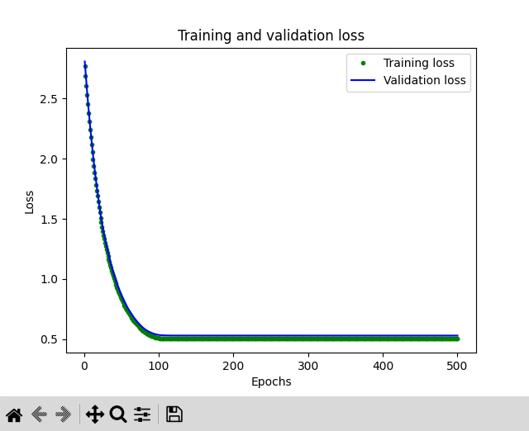

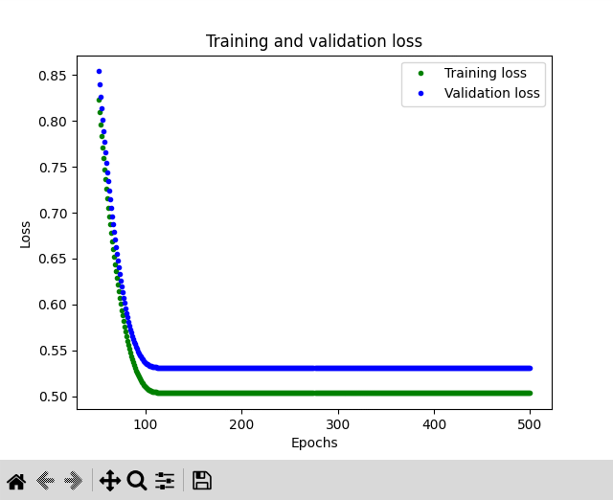

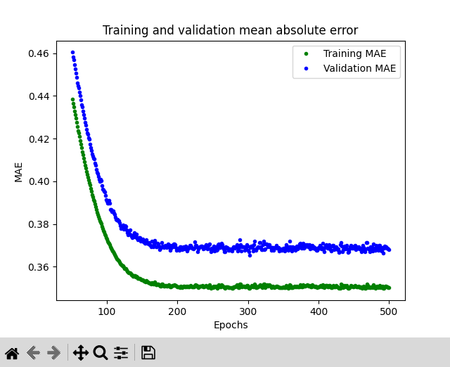

First model run.

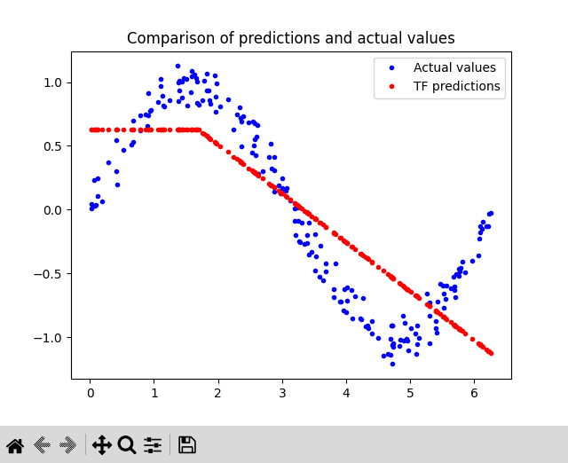

improved

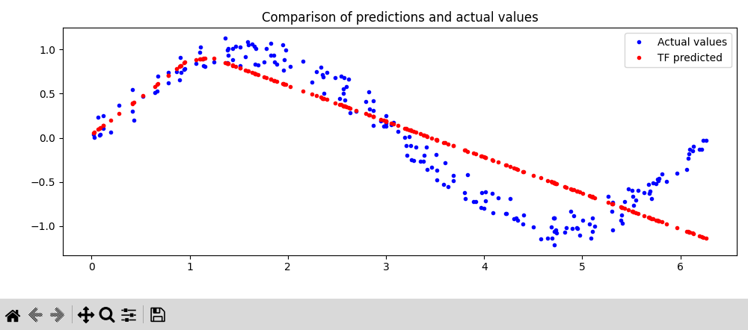

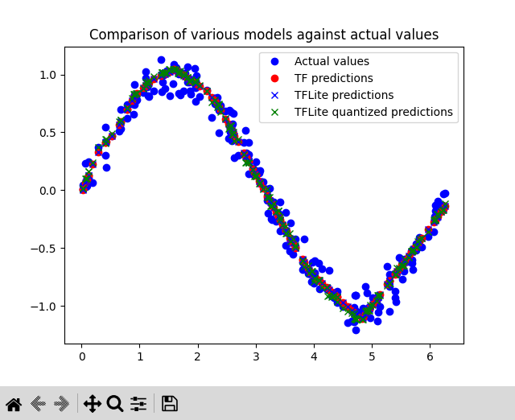

unsigned char g_model[] = {
0x20, 0x00, 0x00, 0x00, 0x54, 0x46, 0x4c, 0x33, 0x00, 0x00, 0x00, 0x00,
0x14, 0x00, 0x20, 0x00, 0x1c, 0x00, 0x18, 0x00, 0x14, 0x00, 0x10, 0x00,
0x0c, 0x00, 0x00, 0x00, 0x08, 0x00, 0x04, 0x00, 0x14, 0x00, 0x00, 0x00,
0x1c, 0x00, 0x00, 0x00, 0x94, 0x00, 0x00, 0x00, 0xec, 0x00, 0x00, 0x00,
0xa8, 0x03, 0x00, 0x00, 0xb8, 0x03, 0x00, 0x00, 0xfc, 0x09, 0x00, 0x00,
0x03, 0x00, 0x00, 0x00, 0x01, 0x00, 0x00, 0x00, 0x10, 0x00, 0x00, 0x00,
0x00, 0x00, 0x0a, 0x00, 0x10, 0x00, 0x0c, 0x00, 0x08, 0x00, 0x04, 0x00,
0x0a, 0x00, 0x00, 0x00, 0x0c, 0x00, 0x00, 0x00, 0x1c, 0x00, 0x00, 0x00,
0x38, 0x00, 0x00, 0x00, 0x0f, 0x00, 0x00, 0x00, 0x73, 0x65, 0x72, 0x76,
0x69, 0x6e, 0x67, 0x5f, 0x64, 0x65, 0x66, 0x61, 0x75, 0x6c, 0x74, 0x00,
0x01, 0x00, 0x00, 0x00, 0x04, 0x00, 0x00, 0x00, 0x94, 0xff, 0xff, 0xff,
0x09, 0x00, 0x00, 0x00, 0x04, 0x00, 0x00, 0x00, 0x07, 0x00, 0x00, 0x00,
0x64, 0x65, 0x6e, 0x73, 0x65, 0x5f, 0x34, 0x00, 0x01, 0x00, 0x00, 0x00,
0x04, 0x00, 0x00, 0x00, 0xf2, 0xfc, 0xff, 0xff, 0x04, 0x00, 0x00, 0x00,
0x0d, 0x00, 0x00, 0x00, 0x64, 0x65, 0x6e, 0x73, 0x65, 0x5f, 0x32, 0x5f,
0x69, 0x6e, 0x70, 0x75, 0x74, 0x00, 0x00, 0x00, 0x02, 0x00, 0x00, 0x00,
0x34, 0x00, 0x00, 0x00, 0x04, 0x00, 0x00, 0x00, 0xdc, 0xff, 0xff, 0xff,
0x0c, 0x00, 0x00, 0x00, 0x04, 0x00, 0x00, 0x00, 0x13, 0x00, 0x00, 0x00,
0x43, 0x4f, 0x4e, 0x56, 0x45, 0x52, 0x53, 0x49, 0x4f, 0x4e, 0x5f, 0x4d,
0x45, 0x54, 0x41, 0x44, 0x41, 0x54, 0x41, 0x00, 0x08, 0x00, 0x0c, 0x00,
0x08, 0x00, 0x04, 0x00, 0x08, 0x00, 0x00, 0x00, 0x0b, 0x00, 0x00, 0x00,
0x04, 0x00, 0x00, 0x00, 0x13, 0x00, 0x00, 0x00, 0x6d, 0x69, 0x6e, 0x5f,
0x72, 0x75, 0x6e, 0x74, 0x69, 0x6d, 0x65, 0x5f, 0x76, 0x65, 0x72, 0x73,
0x69, 0x6f, 0x6e, 0x00, 0x0d, 0x00, 0x00, 0x00, 0xb8, 0x02, 0x00, 0x00,
0xb0, 0x02, 0x00, 0x00, 0x90, 0x02, 0x00, 0x00, 0x38, 0x02, 0x00, 0x00,
0x28, 0x01, 0x00, 0x00, 0xd8, 0x00, 0x00, 0x00, 0xb8, 0x00, 0x00, 0x00,
0xa4, 0x00, 0x00, 0x00, 0x9c, 0x00, 0x00, 0x00, 0x94, 0x00, 0x00, 0x00,
0x8c, 0x00, 0x00, 0x00, 0x6c, 0x00, 0x00, 0x00, 0x04, 0x00, 0x00, 0x00,
0xa2, 0xfd, 0xff, 0xff, 0x04, 0x00, 0x00, 0x00, 0x58, 0x00, 0x00, 0x00,
0x0c, 0x00, 0x00, 0x00, 0x08, 0x00, 0x0e, 0x00, 0x08, 0x00, 0x04, 0x00,
0x08, 0x00, 0x00, 0x00, 0x10, 0x00, 0x00, 0x00, 0x28, 0x00, 0x00, 0x00,
0x00, 0x00, 0x06, 0x00, 0x08, 0x00, 0x04, 0x00, 0x06, 0x00, 0x00, 0x00,
0x04, 0x00, 0x00, 0x00, 0x01, 0x00, 0x00, 0x00, 0xeb, 0x03, 0x00, 0x00,
0x00, 0x00, 0x0a, 0x00, 0x10, 0x00, 0x0c, 0x00, 0x08, 0x00, 0x04, 0x00,
0x0a, 0x00, 0x00, 0x00, 0x01, 0x00, 0x00, 0x00, 0x02, 0x00, 0x00, 0x00,
0x04, 0x00, 0x00, 0x00, 0x05, 0x00, 0x00, 0x00, 0x32, 0x2e, 0x39, 0x2e,
0x30, 0x00, 0x00, 0x00, 0x06, 0xfe, 0xff, 0xff, 0x04, 0x00, 0x00, 0x00,
0x10, 0x00, 0x00, 0x00, 0x31, 0x2e, 0x31, 0x34, 0x2e, 0x30, 0x00, 0x00,
0x00, 0x00, 0x00, 0x00, 0x00, 0x00, 0x00, 0x00, 0x84, 0xfd, 0xff, 0xff,
0x88, 0xfd, 0xff, 0xff, 0x8c, 0xfd, 0xff, 0xff, 0x2e, 0xfe, 0xff, 0xff,
0x04, 0x00, 0x00, 0x00, 0x04, 0x00, 0x00, 0x00, 0x8c, 0xef, 0xff, 0xff,
0x3e, 0xfe, 0xff, 0xff, 0x04, 0x00, 0x00, 0x00, 0x10, 0x00, 0x00, 0x00,
0x21, 0xa5, 0x8b, 0xca, 0x5e, 0x1d, 0xce, 0x42, 0x9d, 0xce, 0x1f, 0xb0,
0xdf, 0x54, 0x2f, 0x81, 0x5a, 0xfe, 0xff, 0xff, 0x04, 0x00, 0x00, 0x00,
0x40, 0x00, 0x00, 0x00, 0x00, 0x00, 0x00, 0x00, 0xb5, 0x04, 0x00, 0x00,
0x78, 0x0a, 0x00, 0x00, 0x2d, 0x06, 0x00, 0x00, 0x71, 0xf8, 0xff, 0xff,
0x00, 0x00, 0x00, 0x00, 0x99, 0x0a, 0x00, 0x00, 0xfe, 0xf7, 0xff, 0xff,
0x0f, 0x05, 0x00, 0x00, 0xd4, 0x09, 0x00, 0x00, 0x47, 0xfe, 0xff, 0xff,
0xb6, 0x04, 0x00, 0x00, 0x00, 0x00, 0x00, 0x00, 0xac, 0xf7, 0xff, 0xff,
0x4b, 0xf9, 0xff, 0xff, 0x4a, 0x05, 0x00, 0x00, 0xa6, 0xfe, 0xff, 0xff,
0x04, 0x00, 0x00, 0x00, 0x00, 0x01, 0x00, 0x00, 0xee, 0xfc, 0x00, 0xec,
0x05, 0x17, 0xef, 0xec, 0xe6, 0xf8, 0x03, 0x01, 0x00, 0xfa, 0xf8, 0xf5,
0xdc, 0xeb, 0x27, 0x14, 0xf1, 0xde, 0xe2, 0xdb, 0xf0, 0xde, 0x31, 0x06,
0x02, 0xe6, 0xee, 0xf9, 0x00, 0x16, 0x07, 0xe0, 0xfe, 0xff, 0xe9, 0x06,
0xe7, 0xef, 0x81, 0x1b, 0x18, 0xea, 0xc9, 0x01, 0x0f, 0x00, 0xda, 0xf7,
0x0e, 0xec, 0x13, 0x1f, 0x04, 0x13, 0xb4, 0xe6, 0xfd, 0x06, 0xb9, 0xe0,
0x0d, 0xec, 0xf0, 0xde, 0xeb, 0xf7, 0x05, 0x26, 0x1a, 0xe4, 0x6f, 0x1a,
0xea, 0x1e, 0x35, 0xdf, 0x1a, 0xf3, 0xf1, 0x19, 0x0f, 0x03, 0x1b, 0xe1,
0xde, 0x13, 0xf6, 0x19, 0xff, 0xf6, 0x1b, 0x18, 0xf0, 0x1c, 0xda, 0x1b,
0x1b, 0x20, 0xe5, 0x1a, 0xf5, 0xff, 0x96, 0x0b, 0x00, 0x01, 0xcd, 0xde,
0x0d, 0xf6, 0x16, 0xe3, 0xed, 0xfc, 0x0e, 0xe9, 0xfa, 0xeb, 0x5c, 0xfc,
0x1d, 0x02, 0x5b, 0xe2, 0xe1, 0xf5, 0x15, 0xec, 0xf4, 0x00, 0x13, 0x05,
0xec, 0x0c, 0x1d, 0x14, 0x0e, 0xe7, 0x0b, 0xf4, 0x19, 0x00, 0xd7, 0x05,
0x27, 0x02, 0x15, 0xea, 0xea, 0x02, 0x9b, 0x00, 0x0c, 0xfa, 0xe8, 0xea,
0xfd, 0x00, 0x14, 0xfd, 0x0b, 0x02, 0xef, 0xee, 0x06, 0xee, 0x01, 0x0d,
0x06, 0xe6, 0xf7, 0x11, 0xf7, 0x09, 0xf8, 0xf1, 0x21, 0xff, 0x0e, 0xf3,
0xec, 0x12, 0x26, 0x1d, 0xf2, 0xe9, 0x28, 0x18, 0xe0, 0xfb, 0xf3, 0xf4,
0x05, 0x1d, 0x1d, 0xfb, 0xfd, 0x1e, 0xfc, 0x11, 0xe8, 0x07, 0x09, 0x03,
0x12, 0xf2, 0x36, 0xfb, 0xdc, 0x1c, 0xf9, 0xef, 0xf3, 0xe7, 0x6f, 0x0c,
0x1d, 0x00, 0x45, 0xfd, 0x0e, 0xf0, 0x0b, 0x19, 0x1a, 0xfa, 0xe0, 0x19,
0x1f, 0x13, 0x36, 0x1c, 0x12, 0xeb, 0x3b, 0x0c, 0xb4, 0xcb, 0xe6, 0x13,
0xfa, 0xeb, 0xf1, 0x06, 0x1c, 0xfa, 0x18, 0xe5, 0xeb, 0xcb, 0x0c, 0xf4,
0xb2, 0xff, 0xff, 0xff, 0x04, 0x00, 0x00, 0x00, 0x40, 0x00, 0x00, 0x00,
0x06, 0x00, 0x00, 0x00, 0x77, 0x0b, 0x00, 0x00, 0x53, 0xf6, 0xff, 0xff,
0x00, 0x00, 0x00, 0x00, 0x77, 0x0c, 0x00, 0x00, 0x00, 0x00, 0x00, 0x00,
0x00, 0x00, 0x00, 0x00, 0xd3, 0x06, 0x00, 0x00, 0x00, 0x00, 0x00, 0x00,
0x00, 0x00, 0x00, 0x00, 0x72, 0x21, 0x00, 0x00, 0x00, 0x00, 0x00, 0x00,
0x2f, 0x07, 0x00, 0x00, 0x67, 0xf5, 0xff, 0xff, 0x34, 0xf0, 0xff, 0xff,
0x00, 0x00, 0x00, 0x00, 0x00, 0x00, 0x06, 0x00, 0x08, 0x00, 0x04, 0x00,
0x06, 0x00, 0x00, 0x00, 0x04, 0x00, 0x00, 0x00, 0x10, 0x00, 0x00, 0x00,
0x75, 0x1c, 0x11, 0xe1, 0x0c, 0x81, 0xa5, 0x42, 0xfe, 0xd5, 0xd4, 0xb2,
0x61, 0x78, 0x19, 0xdf, 0x84, 0xff, 0xff, 0xff, 0x88, 0xff, 0xff, 0xff,
0x0f, 0x00, 0x00, 0x00, 0x4d, 0x4c, 0x49, 0x52, 0x20, 0x43, 0x6f, 0x6e,
0x76, 0x65, 0x72, 0x74, 0x65, 0x64, 0x2e, 0x00, 0x01, 0x00, 0x00, 0x00,
0x14, 0x00, 0x00, 0x00, 0x00, 0x00, 0x0e, 0x00, 0x18, 0x00, 0x14, 0x00,
0x10, 0x00, 0x0c, 0x00, 0x08, 0x00, 0x04, 0x00, 0x0e, 0x00, 0x00, 0x00,
0x14, 0x00, 0x00, 0x00, 0x1c, 0x00, 0x00, 0x00, 0xdc, 0x00, 0x00, 0x00,
0xe0, 0x00, 0x00, 0x00, 0xe4, 0x00, 0x00, 0x00, 0x04, 0x00, 0x00, 0x00,
0x6d, 0x61, 0x69, 0x6e, 0x00, 0x00, 0x00, 0x00, 0x03, 0x00, 0x00, 0x00,
0x84, 0x00, 0x00, 0x00, 0x3c, 0x00, 0x00, 0x00, 0x04, 0x00, 0x00, 0x00,
0x96, 0xff, 0xff, 0xff, 0x14, 0x00, 0x00, 0x00, 0x00, 0x00, 0x00, 0x08,
0x10, 0x00, 0x00, 0x00, 0x14, 0x00, 0x00, 0x00, 0x04, 0x00, 0x04, 0x00,
0x04, 0x00, 0x00, 0x00, 0x01, 0x00, 0x00, 0x00, 0x09, 0x00, 0x00, 0x00,
0x03, 0x00, 0x00, 0x00, 0x08, 0x00, 0x00, 0x00, 0x05, 0x00, 0x00, 0x00,
0x06, 0x00, 0x00, 0x00, 0xca, 0xff, 0xff, 0xff, 0x10, 0x00, 0x00, 0x00,
0x00, 0x00, 0x00, 0x08, 0x10, 0x00, 0x00, 0x00, 0x14, 0x00, 0x00, 0x00,
0xba, 0xff, 0xff, 0xff, 0x00, 0x00, 0x00, 0x01, 0x01, 0x00, 0x00, 0x00,
0x08, 0x00, 0x00, 0x00, 0x03, 0x00, 0x00, 0x00, 0x07, 0x00, 0x00, 0x00,
0x03, 0x00, 0x00, 0x00, 0x04, 0x00, 0x00, 0x00, 0x00, 0x00, 0x0e, 0x00,
0x16, 0x00, 0x00, 0x00, 0x10, 0x00, 0x0c, 0x00, 0x0b, 0x00, 0x04, 0x00,
0x0e, 0x00, 0x00, 0x00, 0x18, 0x00, 0x00, 0x00, 0x00, 0x00, 0x00, 0x08,
0x18, 0x00, 0x00, 0x00, 0x1c, 0x00, 0x00, 0x00, 0x00, 0x00, 0x06, 0x00,
0x08, 0x00, 0x07, 0x00, 0x06, 0x00, 0x00, 0x00, 0x00, 0x00, 0x00, 0x01,
0x01, 0x00, 0x00, 0x00, 0x07, 0x00, 0x00, 0x00, 0x03, 0x00, 0x00, 0x00,
0x00, 0x00, 0x00, 0x00, 0x01, 0x00, 0x00, 0x00, 0x02, 0x00, 0x00, 0x00,
0x01, 0x00, 0x00, 0x00, 0x09, 0x00, 0x00, 0x00, 0x01, 0x00, 0x00, 0x00,
0x00, 0x00, 0x00, 0x00, 0x0a, 0x00, 0x00, 0x00, 0xac, 0x04, 0x00, 0x00,
0x2c, 0x04, 0x00, 0x00, 0xa8, 0x03, 0x00, 0x00, 0x3c, 0x03, 0x00, 0x00,
0xc8, 0x02, 0x00, 0x00, 0x5c, 0x02, 0x00, 0x00, 0xe8, 0x01, 0x00, 0x00,
0x34, 0x01, 0x00, 0x00, 0x80, 0x00, 0x00, 0x00, 0x04, 0x00, 0x00, 0x00,
0x90, 0xfb, 0xff, 0xff, 0x18, 0x00, 0x00, 0x00, 0x20, 0x00, 0x00, 0x00,
0x40, 0x00, 0x00, 0x00, 0x0a, 0x00, 0x00, 0x00, 0x00, 0x00, 0x00, 0x09,
0x54, 0x00, 0x00, 0x00, 0x02, 0x00, 0x00, 0x00, 0xff, 0xff, 0xff, 0xff,
0x01, 0x00, 0x00, 0x00, 0x7c, 0xfb, 0xff, 0xff, 0x08, 0x00, 0x00, 0x00,
0x14, 0x00, 0x00, 0x00, 0x01, 0x00, 0x00, 0x00, 0x04, 0x00, 0x00, 0x00,
0x00, 0x00, 0x00, 0x00, 0x00, 0x00, 0x00, 0x00, 0x01, 0x00, 0x00, 0x00,
0x2e, 0xce, 0x0a, 0x3c, 0x19, 0x00, 0x00, 0x00, 0x53, 0x74, 0x61, 0x74,
0x65, 0x66, 0x75, 0x6c, 0x50, 0x61, 0x72, 0x74, 0x69, 0x74, 0x69, 0x6f,
0x6e, 0x65, 0x64, 0x43, 0x61, 0x6c, 0x6c, 0x3a, 0x30, 0x00, 0x00, 0x00,
0x02, 0x00, 0x00, 0x00, 0x01, 0x00, 0x00, 0x00, 0x01, 0x00, 0x00, 0x00,
0x08, 0xfc, 0xff, 0xff, 0x18, 0x00, 0x00, 0x00, 0x20, 0x00, 0x00, 0x00,
0x40, 0x00, 0x00, 0x00, 0x09, 0x00, 0x00, 0x00, 0x00, 0x00, 0x00, 0x09,
0x8c, 0x00, 0x00, 0x00, 0x02, 0x00, 0x00, 0x00, 0xff, 0xff, 0xff, 0xff,
0x10, 0x00, 0x00, 0x00, 0xf4, 0xfb, 0xff, 0xff, 0x08, 0x00, 0x00, 0x00,
0x14, 0x00, 0x00, 0x00, 0x01, 0x00, 0x00, 0x00, 0x80, 0xff, 0xff, 0xff,
0xff, 0xff, 0xff, 0xff, 0x00, 0x00, 0x00, 0x00, 0x01, 0x00, 0x00, 0x00,
0xe8, 0xd1, 0xc0, 0x3b, 0x52, 0x00, 0x00, 0x00, 0x73, 0x65, 0x71, 0x75,
0x65, 0x6e, 0x74, 0x69, 0x61, 0x6c, 0x5f, 0x31, 0x2f, 0x64, 0x65, 0x6e,
0x73, 0x65, 0x5f, 0x33, 0x2f, 0x4d, 0x61, 0x74, 0x4d, 0x75, 0x6c, 0x3b,
0x73, 0x65, 0x71, 0x75, 0x65, 0x6e, 0x74, 0x69, 0x61, 0x6c, 0x5f, 0x31,
0x2f, 0x64, 0x65, 0x6e, 0x73, 0x65, 0x5f, 0x33, 0x2f, 0x52, 0x65, 0x6c,
0x75, 0x3b, 0x73, 0x65, 0x71, 0x75, 0x65, 0x6e, 0x74, 0x69, 0x61, 0x6c,
0x5f, 0x31, 0x2f, 0x64, 0x65, 0x6e, 0x73, 0x65, 0x5f, 0x33, 0x2f, 0x42,
0x69, 0x61, 0x73, 0x41, 0x64, 0x64, 0x00, 0x00, 0x02, 0x00, 0x00, 0x00,
0x01, 0x00, 0x00, 0x00, 0x10, 0x00, 0x00, 0x00, 0xb8, 0xfc, 0xff, 0xff,
0x18, 0x00, 0x00, 0x00, 0x20, 0x00, 0x00, 0x00, 0x40, 0x00, 0x00, 0x00,
0x08, 0x00, 0x00, 0x00, 0x00, 0x00, 0x00, 0x09, 0x8c, 0x00, 0x00, 0x00,
0x02, 0x00, 0x00, 0x00, 0xff, 0xff, 0xff, 0xff, 0x10, 0x00, 0x00, 0x00,
0xa4, 0xfc, 0xff, 0xff, 0x08, 0x00, 0x00, 0x00, 0x14, 0x00, 0x00, 0x00,
0x01, 0x00, 0x00, 0x00, 0x80, 0xff, 0xff, 0xff, 0xff, 0xff, 0xff, 0xff,
0x00, 0x00, 0x00, 0x00, 0x01, 0x00, 0x00, 0x00, 0x5a, 0xdf, 0x47, 0x3c,
0x52, 0x00, 0x00, 0x00, 0x73, 0x65, 0x71, 0x75, 0x65, 0x6e, 0x74, 0x69,
0x61, 0x6c, 0x5f, 0x31, 0x2f, 0x64, 0x65, 0x6e, 0x73, 0x65, 0x5f, 0x32,
0x2f, 0x4d, 0x61, 0x74, 0x4d, 0x75, 0x6c, 0x3b, 0x73, 0x65, 0x71, 0x75,
0x65, 0x6e, 0x74, 0x69, 0x61, 0x6c, 0x5f, 0x31, 0x2f, 0x64, 0x65, 0x6e,
0x73, 0x65, 0x5f, 0x32, 0x2f, 0x52, 0x65, 0x6c, 0x75, 0x3b, 0x73, 0x65,
0x71, 0x75, 0x65, 0x6e, 0x74, 0x69, 0x61, 0x6c, 0x5f, 0x31, 0x2f, 0x64,
0x65, 0x6e, 0x73, 0x65, 0x5f, 0x32, 0x2f, 0x42, 0x69, 0x61, 0x73, 0x41,
0x64, 0x64, 0x00, 0x00, 0x02, 0x00, 0x00, 0x00, 0x01, 0x00, 0x00, 0x00,
0x10, 0x00, 0x00, 0x00, 0xde, 0xfd, 0xff, 0xff, 0x14, 0x00, 0x00, 0x00,
0x30, 0x00, 0x00, 0x00, 0x07, 0x00, 0x00, 0x00, 0x00, 0x00, 0x00, 0x02,
0x54, 0x00, 0x00, 0x00, 0x44, 0xfd, 0xff, 0xff, 0x08, 0x00, 0x00, 0x00,
0x10, 0x00, 0x00, 0x00, 0x01, 0x00, 0x00, 0x00, 0x00, 0x00, 0x00, 0x00,
0x00, 0x00, 0x00, 0x00, 0x01, 0x00, 0x00, 0x00, 0x33, 0xd9, 0x51, 0x38,
0x2b, 0x00, 0x00, 0x00, 0x73, 0x65, 0x71, 0x75, 0x65, 0x6e, 0x74, 0x69,
0x61, 0x6c, 0x5f, 0x31, 0x2f, 0x64, 0x65, 0x6e, 0x73, 0x65, 0x5f, 0x34,
0x2f, 0x42, 0x69, 0x61, 0x73, 0x41, 0x64, 0x64, 0x2f, 0x52, 0x65, 0x61,
0x64, 0x56, 0x61, 0x72, 0x69, 0x61, 0x62, 0x6c, 0x65, 0x4f, 0x70, 0x00,
0x01, 0x00, 0x00, 0x00, 0x01, 0x00, 0x00, 0x00, 0x4e, 0xfe, 0xff, 0xff,
0x14, 0x00, 0x00, 0x00, 0x34, 0x00, 0x00, 0x00, 0x06, 0x00, 0x00, 0x00,
0x00, 0x00, 0x00, 0x09, 0x48, 0x00, 0x00, 0x00, 0xb4, 0xfd, 0xff, 0xff,
0x08, 0x00, 0x00, 0x00, 0x14, 0x00, 0x00, 0x00, 0x01, 0x00, 0x00, 0x00,
0x00, 0x00, 0x00, 0x00, 0x00, 0x00, 0x00, 0x00, 0x00, 0x00, 0x00, 0x00,
0x01, 0x00, 0x00, 0x00, 0xd6, 0x4d, 0x0b, 0x3c, 0x1b, 0x00, 0x00, 0x00,
0x73, 0x65, 0x71, 0x75, 0x65, 0x6e, 0x74, 0x69, 0x61, 0x6c, 0x5f, 0x31,
0x2f, 0x64, 0x65, 0x6e, 0x73, 0x65, 0x5f, 0x34, 0x2f, 0x4d, 0x61, 0x74,
0x4d, 0x75, 0x6c, 0x00, 0x02, 0x00, 0x00, 0x00, 0x01, 0x00, 0x00, 0x00,
0x10, 0x00, 0x00, 0x00, 0xb6, 0xfe, 0xff, 0xff, 0x14, 0x00, 0x00, 0x00,
0x30, 0x00, 0x00, 0x00, 0x05, 0x00, 0x00, 0x00, 0x00, 0x00, 0x00, 0x02,
0x54, 0x00, 0x00, 0x00, 0x1c, 0xfe, 0xff, 0xff, 0x08, 0x00, 0x00, 0x00,
0x10, 0x00, 0x00, 0x00, 0x01, 0x00, 0x00, 0x00, 0x00, 0x00, 0x00, 0x00,
0x00, 0x00, 0x00, 0x00, 0x01, 0x00, 0x00, 0x00, 0xaa, 0x9e, 0x21, 0x39,
0x2b, 0x00, 0x00, 0x00, 0x73, 0x65, 0x71, 0x75, 0x65, 0x6e, 0x74, 0x69,
0x61, 0x6c, 0x5f, 0x31, 0x2f, 0x64, 0x65, 0x6e, 0x73, 0x65, 0x5f, 0x33,
0x2f, 0x42, 0x69, 0x61, 0x73, 0x41, 0x64, 0x64, 0x2f, 0x52, 0x65, 0x61,
0x64, 0x56, 0x61, 0x72, 0x69, 0x61, 0x62, 0x6c, 0x65, 0x4f, 0x70, 0x00,
0x01, 0x00, 0x00, 0x00, 0x10, 0x00, 0x00, 0x00, 0x26, 0xff, 0xff, 0xff,
0x14, 0x00, 0x00, 0x00, 0x34, 0x00, 0x00, 0x00, 0x04, 0x00, 0x00, 0x00,
0x00, 0x00, 0x00, 0x09, 0x48, 0x00, 0x00, 0x00, 0x8c, 0xfe, 0xff, 0xff,
0x08, 0x00, 0x00, 0x00, 0x14, 0x00, 0x00, 0x00, 0x01, 0x00, 0x00, 0x00,
0x00, 0x00, 0x00, 0x00, 0x00, 0x00, 0x00, 0x00, 0x00, 0x00, 0x00, 0x00,
0x01, 0x00, 0x00, 0x00, 0x5d, 0x01, 0x4f, 0x3c, 0x1b, 0x00, 0x00, 0x00,
0x73, 0x65, 0x71, 0x75, 0x65, 0x6e, 0x74, 0x69, 0x61, 0x6c, 0x5f, 0x31,
0x2f, 0x64, 0x65, 0x6e, 0x73, 0x65, 0x5f, 0x33, 0x2f, 0x4d, 0x61, 0x74,
0x4d, 0x75, 0x6c, 0x00, 0x02, 0x00, 0x00, 0x00, 0x10, 0x00, 0x00, 0x00,
0x10, 0x00, 0x00, 0x00, 0x8e, 0xff, 0xff, 0xff, 0x14, 0x00, 0x00, 0x00,
0x30, 0x00, 0x00, 0x00, 0x03, 0x00, 0x00, 0x00, 0x00, 0x00, 0x00, 0x02,
0x54, 0x00, 0x00, 0x00, 0xf4, 0xfe, 0xff, 0xff, 0x08, 0x00, 0x00, 0x00,
0x10, 0x00, 0x00, 0x00, 0x01, 0x00, 0x00, 0x00, 0x00, 0x00, 0x00, 0x00,
0x00, 0x00, 0x00, 0x00, 0x01, 0x00, 0x00, 0x00, 0x28, 0xb3, 0xd9, 0x38,
0x2b, 0x00, 0x00, 0x00, 0x73, 0x65, 0x71, 0x75, 0x65, 0x6e, 0x74, 0x69,
0x61, 0x6c, 0x5f, 0x31, 0x2f, 0x64, 0x65, 0x6e, 0x73, 0x65, 0x5f, 0x32,
0x2f, 0x42, 0x69, 0x61, 0x73, 0x41, 0x64, 0x64, 0x2f, 0x52, 0x65, 0x61,
0x64, 0x56, 0x61, 0x72, 0x69, 0x61, 0x62, 0x6c, 0x65, 0x4f, 0x70, 0x00,
0x01, 0x00, 0x00, 0x00, 0x10, 0x00, 0x00, 0x00, 0x00, 0x00, 0x0e, 0x00,
0x18, 0x00, 0x14, 0x00, 0x13, 0x00, 0x0c, 0x00, 0x08, 0x00, 0x04, 0x00,
0x0e, 0x00, 0x00, 0x00, 0x14, 0x00, 0x00, 0x00, 0x34, 0x00, 0x00, 0x00,
0x02, 0x00, 0x00, 0x00, 0x00, 0x00, 0x00, 0x09, 0x48, 0x00, 0x00, 0x00,
0x74, 0xff, 0xff, 0xff, 0x08, 0x00, 0x00, 0x00, 0x14, 0x00, 0x00, 0x00,
0x01, 0x00, 0x00, 0x00, 0x00, 0x00, 0x00, 0x00, 0x00, 0x00, 0x00, 0x00,
0x00, 0x00, 0x00, 0x00, 0x01, 0x00, 0x00, 0x00, 0xd5, 0x6b, 0x8a, 0x3b,
0x1b, 0x00, 0x00, 0x00, 0x73, 0x65, 0x71, 0x75, 0x65, 0x6e, 0x74, 0x69,
0x61, 0x6c, 0x5f, 0x31, 0x2f, 0x64, 0x65, 0x6e, 0x73, 0x65, 0x5f, 0x32,
0x2f, 0x4d, 0x61, 0x74, 0x4d, 0x75, 0x6c, 0x00, 0x02, 0x00, 0x00, 0x00,
0x10, 0x00, 0x00, 0x00, 0x01, 0x00, 0x00, 0x00, 0x14, 0x00, 0x1c, 0x00,
0x18, 0x00, 0x17, 0x00, 0x10, 0x00, 0x0c, 0x00, 0x08, 0x00, 0x00, 0x00,
0x00, 0x00, 0x04, 0x00, 0x14, 0x00, 0x00, 0x00, 0x18, 0x00, 0x00, 0x00,
0x2c, 0x00, 0x00, 0x00, 0x4c, 0x00, 0x00, 0x00, 0x01, 0x00, 0x00, 0x00,
0x00, 0x00, 0x00, 0x09, 0x64, 0x00, 0x00, 0x00, 0x02, 0x00, 0x00, 0x00,
0xff, 0xff, 0xff, 0xff, 0x01, 0x00, 0x00, 0x00, 0x0c, 0x00, 0x0c, 0x00,
0x00, 0x00, 0x00, 0x00, 0x08, 0x00, 0x04, 0x00, 0x0c, 0x00, 0x00, 0x00,
0x08, 0x00, 0x00, 0x00, 0x14, 0x00, 0x00, 0x00, 0x01, 0x00, 0x00, 0x00,
0x80, 0xff, 0xff, 0xff, 0xff, 0xff, 0xff, 0xff, 0x00, 0x00, 0x00, 0x00,
0x01, 0x00, 0x00, 0x00, 0x5d, 0x4f, 0xc9, 0x3c, 0x1f, 0x00, 0x00, 0x00,
0x73, 0x65, 0x72, 0x76, 0x69, 0x6e, 0x67, 0x5f, 0x64, 0x65, 0x66, 0x61,
0x75, 0x6c, 0x74, 0x5f, 0x64, 0x65, 0x6e, 0x73, 0x65, 0x5f, 0x32, 0x5f,
0x69, 0x6e, 0x70, 0x75, 0x74, 0x3a, 0x30, 0x00, 0x02, 0x00, 0x00, 0x00,
0x01, 0x00, 0x00, 0x00, 0x01, 0x00, 0x00, 0x00, 0x01, 0x00, 0x00, 0x00,
0x10, 0x00, 0x00, 0x00, 0x0c, 0x00, 0x10, 0x00, 0x0f, 0x00, 0x00, 0x00,
0x08, 0x00, 0x04, 0x00, 0x0c, 0x00, 0x00, 0x00, 0x09, 0x00, 0x00, 0x00,
0x04, 0x00, 0x00, 0x00, 0x00, 0x00, 0x00, 0x09
};
unsigned int g_model_len = 2648;

