*********************Default*********************
Re-look Paul's MQTT
Ultibo Australian user
ultibo-mqtt
11/07/22
*********************Default*********************

This is a re-look at ultibo-mqtt, earlier work for use with Raspberry Pi Pico W project.

Goal: To see if the code as downloaded from https://github.com/pjde/ultibo-mqtt.git , from an Ultibo Australian user, compiles and runs on hardware. This will be used as a learning tool
for understanding MQTT in Raspberry Pi Pico W project.
https://ultibo.org/forum/viewtopic.php?f=10&t=1427&p=9844&hilit=mqtt#p9844

“git clone https://github.com/develone/ultibo-mqtt.git”

With Lazarus IDE (Ultibo-Edition)

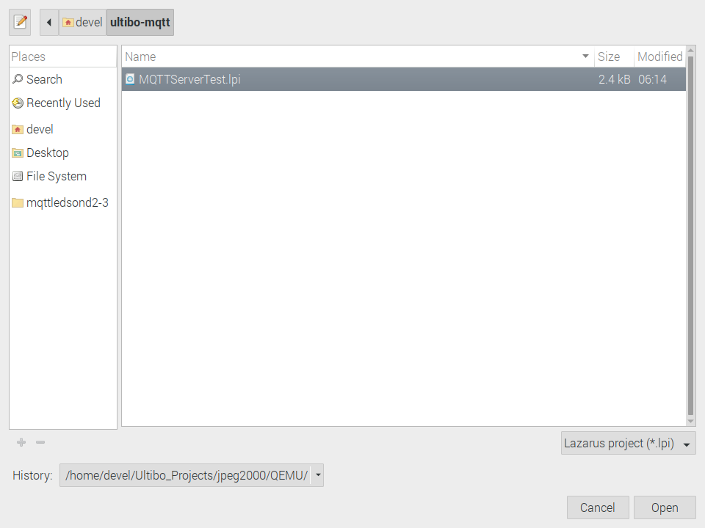
First step is to check that code compiles. From the main Tool Bar select Run/Compile. If the code is okay the green bar will appear. At first glance of the file “MQTTServerTest.lpr” after opening “MQTTServerTest.lpi” project file, is that code was intended for a ”RaspberryPi3”. If the code is to be used on the ”RaspberryPi3” Bare Metal you will need the firmware found at “git clone https://github.com/develone/firmwar_for_ultibo.git”
Ultibo Bare Metal only requires a few file.

bootcode.bin
fixup.dat
fixup4.dat
start.elf
start4.elf
config.txt

The files above provide a way for the kernel to boot an have access to the hardware.

Most of code is contained in file kernel7.img.

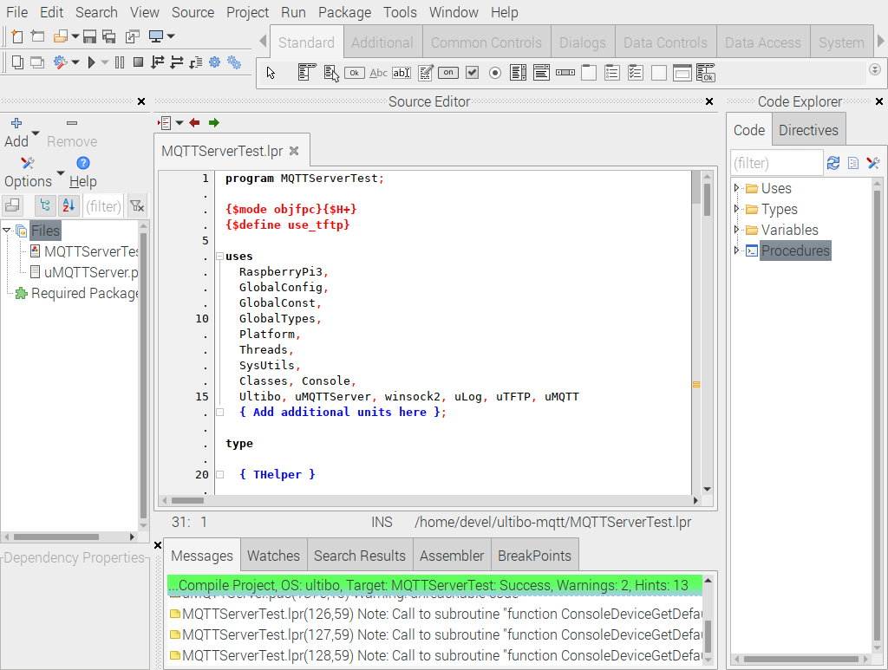

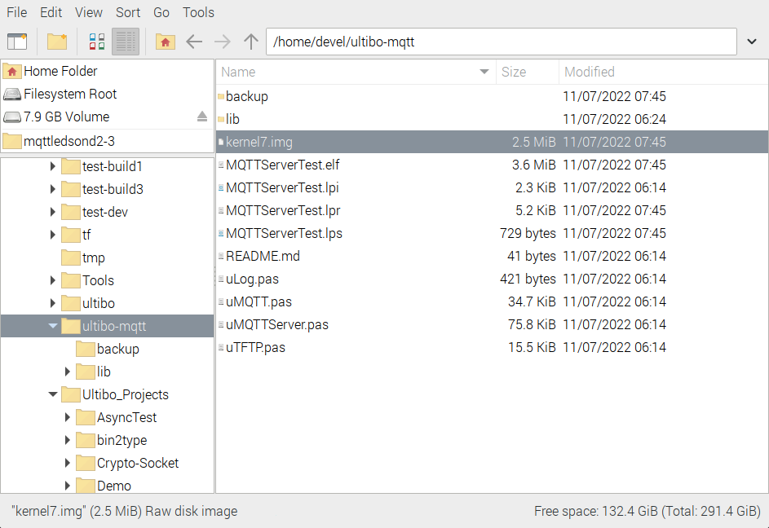

mount the micro sd

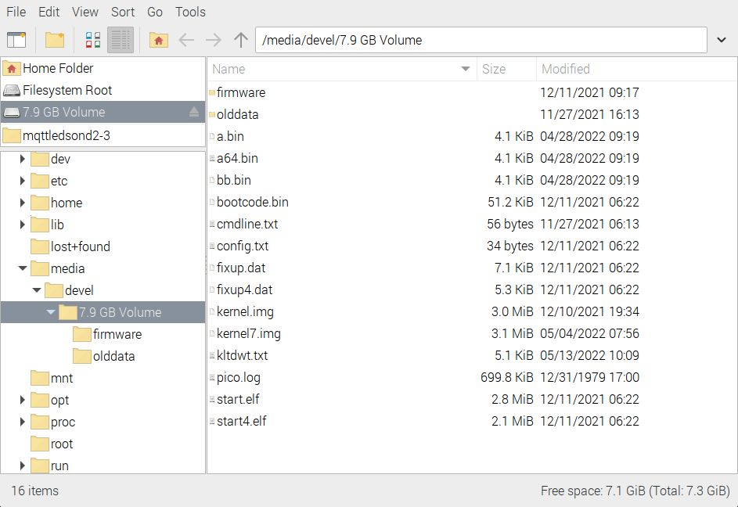

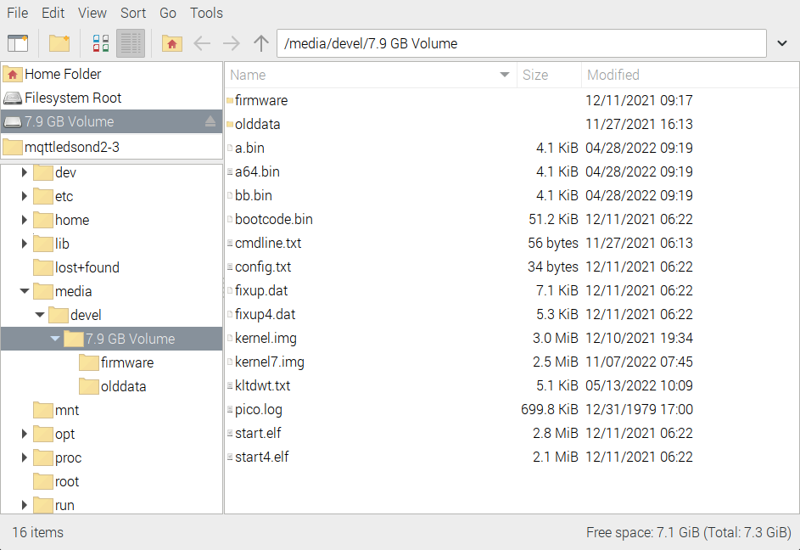

Eject the micro sd and install on Raspberry Pi 2. Put the micro sd in the RPi2 and power up.

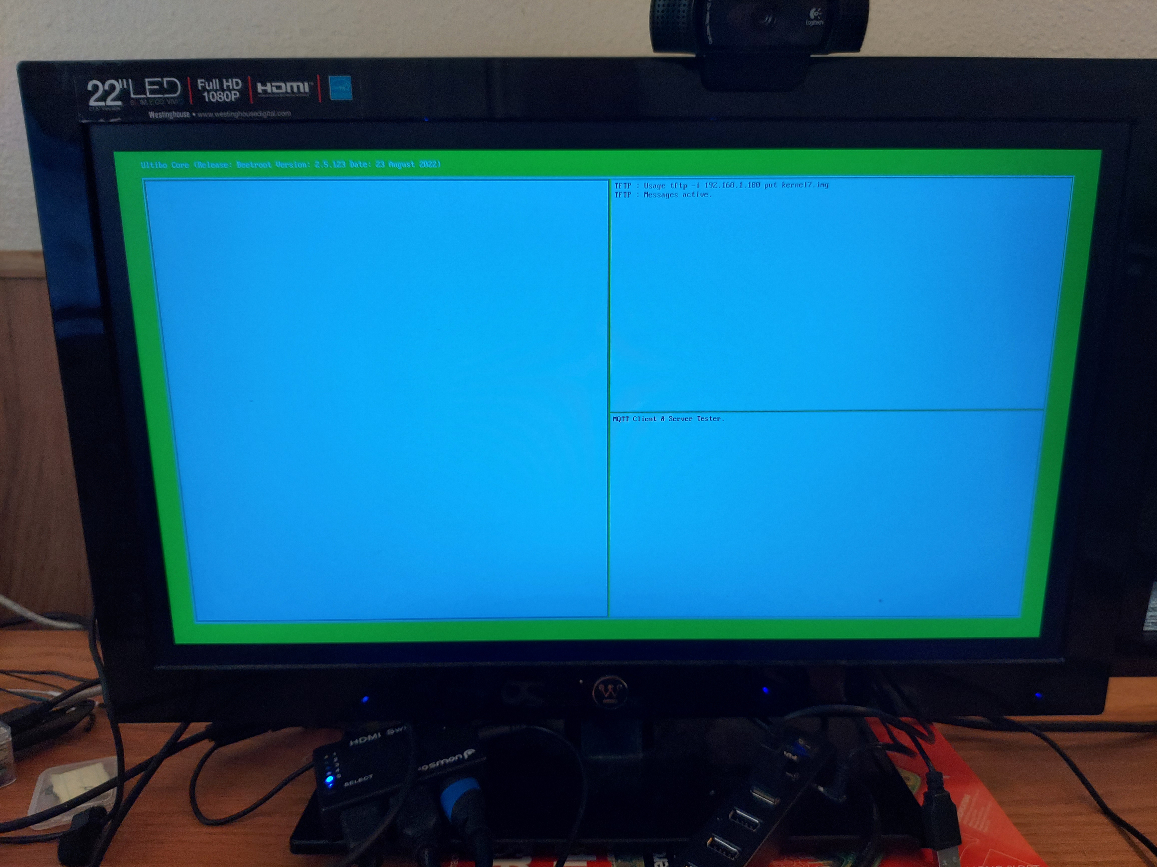

ping 192.168.1.180
PING 192.168.1.180 (192.168.1.180) 56(84) bytes of data.
64 bytes from 192.168.1.180: icmp_seq=2 ttl=128 time=1.88 ms
64 bytes from 192.168.1.180: icmp_seq=3 ttl=128 time=1.75 ms
c64 bytes from 192.168.1.180: icmp_seq=4 ttl=128 time=2.34 ms
64 bytes from 192.168.1.180: icmp_seq=5 ttl=128 time=1.88 ms
^C
--- 192.168.1.180 ping statistics ---
5 packets transmitted, 4 received, 20% packet loss, time 4052ms
rtt min/avg/max/mdev = 1.746/1.963/2.340/0.224 ms

Next we will add telnet to the project

{ needed for telnet }
Shell,
ShellFilesystem,
ShellUpdate,
RemoteShell,
{ needed for telnet }

This now provides a telnet feature to our Bare Metal App.
“telnet 192.168.1.180”
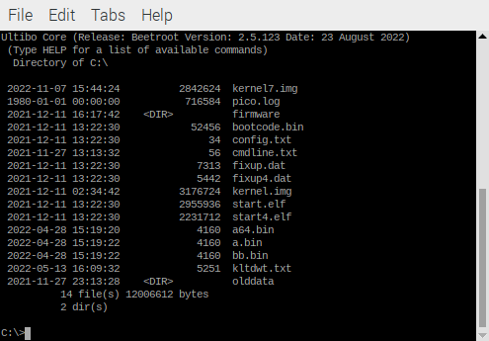
To exit “logout”

Next we will test the tftp support which provides the transfer from the host to the Ultibo Bare Metal and from Ultibo Bare Metal to the host.
First we create an empty file with the command “touch to-bare-metal.txt”.
Add some text

tftp> put to-bare-metal.txt
Sent 95 bytes in 0.0 seconds
tftp> quit

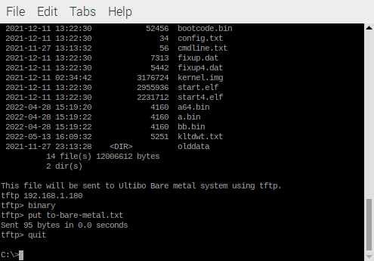

tftp 192.168.1.180
tftp> binary
tftp> put to-bare-metal.txt
Sent 163 bytes in 0.0 seconds

tftp> get config.txt
Received 34 bytes in 0.0 seconds
tftp> quit

cat config.txt
hdmi_force_hotplug=1
gpu_mem=128

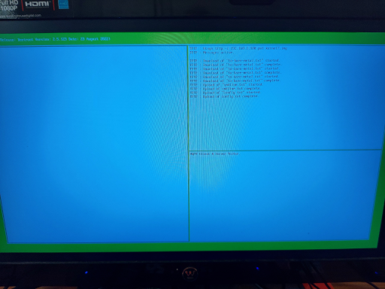
Next step will be to add to Ultibo-Projects

In the folder “Ultibo_Projects/Pauls-ultibo-mqtt”

create 3 folders mkdir RPi3, mkdir RPi2, and mkdir QEMU.

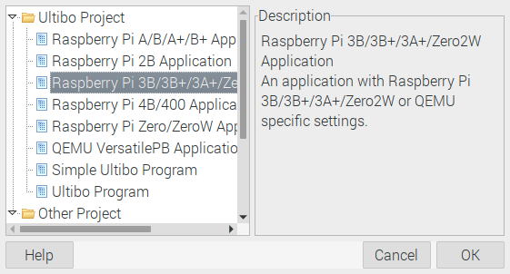

This will bring up a new project when you depress “ok”. We will paste Paul’s code in this new project. Then save in the new folder Ultibo_Projects/Pauls-ultibo-mqtt/

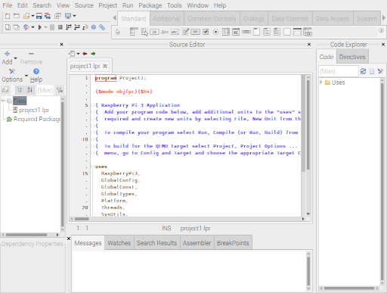

RPi3

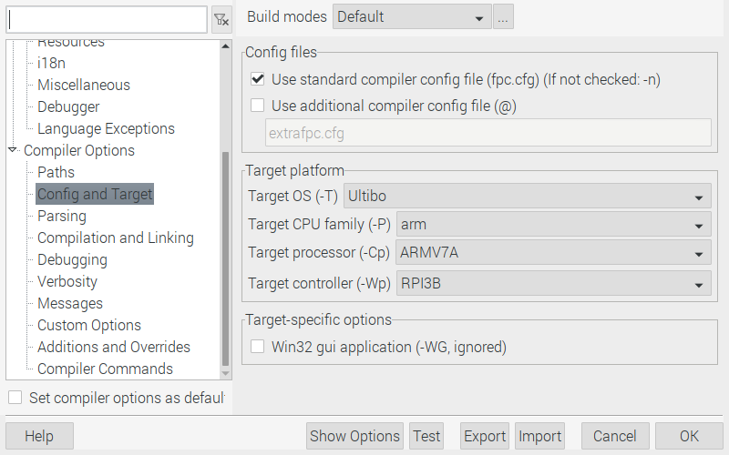

RPi2

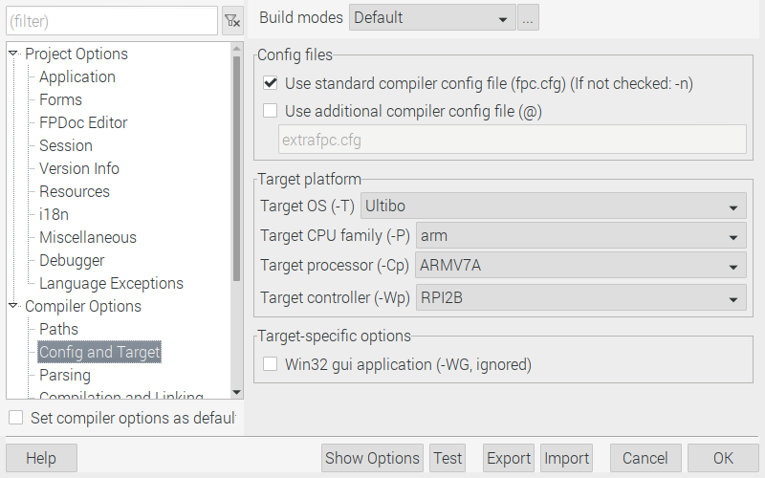
QEMU

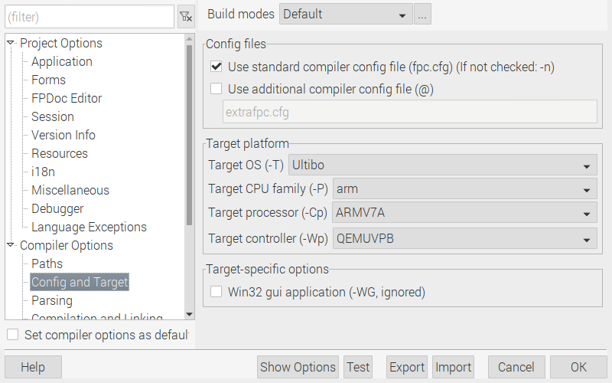
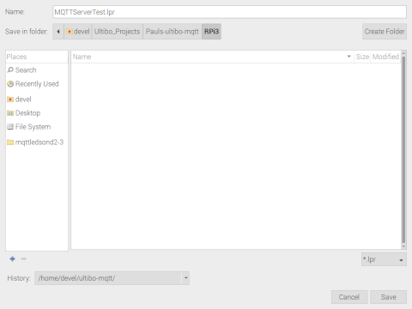
When we try and compile the project we will get an error.

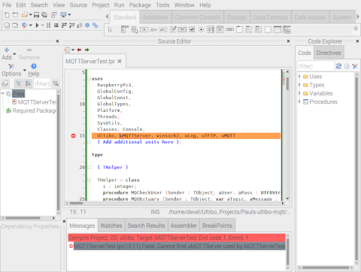
This error occurs, since we do not have the required files.
uLog.pas, uMQTT.pas, uMQTTServer.pas, and uTFTP.pas.
The lower case u is used for Unit.

These steps can only be done if you own the repo and you used
git clone git@github.com:develone/Ultibo_Projects.git git clone
instead of https://github.com/develone/Ultibo_Projects.git

git add RPi3/MQTTServerTest.lpi RPi3/MQTTServerTest.lpr RPi3/README.md RPi3/uLog.pas RPi3/uMQTT.pas RPi3/uMQTTServer.pas RPi3/uTFTP.pas RPi3/README.md

git commit RPi3/MQTTServerTest.lpi RPi3/MQTTServerTest.lpr RPi3/README.md RPi3/uLog.pas RPi3/uMQTT.pas RPi3/uMQTTServer.pas RPi3/uTFTP.pas RPi3/README.md

git push

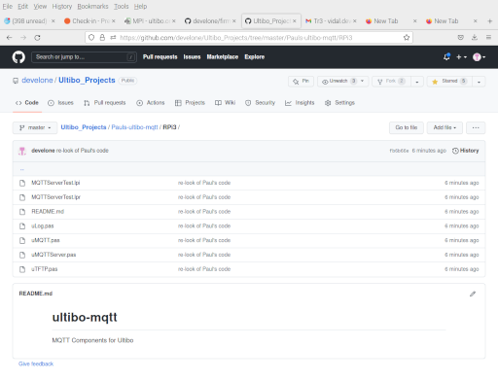

Next we add telnet and create a RPi2 and QEMUVersatilePB .
QEMU will require 2 new files
startqemu.sh and disk.img which takes the place of the micro sd

#!/bin/bash
qemu-system-arm -machine versatilepb -cpu cortex-a8 -kernel kernel.bin \
-net user,hostfwd=tcp::5080-:80,hostfwd=tcp::5023-:23,hostfwd=udp::5069-:69,hostfwd=tcp::6050-:5050 -net nic \
-drive file=disk.img,if=sd,format=raw

The startqemu.sh maps the ports for telnet 20 to 5023 and tftp 69 to 5069.

If you start a new shell without . Ultibo_Projects/picoultibo.sh

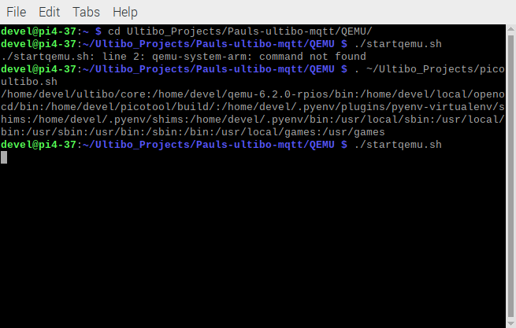

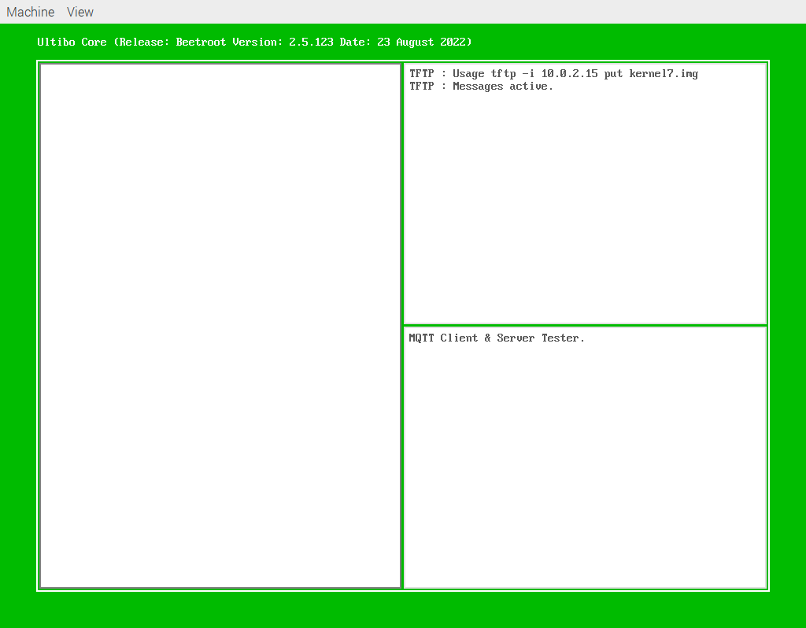
telnet xx.xx.xx.xx 5023

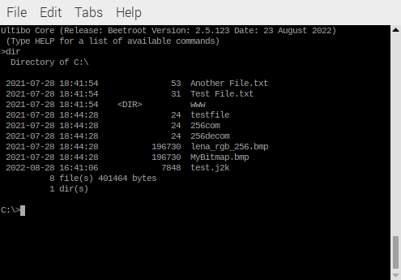

tftp xx.xx.xx.xx 5069
tftp> binary
tftp> get xx.txt
Received 53 bytes in 0.1 seconds
tftp> quit
cat xx.txt
This is another test file, just like the first one tftp xx.xx.xx.xx 5069
tftp> binary
tftp> get xx.txt
Received 53 bytes in 0.1 seconds
tftp> quit
cat xx.txt
This is another test file, just like the first one

The xx.xx.xx.xx is the IP that you see in the right window when running on RPi2.

tftp xx.xx.xx.xx
tftp> binary
tftp> put kernel7.img
Sent 2842624 bytes in 11.7 seconds
tftp>

Note Very important
be vary care with which dev is being used.

sudo fdisk -l
mount the first micro sd
this should show up as /dev/sdx
then mount the next micro sd
this should show up as /dev/sdy
where the x & y are different than your USB
You should wipe /dev/sdy with the command sudo fdisk /dev/sdy
Then umount the /dev/sdy
sudo fdisk -l

sudo dd bs=16M if=/dev/sdb status='progress' of=/dev/sdc
I tested with 2 Raspberry Pi 2

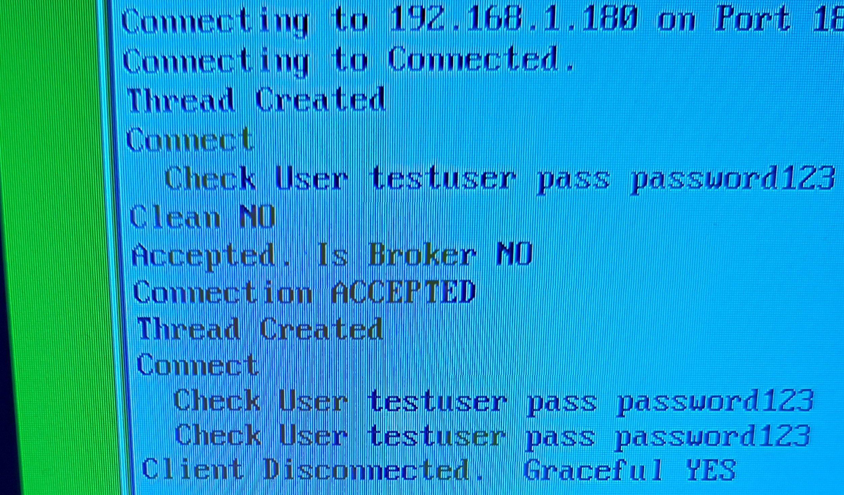
The Arduino Nano-RP2040-Connect connect to Ultibo Bare Metal on a RPi2.



