****************************Default****************************
RaspBerry Pi 4 classification TensorFlow
10/21/22

****************************Default****************************

This can be run on a CoLab at Google classification.ipynb

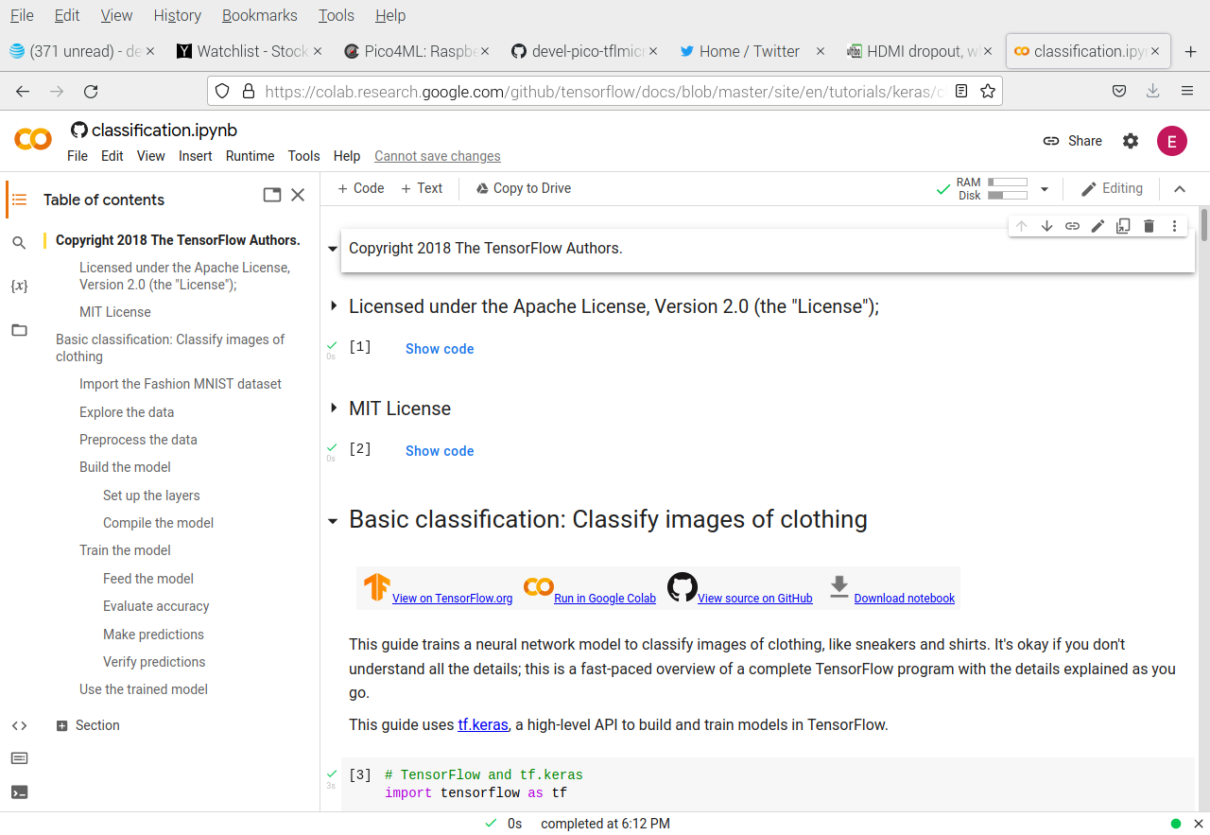

This can be run on a RaspBerry Pi 4 B with 4Gb classification.ipynb

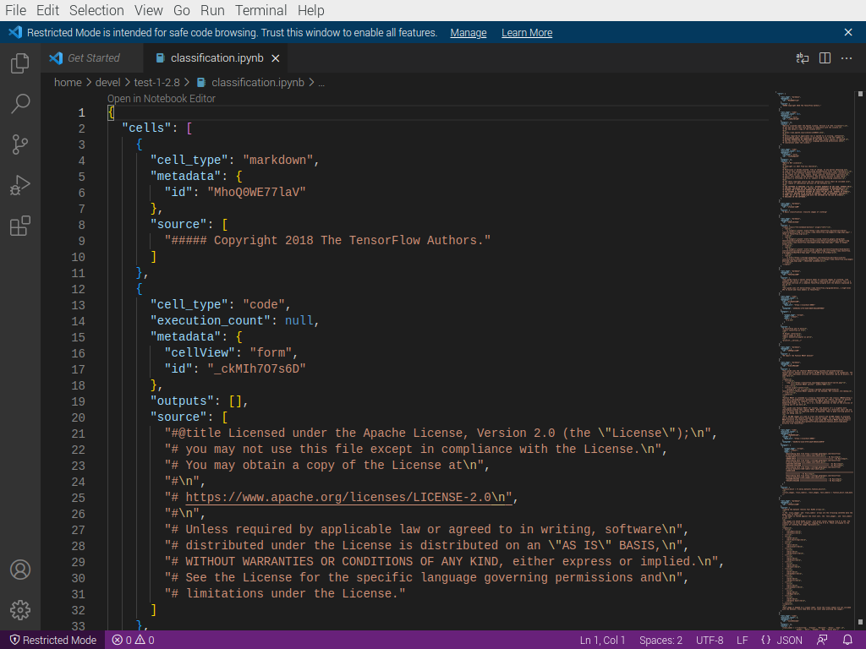

This can be run on RaspBerry Pi 4 classification.ipynb

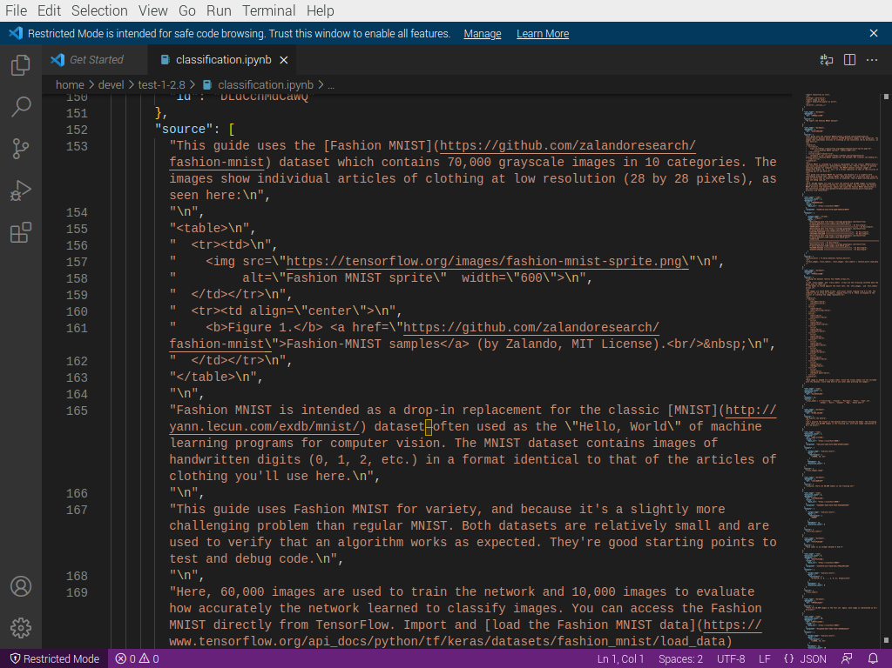

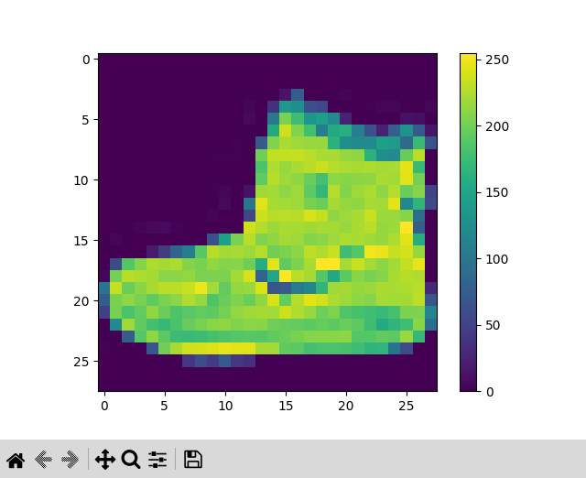
xxx

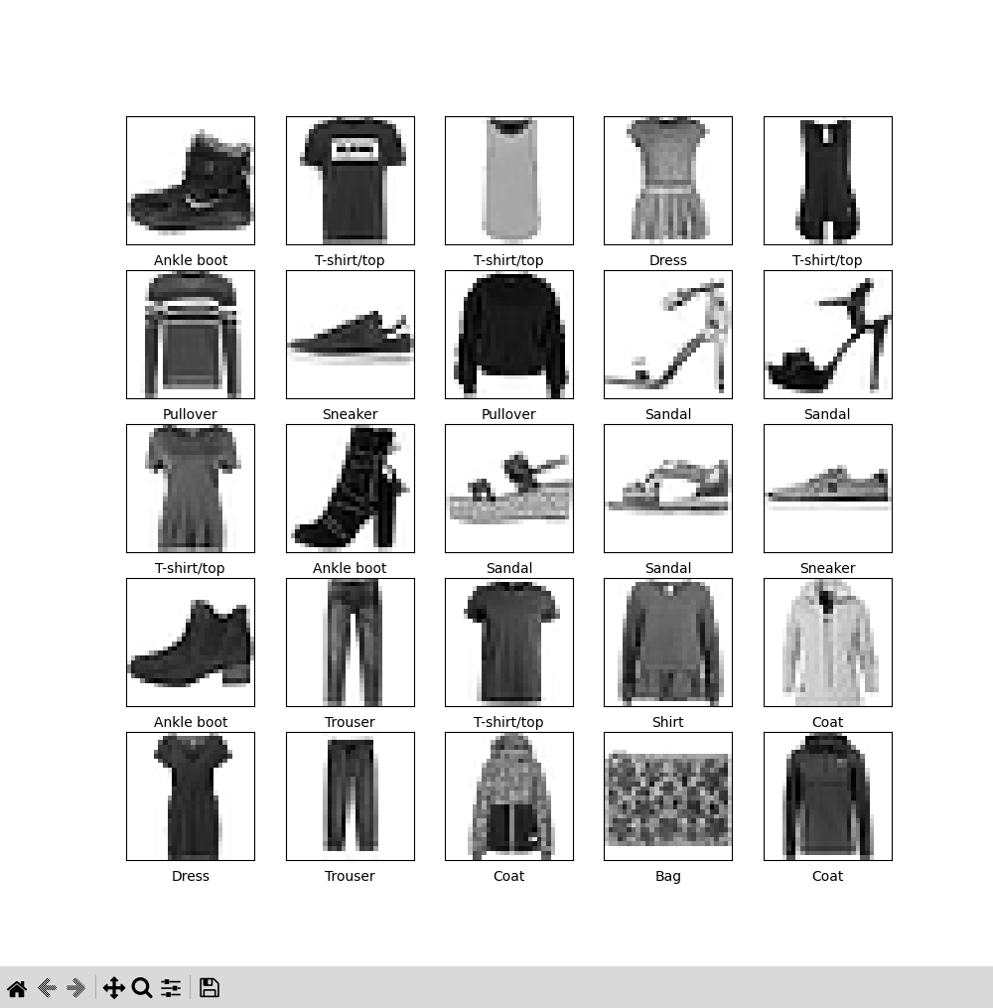
xxx

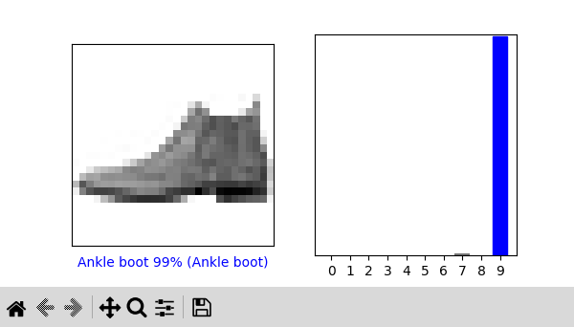
xxx
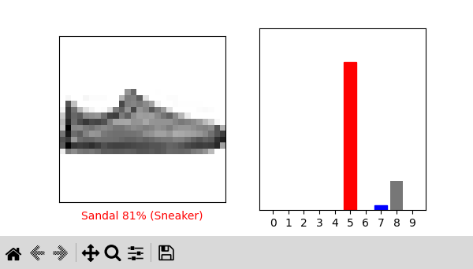
Images after testing
