Parts
Raspberry Pi Pi400 cost TBD SC0373 $70.00
Needs a 64G micro SD

Cable Assembly Mini HDMI-C Male to Micro HDMI-D Male 2.62' (800.00mm)

2.6' SLM CBL MINI HDMI-C – MICRO $18.95

2 RASPBERRY PI PICO W Manufacturer Product Number SC0918 $6.00
2 USB to micro USB to connect the pico_w.
2 PMODUSBUART USB TO UART MODULE 1286-1097-ND $9.99
2 USB to micro USB to connect the MODUSBUART USB TO UART MODULE
RPI USB-C POWER SUPPLY WHITE US 2648-RPIUSB-CPOWERSUPPLYWHITEUS-ND $8.00
RASPBERRY PI MOUSE RED 2648-SC0442-ND $8.00

git clone https://github.com/develone/pico-examples.git -b dev
git clone git@github.com:develone/pico-examples.git -b dev

The files below need your-ssid-password
pico-examples/pico_w/tcp_server/pw_ssid.h
pico-examples/pico_w/tcp_client/pw_ssid.h
pico-examples/pico_w/ntp_client/pw_ssid.h
pico-examples/pico_w/freertos/ping/pw_ssid.h
pico-examples/pico_w/freertos/iperf/pw_ssid.h
pico-examples/pico_w/iperf/pw_ssid.h

WIFI_SSID
pico-examples/pico_w kfreertos/iperf/picow_freertos_iperf.c
pico-examples/pico_w/freertos/ping/picow_freertos_ping.c
pico-examples/pico_w/ntp_client/picow_ntp_client.cpicow_iperf_server_background.elf
pico-examples/pico_w/tcp_server/picow_tcp_server.c
pico-examples/pico_w/tcp_client/picow_tcp_client.c

~/sdk/sspico-sdk

pico-examples/build

You need 2 builds of pico-examples.

first pico_w pico-examples

cmake -DPICO_BOARD=pico_w -DTEST_TCP_SERVER_IP="192.168.1.159" -DWIFI_SSID="ATTtpHTfPi" -DWIFI_PASSWORD="t?bqxvcqh#6t" -DFREERTOS_KERNEL_PATH="../FreeRTOS-Kernel" ..

2nd pico_w pico-examples
cmake -DPICO_BOARD=pico_w -DTEST_TCP_SERVER_IP="192.168.1.160" -DWIFI_SSID="ATTtpHTfPi" -DWIFI_PASSWORD="t?bqxvcqh#6t" -DFREERTOS_KERNEL_PATH="../FreeRTOS-Kernel" ..

openocd -f interface/raspberrypi-swd.cfg -f target/rp2040.cfg -c "program pico_w/freertos/iperf/picow_freertos_iperf_server_sys.elf verify reset exit"
wifi_scan
openocd -f interface/raspberrypi-swd.cfg -f target/rp2040.cfg -c "program pico_w/wifi_scan/picow_wifi_scan_poll.elf verify reset exit"

wifi_scan/picow_wifi_scan_poll.elf
wifi_scan/picow_wifi_scan_background.elf

openocd -f interface/raspberrypi-swd.cfg -f target/rp2040.cfg -c "program pico_w/tcp_server/picow_tcpip_server_background.elf verify reset exit"

openocd -f interface/raspberrypi-swd.cfg -f target/rp2040.cfg -c "program pico_w/tcp_client/picow_tcpip_client_background.elf verify reset exit"

openocd -f interface/raspberrypi-swd.cfg -f target/rp2040.cfg -c "program pico_w/tcp_server/picow_tcpip_server_poll.elf verify reset exit"

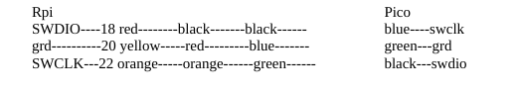

xx

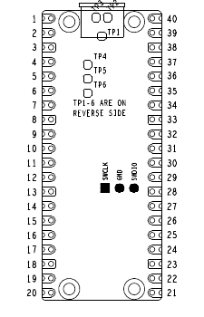

you need 2 shells on system.
1 to see the output of the server
1 to program the pico_w with openocd. This can be done by transferring the uf2 file to the pico_w.

you need 2 shells on a 2nd system.
1 to see the output of the client
1 to program the pico_w with openocd. This can be done by transferring the uf2 file to the pico_w.
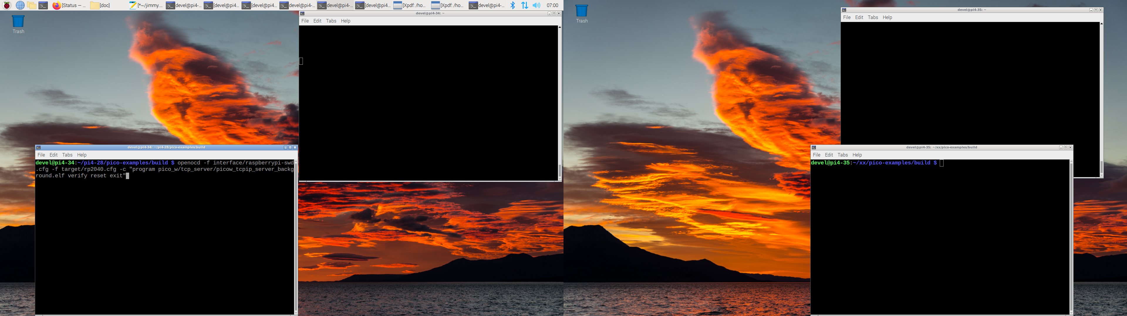

xx

openocd -f interface/raspberrypi-swd.cfg -f target/rp2040.cfg -c "program pico_w/wifi_scan/picow_wifi_scan_poll.elf verify reset exit"

Performing wifi scan
ssid: ATT3TV6WQs rssi: -72 chan: 1 mac: c8:52:61:4e:d25
ssid: ATTtpHTfPi rssi: -7 chan: 1 mac: cc:ab:2c:c7:5e5
ssid: ATTtpHTfPi rssi: -7 chan: 1 mac: cc:ab:2c:c7:5e5
ssid: ATT3TV6WQs rssi: -70 chan: 1 mac: c8:52:61:4e:d25
ssid: ATTjw8tqXi rssi: -78 chan: 1 mac: f4:17:b8:de:a65
ssid: NETGEAR38 rssi: -78 chan: 2 mac: bc:a5:11:1c:a65
ssid: rssi: -76 chan: 1 mac: aa:17:b8:de:a65
ssid: House rssi: -74 chan: 3 mac: c4:41:1e:4e:c35
ssid: House rssi: -75 chan: 3 mac: c4:41:1e:4e:c35
ssid: House rssi: -72 chan: 3 mac: c4:41:1e:4e:c35
ssid: House rssi: -74 chan: 3 mac: c4:41:1e:4e:c35
ssid: SpectrumSetup-EB rssi: -77 chan: 8 mac: c8:b4:22:c8:045
ssid: Steph speaker.o, rssi: -88 chan: 6 mac: fa:8f:ca:99:200
ssid: Steph speaker.o, rssi: -86 chan: 6 mac: fa:8f:ca:99:200
ssid: ATTtpHTfPi rssi: -58 chan: 1 mac: cc:ab:2c:c7:5e5
ssid: ATT47CJH5z_EXT rssi: -82 chan: 11 mac: 3c:84:6a:46:987
ssid: ATT47CJH5z_EXT rssi: -82 chan: 11 mac: 3c:84:6a:46:987
ssid: ATT47CJH5z_EXT rssi: -81 chan: 11 mac: 3c:84:6a:46:987

Performing wifi scan
ssid: ATTjw8tqXi rssi: -76 chan: 1 mac: f4:17:b8:de:a65
ssid: ATT3TV6WQs rssi: -71 chan: 1 mac: c8:52:61:4e:d25
ssid: ATTtpHTfPi rssi: -4 chan: 1 mac: cc:ab:2c:c7:5e5
ssid: ATTtpHTfPi rssi: -5 chan: 1 mac: cc:ab:2c:c7:5e5
ssid: ATTtpHTfPi rssi: -6 chan: 1 mac: cc:ab:2c:c7:5e5
ssid: ATT3TV6WQs rssi: -71 chan: 1 mac: c8:52:61:4e:d25
ssid: ATTjw8tqXi rssi: -78 chan: 1 mac: f4:17:b8:de:a65
ssid: rssi: -73 chan: 3 mac: ca:41:1e:4e:c35
ssid: NETGEAR38 rssi: -79 chan: 2 mac: bc:a5:11:1c:a65
ssid: House rssi: -71 chan: 3 mac: c4:41:1e:4e:c35
ssid: ATTtpHTfPi rssi: -9 chan: 1 mac: cc:ab:2c:c7:5e5
ssid: House rssi: -74 chan: 3 mac: c4:41:1e:4e:c35
ssid: House rssi: -78 chan: 3 mac: c4:41:1e:4e:c35
ssid: SpectrumSetup-EB rssi: -77 chan: 8 mac: c8:b4:22:c8:045
ssid: SpectrumSetup-AO rssi: -84 chan: 6 mac: 68:4a:76:63:6c5
ssid: SpectrumSetup-AO rssi: -82 chan: 6 mac: 68:4a:76:63:6c5
ssid: SpectrumSetup-EB rssi: -79 chan: 8 mac: c8:b4:22:c8:045
ssid: VTECH_5864_4d79 rssi: -87 chan: 6 mac: a6:97:5c:00:4d5
ssid: rssi: -81 chan: 6 mac: 68:4a:76:63:6c0
ssid: rssi: -83 chan: 8 mac: 68:4a:76:63:6c5
ssid: SpectrumSetup-AO rssi: -82 chan: 6 mac: 68:4a:76:63:6c5
ssid: SpectrumSetup-EB rssi: -79 chan: 8 mac: c8:b4:22:c8:045
ssid: rssi: -80 chan: 8 mac: 68:4a:76:64:140
ssid: rssi: -80 chan: 8 mac: 68:4a:76:64:145
ssid: SpectrumSetup-AO rssi: -81 chan: 8 mac: 68:4a:76:64:145
ssid: ATTtpHTfPi rssi: -61 chan: 1 mac: cc:ab:2c:c7:5e5
ssid: ATT47CJH5z rssi: -86 chan: 11 mac: e0:22:02:50:9d5
ssid: ATT47CJH5z_EXT rssi: -82 chan: 11 mac: 3c:84:6a:46:987
ssid: ATT47CJH5z_EXT rssi: -82 chan: 11 mac: 3c:84:6a:46:987
ssid: ATT47CJH5z_EXT rssi: -82 chan: 11 mac: 3c:84:6a:46:987
ssid: ATT47CJH5z rssi: -83 chan: 11 mac: e0:22:02:50:9d5
ssid: ATT47CJH5z_EXT rssi: -81 chan: 11 mac: 3c:84:6a:46:987
ssid: ATT47CJH5z_EXT rssi: -80 chan: 11 mac: 3c:84:6a:46:987
ssid: ATT47CJH5z_EXT rssi: -82 chan: 11 mac: 3c:84:6a:46:987
ssid: ATT47CJH5z_EXT

This would be the test to run from your house to edge of property

First pico_w pico-examples

openocd -f interface/raspberrypi-swd.cfg -f target/rp2040.cfg -c "program pico_w/iperf/picow_iperf_server_background.elf verify reset exit"

Welcome to minicom 2.8

OPTIONS: I18n
Port /dev/ttyUSB0, 09:17:09

Press CTRL-A Z for help on special keys

Connecting to WiFi...
Connected.

Ready, running iperf server at 192.168.1.160

iperf -c 192.168.1.160
------------------------------------------------------------
Client connecting to 192.168.1.160, TCP port 5001
TCP window size: 43.8 KByte (default)
------------------------------------------------------------
[ 3] local 192.168.1.211 port 44508 connected with 192.168.1.160 port 5001
[ ID] Interval Transfer Bandwidth
[ 3] 0.0000-10.0076 sec 17.1 MBytes 14.4 Mbits/sec

Ready, running iperf server at 192.168.1.160
Completed iperf transfer of 17 MBytes @ 14.3 Mbits/sec
Total iperf megabytes since start 17 Mbytes

2nd pico_w pico-examples
openocd -f interface/raspberrypi-swd.cfg -f target/rp2040.cfg -c "program pico_w/iperf/picow_iperf_server_background.elf verify reset exit"

Connecting to WiFi...
Connected.

Ready, running iperf server at 192.168.1.159

iperf -c 192.168.1.159
------------------------------------------------------------
Client connecting to 192.168.1.159, TCP port 5001
TCP window size: 43.8 KByte (default)
------------------------------------------------------------
[ 3] local 192.168.1.211 port 35674 connected with 192.168.1.159 port 5001
[ ID] Interval Transfer Bandwidth
[ 3] 0.0000-10.0056 sec 16.8 MBytes 14.0 Mbits/sec

Ready, running iperf server at 192.168.1.159
Completed iperf transfer of 16 MBytes @ 14.0 Mbits/sec
Total iperf megabytes since start 16 Mbytes

