First QEMU is started using “./startqemu.sh”

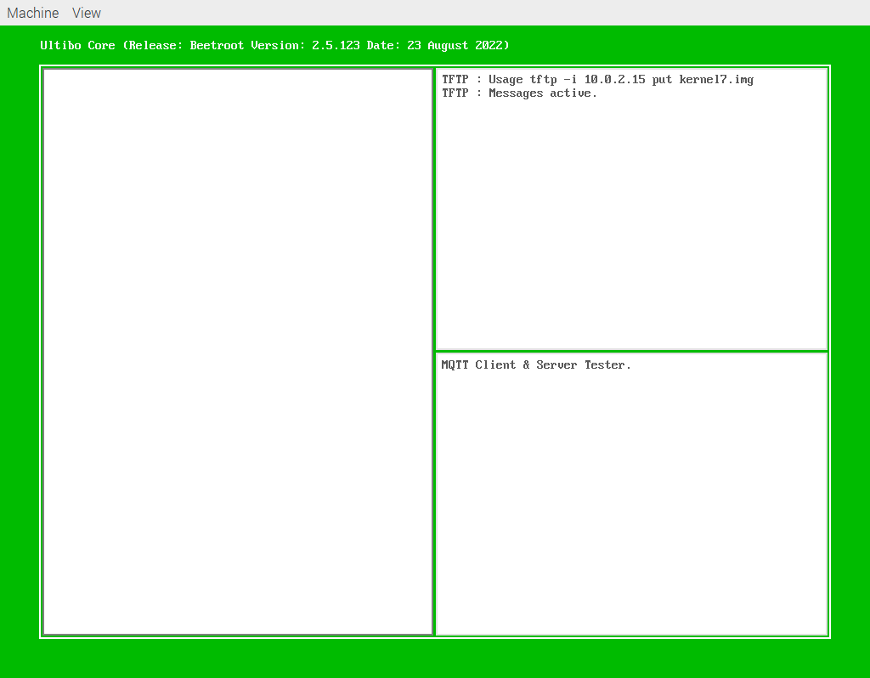

Arduino Nano-RP2040-Connect is programmed with “mqtt.ino” using the Arduino IDE.
RGB
Bl ext
Red ext

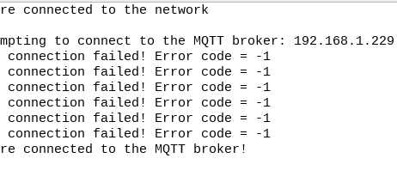
Bl ext on
Bl ext off

WiFi Connection

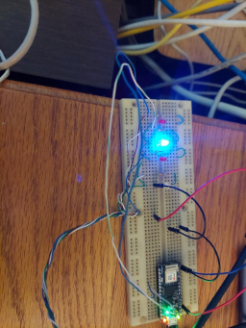

RGB GR/RED toggles
Red ext on

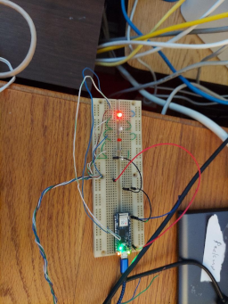

RGB GR/RED toggles
Red ext on

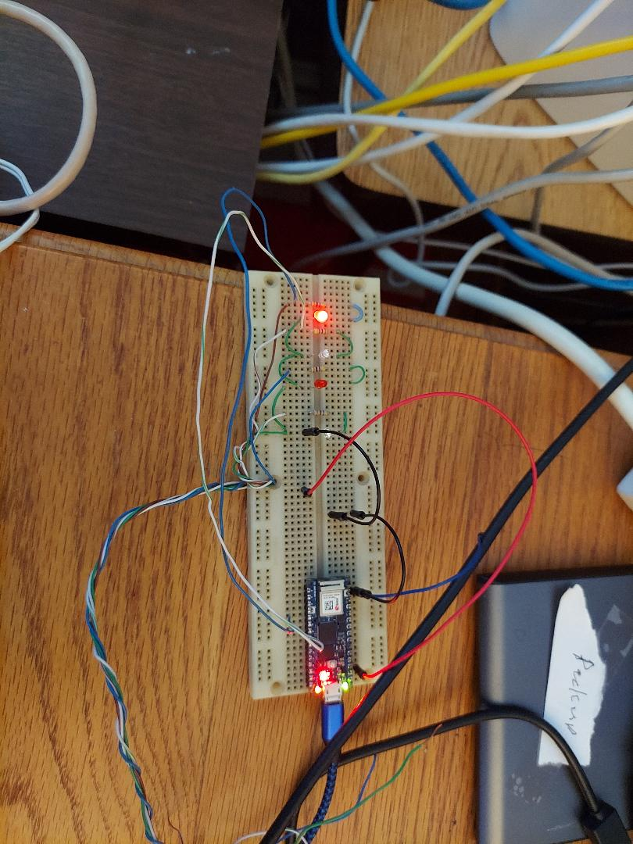

Broker Connection
Red ext on
Bl ext on

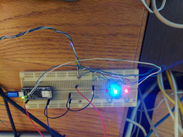

When the 5 is depressed on QEMU

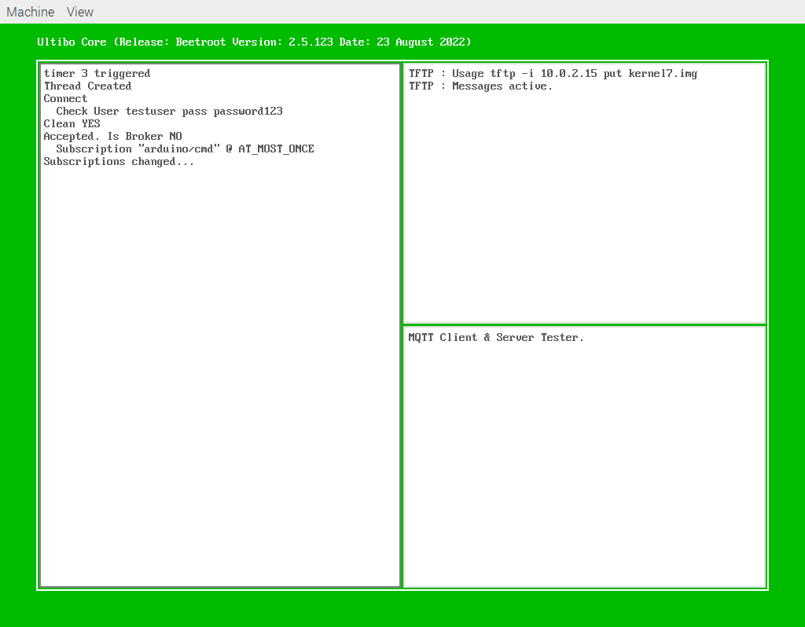

Arduino Nano-RP2040-Connect is programmed with “mqtt.ino” using the Arduino IDE.
Bl ext on
Bl ext off

WiFi Connection

RGB GR/RED toggles
Red ext on

Broker Connection
Red ext on
Bl ext on

When the 5 is depressed on QEMU

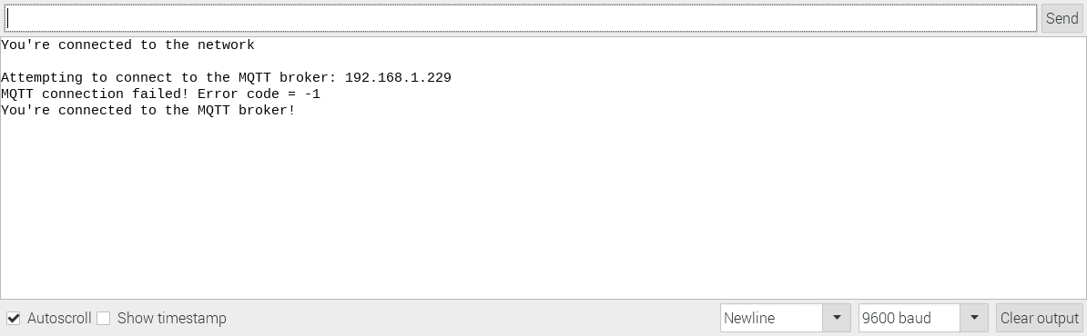
Running 11/08/22

devel@pi4-27:~/my-projects-docs/Ultibo/ultibo-mqtt/nano-qemu $ diff MQTTServerTest.lpr ~/Ultibo_Projects/Pauls-ultibo-mqtt/QEMU/MQTTServerTest.lpr

