************************Draft Valve Control************************
Initial work by Joe Small
using a pico_w programmed with Arduino IDE
L288 Motor Control

08/02/23

************************Draft Valve Control************************

L288 Components

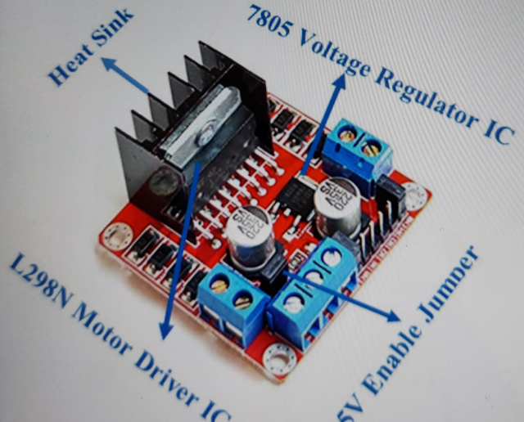

L288 pins description

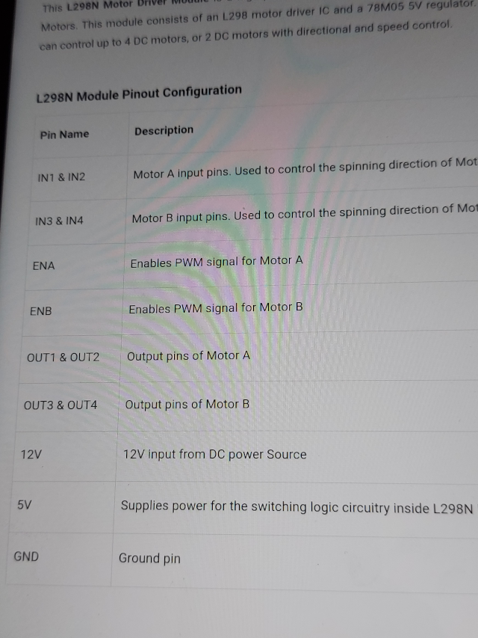

L288 pins.
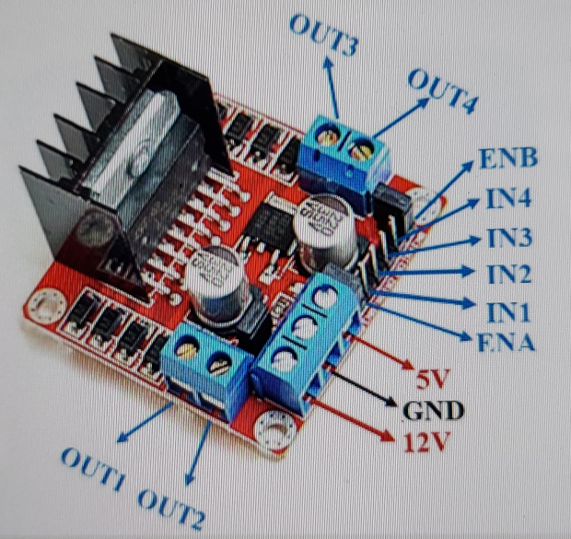

pico_w program provided by Joe Small (setup).

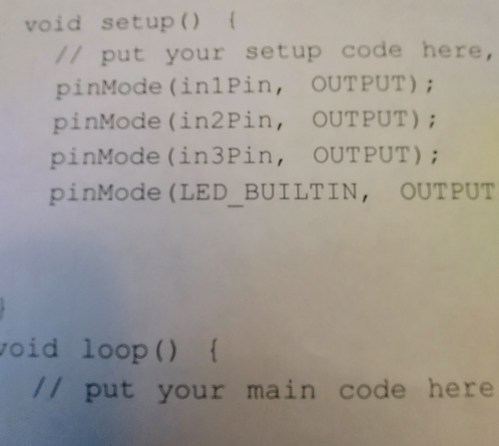

xxpico_w program provided by Joe Small (loop).

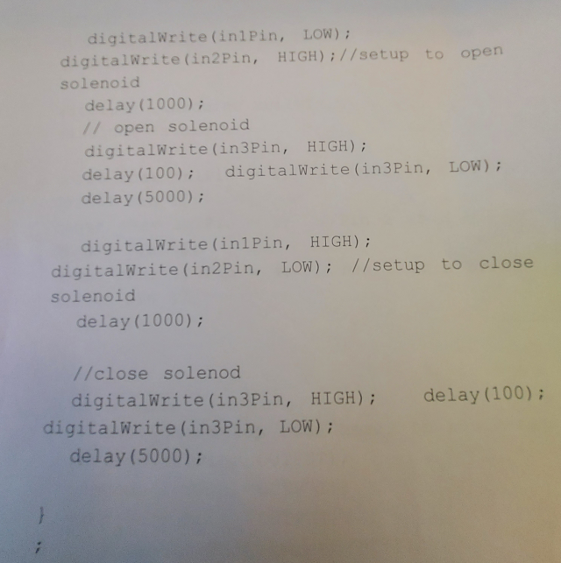

xx

