**********************Default**********************

Raspberry Pi Pico RP2040 with TensorFLow Lite
Programming done on a Raspberry Pi4 and
Google Colaboratory
08/21/22

**********************Default**********************

Goals:
Goal 1.
To program a Raspberry Pi Pico RP2040 with TensorFLow Lite.

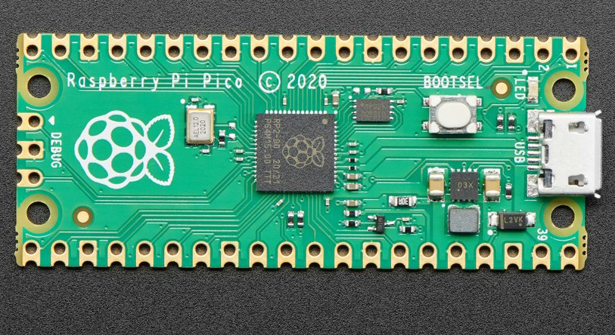

Additional information on process of compiling pico-tflmicro and testing can be found at

https://github.com/develone/my-projects-docs/blob/master/pico/tensorflow.txt

Steps to get the pico executable s
hello_world.elf, hello_world_test.elf & output_handler_test.elf

git clone git@github.com:develone/pico-tflmicro.git

cd pico-tflmicro

git clone git@github.com:develone/pico-sdk.git

cd pico-sdk/

git submodule update --init

cd ../

mkdir build

cd build

export PICO_SDK_PATH=../pico-sdk/

cmake -DPICO_BOARD=pico ..

make

Goal 2. To convert a TensorFLow model to a TensorFlow Lite model.
The command used to create model.cc was “xxd -i model.tflite > model.cc”
model.cc
unsigned char g_model[] = {

model.cpp
#include "model.h"
// Keep model aligned to 8 bytes to guarantee aligned 64-bit accesses.
alignas(8) const unsigned char g_model[] = {

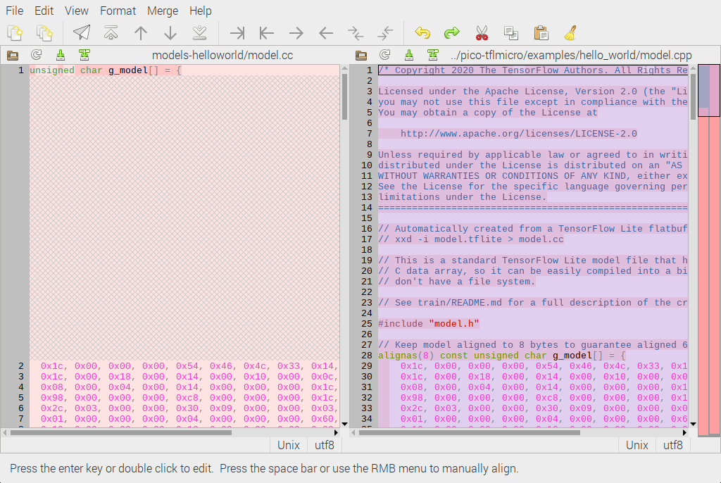
Last of difference

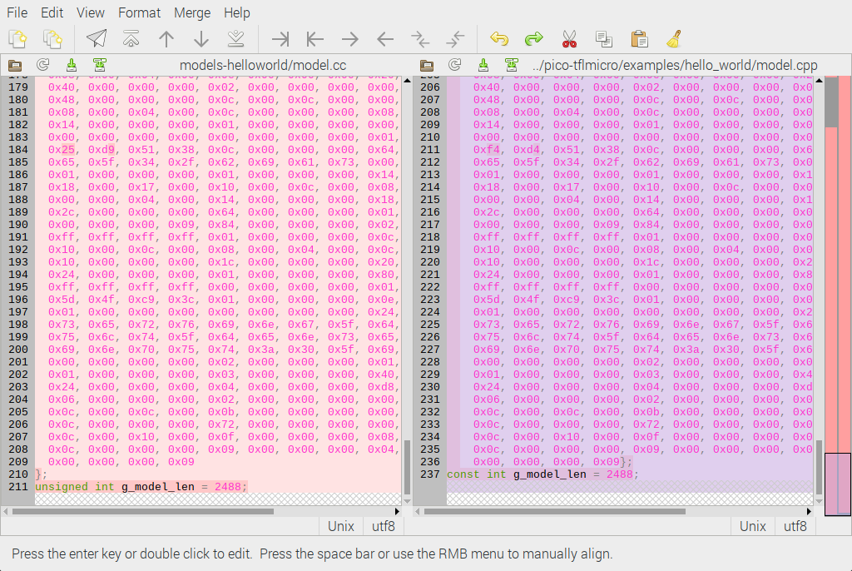

Testing using the xxd command to create the model.cc

devel@pi4-27:~/xx/TF-CL/models-helloworld $ xxd -i model.tflite > tt.cc

diff tt.cc model.cc
1c1
< unsigned char model_tflite[] = {
---
> unsigned char g_model[] = {
211c211
< unsigned int model_tflite_len = 2488;
---
> unsigned int g_model_len = 2488;

The model was saved to my github from

https://www.tensorflow.org/lite/microcontrollers/get_started_low_level

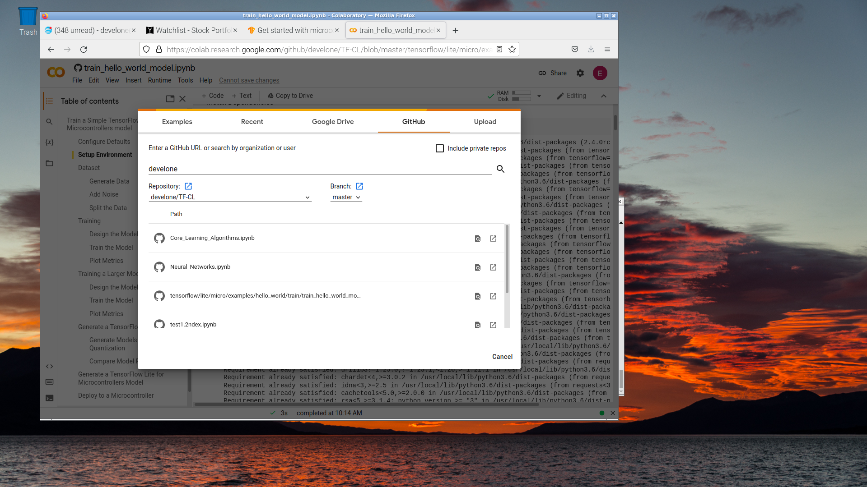
Loading the TensorFlow hello_world

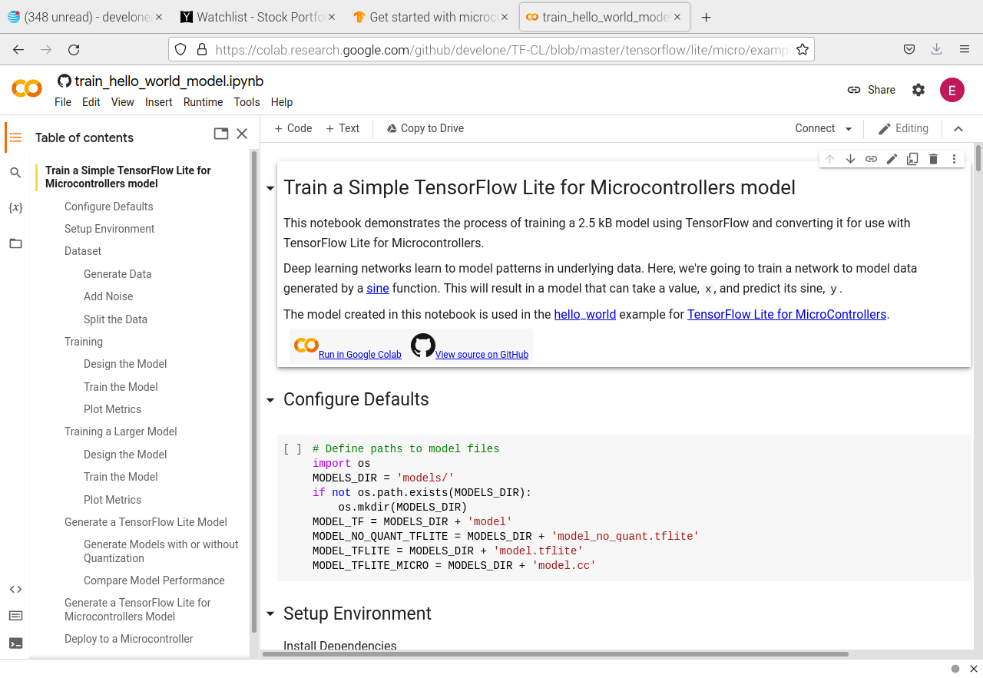
Setup Environment.

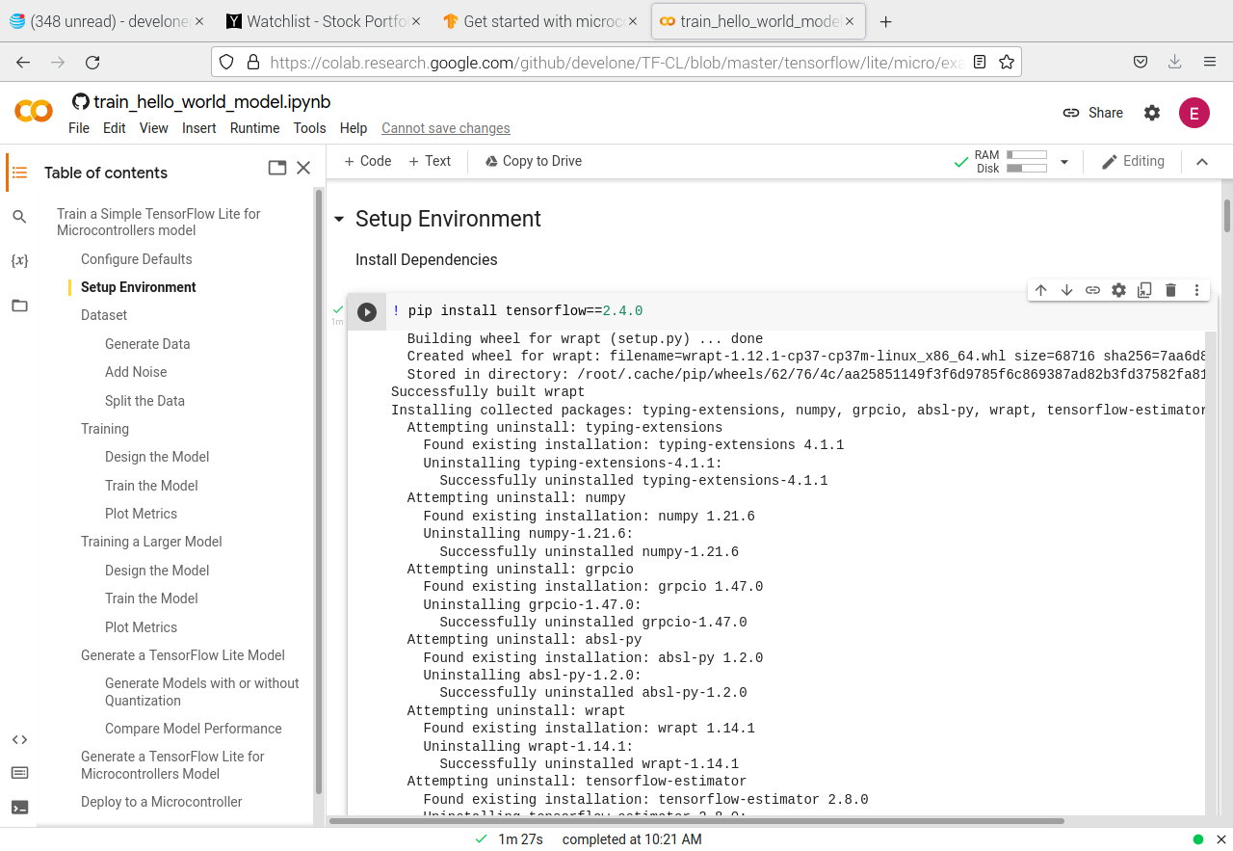
Import Dependencies

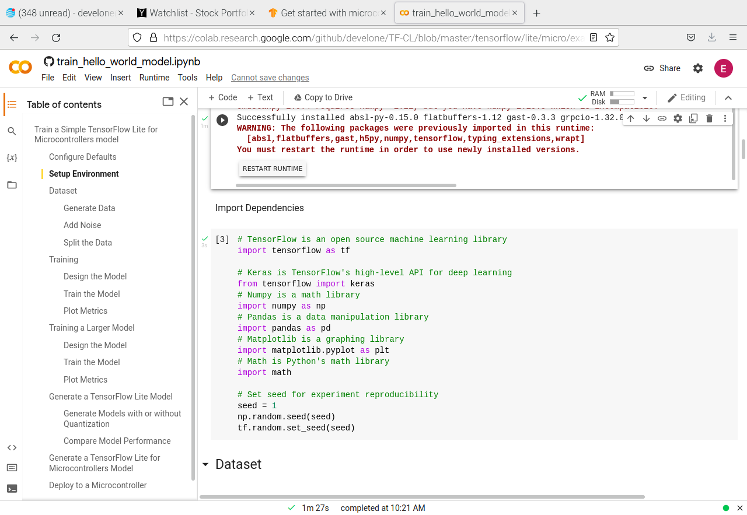
Generate Data

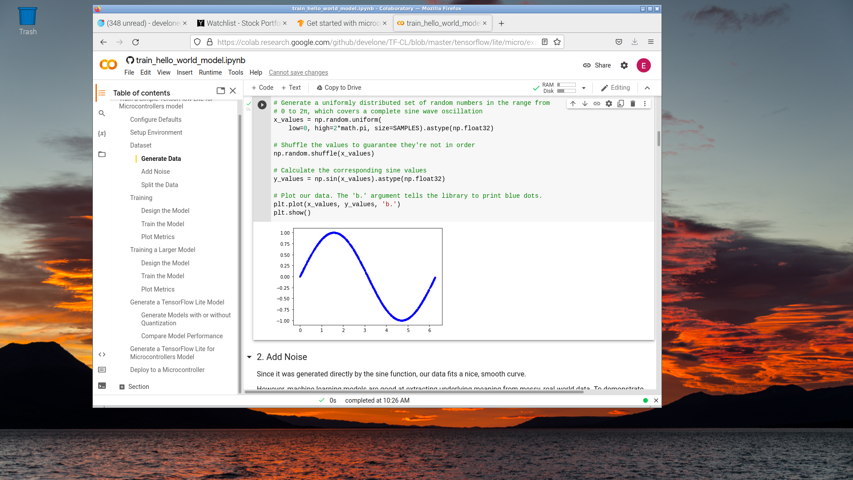
Add Noise

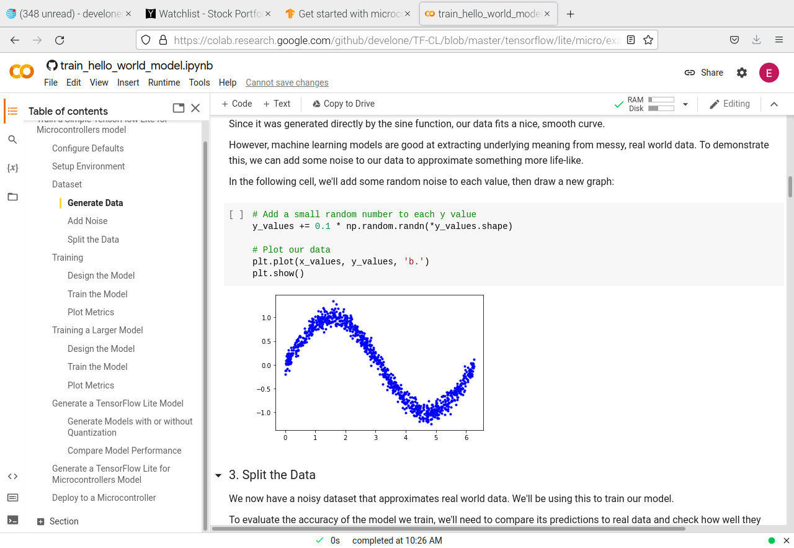
Split Data

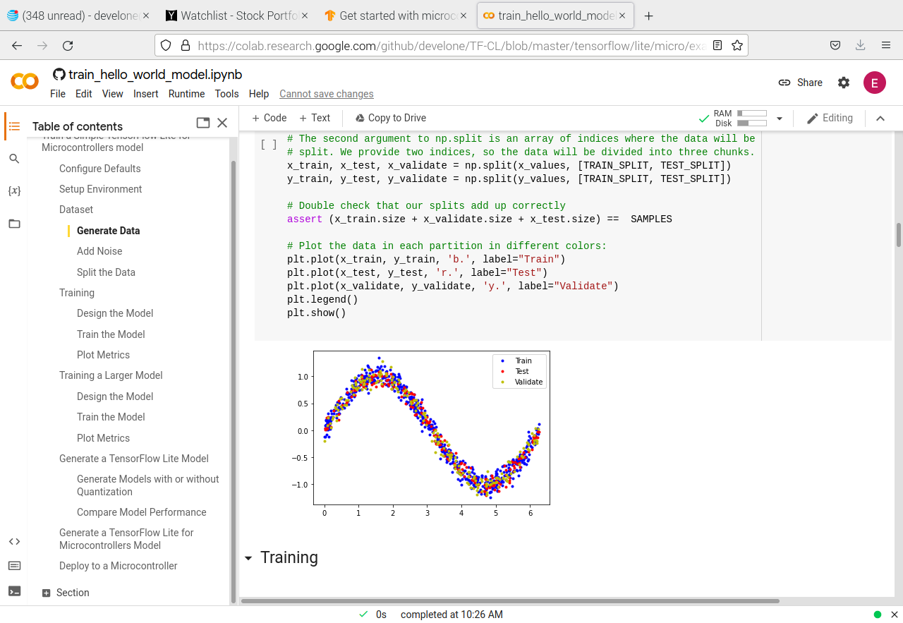
Design the model

### 1. Design the Model
We're going to build a simple neural network model that will take an input value (in this case, `x`) and use it to predict a numeric output value (the sine of `x`). This type of problem is called a _regression_. It will use _layers_ of _neurons_ to attempt to learn any patterns underlying the training data, so it can make predictions.

To begin with, we'll define two layers. The first layer takes a single input (our `x` value) and runs it through 8 neurons. Based on this input, each neuron will become _activated_ to a certain degree based on its internal state (its _weight_ and _bias_ values). A neuron's degree of activation is expressed as a number.

The activation numbers from our first layer will be fed as inputs to our second layer, which is a single neuron. It will apply its own weights and bias to these inputs and calculate its own activation, which will be output as our `y` value.

**Note:** To learn more about how neural networks function, you can explore the [Learn TensorFlow](https://codelabs.developers.google.com/codelabs/tensorflow-lab1-helloworld) codelabs.

The code in the following cell defines our model using [Keras](https://www.tensorflow.org/guide/keras), TensorFlow's high-level API for creating deep learning networks. Once the network is defined, we _compile_ it, specifying parameters that determine how it will be trained:

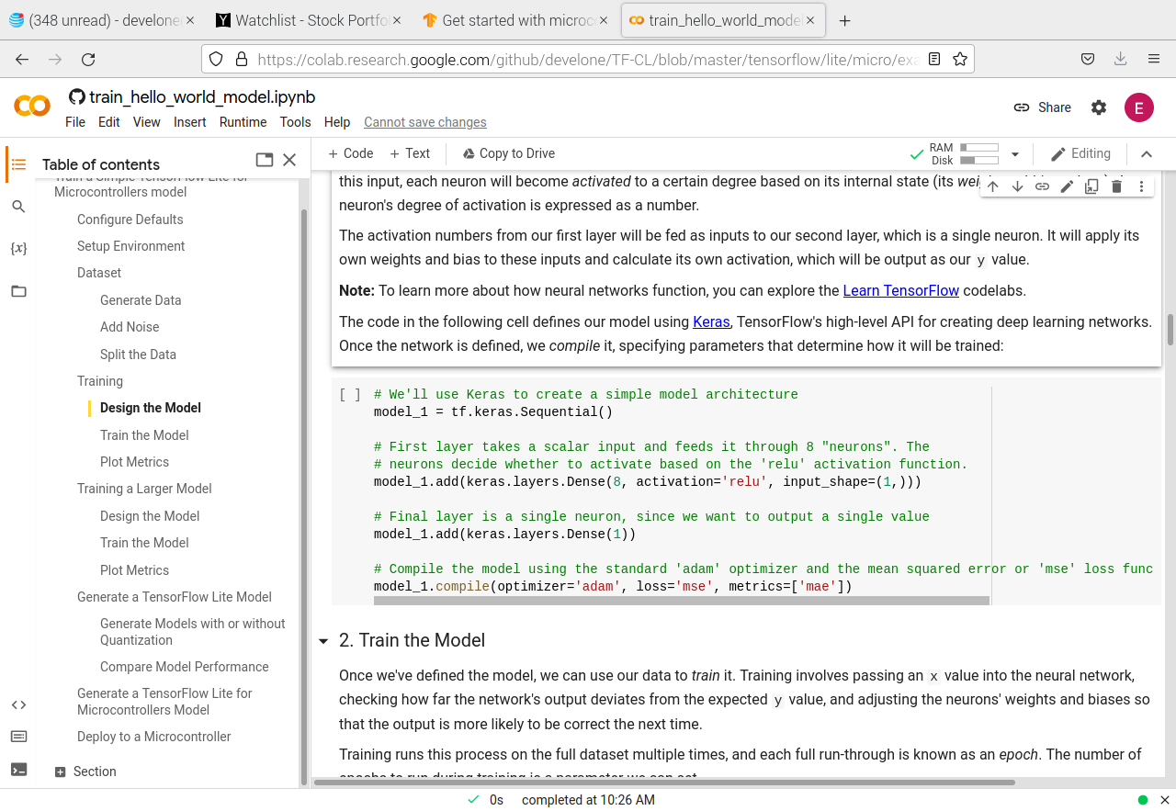
Train the model

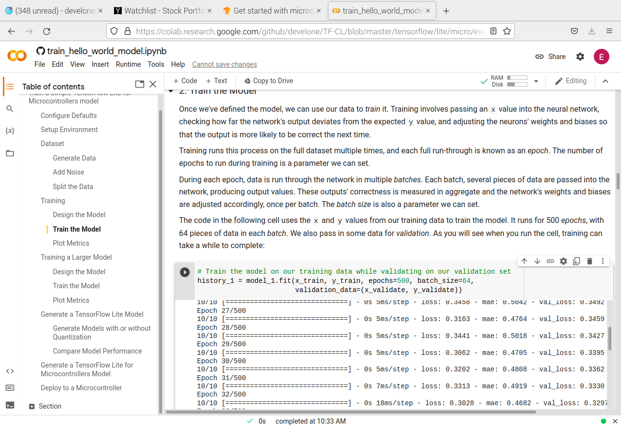
Wanted to determine if making a change in TensorFlow at Google Corroboratory would result in a TensorFlow Lite run on Raspberry Pi Pico.

Changing the line y_values = np.sin(x_values).astype(np.float32) on left
to y_values = np.cos(x_values).astype(np.float32) image on the right.

The original was saved in model-sin.cpp

This created a new model.cpp which was saved as model-cos.cpp

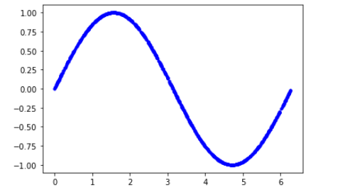
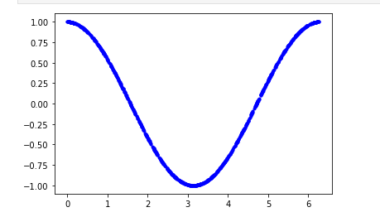

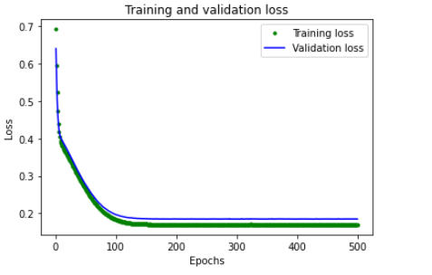

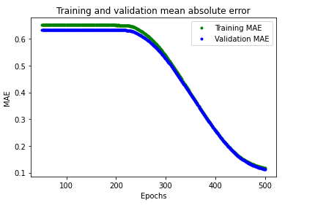

openocd -f interface/raspberrypi-swd.cfg -f target/rp2040.cfg -c "program examples/hello_world/hello_world.elf verify reset exit"

minicom myusb0

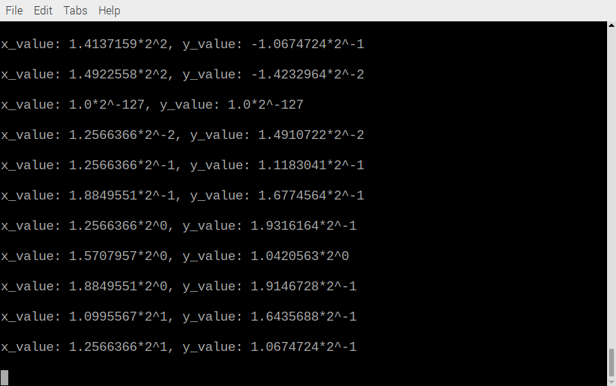

clear
close all
x=[1.0*2^-127,1.2566366*2^-2,1.2566366*2^-1,1.8849551*2^-1,1.2566366*2^0,1.5707957*2^0,1.8849551*2^0, 1.0995567*2^1, 1.2566366*2^1, 1.4137159*2^1, 1.5707957*2^1, 1.7278753*2^1, 1.8849551*2^1, 1.0210171*2^2, 1.0995567*2^2, 1.1780966*2^2, 1.2566366*2^2, 1.3351763*2^2, 1.4137159*2^2, 1.4922558*2^2, 1.0*2^-127];
y=[1.0230449*2^0, 1.9795505*2^-1,1.5803134*2^-1, 1.197711*2^-1, 1.2309807*2^-2, 1.0646323*2^-5, -1.0646323*2^-2, -1.1311719*2^-1, -1.6634879*2^-1, -1.913011*2^-1, -1.9961854*2^-1, -1.8631063*2^-1, -1.6135832*2^-1, -1.1145368*2^-1, -1.0646323*2^-2, 1.0*2^-127, 1.2975204*2^-2, 1.2143458*2^-1, 1.5969484*2^-1, 1.913011*2^-1, 1.0230449*2^0];

yy=[ 1.0*2^-127, 1.4910722*2^-2, 1.1183041*2^-1, 1.6774564*2^-1, 1.9316164*2^-1, 1.0420563*2^0, 1.9146728*2^-1, 1.6435688*2^-1, 1.0674724*2^-1, 1.8977287*2^-3, 1.0844163*2^-7, -1.2199684*2^-2, -1.0674724*2^-1, -1.5588485*2^-1, -1.9316164*2^-1, -1.1098324*2^0, -1.9655047*2^-1, -1.4910722*2^-1, -1.0674724*2^-1, -1.4232964*2^-2, 1.0*2^-127];
figure
plot(x,yy)

figure
plot(x,y)

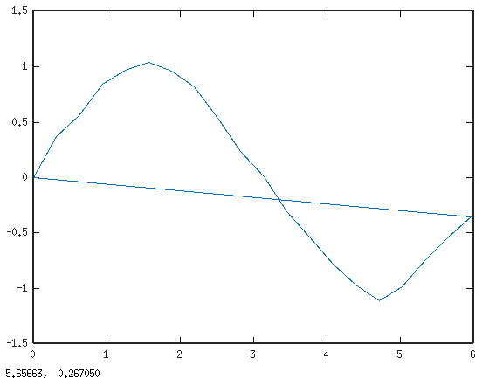
sin

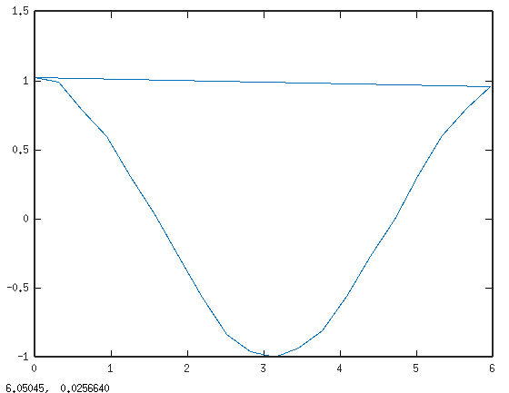
xx
cos

