sudo apt-get install fritzing

https://electronics.stackexchange.com/questions/166670/how-do-i-energize-a-12v-relay-coil-using-a-2n2222-bipolar-transistor

relay control



this is what fritzing provides. Instead of the Rpi which is on the left you can use minicom myusb0 with the ftdi usb to serial
Use fritzing to open
/home/devel/pi4-28/pico-examples/gpio/dht_sensor/pi-and-pico-uart-and-dht-sensor.fzz
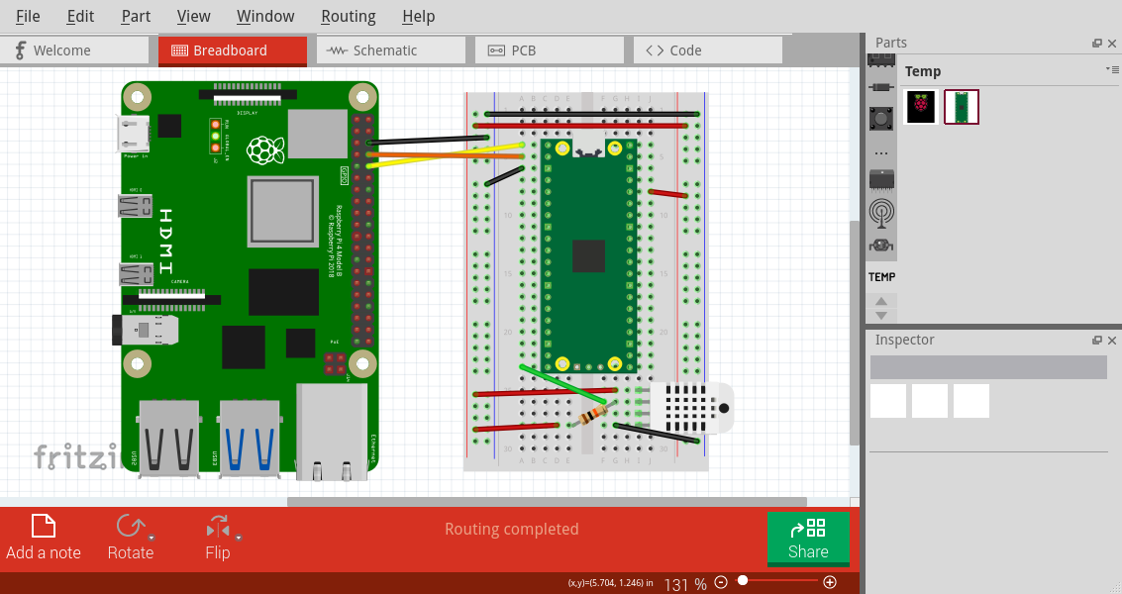

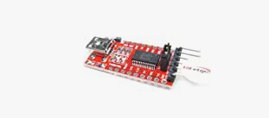

schematic

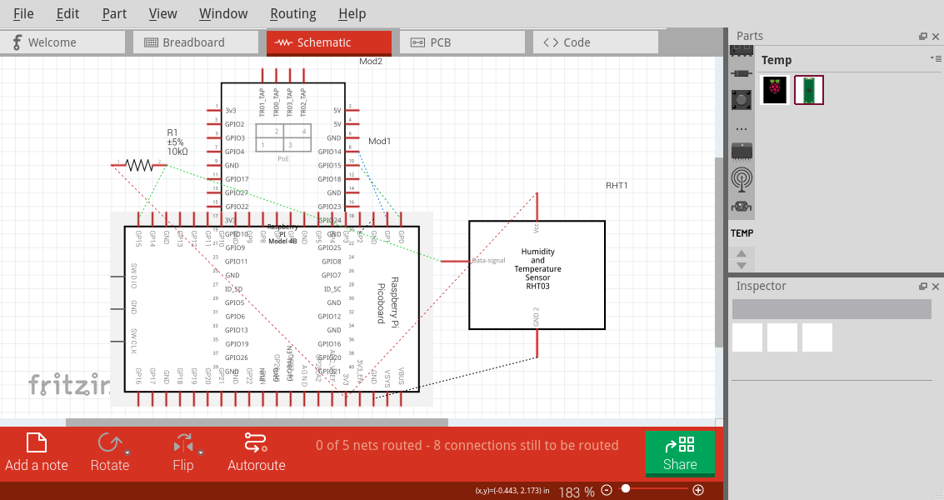
xxx
relay

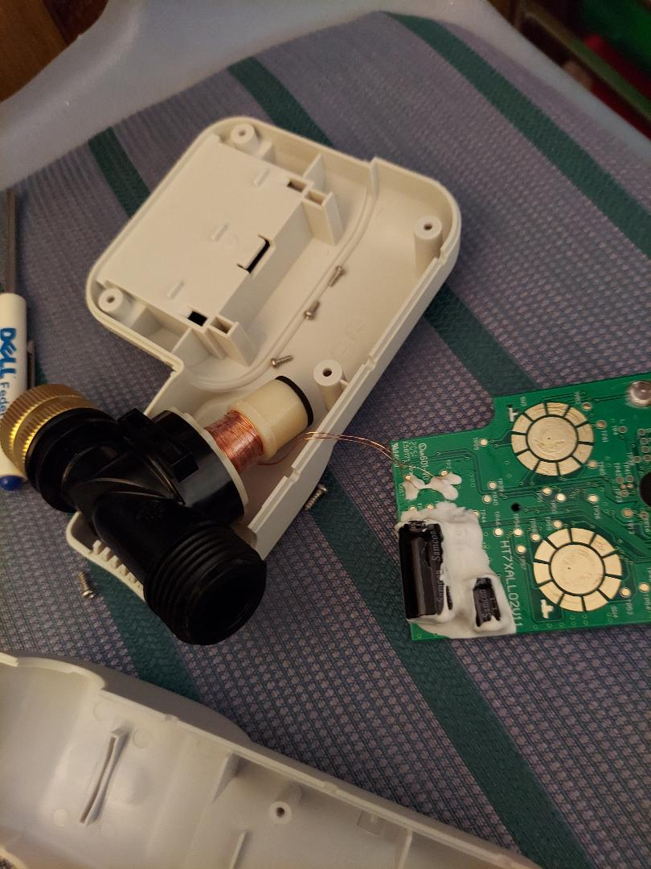
relay1

lower reset upper set

