*****************Draft*****************
WiFi Extender
Provides a 2nd Network
08/15/23
*****************Draft*****************

Requirements:
Raspberry Pi Zero W
USB-to-Ethernet adapter
Ethernet Hub with up link port

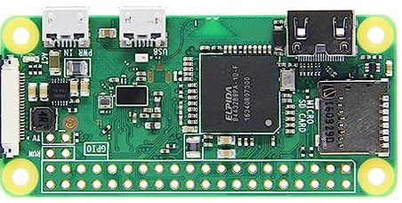

Raspberry Pi Zero W

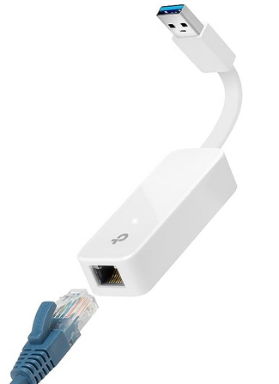

USB-to-Ethernet adapter

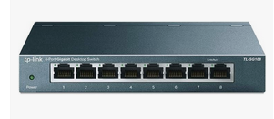

Ethernet Hub with up link port

