****************Draft****************
Using GTKWave to display the CVS from the rp2040-logic-analyzer
07/29/22

****************Draft****************

06/21/23
Goal:
Connect 2 of the 4 inputs of the rp2040 pico to outputs of 2nd pico running an I2C slave_mem program.
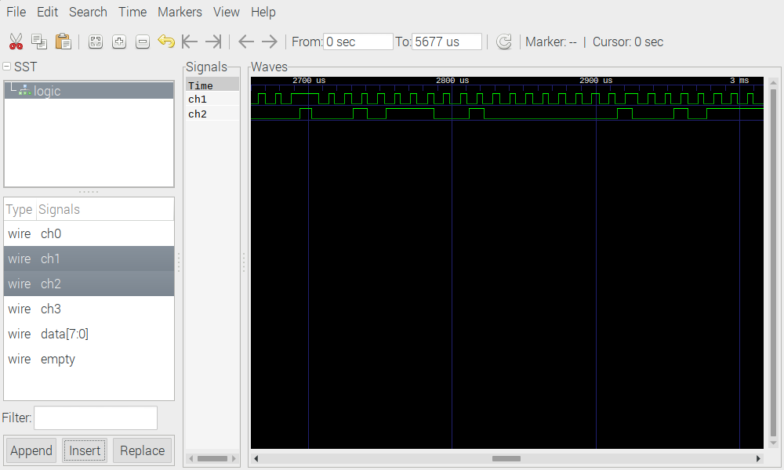
This is one pico running pico-examples/i2c/slave_mem_i2c/slave_mem_i2c.c and a
2nd pico running rp2040-freertos-project/rp2040-logic-analyzer/rp2040-logic-analyzer.c.
The repo https://github.com/develone/rp2040-freertos-project dev branch provides both the
programs needed. In addition https://github.com/develone/generate-vcd/blob/master/sample/4ch.c
compiled with the command "gcc 4ch.c -o 4ch". This is used to convert the output from the
rp2040-logic-analyzer into a vcd file. It also requires
https://github.com/develone/generate-vcd/blob/master/sample/4ch_header.vcd.

The dev branch is used to https://github.com/develone/rp2040-freertos-project/tree/
dev/rp2040-logic-analyzer to create rp2040-logic-analyzer.uf2 or
rp2040-logic-analyzer.elf and slave_mem_i2c.elf which is loaded with exe-slave_mem_i2c.sh

git clone --recursive https://github.com/develone/rp2040-freertos-project.git -b dev
Cloning into 'rp2040-freertos-project'...
remote: Enumerating objects: 2053, done.
remote: Counting objects: 100% (233/233), done.
remote: Compressing objects: 100% (122/122), done.
remote: Total 2053 (delta 115), reused 224 (delta 106), pack-reused 1820
Receiving objects: 100% (2053/2053), 116.01 MiB | 19.49 MiB/s, done.
Resolving deltas: 100% (930/930), done.
Updating files: 100% (306/306), done.
Submodule 'freertos/FreeRTOS-Kernel' (https://github.com/FreeRTOS/FreeRTOS-Kernel) registered for path 'freertos/FreeRTOS-Kernel'
Cloning into '/home/devel/testing/rp2040-freertos-project/freertos/FreeRTOS-Kernel'...
remote: Enumerating objects: 165832, done.
remote: Counting objects: 100% (724/724), done.
remote: Compressing objects: 100% (389/389), done.
remote: Total 165832 (delta 319), reused 641 (delta 266), pack-reused 165108
Receiving objects: 100% (165832/165832), 111.45 MiB | 8.84 MiB/s, done.
Resolving deltas: 100% (118821/118821), done.
Submodule path 'freertos/FreeRTOS-Kernel': checked out '990643ebe8c990dd3672a52079d274e7685df980'
Submodule 'ThirdParty/FreeRTOS-Kernel-Community-Supported-Ports' (https://github.com/FreeRTOS/FreeRTOS-Kernel-Community-Supported-Ports) registered for path 'freertos/FreeRTOS-Kernel/portable/ThirdParty/Community-Supported-Ports'
Submodule 'ThirdParty/FreeRTOS-Kernel-Partner-Supported-Ports' (https://github.com/FreeRTOS/FreeRTOS-Kernel-Partner-Supported-Ports) registered for path 'freertos/FreeRTOS-Kernel/portable/ThirdParty/Partner-Supported-Ports'
Cloning into '/home/devel/testing/rp2040-freertos-project/freertos/FreeRTOS-Kernel/portable/ThirdParty/Community-Supported-Ports'...
remote: Enumerating objects: 76, done.
remote: Counting objects: 100% (76/76), done.
remote: Compressing objects: 100% (53/53), done.
remote: Total 76 (delta 21), reused 62 (delta 16), pack-reused 0
Receiving objects: 100% (76/76), 45.44 KiB | 762.00 KiB/s, done.
Resolving deltas: 100% (21/21), done.
Cloning into '/home/devel/testing/rp2040-freertos-project/freertos/FreeRTOS-Kernel/portable/ThirdParty/Partner-Supported-Ports'...
remote: Enumerating objects: 50, done.
remote: Counting objects: 100% (50/50), done.
remote: Compressing objects: 100% (38/38), done.
remote: Total 50 (delta 17), reused 39 (delta 12), pack-reused 0
Receiving objects: 100% (50/50), 32.51 KiB | 693.00 KiB/s, done.
Resolving deltas: 100% (17/17), done.
Submodule path 'freertos/FreeRTOS-Kernel/portable/ThirdParty/Community-Supported-Ports': checked out 'f0618d9e2f4c5b0a3e472a2673a090e8ef836258'
Submodule path 'freertos/FreeRTOS-Kernel/portable/ThirdParty/Partner-Supported-Ports': checked out '3f9c99a682c5c796bb7eb89fd9c4385688fce27a'

mkdir build

cd build

cmake -DPICO_BOARD=pico DFREERTOS_KERNEL_PATH:PATH=../freertos/FreeRTOS-Kernel ..

Using PICO_SDK_PATH from environment ('/home/devel/sdk/pico-sdk')
PICO_SDK_PATH is /home/devel/sdk/pico-sdk
Defaulting PICO_PLATFORM to rp2040 since not specified.
Defaulting PICO platform compiler to pico_arm_gcc since not specified.
-- Defaulting build type to 'Release' since not specified.
PICO compiler is pico_arm_gcc
-- The C compiler identification is GNU 8.3.1
-- The CXX compiler identification is GNU 8.3.1
-- Detecting C compiler ABI info
-- Detecting C compiler ABI info - done
-- Check for working C compiler: /usr/bin/arm-none-eabi-gcc - skipped
-- Detecting C compile features
-- Detecting C compile features - done
-- Detecting CXX compiler ABI info
-- Detecting CXX compiler ABI info - done
-- Check for working CXX compiler: /usr/bin/arm-none-eabi-g++ - skipped
-- Detecting CXX compile features
-- Detecting CXX compile features - done
-- The ASM compiler identification is GNU
-- Found assembler: /usr/bin/arm-none-eabi-gcc
Build type is Release
PICO target board is pico.
Using board configuration from /home/devel/sdk/pico-sdk/src/boards/include/boards/pico.h
-- Found Python3: /usr/bin/python3.9 (found version "3.9.2") found components: Interpreter
TinyUSB available at /home/devel/sdk/pico-sdk/lib/tinyusb/src/portable/raspberrypi/rp2040; enabling build support for USB.
BTstack available at /home/devel/sdk/pico-sdk/lib/btstack
cyw43-driver available at /home/devel/sdk/pico-sdk/lib/cyw43-driver
Pico W Bluetooth build support available.
lwIP available at /home/devel/sdk/pico-sdk/lib/lwip
mbedtls available at /home/devel/sdk/pico-sdk/lib/mbedtls
-- Configuring done
-- Generating done
-- Build files have been written to: /home/devel/testing/rp2040-freertos-project/buid

make

exe-slave_mem_i2c.sh uses openocd to load the pico with a master slave i2c.
#!/bin/bash
openocd -f interface/raspberrypi-swd.cfg -f target/rp2040.cfg -c "program i2c/slave_mem_i2c/slave_mem_i2c.elf verify reset exit"

rp2040-logic-analyzer.uf2 provides a logic-analyzer.

Welcome to minicom 2.8/devel

OPTIONS: I18n
Port /dev/ttyACM0, 06:18:11

Press CTRL-A Z for help on special keys

p17
Start pin is 17
n4
Total pins is 4
s250000
Sample number is 250000
f1000000
Frequency is 1000000 div is 125.000000
t0
Welcome to minicom 2.8

OPTIONS: I18n
Port /dev/ttyACM0, 06:18:11

Press CTRL-A Z for help on special keys

p17
Start pin is 17
n4
Total pins is 4
s250000
Sample number is 250000
f1000000
Frequency is 1000000 div is 125.000000
t0
Trigger set to 0

CtrlAL
Capture to which file?
> 4ch.csv

CtrlAL
Capture file
Close

CtrlAX
Leave Minicom?
Yes

vi 4ch.csv
g
Clock speed is 125000000
Capture speed is 1000000.000000.2
Arming trigger
0,0,0,0,
0,0,0,0,
0,0,0,0,
0,0,0,0,
0,0,0,0,
0,0,0,0,
0,0,0,0,
1,0,0,0,
1,0,0,0,
1,0,0,0,
1,0,0,0,
1,0,0,0,
0,0,0,0,
0,0,0,0,
.
.
.
1,1,0,0,
1,1,0,0,
1,1,0,0,
1,1,0,0,
1,1,0,0,
1,1,0,0,

Esc:1,$ s/0,0,0,0,/0,0,0,0/g
2413 substitutions on 2413 lines

Esc:1,$ s/0,1,0,0,/0,1,0,0/g
1150 substitutions on 1150 lines

Esc:1,$ s/1,1,0,0,/1,1,0,0/g
245049 substitutions on 245049 lines

Esc:1,$ s/1,0,0,0,/1,0,0,0/g
1388 substitutions on 1388 lines

verify that all of the "," are removed

1G
Delete
g
Clock speed is 125000000
Capture speed is 1000000.000000.2
Arming trigger
with 4dd
Esc:wq

devel@pi4-ultibo:~ $ ./4ch > xx

devel@pi4-ultibo:~ $ cat generate-vcd/sample/4ch_header.vcd xx > test5.vcd

// For this example, we run both the master and slave from the same board.
// You'll need to wire pin GP4 to GP6 (SDA), and pin GP5 to GP7 (SCL).

devel@pi4-50:~/pico-examples/build $ openocd -f interface/raspberrypi-swd.cfg
-f target/rp2040.cfg -c "program i2c/slave_mem_i2c/slave_mem_i2c.elf verify
reset exit"
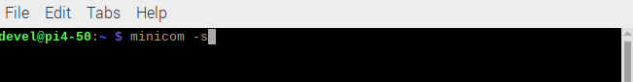
xx

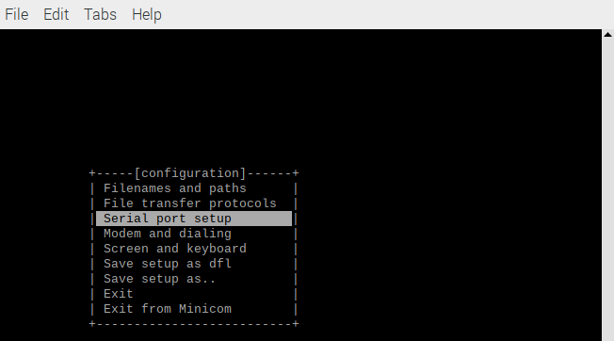
xx

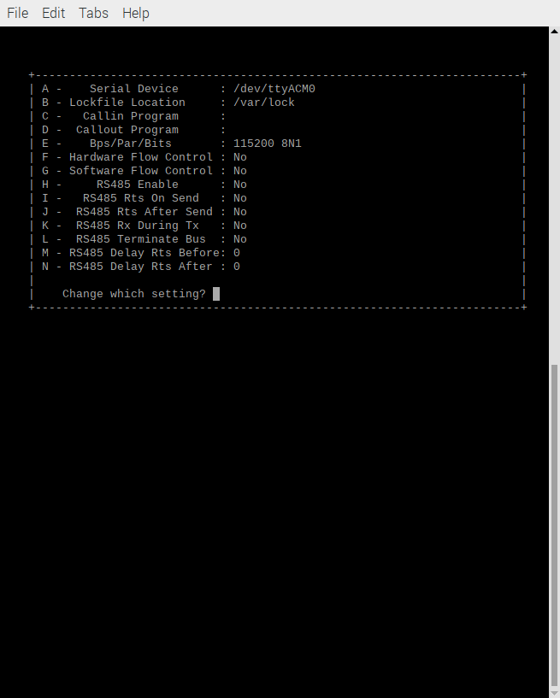
xx

xx
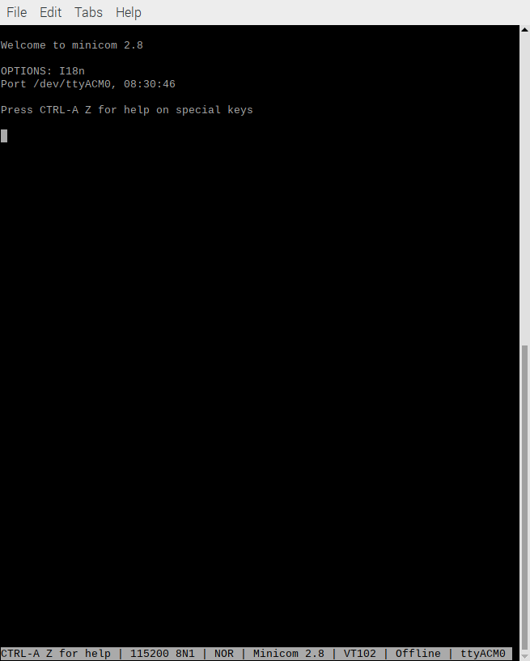
xx

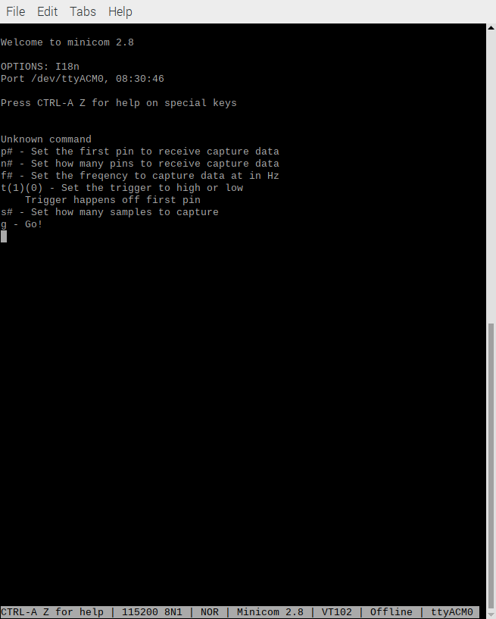
xx

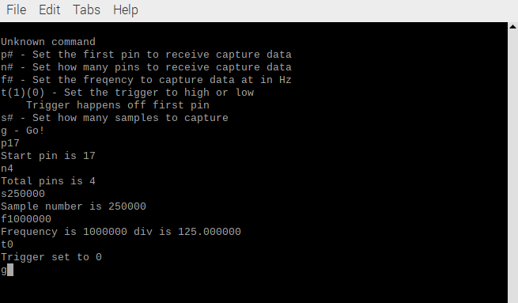

xx

xx

xx

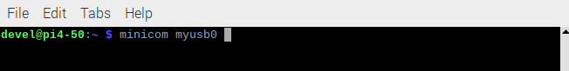
xx

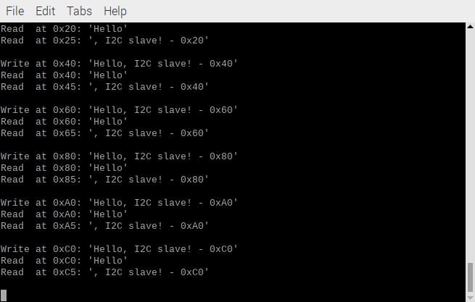

xx
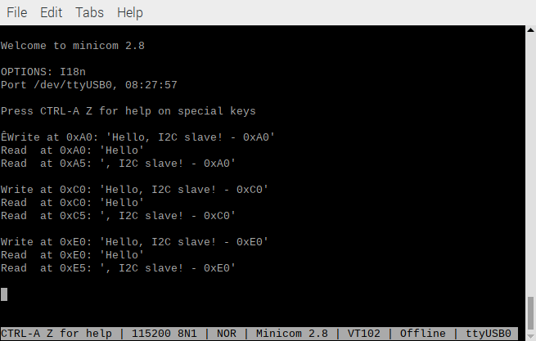
xx

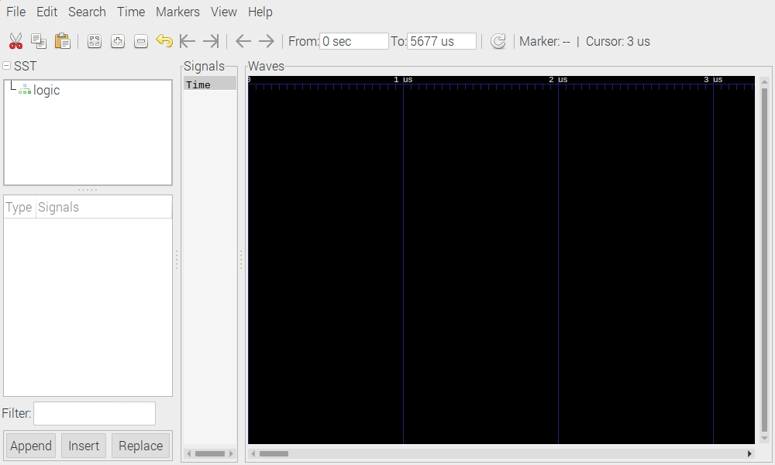
xx
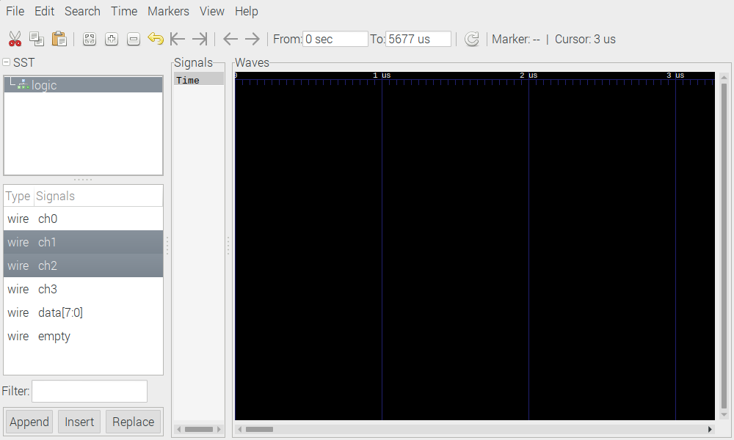
xx
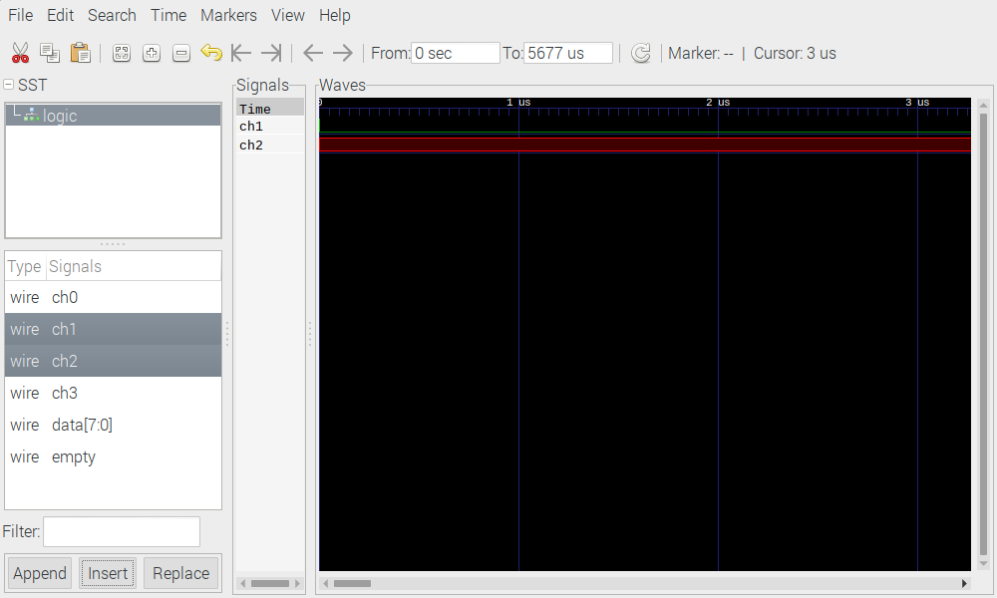
xx
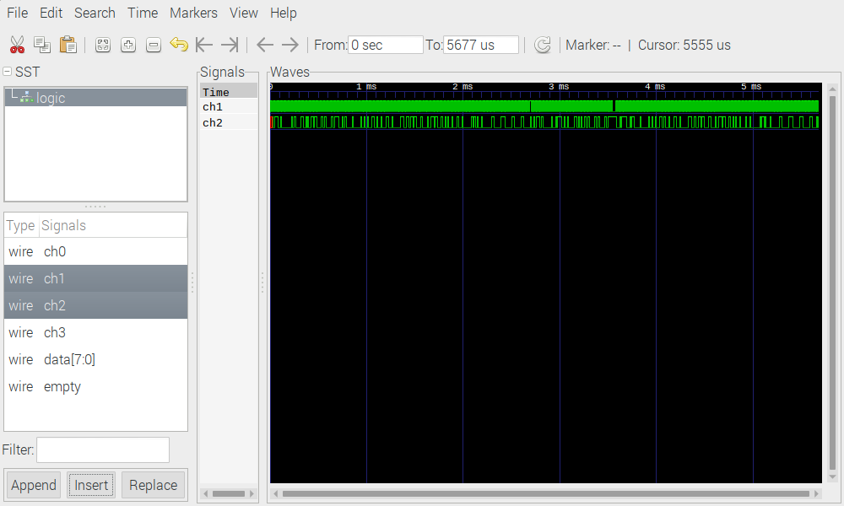
xx
xx
xx

