Continued testing of picotool with wireshark. 05/17/21

https://github.com/develone/rp2040-freertos-project/blob/master/doc/wireshark/4160usbmon0.pcapng

It appears the first packet is at frame 601.

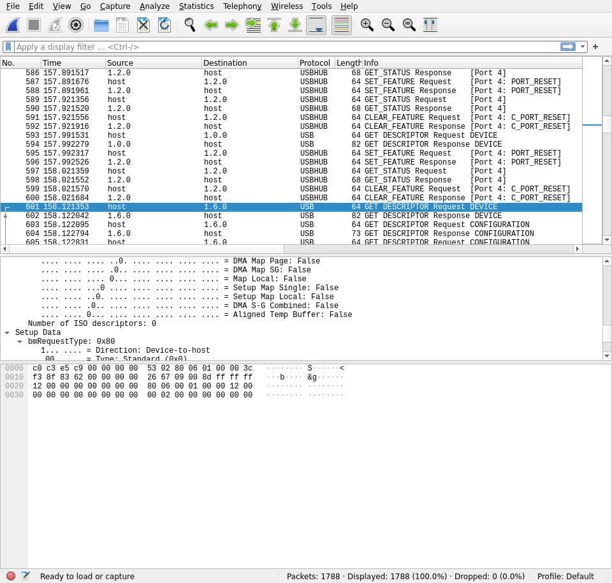
Notice that the length of the packets was 4160

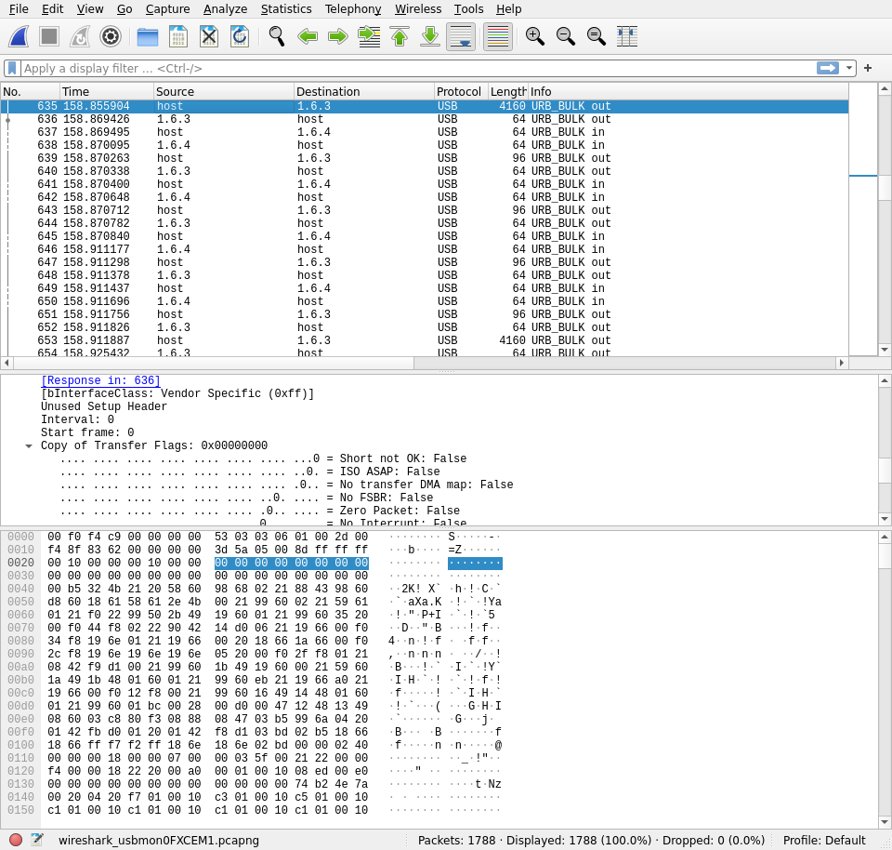

Whenever the picotool is used it comes up with a different device in this case 1.6.3

A hexdump of test-read.elf which is the data sent by the picotool to the pico.

00001000 00 B5 32 4B 21 20 58 60 98 68 02 21 88 43 98 60

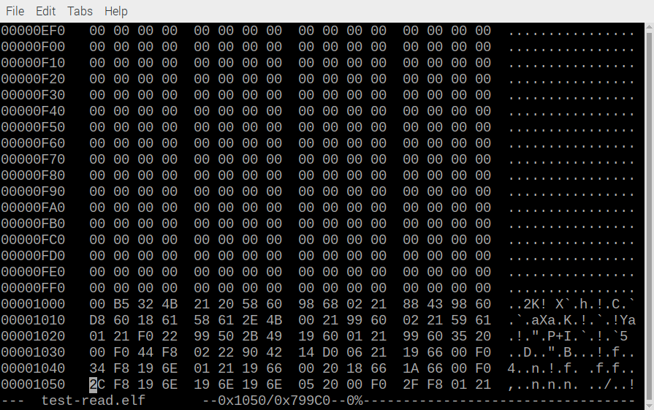
Wireshark frame 635

