iRst goes lo

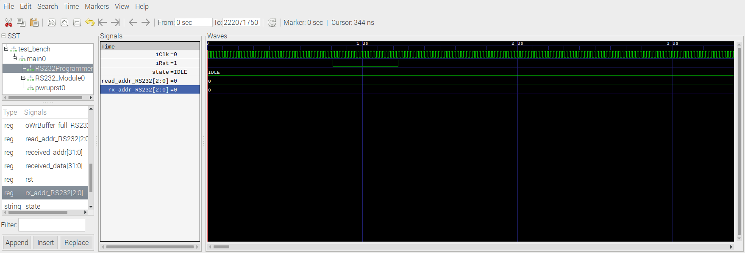
if ((rx_addr != read_addr)) begin

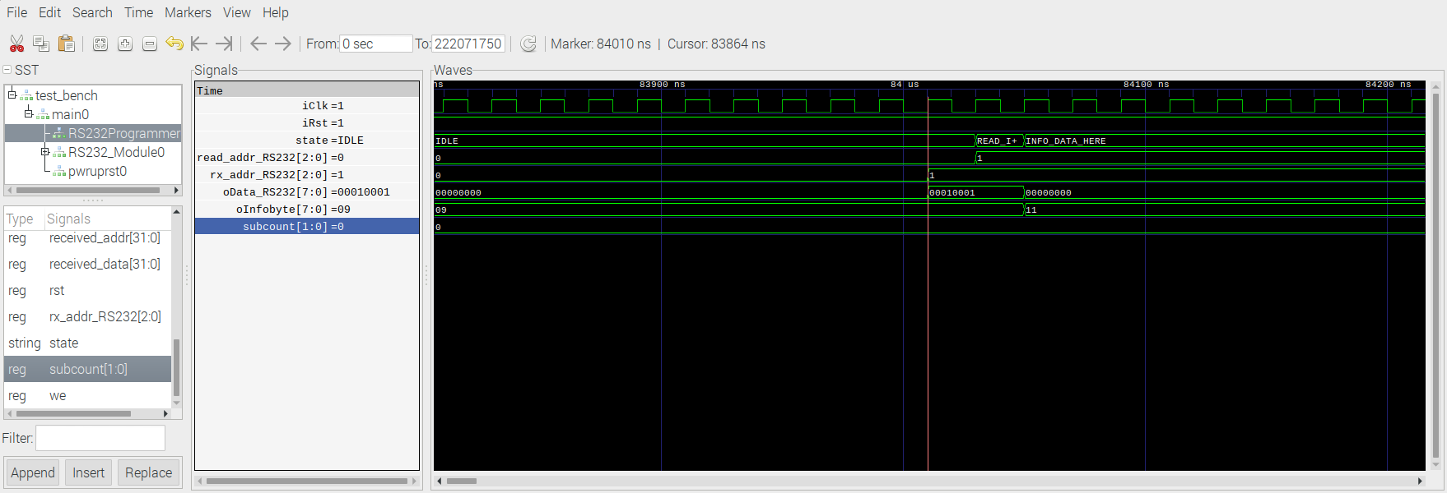
if (RS232Programmer0_isData) begin

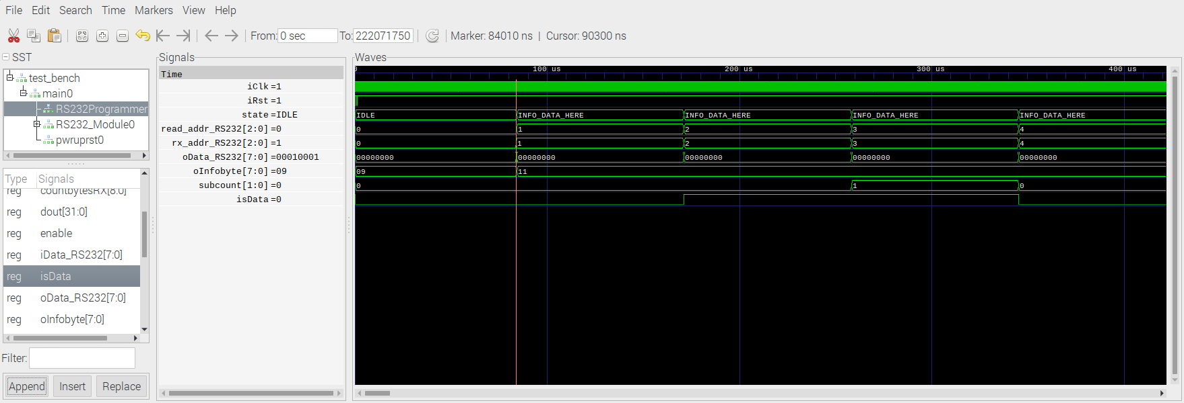
xxx
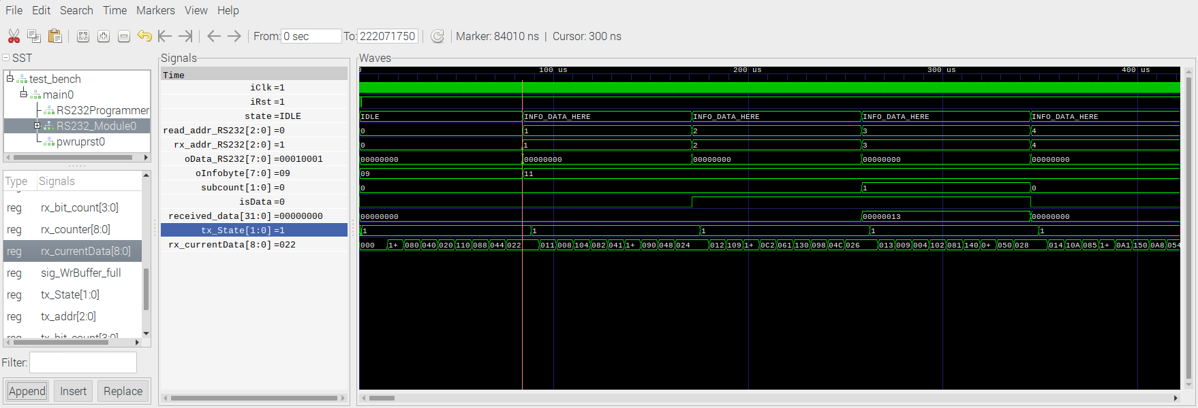
xxx

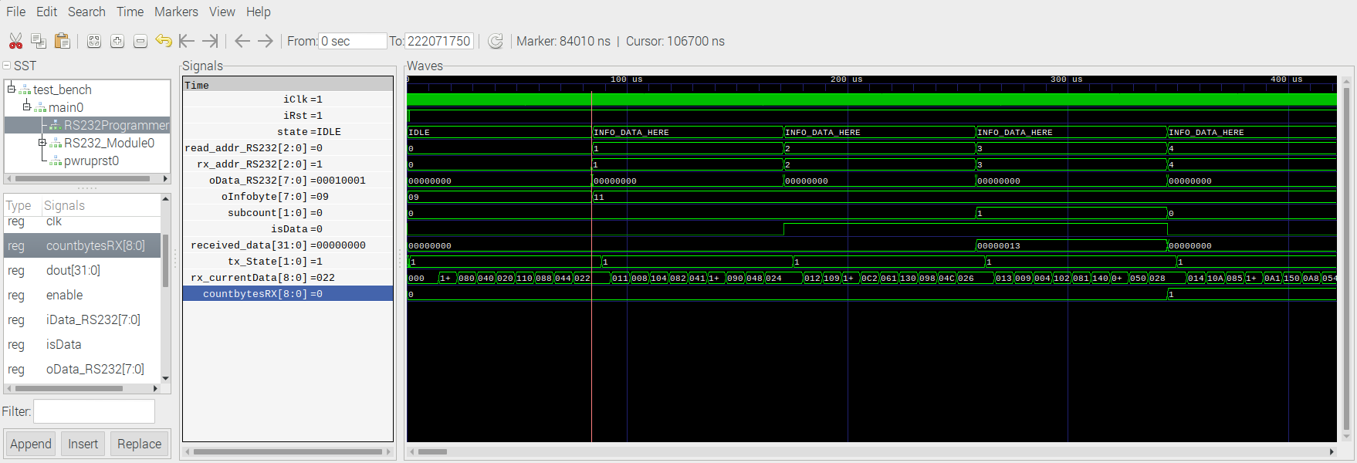
Functions in test_bench

@always_comb
def rs232loopback():
iRX.next=oTX

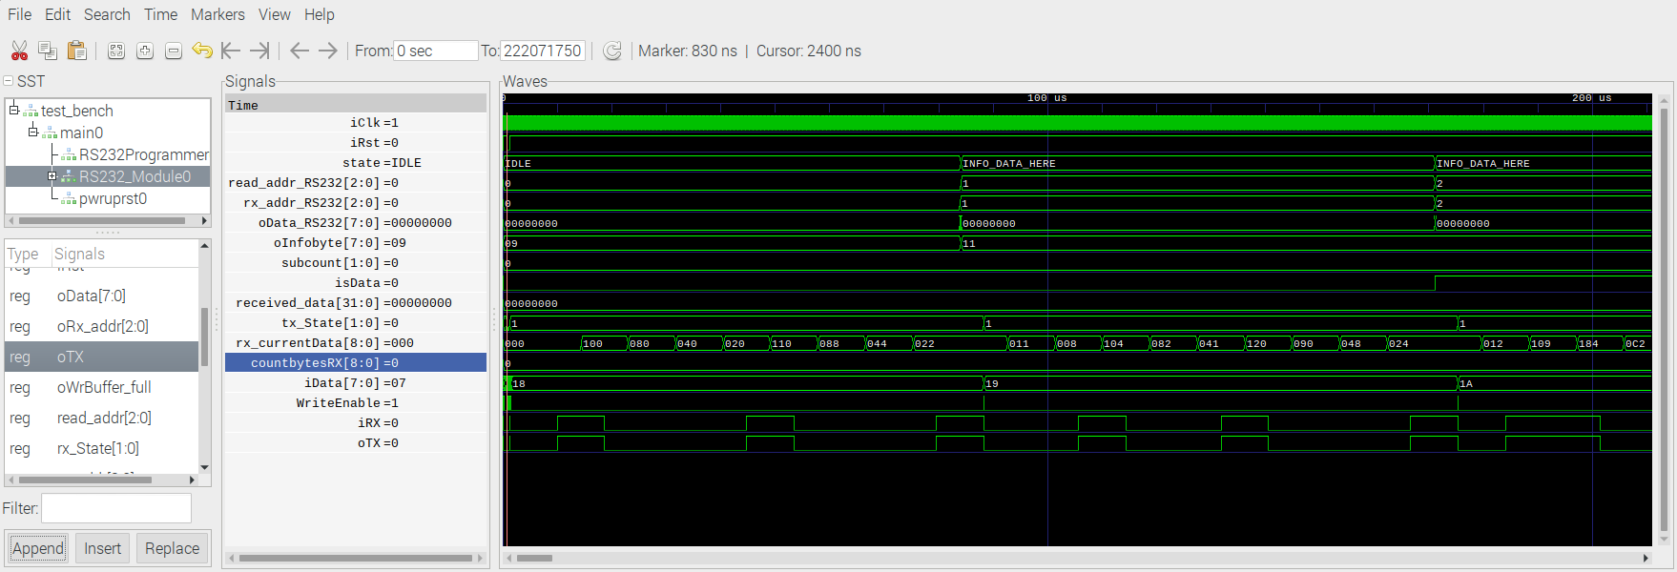

def Write_to_rs232_send_buffer(value):
yield iClk.posedge
while oWrBuffer_full:
yield iClk.posedge
iData.next=value
if oWrBuffer_full:
print "Value:",value,"\tNot written, RS232 Transmittbuffer has indiciated to be allready full. (by oWrBuffer_full)"

WriteEnable.next=1
yield iClk.posedge
WriteEnable.next=0

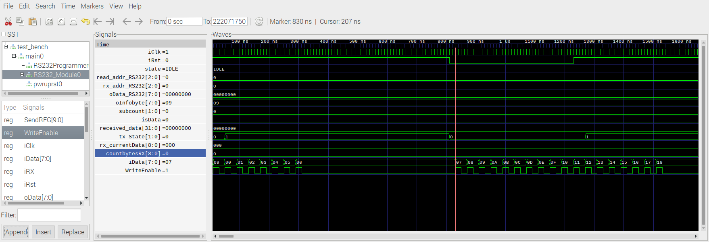

def TestTransmitReceive(testARRAY):
#### Write some Bytes to the Sendbuffer #####
for data in testARRAY:
yield Write_to_rs232_send_buffer(data)

for i in range(int(Clk_f/BAUDRATE)*10*(RX_BUFF_LEN+3))
yield iClk.posedge

